Starting the simulation.

devel@mypi3-16:~/testbuilds/catzip-tst/catzip/sim/verilated $ ./arm-main_tb
Listening on port 8363
Listening on port 8364
> T
CMD: Only sent 0 bytes of 3!

Loading the cputest program.

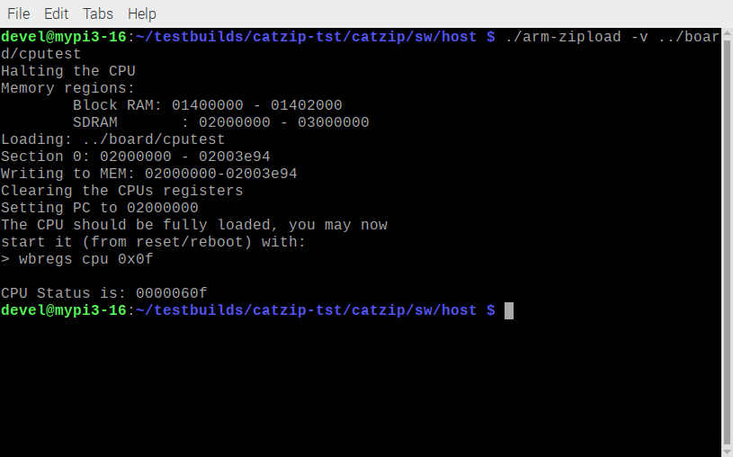
Starting the debugger.
devel@mypi3-16:~/testbuilds/catzip-tst/catzip/sw/host $ ./arm-zipdbg

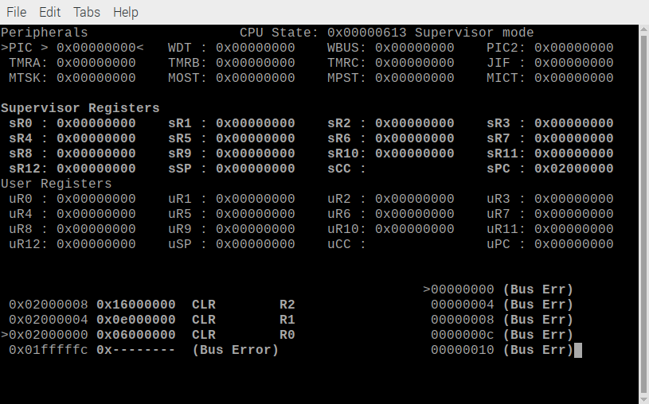
01000000 <_start>:
1000000: 06 00 00 00 CLR R0
1000004: 0e 00 00 00 CLR R1
1000008: 16 00 00 00 CLR R2
100000c: 1e 00 00 00 CLR R3
1000010: 26 00 00 00 CLR R4
1000014: 2e 00 00 00 CLR R5
1000018: 36 00 00 00 CLR R6
100001c: 3e 00 00 00 CLR R7
1000020: 46 00 00 00 CLR R8
1000024: 4e 00 00 00 CLR R9
1000028: 56 00 00 00 CLR R10
100002c: 5e 00 00 00 CLR R11
1000030: 66 00 00 00 CLR R12

After several steps the sSP is set 0x03000000 to the top of sdram. The sPC is at 0x0200003c

