devel@mypi3-16:~/testbuilds/catzip-tst/catzip/sim/verilated $ ./arm-main_tb -trace /media/devel/1b763776-4e1d-499c-9f24-a116a58c161f/bkram.vcd

devel@mypi3-16:~/testbuilds/catzip-tst/catzip/sw/host $ ../../../arm-wrsdram rgb_bkram.bin ; ../../../arm-rdsdram rdtest.bin; diff rgb_bkram.bin rdtest.bin
The size of the buffer is 0x002000 or 8192 words

READ-COMPLETE

Write-COMPLETE
The size of the buffer is 0x002000 or 8192 words
Binary files rgb_bkram.bin and rdtest.bin differ

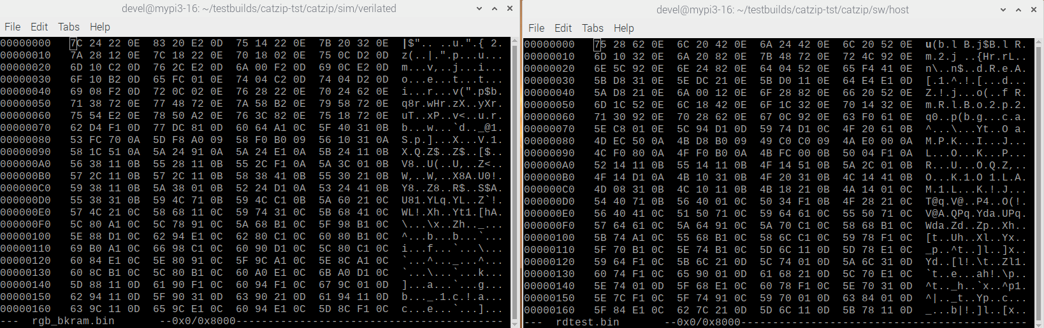
bkram

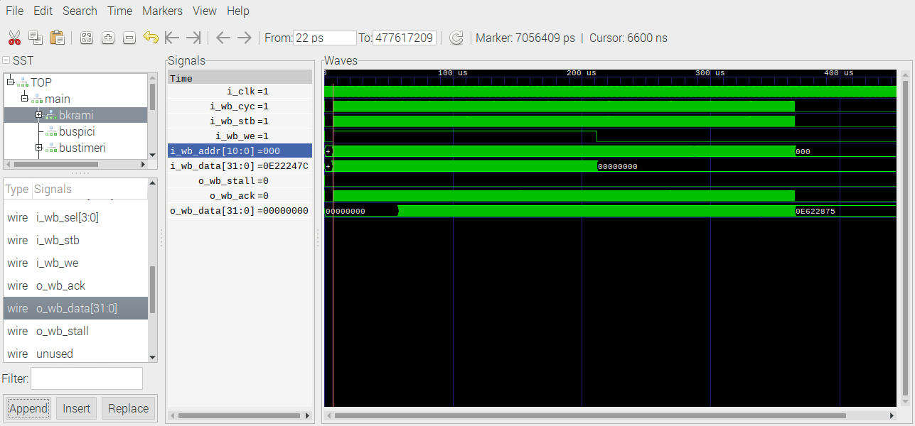
bkram1

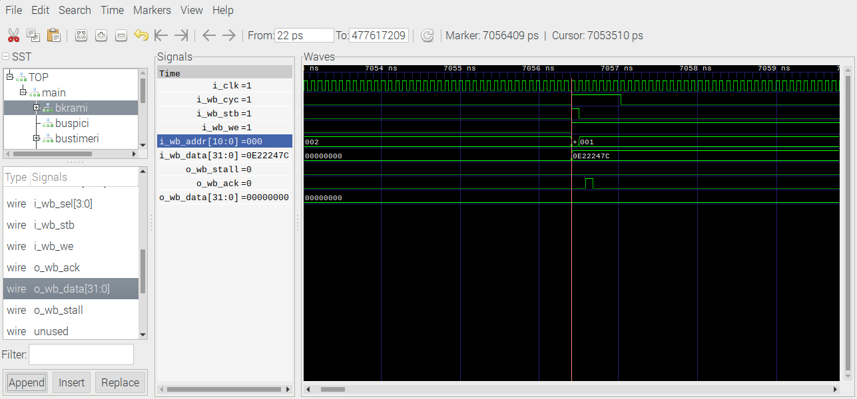
Write 0x0e22247c

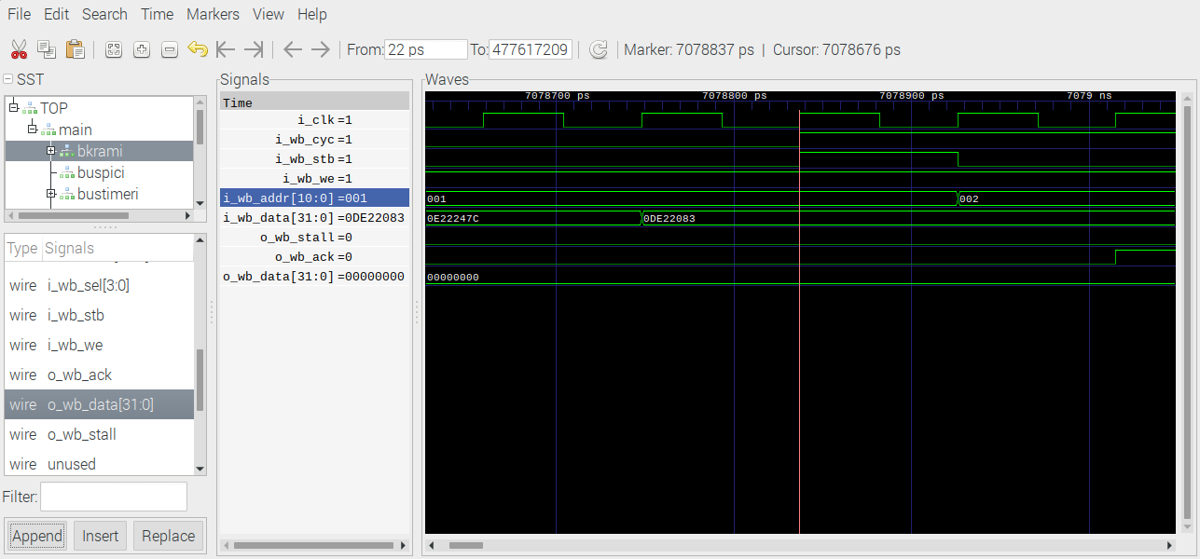
Write 0x0de22083

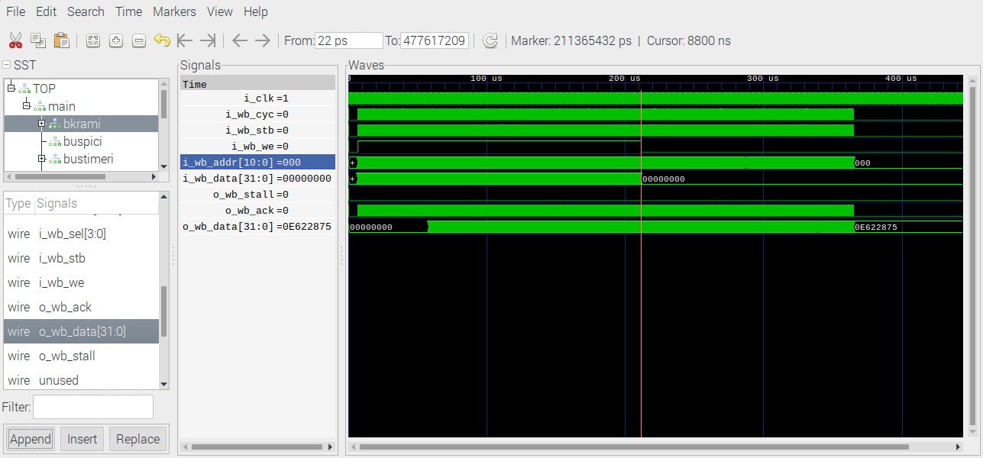
Read 0x0E22247C in error 0x0E622875

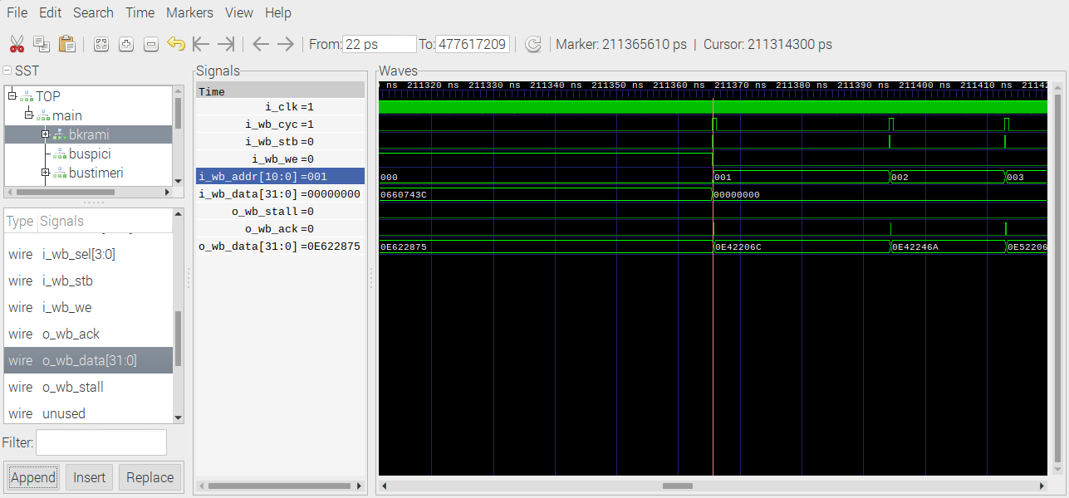
Read 0x8320E20D in error

