The make completed as before. Started the simulator in left shell. In right shell ./arm-zipload -v ../board/cputest Hangs Clearing the CPUs registers

testing using @$(SLAVE.PORTLIST) in bkram.txt
switching order o_wb_ack, o_wb_stall -> o_wb_stall, o_wb_ack

Needed to test an additional change to catzip-tst/catzip/auto-data/sdramdev.txt

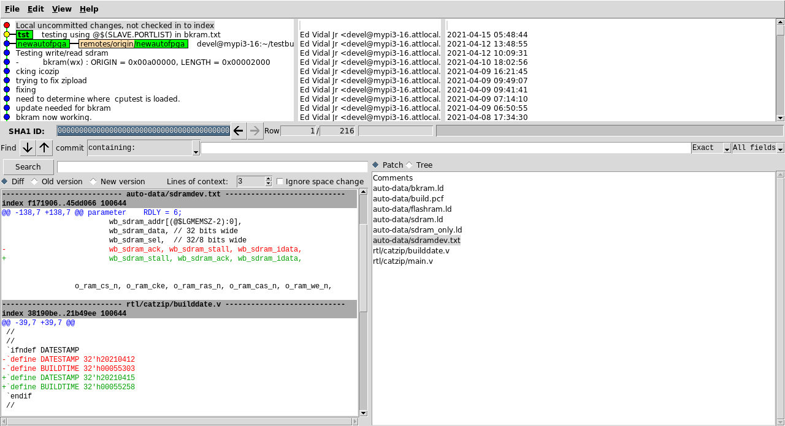
devel@mypi3-16:~/testbuilds/catzip-tst/catzip/sw/host $ ./arm-zipload -v ../board/cputest
Halting the CPU
Memory regions:
Block RAM: 01400000 - 01402000
SDRAM : 02000000 - 03000000
Loading: ../board/cputest
Section 0: 02000000 - 02003e94
Writing to MEM: 02000000-02003e94
Clearing the CPUs registers

POLL = 1
RCVD: 2 bytes
< W
> K00000000
POLL = 1
RCVD: 2 bytes
< W
> K00000000
POLL = 1
RCVD: 2 bytes
< W
> K00000000
POLL = 1
RCVD: 2 bytes
< W
> K00000000
POLL = 1
RCVD: 2 bytes
< W
> K00000000
POLL = 1
RCVD: 2 bytes
< W
> K00000000
POLL = 1
RCVD: 2 bytes
< W
> K00000000
POLL = 1
RCVD: 11 bytes
< A01000015R
> A01000015R20210415
POLL = 1
RCVD: 14 bytes
< A04000001W400
> A04000001K00000000
POLL = 1
RCVD: 11 bytes
< A04000005W
> A04000005

// @REGDEFS.H.DEFNS for masters
#define CLKFREQHZ 40000000
#define R_ZIPCTRL 0x04000000
#define R_ZIPDATA 0x04000004
#define RESET_ADDRESS 0x01400000
// @REGDEFS.H.DEFNS for peripherals
#define BKRAMBASE 0x01400000
#define BKRAMLEN 0x00002000
#define SDRAMBASE 0x02000000
#define SDRAMLEN 0x01000000

#define CPU_GO 0x0000
#define CPU_RESET 0x0040
#define CPU_INT 0x0080
#define CPU_STEP 0x0100
#define CPU_STALL 0x0200
#define CPU_HALT 0x0400
#define CPU_CLRCACHE 0x0800
#define CPU_sR0 0x0000
#define CPU_sSP 0x000d
#define CPU_sCC 0x000e
#define CPU_sPC 0x000f
#define CPU_uR0 0x0010
#define CPU_uSP 0x001d
#define CPU_uCC 0x001e

#define CPU_uPC 0x001f

I had a program arm-wrsdram which writes to 0x01400000 8192 words.

devel@mypi3-16:~/testbuilds/catzip-tst/catzip/sw/host $ ../../../../catzip-newautofpga/arm-wrsdram rgb_pack.bin
The size of the buffer is 0x002000 or 8192 words

This also hangs.

devel@mypi3-16:~/testbuilds/catzip-tst/catzip/sw/host $ ./arm-wrsdram rgb_pack.bin
The size of the buffer is 0x010000 or 65536 words

READ-COMPLETE

./arm-rdsdram rdtest.bin

Write-COMPLETE
The size of the buffer is 0x010000 or 65536 words

Write data 0x0200f120 65536 words. I beleve this confirm that the problem is in the bkram.

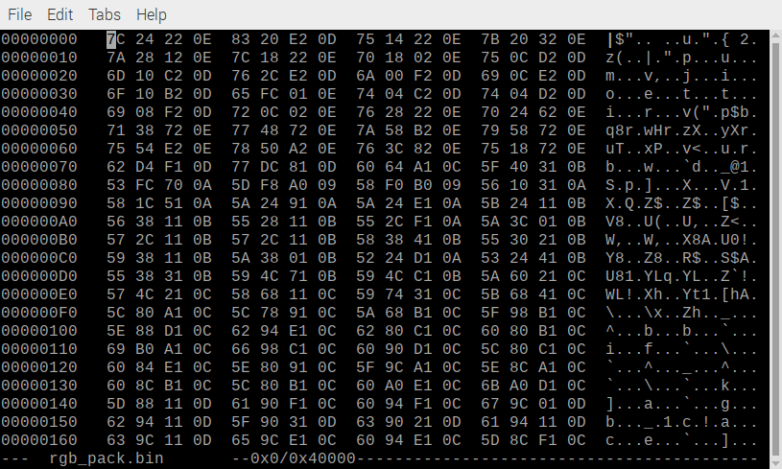

Read data

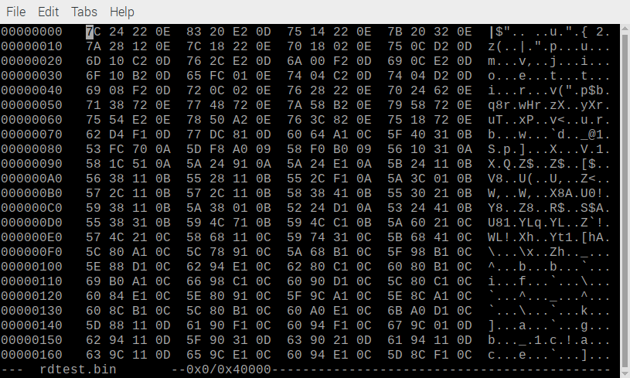
ran a simulation with a trace.

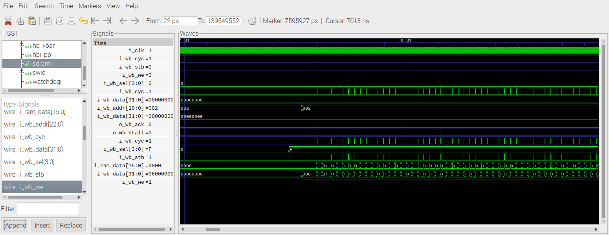

I created a tst branch.

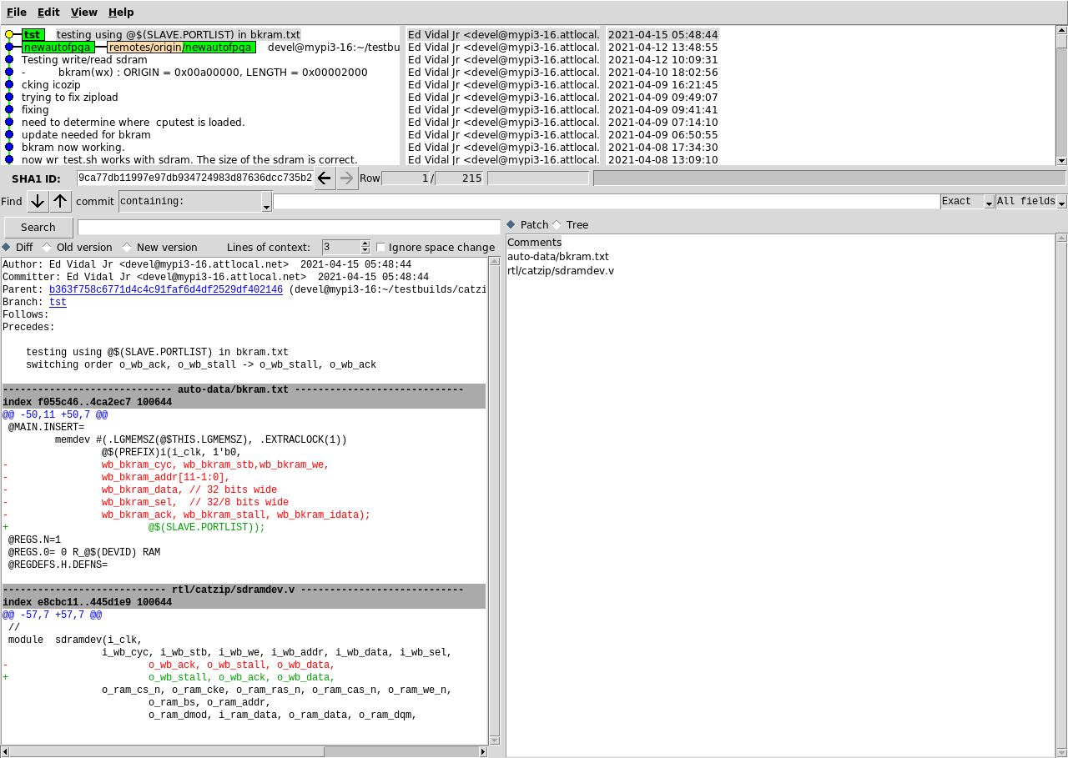
./arm-wbregs version ok.

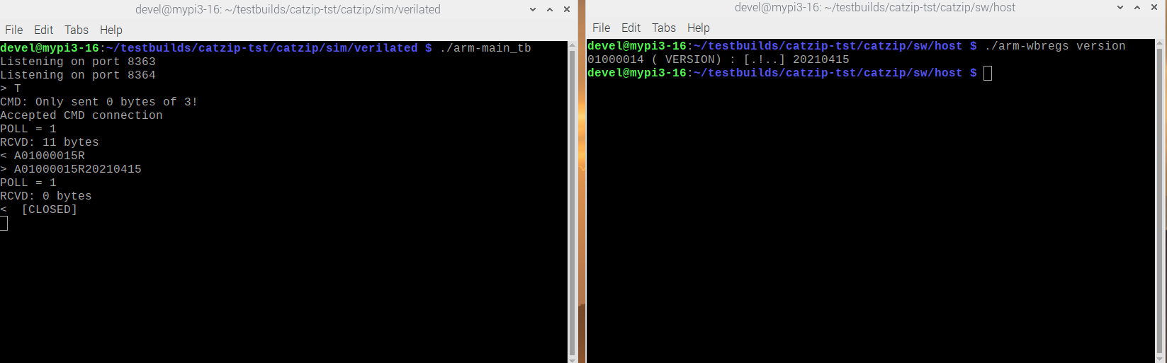

The make completed as before. Started the simulator in left shell. In right shell ./arm-zipload -v ../board/cputest Hangs Clearing the CPUs registers

