****************DRAFT****************
Testing Docker image zipcpu:0.62
01/20/20
****************DRAFT****************

The docker image starts with ubuntu:16.04. Adds several package needed to support Starting the docker image on Ubuntu 16.04 ws009. The Dockerfile found at Appendix A was The Dockerfile used to create the docker image. The file build.sh found at Append B was the command run to create the docker image zipcpu:0.62. Current packages installed is 609, the list of packages is found at Appendix C. The lines in the Dockerfile is what installs the dependencies to install zipcpu, verilator, autofpga, icestorm, nextpnr, and yosys.

RUN apt-get update && apt-get -y install gawk wget git-core diffstat unzip texinfo gcc-multilib \
build-essential chrpath socat cpio python python3 python3-pip python3-pexpect \
xz-utils debianutils iputils-ping libsdl1.2-dev xterm tar locales \
bison flex autoconf automake libtool libgmp3-dev \
libmpfr-dev libmpfr-doc libmpfr4 libmpfr4-dbg libmpc-dev libelf-dev bc \
ncurses-dev ctags mercurial gperf \
clang libreadline-dev tcl-dev libffi-dev pkg-config libftdi-dev libboost-all-dev \
cmake libeigen3-dev

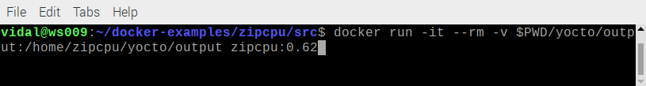
The boot time is extremely quick.

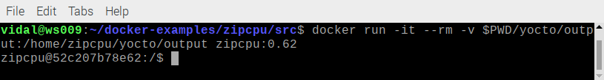
On the host system user vidal is 1000 in group 1000. This matched in the Dockerfile with the lines
# The running container writes all the build artefacts to a host directory (outside the container).
# The container can only write files to host directories, if it uses the same user ID and
# group ID owning the host directories. The host_uid and group_uid are passed to the docker build
# command with the --build-arg option. By default, they are both 1000. The docker image creates
# a group with host_gid and a user with host_uid and adds the user to the group. The symbolic
# name of the group and user is cuteradio.
ARG host_uid=1000
ARG host_gid=1000

Setup the enviorment to work on catzip.

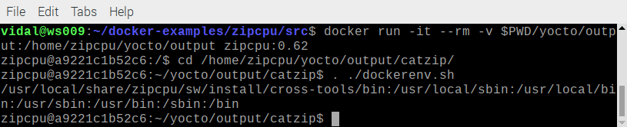
Execute the autofpga program.

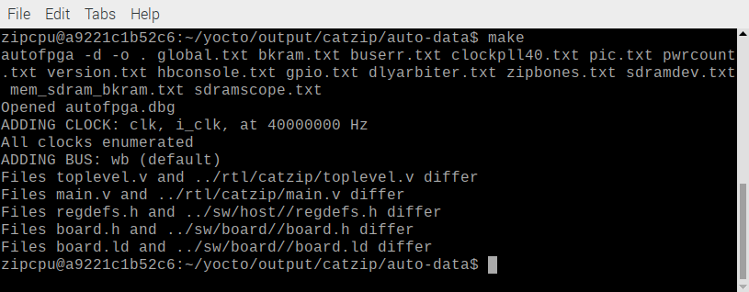
Create the catzip.bin using yosys, nexpnr, icepack and icetime.
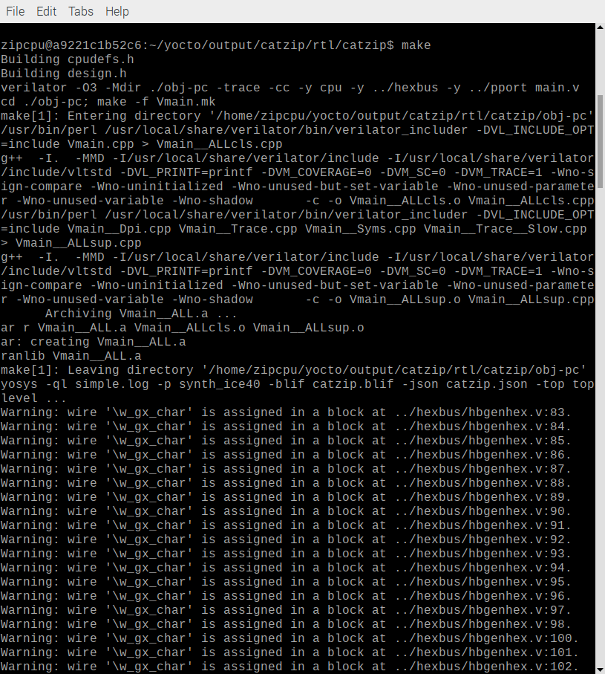
When the catzip is created icetime checks the clock used passes.

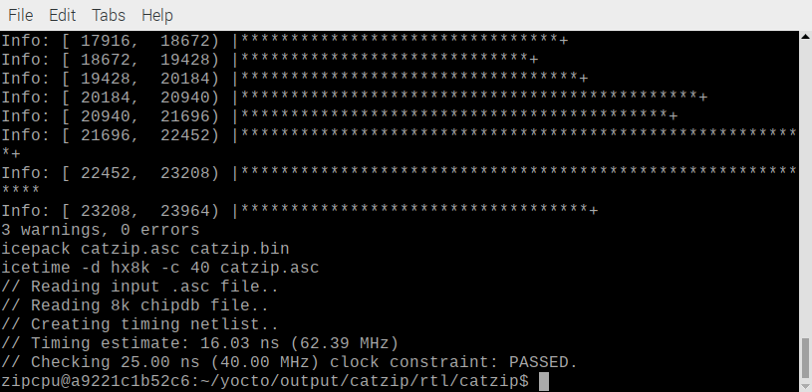
Create the simulator using verilator.

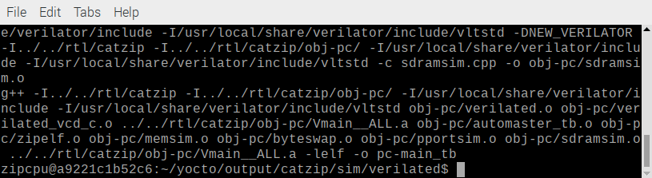
Create the software to communicate with the simulator or FPGA.

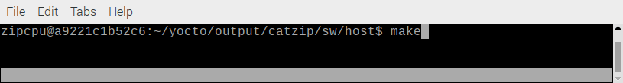
The pc-files are the green ones needed to communicate with simulator or FPGA.
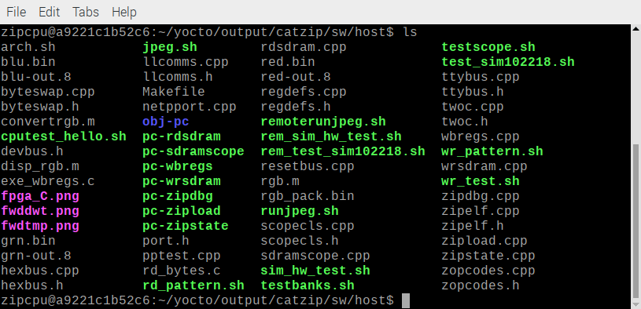
Creare the libcatzip.a

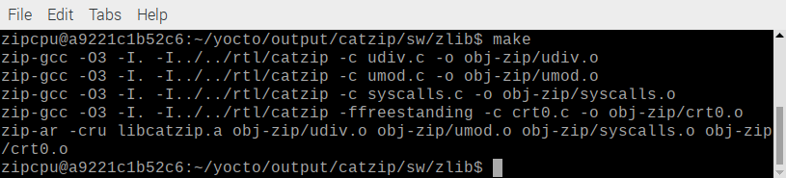
Create cputest, hello, and jpeg programs which execute on the simulator or FPGA.

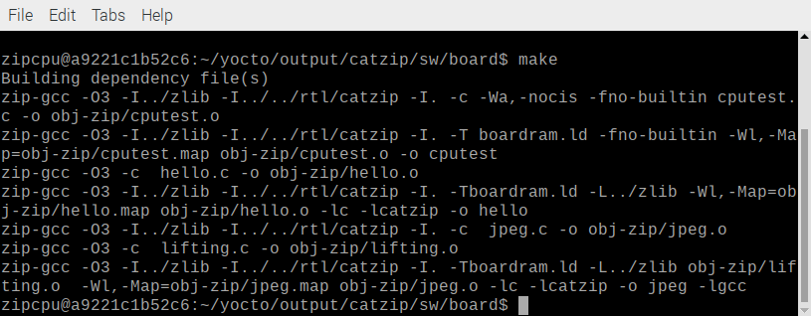
Determing the ip of docker container.

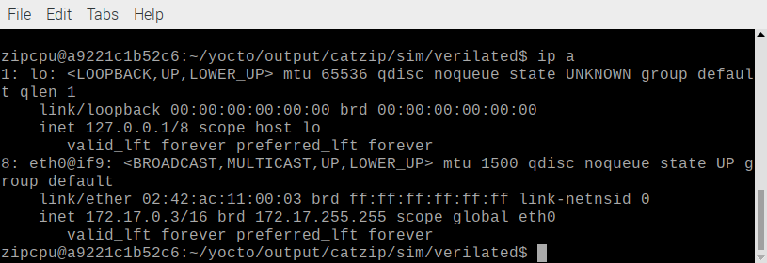
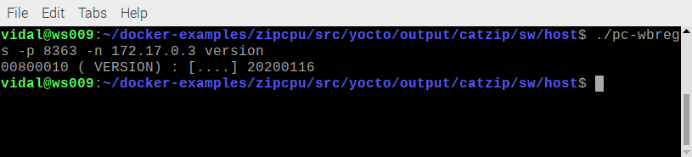

Start the simulator
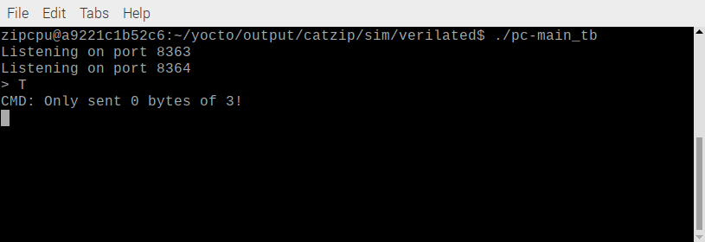
Check the build date.

The cputest program

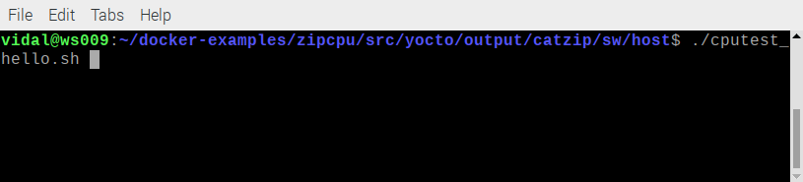
Results of cputest
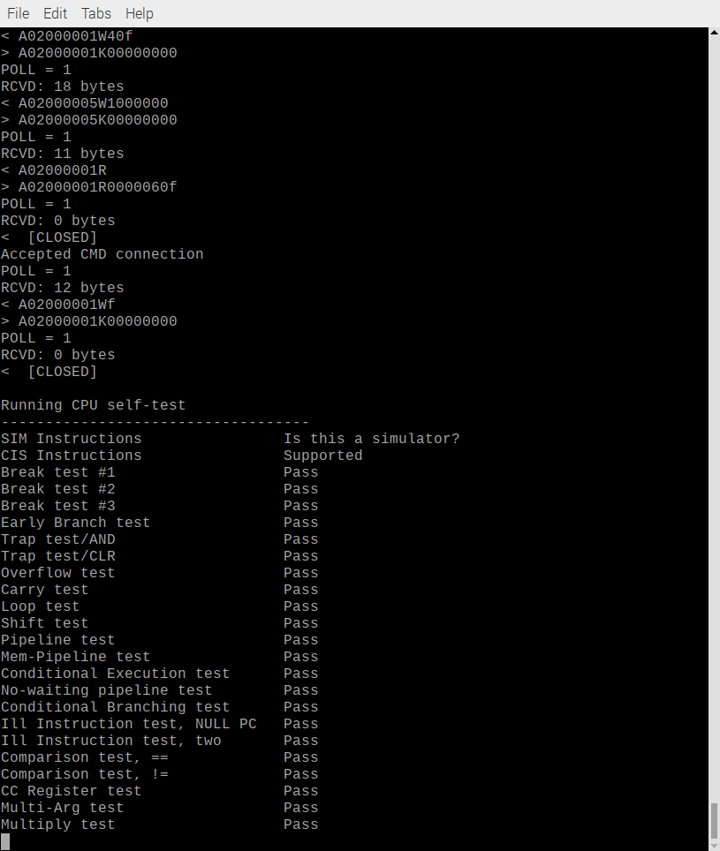
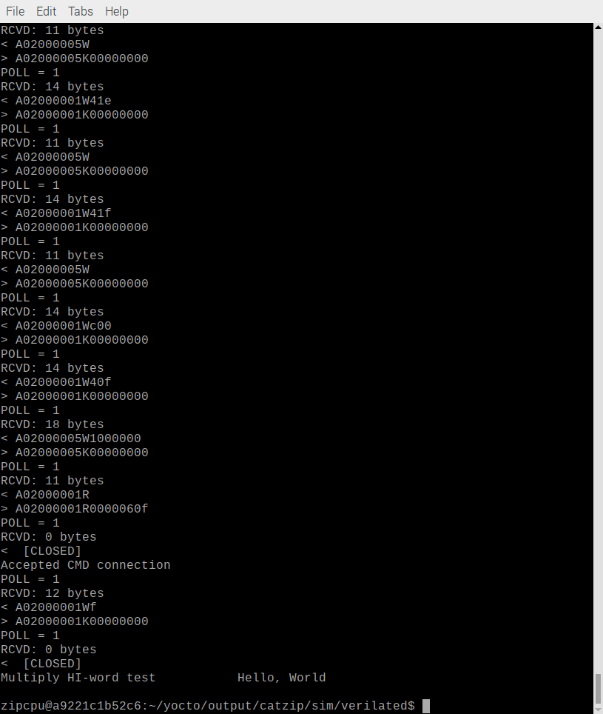

zipcpu@a9221c1b52c6:~/yocto/output/catzip/rtl/catzip$ md5sum catzip.bin
a7e9e8c6687702feecbe4fbf7b918797 catzip.bin
zipcpu@a9221c1b52c6:~/yocto/output/catzip/rtl/catzip$ scp catzip.bin devel@192.168.1.69:~/testbuilds/catzip/rtl/catzip/
The authenticity of host '192.168.1.69 (192.168.1.69)' can't be established.
ECDSA key fingerprint is SHA256:Bbi9VZShq4oPPLO/2sdVWLqT9dfufvoWSumdyGevmZk.
Are you sure you want to continue connecting (yes/no)? yes
Warning: Permanently added '192.168.1.69' (ECDSA) to the list of known hosts.
devel@192.168.1.69's password:
catzip.bin 100% 132KB 131.9KB/s 00:00

devel@mypi3-16:~/testbuilds/catzip/rtl/catzip $ md5sum catzip.bin
a7e9e8c6687702feecbe4fbf7b918797 catzip.bin

Load the catzip.bin on catboard.

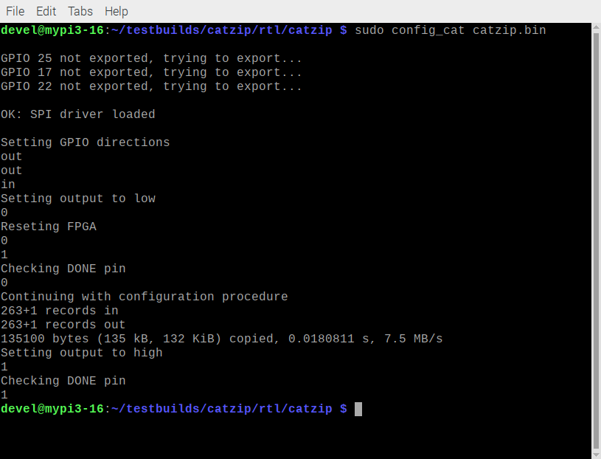

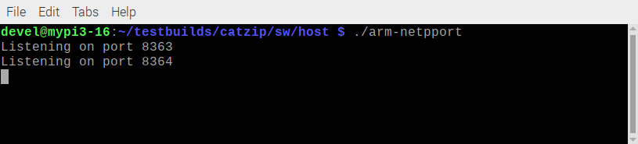
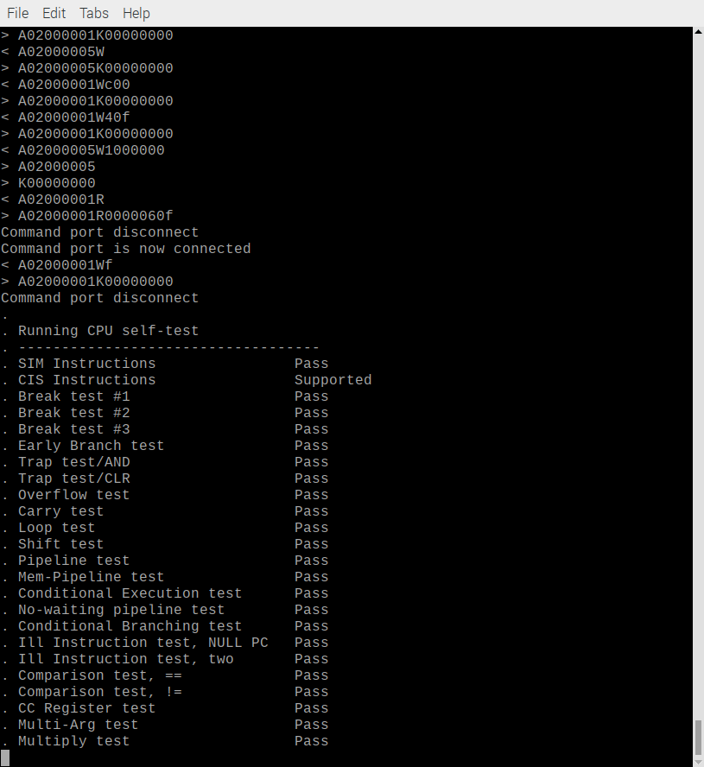
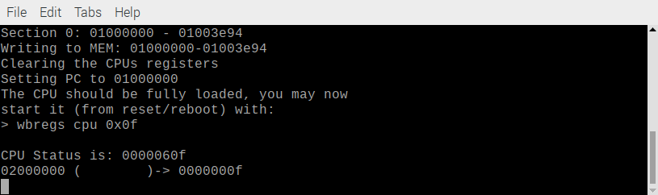

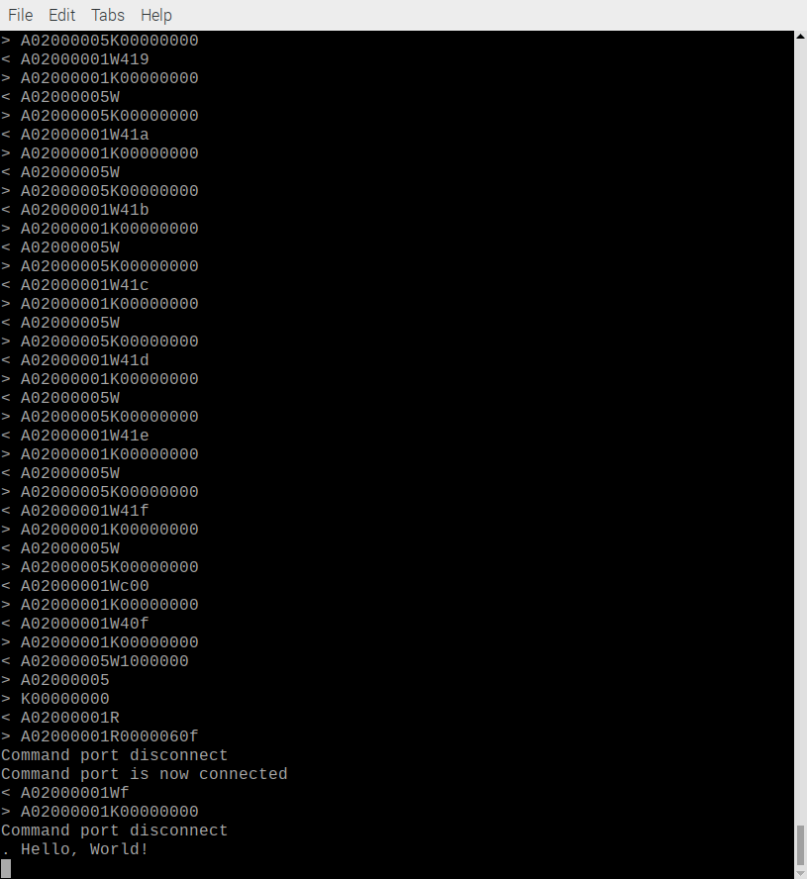

Check the build date

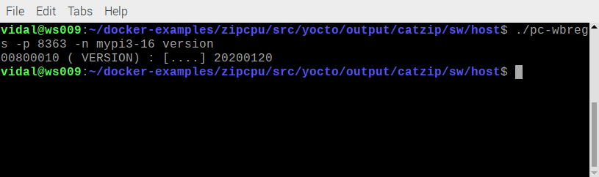

zipcpu ver 752bcc

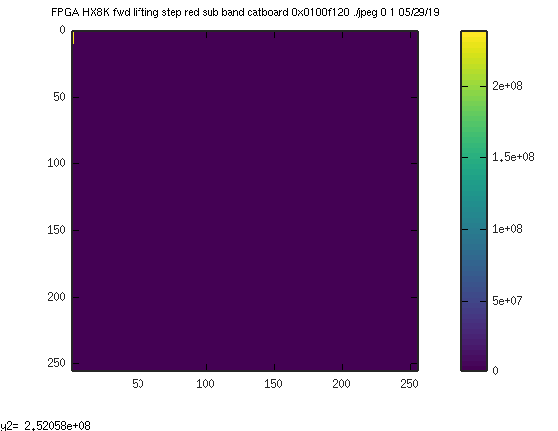

zipcpu ver 006f4c

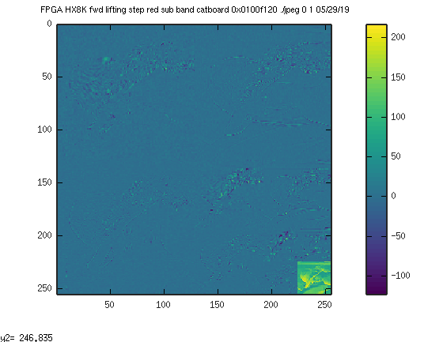

Appendix A: Dockerfile.

# Copyright 2019, Burkhard Stubert (DBA Embedded Use)

# In any directory on the docker host, perform the following actions:
# * Copy this Dockerfile in the directory.
# * Create input and output directories: mkdir -p yocto/output yocto/input
# * Build the Docker image with the following command:
# docker build --no-cache --build-arg "host_uid=$(id -u)" --build-arg "host_gid=$(id -g)" \
# --tag "cuteradio-image:latest" .
# * Run the Docker image, which in turn runs the Yocto and which produces the Linux rootfs,
# with the following command:
# docker run -it --rm -v $PWD/yocto/output:/home/zipcpu/yocto/output zipcpu:0.62

# Use Ubuntu 16.04 LTS as the basis for the Docker image.
FROM ubuntu:16.04

# Install all the Linux packages required for Yocto builds. Note that the packages python3,
# tar, locales and cpio are not listed in the official Yocto documentation. The build, however,
# without them.
RUN apt-get update && apt-get -y install gawk wget git-core diffstat unzip texinfo gcc-multilib \
build-essential chrpath socat cpio python python3 python3-pip python3-pexpect \
xz-utils debianutils iputils-ping libsdl1.2-dev xterm tar locales \
bison flex autoconf automake libtool libgmp3-dev \
libmpfr-dev libmpfr-doc libmpfr4 libmpfr4-dbg libmpc-dev libelf-dev bc \
ncurses-dev ctags mercurial gperf \
clang libreadline-dev tcl-dev libffi-dev pkg-config libftdi-dev libboost-all-dev \
cmake libeigen3-dev
#The following packages are needed when creating zipcpu:06
#with docker-fpga-builder
# clang libreadline-dev tcl-dev libffi-dev pkg-config libftdi-dev libboost-all-dev \
# cmake libeigen3-dev

# By default, Ubuntu uses dash as an alias for sh. Dash does not support the source command
# needed for setting up the build environment in CMD. Use bash as an alias for sh.
RUN rm /bin/sh && ln -s bash /bin/sh

# Set the locale to en_US.UTF-8, because the Yocto build fails without any locale set.
RUN locale-gen en_US.UTF-8 && update-locale LC_ALL=en_US.UTF-8 LANG=en_US.UTF-8
ENV LANG en_US.UTF-8
ENV LC_ALL en_US.UTF-8

ENV USER_NAME zipcpu
ENV PROJECT zipcpu

# The running container writes all the build artefacts to a host directory (outside the container).
# The container can only write files to host directories, if it uses the same user ID and
# group ID owning the host directories. The host_uid and group_uid are passed to the docker build
# command with the --build-arg option. By default, they are both 1001. The docker image creates
# a group with host_gid and a user with host_uid and adds the user to the group. The symbolic
# name of the group and user is cuteradio.
ARG host_uid=1000
ARG host_gid=1000
RUN groupadd -g $host_gid $USER_NAME && useradd -g $host_gid -m -s /bin/bash -u $host_uid $USER_NAME

# Perform the Yocto build as user cuteradio (not as root).
# NOTE: The USER command does not set the environment variable HOME.

RUN git clone https://github.com/develone/icestorm.git icestorm \
&& cd icestorm \
&& make -j$(nproc) \
&& make install \
&& cd .. && rm -rf icestorm

RUN git clone https://github.com/develone/nextpnr nextpnr \
&& cd nextpnr \
&& cmake -DARCH=ice40 -DBUILD_GUI=OFF -DCMAKE_INSTALL_PREFIX=/usr/local . \
&& make -j$(nproc) \
&& make install \
&& cd .. && rm -rf nextpnr

RUN git clone https://github.com/develone/yosys.git yosys \
&& cd yosys \
&& make -j$(nproc) \
&& make install \
&& cd .. && rm -rf yosys

#/using ver from mypi3-15
RUN git clone https://git.veripool.org/git/verilator \
&& cd verilator && git checkout v3.926 \
&& autoconf \
&& ./configure --prefix /usr/local \
&& make \
&& make install \
&& cd ../ \
&& rm -rf verilator

#/using ver from mypi3-15
RUN git clone https://github.com/develone/zipcpu.git \
&& cd zipcpu && git checkout 006f4c \
&& make \
&& tar -cvf /usr/local/share/zipcpu.tar ../zipcpu \
&& cd /usr/local/share \
&& tar -xvf zipcpu.tar \
&& rm -f zipcpu.tar

RUN git clone https://github.com/develone/autofpga.git autofpga \
&& cd autofpga \
&& make \
&& cp sw/autofpga /usr/local/bin \
&& cd .. && rm -rf autofpga
# By default, docker runs as root. However, Yocto builds should not be run as root, but as a
# normal user. Hence, we switch to the newly created user cuteradio.
USER $USER_NAME

# Create the directory structure for the Yocto build in the container. The lowest two directory
# levels must be the same as on the host.
ENV BUILD_INPUT_DIR /home/$USER_NAME/yocto/input
ENV BUILD_OUTPUT_DIR /home/$USER_NAME/yocto/output
RUN mkdir -p $BUILD_INPUT_DIR $BUILD_OUTPUT_DIR

Appendix B: build.sh

#!/bin/bash
docker build -t="zipcpu:0.62" .

Appendix C: list of packages.

+++-======================================-=====================================-============-================================================================================================
Desired=Unknown/Install/Remove/Purge/Hold
|/ Err?=(none)/Reinst-required (Status,Err: uppercase=bad)
ii adduser 3.113+nmu3ubuntu4 all add and remove users and groups
ii apt 1.2.32 amd64 commandline package manager
ii autoconf 2.69-9 all automatic configure script builder
ii automake 1:1.15-4ubuntu1 all Tool for generating GNU Standards-compliant Makefiles
ii autotools-dev 20150820.1 all Update infrastructure for config.{guess,sub} files
ii base-files 9.4ubuntu4.11 amd64 Debian base system miscellaneous files
ii base-passwd 3.5.39 amd64 Debian base system master password and group files
ii bash 4.3-14ubuntu1.4 amd64 GNU Bourne Again SHell
ii bc 1.06.95-9build1 amd64 GNU bc arbitrary precision calculator language
ii binfmt-support 2.1.6-1 amd64 Support for extra binary formats
ii binutils 2.26.1-1ubuntu1~16.04.8 amd64 GNU assembler, linker and binary utilities
ii bison 2:3.0.4.dfsg-1 amd64 YACC-compatible parser generator
ii bsdutils 1:2.27.1-6ubuntu3.9 amd64 basic utilities from 4.4BSD-Lite
ii build-essential 12.1ubuntu2 amd64 Informational list of build-essential packages
ii bzip2 1.0.6-8ubuntu0.2 amd64 high-quality block-sorting file compressor - utilities
ii ca-certificates 20170717~16.04.2 all Common CA certificates
ii chrpath 0.16-1 amd64 Tool to edit the rpath in ELF binaries
ii clang 1:3.8-33ubuntu3.1 amd64 C, C++ and Objective-C compiler (LLVM based)
ii clang-3.8 1:3.8-2ubuntu4 amd64 C, C++ and Objective-C compiler (LLVM based)
ii cmake 3.5.1-1ubuntu3 amd64 cross-platform, open-source make system
ii cmake-data 3.5.1-1ubuntu3 all CMake data files (modules, templates and documentation)
ii coreutils 8.25-2ubuntu3~16.04 amd64 GNU core utilities
ii cpio 2.11+dfsg-5ubuntu1.1 amd64 GNU cpio -- a program to manage archives of files
ii cpp 4:5.3.1-1ubuntu1 amd64 GNU C preprocessor (cpp)
ii cpp-5 5.4.0-6ubuntu1~16.04.12 amd64 GNU C preprocessor
ii dash 0.5.8-2.1ubuntu2 amd64 POSIX-compliant shell
ii dbus 1.10.6-1ubuntu3.5 amd64 simple interprocess messaging system (daemon and utilities)
ii debconf 1.5.58ubuntu2 all Debian configuration management system
ii debianutils 4.7 amd64 Miscellaneous utilities specific to Debian
ii dh-python 2.20151103ubuntu1.2 all Debian helper tools for packaging Python libraries and applications
ii diffstat 1.61-1 amd64 produces graph of changes introduced by a diff file
ii diffutils 1:3.3-3 amd64 File comparison utilities
ii dpkg 1.18.4ubuntu1.6 amd64 Debian package management system
ii dpkg-dev 1.18.4ubuntu1.6 all Debian package development tools
ii e2fslibs:amd64 1.42.13-1ubuntu1.1 amd64 ext2/ext3/ext4 file system libraries
ii e2fsprogs 1.42.13-1ubuntu1.1 amd64 ext2/ext3/ext4 file system utilities
ii exuberant-ctags 1:5.9~svn20110310-11 amd64 build tag file indexes of source code definitions
ii fakeroot 1.20.2-1ubuntu1 amd64 tool for simulating superuser privileges
ii file 1:5.25-2ubuntu1.3 amd64 Determines file type using "magic" numbers
ii findutils 4.6.0+git+20160126-2 amd64 utilities for finding files--find, xargs
ii flex 2.6.0-11 amd64 fast lexical analyzer generator
ii fontconfig-config 2.11.94-0ubuntu1.1 all generic font configuration library - configuration
ii fonts-dejavu-core 2.35-1 all Vera font family derivate with additional characters
ii g++ 4:5.3.1-1ubuntu1 amd64 GNU C++ compiler
ii g++-5 5.4.0-6ubuntu1~16.04.12 amd64 GNU C++ compiler
ii gawk 1:4.1.3+dfsg-0.1 amd64 GNU awk, a pattern scanning and processing language
ii gcc 4:5.3.1-1ubuntu1 amd64 GNU C compiler
ii gcc-5 5.4.0-6ubuntu1~16.04.12 amd64 GNU C compiler
ii gcc-5-base:amd64 5.4.0-6ubuntu1~16.04.12 amd64 GCC, the GNU Compiler Collection (base package)
ii gcc-5-multilib 5.4.0-6ubuntu1~16.04.12 amd64 GNU C compiler (multilib support)
ii gcc-6-base:amd64 6.0.1-0ubuntu1 amd64 GCC, the GNU Compiler Collection (base package)
ii gcc-multilib 4:5.3.1-1ubuntu1 amd64 GNU C compiler (multilib files)
ii git 1:2.7.4-0ubuntu1.7 amd64 fast, scalable, distributed revision control system
ii git-core 1:2.7.4-0ubuntu1.7 all fast, scalable, distributed revision control system (obsolete)
ii git-man 1:2.7.4-0ubuntu1.7 all fast, scalable, distributed revision control system (manual pages)
ii gnupg 1.4.20-1ubuntu3.3 amd64 GNU privacy guard - a free PGP replacement
ii gperf 3.0.4-2 amd64 Perfect hash function generator
ii gpgv 1.4.20-1ubuntu3.3 amd64 GNU privacy guard - signature verification tool
ii grep 2.25-1~16.04.1 amd64 GNU grep, egrep and fgrep
ii gzip 1.6-4ubuntu1 amd64 GNU compression utilities
ii hostname 3.16ubuntu2 amd64 utility to set/show the host name or domain name
ii icu-devtools 55.1-7ubuntu0.4 amd64 Development utilities for International Components for Unicode
ii ifupdown 0.8.10ubuntu1.4 amd64 high level tools to configure network interfaces
ii init 1.29ubuntu4 amd64 System-V-like init utilities - metapackage
ii initscripts 2.88dsf-59.3ubuntu2 amd64 scripts for initializing and shutting down the system
ii init-system-helpers 1.29ubuntu4 all helper tools for all init systems
ii insserv 1.14.0-5ubuntu3 amd64 boot sequence organizer using LSB init.d script dependency information
ii iproute2 4.3.0-1ubuntu3.16.04.5 amd64 networking and traffic control tools
ii iputils-ping 3:20121221-5ubuntu2 amd64 Tools to test the reachability of network hosts
ii isc-dhcp-client 4.3.3-5ubuntu12.10 amd64 DHCP client for automatically obtaining an IP address
ii isc-dhcp-common 4.3.3-5ubuntu12.10 amd64 common files used by all of the isc-dhcp packages
ii javascript-common 11 all Base support for JavaScript library packages
ii krb5-locales 1.13.2+dfsg-5ubuntu2.1 all Internationalization support for MIT Kerberos
ii less 481-2.1ubuntu0.2 amd64 pager program similar to more
ii lib32asan2 5.4.0-6ubuntu1~16.04.12 amd64 AddressSanitizer -- a fast memory error detector (32bit)
ii lib32atomic1 5.4.0-6ubuntu1~16.04.12 amd64 support library providing __atomic built-in functions (32bit)
ii lib32cilkrts5 5.4.0-6ubuntu1~16.04.12 amd64 Intel Cilk Plus language extensions (32bit)
ii lib32gcc1 1:6.0.1-0ubuntu1 amd64 GCC support library (32 bit Version)
ii lib32gcc-5-dev 5.4.0-6ubuntu1~16.04.12 amd64 GCC support library (32 bit development files)
ii lib32gomp1 5.4.0-6ubuntu1~16.04.12 amd64 GCC OpenMP (GOMP) support library (32bit)
ii lib32itm1 5.4.0-6ubuntu1~16.04.12 amd64 GNU Transactional Memory Library (32bit)
ii lib32mpx0 5.4.0-6ubuntu1~16.04.12 amd64 Intel memory protection extensions (32bit)
ii lib32quadmath0 5.4.0-6ubuntu1~16.04.12 amd64 GCC Quad-Precision Math Library (32bit)
ii lib32stdc++6 5.4.0-6ubuntu1~16.04.12 amd64 GNU Standard C++ Library v3 (32 bit Version)
ii lib32ubsan0 5.4.0-6ubuntu1~16.04.12 amd64 UBSan -- undefined behaviour sanitizer (32bit)
ii libacl1:amd64 2.2.52-3 amd64 Access control list shared library
ii libalgorithm-diff-perl 1.19.03-1 all module to find differences between files
ii libalgorithm-diff-xs-perl 0.04-4build1 amd64 module to find differences between files (XS accelerated)
ii libalgorithm-merge-perl 0.08-3 all Perl module for three-way merge of textual data
ii libapparmor1:amd64 2.10.95-0ubuntu2.11 amd64 changehat AppArmor library
ii libapt-pkg5.0:amd64 1.2.32 amd64 package management runtime library
ii libarchive13:amd64 3.1.2-11ubuntu0.16.04.7 amd64 Multi-format archive and compression library (shared library)
ii libasan2:amd64 5.4.0-6ubuntu1~16.04.12 amd64 AddressSanitizer -- a fast memory error detector
ii libasn1-8-heimdal:amd64 1.7~git20150920+dfsg-4ubuntu1.16.04.1 amd64 Heimdal Kerberos - ASN.1 library
ii libasound2:amd64 1.1.0-0ubuntu1 amd64 shared library for ALSA applications
ii libasound2-data 1.1.0-0ubuntu1 all Configuration files and profiles for ALSA drivers
ii libasound2-dev:amd64 1.1.0-0ubuntu1 amd64 shared library for ALSA applications -- development files
ii libasyncns0:amd64 0.8-5build1 amd64 Asynchronous name service query library
ii libatm1:amd64 1:2.5.1-1.5 amd64 shared library for ATM (Asynchronous Transfer Mode)
ii libatomic1:amd64 5.4.0-6ubuntu1~16.04.12 amd64 support library providing __atomic built-in functions
ii libattr1:amd64 1:2.4.47-2 amd64 Extended attribute shared library
ii libaudit1:amd64 1:2.4.5-1ubuntu2.1 amd64 Dynamic library for security auditing
ii libaudit-common 1:2.4.5-1ubuntu2.1 all Dynamic library for security auditing - common files
ii libauthen-sasl-perl 2.1600-1 all Authen::SASL - SASL Authentication framework
ii libbison-dev:amd64 2:3.0.4.dfsg-1 amd64 YACC-compatible parser generator - development library
ii libblkid1:amd64 2.27.1-6ubuntu3.9 amd64 block device ID library
ii libboost1.58-dev:amd64 1.58.0+dfsg-5ubuntu3.1 amd64 Boost C++ Libraries development files
ii libboost1.58-tools-dev 1.58.0+dfsg-5ubuntu3.1 amd64 Boost C++ Libraries development tools
ii libboost-all-dev 1.58.0.1ubuntu1 amd64 Boost C++ Libraries development files (ALL) (default version)
ii libboost-atomic1.58.0:amd64 1.58.0+dfsg-5ubuntu3.1 amd64 atomic data types, operations, and memory ordering constraints
ii libboost-atomic1.58-dev:amd64 1.58.0+dfsg-5ubuntu3.1 amd64 atomic data types, operations, and memory ordering constraints
ii libboost-atomic-dev:amd64 1.58.0.1ubuntu1 amd64 atomic data types, operations, and memory ordering constraints (default version)
ii libboost-chrono1.58.0:amd64 1.58.0+dfsg-5ubuntu3.1 amd64 C++ representation of time duration, time point, and clocks
ii libboost-chrono1.58-dev:amd64 1.58.0+dfsg-5ubuntu3.1 amd64 C++ representation of time duration, time point, and clocks
ii libboost-chrono-dev:amd64 1.58.0.1ubuntu1 amd64 C++ representation of time duration, time point, and clocks (default version)
ii libboost-context1.58.0:amd64 1.58.0+dfsg-5ubuntu3.1 amd64 provides a sort of cooperative multitasking on a single thread
ii libboost-context1.58-dev:amd64 1.58.0+dfsg-5ubuntu3.1 amd64 provides a sort of cooperative multitasking on a single thread
ii libboost-context-dev:amd64 1.58.0.1ubuntu1 amd64 provides a sort of cooperative multitasking on a single thread (default version)
ii libboost-coroutine1.58.0:amd64 1.58.0+dfsg-5ubuntu3.1 amd64 provides a sort of cooperative multitasking on a single thread
ii libboost-coroutine1.58-dev:amd64 1.58.0+dfsg-5ubuntu3.1 amd64 provides a sort of cooperative multitasking on a single thread
ii libboost-coroutine-dev:amd64 1.58.0.1ubuntu1 amd64 provides a sort of cooperative multitasking on a single thread (default version)
ii libboost-date-time1.58.0:amd64 1.58.0+dfsg-5ubuntu3.1 amd64 set of date-time libraries based on generic programming concepts
ii libboost-date-time1.58-dev:amd64 1.58.0+dfsg-5ubuntu3.1 amd64 set of date-time libraries based on generic programming concepts
ii libboost-date-time-dev:amd64 1.58.0.1ubuntu1 amd64 set of date-time libraries based on generic programming concepts (default version)
ii libboost-dev:amd64 1.58.0.1ubuntu1 amd64 Boost C++ Libraries development files (default version)
ii libboost-exception1.58-dev:amd64 1.58.0+dfsg-5ubuntu3.1 amd64 library to help write exceptions and handlers
ii libboost-exception-dev:amd64 1.58.0.1ubuntu1 amd64 library to help write exceptions and handlers (default version)
ii libboost-filesystem1.58.0:amd64 1.58.0+dfsg-5ubuntu3.1 amd64 filesystem operations (portable paths, iteration over directories, etc) in C++
ii libboost-filesystem1.58-dev:amd64 1.58.0+dfsg-5ubuntu3.1 amd64 filesystem operations (portable paths, iteration over directories, etc) in C++
ii libboost-filesystem-dev:amd64 1.58.0.1ubuntu1 amd64 filesystem operations (portable paths, iteration over directories, etc) in C++ (default version)
ii libboost-graph1.58.0:amd64 1.58.0+dfsg-5ubuntu3.1 amd64 generic graph components and algorithms in C++
ii libboost-graph1.58-dev:amd64 1.58.0+dfsg-5ubuntu3.1 amd64 generic graph components and algorithms in C++
ii libboost-graph-dev:amd64 1.58.0.1ubuntu1 amd64 generic graph components and algorithms in C++ (default version)
ii libboost-graph-parallel1.58.0 1.58.0+dfsg-5ubuntu3.1 amd64 generic graph components and algorithms in C++
ii libboost-graph-parallel1.58-dev 1.58.0+dfsg-5ubuntu3.1 amd64 generic graph components and algorithms in C++
ii libboost-graph-parallel-dev 1.58.0.1ubuntu1 amd64 generic graph components and algorithms in C++ (default version)
ii libboost-iostreams1.58.0:amd64 1.58.0+dfsg-5ubuntu3.1 amd64 Boost.Iostreams Library
ii libboost-iostreams1.58-dev:amd64 1.58.0+dfsg-5ubuntu3.1 amd64 Boost.Iostreams Library development files
ii libboost-iostreams-dev:amd64 1.58.0.1ubuntu1 amd64 Boost.Iostreams Library development files (default version)
ii libboost-locale1.58.0:amd64 1.58.0+dfsg-5ubuntu3.1 amd64 C++ facilities for localization
ii libboost-locale1.58-dev:amd64 1.58.0+dfsg-5ubuntu3.1 amd64 C++ facilities for localization
ii libboost-locale-dev:amd64 1.58.0.1ubuntu1 amd64 C++ facilities for localization (default version)
ii libboost-log1.58.0 1.58.0+dfsg-5ubuntu3.1 amd64 C++ logging library
ii libboost-log1.58-dev 1.58.0+dfsg-5ubuntu3.1 amd64 C++ logging library
ii libboost-log-dev 1.58.0.1ubuntu1 amd64 C++ logging library (default version)
ii libboost-math1.58.0:amd64 1.58.0+dfsg-5ubuntu3.1 amd64 Boost.Math Library
ii libboost-math1.58-dev:amd64 1.58.0+dfsg-5ubuntu3.1 amd64 Boost.Math Library development files
ii libboost-math-dev:amd64 1.58.0.1ubuntu1 amd64 Boost.Math Library development files (default version)
ii libboost-mpi1.58.0 1.58.0+dfsg-5ubuntu3.1 amd64 C++ interface to the Message Passing Interface (MPI)
ii libboost-mpi1.58-dev 1.58.0+dfsg-5ubuntu3.1 amd64 C++ interface to the Message Passing Interface (MPI)
ii libboost-mpi-dev 1.58.0.1ubuntu1 amd64 C++ interface to the Message Passing Interface (MPI) (default version)
ii libboost-mpi-python1.58.0 1.58.0+dfsg-5ubuntu3.1 amd64 C++ interface to the Message Passing Interface (MPI), Python Bindings
ii libboost-mpi-python1.58-dev 1.58.0+dfsg-5ubuntu3.1 amd64 C++ interface to the Message Passing Interface (MPI), Python Bindings
ii libboost-mpi-python-dev 1.58.0.1ubuntu1 amd64 C++ interface to the Message Passing Interface (MPI), Python Bindings (default version)
ii libboost-program-options1.58.0:amd64 1.58.0+dfsg-5ubuntu3.1 amd64 program options library for C++
ii libboost-program-options1.58-dev:amd64 1.58.0+dfsg-5ubuntu3.1 amd64 program options library for C++
ii libboost-program-options-dev:amd64 1.58.0.1ubuntu1 amd64 program options library for C++ (default version)
ii libboost-python1.58.0 1.58.0+dfsg-5ubuntu3.1 amd64 Boost.Python Library
ii libboost-python1.58-dev 1.58.0+dfsg-5ubuntu3.1 amd64 Boost.Python Library development files
ii libboost-python-dev 1.58.0.1ubuntu1 amd64 Boost.Python Library development files (default version)
ii libboost-random1.58.0:amd64 1.58.0+dfsg-5ubuntu3.1 amd64 Boost Random Number Library
ii libboost-random1.58-dev:amd64 1.58.0+dfsg-5ubuntu3.1 amd64 Boost Random Number Library
ii libboost-random-dev:amd64 1.58.0.1ubuntu1 amd64 Boost Random Number Library (default version)
ii libboost-regex1.58.0:amd64 1.58.0+dfsg-5ubuntu3.1 amd64 regular expression library for C++
ii libboost-regex1.58-dev:amd64 1.58.0+dfsg-5ubuntu3.1 amd64 regular expression library for C++
ii libboost-regex-dev:amd64 1.58.0.1ubuntu1 amd64 regular expression library for C++ (default version)
ii libboost-serialization1.58.0:amd64 1.58.0+dfsg-5ubuntu3.1 amd64 serialization library for C++
ii libboost-serialization1.58-dev:amd64 1.58.0+dfsg-5ubuntu3.1 amd64 serialization library for C++
ii libboost-serialization-dev:amd64 1.58.0.1ubuntu1 amd64 serialization library for C++ (default version)
ii libboost-signals1.58.0:amd64 1.58.0+dfsg-5ubuntu3.1 amd64 managed signals and slots library for C++
ii libboost-signals1.58-dev:amd64 1.58.0+dfsg-5ubuntu3.1 amd64 managed signals and slots library for C++
ii libboost-signals-dev:amd64 1.58.0.1ubuntu1 amd64 managed signals and slots library for C++ (default version)
ii libboost-system1.58.0:amd64 1.58.0+dfsg-5ubuntu3.1 amd64 Operating system (e.g. diagnostics support) library
ii libboost-system1.58-dev:amd64 1.58.0+dfsg-5ubuntu3.1 amd64 Operating system (e.g. diagnostics support) library
ii libboost-system-dev:amd64 1.58.0.1ubuntu1 amd64 Operating system (e.g. diagnostics support) library (default version)
ii libboost-test1.58.0:amd64 1.58.0+dfsg-5ubuntu3.1 amd64 components for writing and executing test suites
ii libboost-test1.58-dev:amd64 1.58.0+dfsg-5ubuntu3.1 amd64 components for writing and executing test suites
ii libboost-test-dev:amd64 1.58.0.1ubuntu1 amd64 components for writing and executing test suites (default version)
ii libboost-thread1.58.0:amd64 1.58.0+dfsg-5ubuntu3.1 amd64 portable C++ multi-threading
ii libboost-thread1.58-dev:amd64 1.58.0+dfsg-5ubuntu3.1 amd64 portable C++ multi-threading
ii libboost-thread-dev:amd64 1.58.0.1ubuntu1 amd64 portable C++ multi-threading (default version)
ii libboost-timer1.58.0:amd64 1.58.0+dfsg-5ubuntu3.1 amd64 C++ wall clock and CPU process timers
ii libboost-timer1.58-dev:amd64 1.58.0+dfsg-5ubuntu3.1 amd64 C++ wall clock and CPU process timers
ii libboost-timer-dev:amd64 1.58.0.1ubuntu1 amd64 C++ wall clock and CPU process timers (default version)
ii libboost-tools-dev 1.58.0.1ubuntu1 amd64 Boost C++ Libraries development tools (default version)
ii libboost-wave1.58.0:amd64 1.58.0+dfsg-5ubuntu3.1 amd64 C99/C++ preprocessor library
ii libboost-wave1.58-dev:amd64 1.58.0+dfsg-5ubuntu3.1 amd64 C99/C++ preprocessor library
ii libboost-wave-dev:amd64 1.58.0.1ubuntu1 amd64 C99/C++ preprocessor library (default version)
ii libbsd0:amd64 0.8.2-1 amd64 utility functions from BSD systems - shared library
ii libbz2-1.0:amd64 1.0.6-8ubuntu0.2 amd64 high-quality block-sorting file compressor library - runtime
ii libc6:amd64 2.23-0ubuntu11 amd64 GNU C Library: Shared libraries
ii libc6-dev:amd64 2.23-0ubuntu11 amd64 GNU C Library: Development Libraries and Header Files
ii libc6-dev-i386 2.23-0ubuntu11 amd64 GNU C Library: 32-bit development libraries for AMD64
ii libc6-dev-x32 2.23-0ubuntu11 amd64 GNU C Library: X32 ABI Development Libraries for AMD64
ii libc6-i386 2.23-0ubuntu11 amd64 GNU C Library: 32-bit shared libraries for AMD64
ii libc6-x32 2.23-0ubuntu11 amd64 GNU C Library: X32 ABI Shared libraries for AMD64
ii libcaca0:amd64 0.99.beta19-2ubuntu0.16.04.1 amd64 colour ASCII art library
ii libcaca-dev 0.99.beta19-2ubuntu0.16.04.1 amd64 development files for libcaca
ii libcap2:amd64 1:2.24-12 amd64 POSIX 1003.1e capabilities (library)
ii libcap2-bin 1:2.24-12 amd64 POSIX 1003.1e capabilities (utilities)
ii libcap-ng0:amd64 0.7.7-1 amd64 An alternate POSIX capabilities library
ii libc-bin 2.23-0ubuntu11 amd64 GNU C Library: Binaries
ii libcc1-0:amd64 5.4.0-6ubuntu1~16.04.12 amd64 GCC cc1 plugin for GDB
ii libc-dev-bin 2.23-0ubuntu11 amd64 GNU C Library: Development binaries
ii libcilkrts5:amd64 5.4.0-6ubuntu1~16.04.12 amd64 Intel Cilk Plus language extensions (runtime)
ii libclang1-3.8:amd64 1:3.8-2ubuntu4 amd64 C interface to the clang library
ii libclang-common-3.8-dev 1:3.8-2ubuntu4 amd64 clang library - Common development package
ii libcomerr2:amd64 1.42.13-1ubuntu1.1 amd64 common error description library
ii libcryptsetup4:amd64 2:1.6.6-5ubuntu2.1 amd64 disk encryption support - shared library
ii libcurl3:amd64 7.47.0-1ubuntu2.14 amd64 easy-to-use client-side URL transfer library (OpenSSL flavour)
ii libcurl3-gnutls:amd64 7.47.0-1ubuntu2.14 amd64 easy-to-use client-side URL transfer library (GnuTLS flavour)
ii libdb5.3:amd64 5.3.28-11ubuntu0.2 amd64 Berkeley v5.3 Database Libraries [runtime]
ii libdbus-1-3:amd64 1.10.6-1ubuntu3.5 amd64 simple interprocess messaging system (library)
ii libdebconfclient0:amd64 0.198ubuntu1 amd64 Debian Configuration Management System (C-implementation library)
ii libdevmapper1.02.1:amd64 2:1.02.110-1ubuntu10 amd64 Linux Kernel Device Mapper userspace library
ii libdns-export162 1:9.10.3.dfsg.P4-8ubuntu1.15 amd64 Exported DNS Shared Library
ii libdpkg-perl 1.18.4ubuntu1.6 all Dpkg perl modules
ii libdrm2:amd64 2.4.91-2~16.04.1 amd64 Userspace interface to kernel DRM services -- runtime
ii libdrm-amdgpu1:amd64 2.4.91-2~16.04.1 amd64 Userspace interface to amdgpu-specific kernel DRM services -- runtime
ii libdrm-common 2.4.91-2~16.04.1 all Userspace interface to kernel DRM services -- common files
ii libdrm-dev:amd64 2.4.91-2~16.04.1 amd64 Userspace interface to kernel DRM services -- development files
ii libdrm-intel1:amd64 2.4.91-2~16.04.1 amd64 Userspace interface to intel-specific kernel DRM services -- runtime
ii libdrm-nouveau2:amd64 2.4.91-2~16.04.1 amd64 Userspace interface to nouveau-specific kernel DRM services -- runtime
ii libdrm-radeon1:amd64 2.4.91-2~16.04.1 amd64 Userspace interface to radeon-specific kernel DRM services -- runtime
ii libedit2:amd64 3.1-20150325-1ubuntu2 amd64 BSD editline and history libraries
ii libeigen3-dev 3.3~beta1-2 all lightweight C++ template library for linear algebra
ii libelf1:amd64 0.165-3ubuntu1.2 amd64 library to read and write ELF files
ii libelf-dev:amd64 0.165-3ubuntu1.2 amd64 libelf1 development libraries and header files
ii libencode-locale-perl 1.05-1 all utility to determine the locale encoding
ii liberror-perl 0.17-1.2 all Perl module for error/exception handling in an OO-ish way
ii libexpat1:amd64 2.1.0-7ubuntu0.16.04.5 amd64 XML parsing C library - runtime library
ii libexpat1-dev:amd64 2.1.0-7ubuntu0.16.04.5 amd64 XML parsing C library - development kit
ii libfakeroot:amd64 1.20.2-1ubuntu1 amd64 tool for simulating superuser privileges - shared libraries
ii libfdisk1:amd64 2.27.1-6ubuntu3.9 amd64 fdisk partitioning library
ii libffi6:amd64 3.2.1-4 amd64 Foreign Function Interface library runtime
ii libffi-dev:amd64 3.2.1-4 amd64 Foreign Function Interface library (development files)
ii libfile-fcntllock-perl 0.22-3 amd64 Perl module for file locking with fcntl(2)
ii libfile-listing-perl 6.04-1 all module to parse directory listings
ii libflac8:amd64 1.3.1-4 amd64 Free Lossless Audio Codec - runtime C library
ii libfl-dev:amd64 2.6.0-11 amd64 static library for flex (a fast lexical analyzer generator)
ii libfont-afm-perl 1.20-1 all Font::AFM - Interface to Adobe Font Metrics files
ii libfontconfig1:amd64 2.11.94-0ubuntu1.1 amd64 generic font configuration library - runtime
ii libfontenc1:amd64 1:1.1.3-1 amd64 X11 font encoding library
ii libfreetype6:amd64 2.6.1-0.1ubuntu2.4 amd64 FreeType 2 font engine, shared library files
ii libftdi1:amd64 0.20-4build1 amd64 Library to control and program the FTDI USB controller
ii libftdi-dev 0.20-4build1 amd64 Development files for libftdi
ii libgcc1:amd64 1:6.0.1-0ubuntu1 amd64 GCC support library
ii libgcc-5-dev:amd64 5.4.0-6ubuntu1~16.04.12 amd64 GCC support library (development files)
ii libgcrypt20:amd64 1.6.5-2ubuntu0.5 amd64 LGPL Crypto library - runtime library
ii libgdbm3:amd64 1.8.3-13.1 amd64 GNU dbm database routines (runtime version)
ii libgl1-mesa-dev:amd64 18.0.5-0ubuntu0~16.04.1 amd64 free implementation of the OpenGL API -- GLX development files
ii libgl1-mesa-dri:amd64 18.0.5-0ubuntu0~16.04.1 amd64 free implementation of the OpenGL API -- DRI modules
ii libgl1-mesa-glx:amd64 18.0.5-0ubuntu0~16.04.1 amd64 free implementation of the OpenGL API -- GLX runtime
ii libglapi-mesa:amd64 18.0.5-0ubuntu0~16.04.1 amd64 free implementation of the GL API -- shared library
ii libglib2.0-0:amd64 2.48.2-0ubuntu4.4 amd64 GLib library of C routines
ii libglib2.0-bin 2.48.2-0ubuntu4.4 amd64 Programs for the GLib library
ii libglib2.0-data 2.48.2-0ubuntu4.4 all Common files for GLib library
ii libglib2.0-dev 2.48.2-0ubuntu4.4 amd64 Development files for the GLib library
ii libglu1-mesa:amd64 9.0.0-2.1 amd64 Mesa OpenGL utility library (GLU)
ii libglu1-mesa-dev:amd64 9.0.0-2.1 amd64 Mesa OpenGL utility library -- development files
ii libgmp10:amd64 2:6.1.0+dfsg-2 amd64 Multiprecision arithmetic library
ii libgmp3-dev 2:6.1.0+dfsg-2 amd64 Multiprecision arithmetic library developers tools
ii libgmp-dev:amd64 2:6.1.0+dfsg-2 amd64 Multiprecision arithmetic library developers tools
ii libgmpxx4ldbl:amd64 2:6.1.0+dfsg-2 amd64 Multiprecision arithmetic library (C++ bindings)
ii libgnutls30:amd64 3.4.10-4ubuntu1.6 amd64 GNU TLS library - main runtime library
ii libgnutls-openssl27:amd64 3.4.10-4ubuntu1.6 amd64 GNU TLS library - OpenSSL wrapper
ii libgomp1:amd64 5.4.0-6ubuntu1~16.04.12 amd64 GCC OpenMP (GOMP) support library
ii libgpg-error0:amd64 1.21-2ubuntu1 amd64 library for common error values and messages in GnuPG components
ii libgssapi3-heimdal:amd64 1.7~git20150920+dfsg-4ubuntu1.16.04.1 amd64 Heimdal Kerberos - GSSAPI support library
ii libgssapi-krb5-2:amd64 1.13.2+dfsg-5ubuntu2.1 amd64 MIT Kerberos runtime libraries - krb5 GSS-API Mechanism
ii libhcrypto4-heimdal:amd64 1.7~git20150920+dfsg-4ubuntu1.16.04.1 amd64 Heimdal Kerberos - crypto library
ii libheimbase1-heimdal:amd64 1.7~git20150920+dfsg-4ubuntu1.16.04.1 amd64 Heimdal Kerberos - Base library
ii libheimntlm0-heimdal:amd64 1.7~git20150920+dfsg-4ubuntu1.16.04.1 amd64 Heimdal Kerberos - NTLM support library
ii libhogweed4:amd64 3.2-1ubuntu0.16.04.1 amd64 low level cryptographic library (public-key cryptos)
ii libhtml-format-perl 2.11-2 all module for transforming HTML into various formats
ii libhtml-form-perl 6.03-1 all module that represents an HTML form element
ii libhtml-parser-perl 3.72-1 amd64 collection of modules that parse HTML text documents
ii libhtml-tagset-perl 3.20-2 all Data tables pertaining to HTML
ii libhtml-tree-perl 5.03-2 all Perl module to represent and create HTML syntax trees
ii libhttp-cookies-perl 6.01-1 all HTTP cookie jars
ii libhttp-daemon-perl 6.01-1 all simple http server class
ii libhttp-date-perl 6.02-1 all module of date conversion routines
ii libhttp-message-perl 6.11-1 all perl interface to HTTP style messages
ii libhttp-negotiate-perl 6.00-2 all implementation of content negotiation
ii libhwloc5:amd64 1.11.2-3 amd64 Hierarchical view of the machine - shared libs
ii libhwloc-dev:amd64 1.11.2-3 amd64 Hierarchical view of the machine - static libs and headers
ii libhwloc-plugins 1.11.2-3 amd64 Hierarchical view of the machine - plugins
ii libhx509-5-heimdal:amd64 1.7~git20150920+dfsg-4ubuntu1.16.04.1 amd64 Heimdal Kerberos - X509 support library
ii libibverbs1 1.1.8-1.1ubuntu2 amd64 Library for direct userspace use of RDMA (InfiniBand/iWARP)
ii libibverbs-dev 1.1.8-1.1ubuntu2 amd64 Development files for the libibverbs library
ii libice6:amd64 2:1.0.9-1 amd64 X11 Inter-Client Exchange library
ii libicu55:amd64 55.1-7ubuntu0.4 amd64 International Components for Unicode
ii libicu-dev:amd64 55.1-7ubuntu0.4 amd64 Development files for International Components for Unicode
ii libidn11:amd64 1.32-3ubuntu1.2 amd64 GNU Libidn library, implementation of IETF IDN specifications
ii libio-html-perl 1.001-1 all open an HTML file with automatic charset detection
ii libio-socket-ssl-perl 2.024-1 all Perl module implementing object oriented interface to SSL sockets
ii libisc-export160 1:9.10.3.dfsg.P4-8ubuntu1.15 amd64 Exported ISC Shared Library
ii libisl15:amd64 0.16.1-1 amd64 manipulating sets and relations of integer points bounded by linear constraints
ii libitm1:amd64 5.4.0-6ubuntu1~16.04.12 amd64 GNU Transactional Memory Library
ii libjs-excanvas 0.r3-4 all HTML5 Canvas for Internet Explorer
ii libjson-c2:amd64 0.11-4ubuntu2 amd64 JSON manipulation library - shared library
ii libjsoncpp1:amd64 1.7.2-1 amd64 library for reading and writing JSON for C++
ii libk5crypto3:amd64 1.13.2+dfsg-5ubuntu2.1 amd64 MIT Kerberos runtime libraries - Crypto Library
ii libkeyutils1:amd64 1.5.9-8ubuntu1 amd64 Linux Key Management Utilities (library)
ii libkmod2:amd64 22-1ubuntu5.2 amd64 libkmod shared library
ii libkrb5-26-heimdal:amd64 1.7~git20150920+dfsg-4ubuntu1.16.04.1 amd64 Heimdal Kerberos - libraries
ii libkrb5-3:amd64 1.13.2+dfsg-5ubuntu2.1 amd64 MIT Kerberos runtime libraries
ii libkrb5support0:amd64 1.13.2+dfsg-5ubuntu2.1 amd64 MIT Kerberos runtime libraries - Support library
ii libldap-2.4-2:amd64 2.4.42+dfsg-2ubuntu3.7 amd64 OpenLDAP libraries
ii libllvm3.8:amd64 1:3.8-2ubuntu4 amd64 Modular compiler and toolchain technologies, runtime library
ii libllvm6.0:amd64 1:6.0-1ubuntu2~16.04.1 amd64 Modular compiler and toolchain technologies, runtime library
ii liblsan0:amd64 5.4.0-6ubuntu1~16.04.12 amd64 LeakSanitizer -- a memory leak detector (runtime)
ii libltdl7:amd64 2.4.6-0.1 amd64 System independent dlopen wrapper for GNU libtool
ii libltdl-dev:amd64 2.4.6-0.1 amd64 System independent dlopen wrapper for GNU libtool
ii liblwp-mediatypes-perl 6.02-1 all module to guess media type for a file or a URL
ii liblwp-protocol-https-perl 6.06-2 all HTTPS driver for LWP::UserAgent
ii liblz4-1:amd64 0.0~r131-2ubuntu2 amd64 Fast LZ compression algorithm library - runtime
ii liblzma5:amd64 5.1.1alpha+20120614-2ubuntu2 amd64 XZ-format compression library
ii liblzo2-2:amd64 2.08-1.2 amd64 data compression library
ii libmagic1:amd64 1:5.25-2ubuntu1.3 amd64 File type determination library using "magic" numbers
ii libmailtools-perl 2.13-1 all Manipulate email in perl programs
ii libmnl0:amd64 1.0.3-5 amd64 minimalistic Netlink communication library
ii libmount1:amd64 2.27.1-6ubuntu3.9 amd64 device mounting library
ii libmpc3:amd64 1.0.3-1 amd64 multiple precision complex floating-point library
ii libmpc-dev:amd64 1.0.3-1 amd64 multiple precision complex floating-point library development package
ii libmpdec2:amd64 2.4.2-1 amd64 library for decimal floating point arithmetic (runtime library)
ii libmpfr4:amd64 3.1.4-1 amd64 multiple precision floating-point computation
ii libmpfr4-dbg:amd64 3.1.4-1 amd64 multiple precision floating-point computation (debug symbols)
ii libmpfr-dev:amd64 3.1.4-1 amd64 multiple precision floating-point computation developers tools
ii libmpfr-doc 3.1.4-1 all multiple precision floating-point computation documentation
ii libmpx0:amd64 5.4.0-6ubuntu1~16.04.12 amd64 Intel memory protection extensions (runtime)
ii libncurses5:amd64 6.0+20160213-1ubuntu1 amd64 shared libraries for terminal handling
ii libncurses5-dev:amd64 6.0+20160213-1ubuntu1 amd64 developer's libraries for ncurses
ii libncursesw5:amd64 6.0+20160213-1ubuntu1 amd64 shared libraries for terminal handling (wide character support)
ii libnet-http-perl 6.09-1 all module providing low-level HTTP connection client
ii libnet-smtp-ssl-perl 1.03-1 all Perl module providing SSL support to Net::SMTP
ii libnet-ssleay-perl 1.72-1build1 amd64 Perl module for Secure Sockets Layer (SSL)
ii libnettle6:amd64 3.2-1ubuntu0.16.04.1 amd64 low level cryptographic library (symmetric and one-way cryptos)
ii libnuma1:amd64 2.0.11-1ubuntu1.1 amd64 Libraries for controlling NUMA policy
ii libnuma-dev:amd64 2.0.11-1ubuntu1.1 amd64 Development files for libnuma
ii libobjc4:amd64 5.4.0-6ubuntu1~16.04.12 amd64 Runtime library for GNU Objective-C applications
ii libobjc-5-dev:amd64 5.4.0-6ubuntu1~16.04.12 amd64 Runtime library for GNU Objective-C applications (development files)
ii libogg0:amd64 1.3.2-1 amd64 Ogg bitstream library
ii libopenmpi1.10 1.10.2-8ubuntu1 amd64 high performance message passing library -- shared library
ii libopenmpi-dev 1.10.2-8ubuntu1 amd64 high performance message passing library -- header files
ii libp11-kit0:amd64 0.23.2-5~ubuntu16.04.1 amd64 library for loading and coordinating access to PKCS#11 modules - runtime
ii libpam0g:amd64 1.1.8-3.2ubuntu2.1 amd64 Pluggable Authentication Modules library
ii libpam-modules:amd64 1.1.8-3.2ubuntu2.1 amd64 Pluggable Authentication Modules for PAM
ii libpam-modules-bin 1.1.8-3.2ubuntu2.1 amd64 Pluggable Authentication Modules for PAM - helper binaries
ii libpam-runtime 1.1.8-3.2ubuntu2.1 all Runtime support for the PAM library
ii libpciaccess0:amd64 0.13.4-1 amd64 Generic PCI access library for X
ii libpcre16-3:amd64 2:8.38-3.1 amd64 Perl 5 Compatible Regular Expression Library - 16 bit runtime files
ii libpcre32-3:amd64 2:8.38-3.1 amd64 Perl 5 Compatible Regular Expression Library - 32 bit runtime files
ii libpcre3:amd64 2:8.38-3.1 amd64 Perl 5 Compatible Regular Expression Library - runtime files
ii libpcre3-dev:amd64 2:8.38-3.1 amd64 Perl 5 Compatible Regular Expression Library - development files
ii libpcrecpp0v5:amd64 2:8.38-3.1 amd64 Perl 5 Compatible Regular Expression Library - C++ runtime files
ii libperl5.22:amd64 5.22.1-9ubuntu0.6 amd64 shared Perl library
ii libpipeline1:amd64 1.4.1-2 amd64 pipeline manipulation library
ii libpng12-0:amd64 1.2.54-1ubuntu1.1 amd64 PNG library - runtime
ii libpng12-dev:amd64 1.2.54-1ubuntu1.1 amd64 PNG library - development
ii libpopt0:amd64 1.16-10 amd64 lib for parsing cmdline parameters
ii libprocps4:amd64 2:3.3.10-4ubuntu2.4 amd64 library for accessing process information from /proc
ii libpthread-stubs0-dev:amd64 0.3-4 amd64 pthread stubs not provided by native libc, development files
ii libpulse0:amd64 1:8.0-0ubuntu3.10 amd64 PulseAudio client libraries
ii libpulse-dev:amd64 1:8.0-0ubuntu3.10 amd64 PulseAudio client development headers and libraries
ii libpulse-mainloop-glib0:amd64 1:8.0-0ubuntu3.10 amd64 PulseAudio client libraries (glib support)
ii libpython2.7:amd64 2.7.12-1ubuntu0~16.04.9 amd64 Shared Python runtime library (version 2.7)
ii libpython2.7-dev:amd64 2.7.12-1ubuntu0~16.04.9 amd64 Header files and a static library for Python (v2.7)
ii libpython2.7-minimal:amd64 2.7.12-1ubuntu0~16.04.9 amd64 Minimal subset of the Python language (version 2.7)
ii libpython2.7-stdlib:amd64 2.7.12-1ubuntu0~16.04.9 amd64 Interactive high-level object-oriented language (standard library, version 2.7)
ii libpython3.5:amd64 3.5.2-2ubuntu0~16.04.9 amd64 Shared Python runtime library (version 3.5)
ii libpython3.5-dev:amd64 3.5.2-2ubuntu0~16.04.9 amd64 Header files and a static library for Python (v3.5)
ii libpython3.5-minimal:amd64 3.5.2-2ubuntu0~16.04.9 amd64 Minimal subset of the Python language (version 3.5)
ii libpython3.5-stdlib:amd64 3.5.2-2ubuntu0~16.04.9 amd64 Interactive high-level object-oriented language (standard library, version 3.5)
ii libpython3-dev:amd64 3.5.1-3 amd64 header files and a static library for Python (default)
ii libpython3-stdlib:amd64 3.5.1-3 amd64 interactive high-level object-oriented language (default python3 version)
ii libpython-dev:amd64 2.7.12-1~16.04 amd64 header files and a static library for Python (default)
ii libpython-stdlib:amd64 2.7.12-1~16.04 amd64 interactive high-level object-oriented language (default python version)
ii libquadmath0:amd64 5.4.0-6ubuntu1~16.04.12 amd64 GCC Quad-Precision Math Library
ii libreadline6:amd64 6.3-8ubuntu2 amd64 GNU readline and history libraries, run-time libraries
ii libreadline6-dev:amd64 6.3-8ubuntu2 amd64 GNU readline and history libraries, development files
ii libreadline-dev:amd64 6.3-8ubuntu2 amd64 GNU readline and history libraries, development files
ii libroken18-heimdal:amd64 1.7~git20150920+dfsg-4ubuntu1.16.04.1 amd64 Heimdal Kerberos - roken support library
ii librtmp1:amd64 2.4+20151223.gitfa8646d-1ubuntu0.1 amd64 toolkit for RTMP streams (shared library)
ii libsasl2-2:amd64 2.1.26.dfsg1-14ubuntu0.1 amd64 Cyrus SASL - authentication abstraction library
ii libsasl2-modules:amd64 2.1.26.dfsg1-14ubuntu0.1 amd64 Cyrus SASL - pluggable authentication modules
ii libsasl2-modules-db:amd64 2.1.26.dfsg1-14ubuntu0.1 amd64 Cyrus SASL - pluggable authentication modules (DB)
ii libsdl1.2debian:amd64 1.2.15+dfsg1-3ubuntu0.1 amd64 Simple DirectMedia Layer
ii libsdl1.2-dev 1.2.15+dfsg1-3ubuntu0.1 amd64 Simple DirectMedia Layer development files
ii libseccomp2:amd64 2.4.1-0ubuntu0.16.04.2 amd64 high level interface to Linux seccomp filter
ii libselinux1:amd64 2.4-3build2 amd64 SELinux runtime shared libraries
ii libsemanage1:amd64 2.3-1build3 amd64 SELinux policy management library
ii libsemanage-common 2.3-1build3 all Common files for SELinux policy management libraries
ii libsensors4:amd64 1:3.4.0-2 amd64 library to read temperature/voltage/fan sensors
ii libsepol1:amd64 2.4-2 amd64 SELinux library for manipulating binary security policies
ii libsigsegv2:amd64 2.10-4 amd64 Library for handling page faults in a portable way
ii libslang2:amd64 2.3.0-2ubuntu1.1 amd64 S-Lang programming library - runtime version
ii libslang2-dev:amd64 2.3.0-2ubuntu1.1 amd64 S-Lang programming library, development version
ii libsm6:amd64 2:1.2.2-1 amd64 X11 Session Management library
ii libsmartcols1:amd64 2.27.1-6ubuntu3.9 amd64 smart column output alignment library
ii libsndfile1:amd64 1.0.25-10ubuntu0.16.04.2 amd64 Library for reading/writing audio files
ii libsqlite3-0:amd64 3.11.0-1ubuntu1.3 amd64 SQLite 3 shared library
ii libss2:amd64 1.42.13-1ubuntu1.1 amd64 command-line interface parsing library
ii libssl1.0.0:amd64 1.0.2g-1ubuntu4.15 amd64 Secure Sockets Layer toolkit - shared libraries
ii libstdc++-5-dev:amd64 5.4.0-6ubuntu1~16.04.12 amd64 GNU Standard C++ Library v3 (development files)
ii libstdc++6:amd64 5.4.0-6ubuntu1~16.04.12 amd64 GNU Standard C++ Library v3
ii libsystemd0:amd64 229-4ubuntu21.23 amd64 systemd utility library
ii libtasn1-6:amd64 4.7-3ubuntu0.16.04.3 amd64 Manage ASN.1 structures (runtime)
ii libtcl8.6:amd64 8.6.5+dfsg-2 amd64 Tcl (the Tool Command Language) v8.6 - run-time library files
ii libtext-unidecode-perl 1.27-1 all Text::Unidecode -- US-ASCII transliterations of Unicode text
ii libtimedate-perl 2.3000-2 all collection of modules to manipulate date/time information
ii libtinfo5:amd64 6.0+20160213-1ubuntu1 amd64 shared low-level terminfo library for terminal handling
ii libtinfo-dev:amd64 6.0+20160213-1ubuntu1 amd64 developer's library for the low-level terminfo library
ii libtool 2.4.6-0.1 all Generic library support script
ii libtsan0:amd64 5.4.0-6ubuntu1~16.04.12 amd64 ThreadSanitizer -- a Valgrind-based detector of data races (runtime)
ii libtxc-dxtn-s2tc0:amd64 0~git20131104-1.1 amd64 Texture compression library for Mesa
ii libubsan0:amd64 5.4.0-6ubuntu1~16.04.12 amd64 UBSan -- undefined behaviour sanitizer (runtime)
ii libudev1:amd64 229-4ubuntu21.23 amd64 libudev shared library
ii liburi-perl 1.71-1 all module to manipulate and access URI strings
ii libusb-0.1-4:amd64 2:0.1.12-28 amd64 userspace USB programming library
ii libusb-dev 2:0.1.12-28 amd64 userspace USB programming library development files
ii libustr-1.0-1:amd64 1.0.4-5 amd64 Micro string library: shared library
ii libutempter0:amd64 1.1.6-3 amd64 privileged helper for utmp/wtmp updates (runtime)
ii libuuid1:amd64 2.27.1-6ubuntu3.9 amd64 Universally Unique ID library
ii libvorbis0a:amd64 1.3.5-3ubuntu0.2 amd64 decoder library for Vorbis General Audio Compression Codec
ii libvorbisenc2:amd64 1.3.5-3ubuntu0.2 amd64 encoder library for Vorbis General Audio Compression Codec
ii libwind0-heimdal:amd64 1.7~git20150920+dfsg-4ubuntu1.16.04.1 amd64 Heimdal Kerberos - stringprep implementation
ii libwrap0:amd64 7.6.q-25 amd64 Wietse Venema's TCP wrappers library
ii libwww-perl 6.15-1 all simple and consistent interface to the world-wide web
ii libwww-robotrules-perl 6.01-1 all database of robots.txt-derived permissions
ii libx11-6:amd64 2:1.6.3-1ubuntu2.1 amd64 X11 client-side library
ii libx11-data 2:1.6.3-1ubuntu2.1 all X11 client-side library
ii libx11-dev:amd64 2:1.6.3-1ubuntu2.1 amd64 X11 client-side library (development headers)
ii libx11-doc 2:1.6.3-1ubuntu2.1 all X11 client-side library (development documentation)
ii libx11-xcb1:amd64 2:1.6.3-1ubuntu2.1 amd64 Xlib/XCB interface library
ii libx11-xcb-dev:amd64 2:1.6.3-1ubuntu2.1 amd64 Xlib/XCB interface library (development headers)
ii libx32asan2 5.4.0-6ubuntu1~16.04.12 amd64 AddressSanitizer -- a fast memory error detector (x32)
ii libx32atomic1 5.4.0-6ubuntu1~16.04.12 amd64 support library providing __atomic built-in functions (x32)
ii libx32cilkrts5 5.4.0-6ubuntu1~16.04.12 amd64 Intel Cilk Plus language extensions (x32)
ii libx32gcc1 1:6.0.1-0ubuntu1 amd64 GCC support library (x32)
ii libx32gcc-5-dev 5.4.0-6ubuntu1~16.04.12 amd64 GCC support library (x32 development files)
ii libx32gomp1 5.4.0-6ubuntu1~16.04.12 amd64 GCC OpenMP (GOMP) support library (x32)
ii libx32itm1 5.4.0-6ubuntu1~16.04.12 amd64 GNU Transactional Memory Library (x32)
ii libx32quadmath0 5.4.0-6ubuntu1~16.04.12 amd64 GCC Quad-Precision Math Library (x32)
ii libx32stdc++6 5.4.0-6ubuntu1~16.04.12 amd64 GNU Standard C++ Library v3 (x32)
ii libx32ubsan0 5.4.0-6ubuntu1~16.04.12 amd64 UBSan -- undefined behaviour sanitizer (x32)
ii libxau6:amd64 1:1.0.8-1 amd64 X11 authorisation library
ii libxau-dev:amd64 1:1.0.8-1 amd64 X11 authorisation library (development headers)
ii libxaw7:amd64 2:1.0.13-1 amd64 X11 Athena Widget library
ii libxcb1:amd64 1.11.1-1ubuntu1 amd64 X C Binding
ii libxcb1-dev:amd64 1.11.1-1ubuntu1 amd64 X C Binding, development files
ii libxcb-dri2-0:amd64 1.11.1-1ubuntu1 amd64 X C Binding, dri2 extension
ii libxcb-dri2-0-dev:amd64 1.11.1-1ubuntu1 amd64 X C Binding, dri2 extension, development files
ii libxcb-dri3-0:amd64 1.11.1-1ubuntu1 amd64 X C Binding, dri3 extension
ii libxcb-dri3-dev:amd64 1.11.1-1ubuntu1 amd64 X C Binding, dri3 extension, development files
ii libxcb-glx0:amd64 1.11.1-1ubuntu1 amd64 X C Binding, glx extension
ii libxcb-glx0-dev:amd64 1.11.1-1ubuntu1 amd64 X C Binding, glx extension, development files
ii libxcb-present0:amd64 1.11.1-1ubuntu1 amd64 X C Binding, present extension
ii libxcb-present-dev:amd64 1.11.1-1ubuntu1 amd64 X C Binding, present extension, development files
ii libxcb-randr0:amd64 1.11.1-1ubuntu1 amd64 X C Binding, randr extension
ii libxcb-randr0-dev:amd64 1.11.1-1ubuntu1 amd64 X C Binding, randr extension, development files
ii libxcb-render0:amd64 1.11.1-1ubuntu1 amd64 X C Binding, render extension
ii libxcb-render0-dev:amd64 1.11.1-1ubuntu1 amd64 X C Binding, render extension, development files
ii libxcb-shape0:amd64 1.11.1-1ubuntu1 amd64 X C Binding, shape extension
ii libxcb-shape0-dev:amd64 1.11.1-1ubuntu1 amd64 X C Binding, shape extension, development files
ii libxcb-sync1:amd64 1.11.1-1ubuntu1 amd64 X C Binding, sync extension
ii libxcb-sync-dev:amd64 1.11.1-1ubuntu1 amd64 X C Binding, sync extension, development files
ii libxcb-xfixes0:amd64 1.11.1-1ubuntu1 amd64 X C Binding, xfixes extension
ii libxcb-xfixes0-dev:amd64 1.11.1-1ubuntu1 amd64 X C Binding, xfixes extension, development files
ii libxcomposite1:amd64 1:0.4.4-1 amd64 X11 Composite extension library
ii libxdamage1:amd64 1:1.1.4-2 amd64 X11 damaged region extension library
ii libxdamage-dev:amd64 1:1.1.4-2 amd64 X11 damaged region extension library (development headers)
ii libxdmcp6:amd64 1:1.1.2-1.1 amd64 X11 Display Manager Control Protocol library
ii libxdmcp-dev:amd64 1:1.1.2-1.1 amd64 X11 authorisation library (development headers)
ii libxext6:amd64 2:1.3.3-1 amd64 X11 miscellaneous extension library
ii libxext-dev:amd64 2:1.3.3-1 amd64 X11 miscellaneous extensions library (development headers)
ii libxfixes3:amd64 1:5.0.1-2 amd64 X11 miscellaneous 'fixes' extension library
ii libxfixes-dev:amd64 1:5.0.1-2 amd64 X11 miscellaneous 'fixes' extension library (development headers)
ii libxft2:amd64 2.3.2-1 amd64 FreeType-based font drawing library for X
ii libxi6:amd64 2:1.7.6-1 amd64 X11 Input extension library
ii libxinerama1:amd64 2:1.1.3-1 amd64 X11 Xinerama extension library
ii libxml2:amd64 2.9.3+dfsg1-1ubuntu0.6 amd64 GNOME XML library
ii libxml-libxml-perl 2.0123+dfsg-1ubuntu0.1 amd64 Perl interface to the libxml2 library
ii libxml-namespacesupport-perl 1.11-1 all Perl module for supporting simple generic namespaces
ii libxml-parser-perl 2.44-1build1 amd64 Perl module for parsing XML files
ii libxml-sax-base-perl 1.07-1 all base class for SAX drivers and filters
ii libxml-sax-expat-perl 0.40-2 all Perl module for a SAX2 driver for Expat (XML::Parser)
ii libxml-sax-perl 0.99+dfsg-2ubuntu1 all Perl module for using and building Perl SAX2 XML processors
ii libxmu6:amd64 2:1.1.2-2 amd64 X11 miscellaneous utility library
ii libxmuu1:amd64 2:1.1.2-2 amd64 X11 miscellaneous micro-utility library
ii libxpm4:amd64 1:3.5.11-1ubuntu0.16.04.1 amd64 X11 pixmap library
ii libxrandr2:amd64 2:1.5.0-1 amd64 X11 RandR extension library
ii libxrender1:amd64 1:0.9.9-0ubuntu1 amd64 X Rendering Extension client library
ii libxshmfence1:amd64 1.2-1 amd64 X shared memory fences - shared library
ii libxshmfence-dev:amd64 1.2-1 amd64 X shared memory fences - development files
ii libxt6:amd64 1:1.1.5-0ubuntu1 amd64 X11 toolkit intrinsics library
ii libxtables11:amd64 1.6.0-2ubuntu3 amd64 netfilter xtables library
ii libxtst6:amd64 2:1.2.2-1 amd64 X11 Testing -- Record extension library
ii libxv1:amd64 2:1.0.10-1 amd64 X11 Video extension library
ii libxxf86dga1:amd64 2:1.1.4-1 amd64 X11 Direct Graphics Access extension library
ii libxxf86vm1:amd64 1:1.1.4-1 amd64 X11 XFree86 video mode extension library
ii libxxf86vm-dev:amd64 1:1.1.4-1 amd64 X11 XFree86 video mode extension library (development headers)
ii linux-libc-dev:amd64 4.4.0-171.200 amd64 Linux Kernel Headers for development
ii llvm-3.8 1:3.8-2ubuntu4 amd64 Modular compiler and toolchain technologies
ii llvm-3.8-dev 1:3.8-2ubuntu4 amd64 Modular compiler and toolchain technologies, libraries and headers
ii llvm-3.8-runtime 1:3.8-2ubuntu4 amd64 Modular compiler and toolchain technologies, IR interpreter
ii locales 2.23-0ubuntu11 all GNU C Library: National Language (locale) data [support]
ii login 1:4.2-3.1ubuntu5.4 amd64 system login tools
ii lsb-base 9.20160110ubuntu0.2 all Linux Standard Base init script functionality
ii m4 1.4.17-5 amd64 macro processing language
ii make 4.1-6 amd64 utility for directing compilation
ii makedev 2.3.1-93ubuntu2~ubuntu16.04.1 all creates device files in /dev
ii manpages 4.04-2 all Manual pages about using a GNU/Linux system
ii manpages-dev 4.04-2 all Manual pages about using GNU/Linux for development
ii mawk 1.3.3-17ubuntu2 amd64 a pattern scanning and text processing language
ii mercurial 3.7.3-1ubuntu1.2 amd64 easy-to-use, scalable distributed version control system
ii mercurial-common 3.7.3-1ubuntu1.2 all easy-to-use, scalable distributed version control system (common files)
ii mesa-common-dev:amd64 18.0.5-0ubuntu0~16.04.1 amd64 Developer documentation for Mesa
ii mime-support 3.59ubuntu1 all MIME files 'mime.types' & 'mailcap', and support programs
ii mount 2.27.1-6ubuntu3.9 amd64 tools for mounting and manipulating filesystems
ii mpi-default-bin 1.4 amd64 Standard MPI runtime programs (metapackage)
ii mpi-default-dev 1.4 amd64 Standard MPI development files (metapackage)
ii multiarch-support 2.23-0ubuntu11 amd64 Transitional package to ensure multiarch compatibility
ii ncurses-base 6.0+20160213-1ubuntu1 all basic terminal type definitions
ii ncurses-bin 6.0+20160213-1ubuntu1 amd64 terminal-related programs and man pages
ii netbase 5.3 all Basic TCP/IP networking system
ii ocl-icd-libopencl1:amd64 2.2.8-1 amd64 Generic OpenCL ICD Loader
ii openmpi-bin 1.10.2-8ubuntu1 amd64 high performance message passing library -- binaries
ii openmpi-common 1.10.2-8ubuntu1 all high performance message passing library -- common files
ii openssh-client 1:7.2p2-4ubuntu2.8 amd64 secure shell (SSH) client, for secure access to remote machines
ii openssl 1.0.2g-1ubuntu4.15 amd64 Secure Sockets Layer toolkit - cryptographic utility
ii passwd 1:4.2-3.1ubuntu5.4 amd64 change and administer password and group data
ii patch 2.7.5-1ubuntu0.16.04.2 amd64 Apply a diff file to an original
ii perl 5.22.1-9ubuntu0.6 amd64 Larry Wall's Practical Extraction and Report Language
ii perl-base 5.22.1-9ubuntu0.6 amd64 minimal Perl system
ii perl-modules-5.22 5.22.1-9ubuntu0.6 all Core Perl modules
ii pkg-config 0.29.1-0ubuntu1 amd64 manage compile and link flags for libraries
ii procps 2:3.3.10-4ubuntu2.4 amd64 /proc file system utilities
ii python 2.7.12-1~16.04 amd64 interactive high-level object-oriented language (default version)
ii python2.7 2.7.12-1ubuntu0~16.04.9 amd64 Interactive high-level object-oriented language (version 2.7)
ii python2.7-dev 2.7.12-1ubuntu0~16.04.9 amd64 Header files and a static library for Python (v2.7)
ii python2.7-minimal 2.7.12-1ubuntu0~16.04.9 amd64 Minimal subset of the Python language (version 2.7)
ii python3 3.5.1-3 amd64 interactive high-level object-oriented language (default python3 version)
ii python3.5 3.5.2-2ubuntu0~16.04.9 amd64 Interactive high-level object-oriented language (version 3.5)
ii python3.5-dev 3.5.2-2ubuntu0~16.04.9 amd64 Header files and a static library for Python (v3.5)
ii python3.5-minimal 3.5.2-2ubuntu0~16.04.9 amd64 Minimal subset of the Python language (version 3.5)
ii python3-dev 3.5.1-3 amd64 header files and a static library for Python (default)
ii python3-minimal 3.5.1-3 amd64 minimal subset of the Python language (default python3 version)
ii python3-pexpect 4.0.1-1 all Python 3 module for automating interactive applications
ii python3-pip 8.1.1-2ubuntu0.4 all alternative Python package installer - Python 3 version of the package
ii python3-pkg-resources 20.7.0-1 all Package Discovery and Resource Access using pkg_resources
ii python3-ptyprocess 0.5-1 all Run a subprocess in a pseudo terminal from Python 3
ii python3-setuptools 20.7.0-1 all Python3 Distutils Enhancements
ii python3-wheel 0.29.0-1 all built-package format for Python
ii python-dev 2.7.12-1~16.04 amd64 header files and a static library for Python (default)
ii python-minimal 2.7.12-1~16.04 amd64 minimal subset of the Python language (default version)
ii python-pip-whl 8.1.1-2ubuntu0.4 all alternative Python package installer
ii readline-common 6.3-8ubuntu2 all GNU readline and history libraries, common files
ii rename 0.20-4 all Perl extension for renaming multiple files
ii rsync 3.1.1-3ubuntu1.2 amd64 fast, versatile, remote (and local) file-copying tool
ii sed 4.2.2-7 amd64 The GNU sed stream editor
ii sensible-utils 0.0.9ubuntu0.16.04.1 all Utilities for sensible alternative selection
ii sgml-base 1.26+nmu4ubuntu1 all SGML infrastructure and SGML catalog file support
ii shared-mime-info 1.5-2ubuntu0.2 amd64 FreeDesktop.org shared MIME database and spec
ii socat 1.7.3.1-1 amd64 multipurpose relay for bidirectional data transfer
ii systemd 229-4ubuntu21.23 amd64 system and service manager
ii systemd-sysv 229-4ubuntu21.23 amd64 system and service manager - SysV links
ii sysvinit-utils 2.88dsf-59.3ubuntu2 amd64 System-V-like utilities
ii sysv-rc 2.88dsf-59.3ubuntu2 all System-V-like runlevel change mechanism
ii tar 1.28-2.1ubuntu0.1 amd64 GNU version of the tar archiving utility
ii tcl 8.6.0+9 amd64 Tool Command Language (default version) - shell
ii tcl8.6 8.6.5+dfsg-2 amd64 Tcl (the Tool Command Language) v8.6 - shell
ii tcl8.6-dev:amd64 8.6.5+dfsg-2 amd64 Tcl (the Tool Command Language) v8.6 - development files
ii tcl-dev:amd64 8.6.0+9 amd64 Tool Command Language (default version) - development files
ii tcpd 7.6.q-25 amd64 Wietse Venema's TCP wrapper utilities
ii tex-common 6.04ubuntu1 all common infrastructure for building and installing TeX
ii texinfo 6.1.0.dfsg.1-5 amd64 Documentation system for on-line information and printed output
ii tzdata 2019c-0ubuntu0.16.04 all time zone and daylight-saving time data
ii ubuntu-keyring 2012.05.19 all GnuPG keys of the Ubuntu archive
ii ucf 3.0036 all Update Configuration File(s): preserve user changes to config files
ii unzip 6.0-20ubuntu1 amd64 De-archiver for .zip files
ii util-linux 2.27.1-6ubuntu3.9 amd64 miscellaneous system utilities
ii wget 1.17.1-1ubuntu1.5 amd64 retrieves files from the web
ii x11-common 1:7.7+13ubuntu3.1 all X Window System (X.Org) infrastructure
ii x11proto-core-dev 7.0.31-1~ubuntu16.04.2 all X11 core wire protocol and auxiliary headers
ii x11proto-damage-dev 1:1.2.1-2 all X11 Damage extension wire protocol
ii x11proto-dri2-dev 2.8-2 all X11 DRI2 extension wire protocol
ii x11proto-fixes-dev 1:5.0-2ubuntu2 all X11 Fixes extension wire protocol
ii x11proto-gl-dev 1.4.17-1 all X11 OpenGL extension wire protocol
ii x11proto-input-dev 2.3.1-1 all X11 Input extension wire protocol
ii x11proto-kb-dev 1.0.7-0ubuntu1 all X11 XKB extension wire protocol
ii x11proto-xext-dev 7.3.0-1 all X11 various extension wire protocol
ii x11proto-xf86vidmode-dev 2.3.1-2 all X11 Video Mode extension wire protocol
ii x11-utils 7.7+3 amd64 X11 utilities
ii xauth 1:1.0.9-1ubuntu2 amd64 X authentication utility
ii xbitmaps 1.1.1-2 all Base X bitmaps
ii xdg-user-dirs 0.15-2ubuntu6.16.04.1 amd64 tool to manage well known user directories
ii xml-core 0.13+nmu2 all XML infrastructure and XML catalog file support
ii xorg-sgml-doctools 1:1.11-1 all Common tools for building X.Org SGML documentation
ii xterm 322-1ubuntu1 amd64 X terminal emulator
ii xtrans-dev 1.3.5-1 all X transport library (development files)
ii xz-utils 5.1.1alpha+20120614-2ubuntu2 amd64 XZ-format compression utilities
ii zlib1g:amd64 1:1.2.8.dfsg-2ubuntu4.1 amd64 compression library - runtime
ii zlib1g-dev:amd64 1:1.2.8.dfsg-2ubuntu4.1 amd64 compression library - development
||/ Name Version Architecture Description
| Status=Not/Inst/Conf-files/Unpacked/halF-conf/Half-inst/trig-aWait/Trig-pend

