Next steps need to update the openjp2 library.
ls *.c
bio.c function_list.c jp2.c opj_clock.c sparse_array.c tgt.c
cio.c image.c mct.c opj_malloc.c t1.c thread.c
dwt.c invert.c mqc.c pi.c t2.c
event.c j2k.c openjpeg.c rd-wr-ops.c tcd.c

modified: dwt.c
modified: dwt.h
modified: j2k.c
modified: j2k.h
modified: jp2.c
modified: jp2.h
modified: mct.c
modified: mct.h
modified: mqc.c
modified: mqc.h
modified: openjpeg.c
modified: openjpeg.h
modified: pi.c
modified: t1.c
modified: t1.h
modified: t2.c
modified: t2.h
modified: tcd.c
modified: tcd.h
pi5-80
git clone https://github.com/develone/dwtlift-pi.git
cd dwtlift-pi/src/
./compile_pi.sh
../pi-myTTEncoder/
./libbuild.sh

gcc -g myTTEncoder.c -L. -ldwtlift -lm -o myTTEncoder
./myTTEncoder

cp test.j2k ../pi-myTTDecoder/
cd ../pi-myTTDecoder/
./libbuild.sh

gcc -Wall -Werror -g myTTDecoder.c -L. -ldwtlift -lm -o myTTDecoder
./myTTDecoder

octave
rgb

git clone https://github.com/develone/dwtlift-pi.git
cd dwtlift-pi
gitk &
cd src/

./compile_pi.sh
cd ../pi-myTTDecoder/

./libbuild.sh

gcc -Wall -Werror -g myTTDecoder.c -L. -ldwtlift -lm -o myTTDecoder
./myTTDecoder

octave rgb.m now 06/07/26

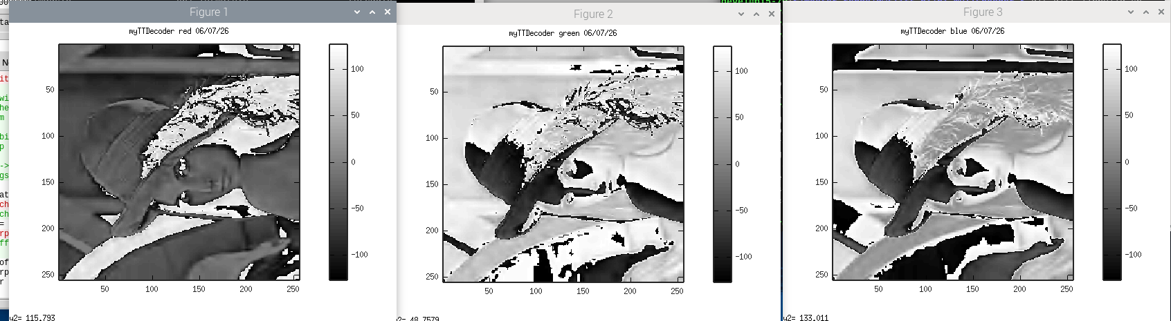
git diff ../pi-myTTEncoder/myTTEncoder.c
diff --git a/pi-myTTEncoder/myTTEncoder.c b/pi-myTTEncoder/myTTEncoder.c
index 9fb9e55..499eb29 100644
--- a/pi-myTTEncoder/myTTEncoder.c
+++ b/pi-myTTEncoder/myTTEncoder.c
@@ -123,7 +123,7 @@ typedef struct {
char *bufferptr;
//printf("bufferptr 0x%x *bufferptr 0x%x \n",bufferptr,*bufferptr);
int n,loop;
- char fname[] = "lena_rgb_256.bmp";
+ char fname[] = "lena_rgb_2048.bmp";
//*bufferptr = buffer;
//printf("0x%x *bufferptr\n",bufferptr);
//printf("fname = %s \n",fname);

git diff myTTDecoder.c
diff --git a/pi-myTTDecoder/myTTDecoder.c b/pi-myTTDecoder/myTTDecoder.c
index 09b8aa8..9148dd6 100644
--- a/pi-myTTDecoder/myTTDecoder.c
+++ b/pi-myTTDecoder/myTTDecoder.c
@@ -95,8 +95,8 @@ printf("CR = %d flg = %d bp = %d imgsz = %d \n",CR, flg, bp, imgsz);
*/
da_x0 = 0;
da_y0 = 0;
-da_x1 = 256;
-da_y1= 256;
+da_x1 = 2048;
+da_y1= 2048;

printf("da_x0 = %d da_y0 = %d da_x1 = %d da_y1 = %d\n",da_x0, da_y0, da_x1, da_y1);

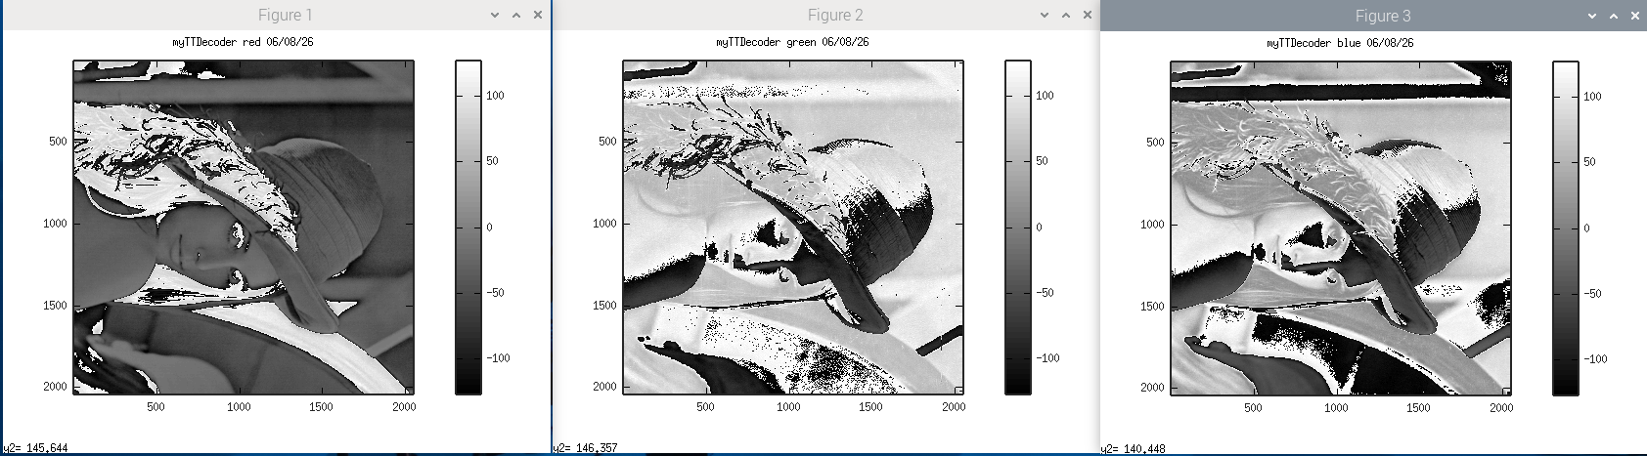
xx

