************************Draft************************
myTTDecoder
05/25/26
************************Draft************************

devel@pi4-50:~/dwtlift-pi/src $ ./compile_pi.sh

devel@pi4-50:~/dwtlift-pi/pi-xx $ ./libbuild.sh

7877 May 24 13:21 test.j2k

steps to get a test.j2k from lena_rgb_256.bmp

devel@pi5-70:~ $ git clone https://github.com/develone/openjpeg.git -b ultibo

devel@pi5-70:~ $ cd openjpeg/

devel@pi5-70:~/openjpeg $ cd build

devel@pi5-70:~/openjpeg/build $ cmake ../

devel@pi5-70:~/openjpeg/build $ make

devel@pi5-70:~/openjpeg/build $ cd bin

devel@pi5-70:~/openjpeg/build/bin $ ./opj_compress -r 25 -i ../../lena_rgb_256.bmp -o test.j2k

devel@pi4-50:~/dwtlift-pi/pi-xx $ git remote -v
origin https://github.com/develone/dwtlift-pi.git (fetch)
origin https://github.com/develone/dwtlift-pi.git (push)

commit 9a44fcff48271b497f24f9a13e79c804f192cf2e (HEAD -> main)
Author: Edward Vidal Jr <develone@sbcglobal.net>
Date: Mon May 25 13:32:08 2026 -0600

update needed
196730 May 25 16:37 test_wr.bmp

devel@pi4-50:~/dwtlift-pi/pi-xx $ gcc -g myTTDecoder.c -L. -ldwtlift -lm -o myTTDecoder

devel@pi4-50:~/dwtlift-pi/pi-xx $ ./myTTDecoder
da_x0 = 0 da_y0 = 0 da_x1 = 256 da_y1 = 256
*ff = 0x74 ff_in= test.j2k
calling decom_test
In decom_test called by C myTTDecoder.c test.j2k 0 0 256 256 test.j2k
0 0 256 256 test.j2k l_data_size 196608 0xb28bf010
Start decompression: -1780533041 seconds -1779748648 useconds -784393 starting openjpeg
l_stream 0xc4695890
In infile_format test.j2k reader 0xc4696920
test.j2k l_nb_read 12 0xc4696920 0xff 0x4f 0xff 0x51 0x0 0x2f 0x0 0x0 0x0 0x0 0x1 0x0
[INFO] Start to read j2k main header (0).
[INFO] Main header has been correctly decoded.
[INFO] Setting decoding area to 0,0,256,256
[INFO] Header of tile 1 / 1 has been read.
Decompression time: 56771 seconds 0 useconds 56771
start writing: -118 seconds 0 useconds -118 starting openjpeg
file name red data ptr 0xb28bf010 size 65536
file name green data ptr 0xb28df010 size 65536
file name blue data ptr 0xb28cf010 size 65536
WR imagesize = 0x30000
Wr bpp = 24
Wr xresolution = 2835 yresolution 2835
File writes: 18857 seconds 0 useconds 18857 starting openjpeg

rgb.m

clear
fid = fopen('red','r'); im1 = fread(fid, [256,inf], 'int8'); fclose(fid);
fid = fopen('green','r'); im2 = fread(fid, [256,inf], 'int8'); fclose(fid);
fid = fopen('blue','r'); im3 = fread(fid, [256,inf], 'int8'); fclose(fid);

figure;
imagesc(im1);
colorbar
colormap 'gray'
title "myTTDecoder red 05/25/26"

figure;
imagesc(im2);
colorbar;
colormap 'gray'
title "myTTDecoder green 05/25/26"

figure;
imagesc(im3);
colorbar;
colormap 'gray'
title "myTTDecoder blue 05/25/26"

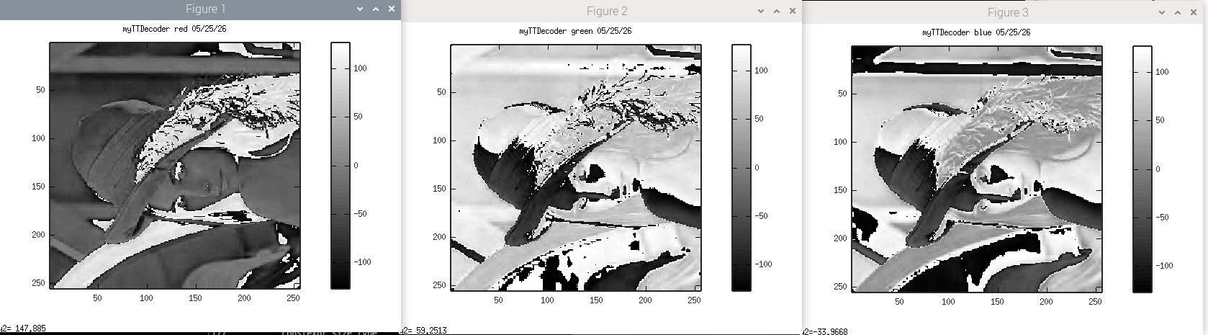
xx

