********************Default********************
Different test.j2k files using myTTDecoder
05/26/26
********************Default********************

myTTDecoder is currently running on a Raspberry Pi4 or Raspberry Pi-zero.

Raspberry Pi 4 4Gb

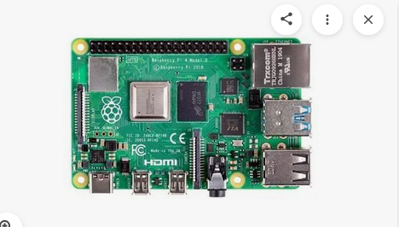

Raspberry Pi-Zero

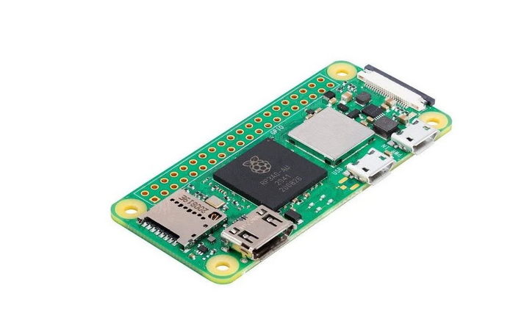

The goal is to get this code running on a Raspberry Pico or Raspberry Pico2.
Pico a$4.00 device

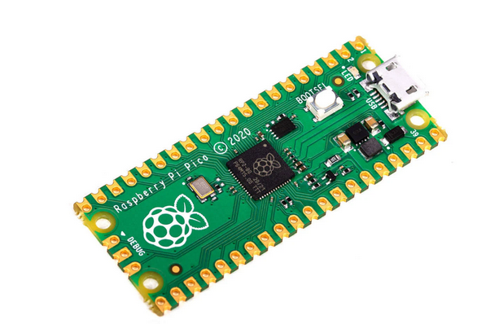

Pico2 a $6.00 device

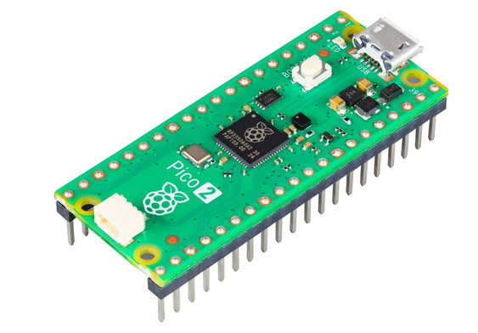

The smaller the test.j2k file the more compression was done.

Three test.j2k files were tested test_256_125.j2k, test_256_100.j2k, and test_256_25.j2k.

devel@pi5-70:~/dwtlift-pi/pi-xx $ ls -la test*.j2k
-rw-r--r-- 1 devel devel 1980 May 26 12:00 test_256_100.j2k
-rw-r--r-- 1 devel devel 1557 May 26 12:00 test_256_125.j2k
-rw-r--r-- 1 devel devel 7877 May 26 12:00 test_256_25.j2k
-rw-r--r-- 1 devel devel 3945 May 26 12:00 test_256_50.j2k
-rw-r--r-- 1 devel devel 2554 May 26 12:00 test_256_75.j2k
-rw-r--r-- 1 devel devel 7877 May 26 12:35 test.j2k

devel@pi5-70:~/dwtlift-pi/pi-xx $ diff test_256_125.j2k test.j2k

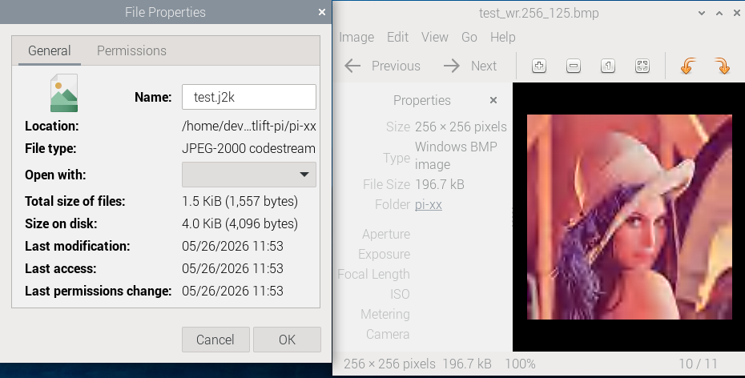
devel@pi5-70:~/dwtlift-pi/pi-xx $ ./myTTDecoder
da_x0 = 0 da_y0 = 0 da_x1 = 256 da_y1 = 256
*ff = 0x74 ff_in= test.j2k
calling decom_test
In decom_test called by C myTTDecoder.c test.j2k 0 0 256 256 test.j2k
0 0 256 256 test.j2k l_data_size 196608 0x3306c010
Start decompression: -1780666187 seconds -1779817991 useconds -848196 starting openjpeg
l_stream 0xcf2a4890
In infile_format test.j2k reader 0xcf2a5920
test.j2k l_nb_read 12 0xcf2a5920 0xff 0x4f 0xff 0x51 0x0 0x2f 0x0 0x0 0x0 0x0 0x1 0x0
[INFO] Start to read j2k main header (0).
[INFO] Main header has been correctly decoded.
[INFO] Setting decoding area to 0,0,256,256
[INFO] Header of tile 1 / 1 has been read.
Decompression time: 14545 seconds 0 useconds 14545
start writing: -28 seconds 0 useconds -28 starting openjpeg
file name red data ptr 0x3306c010 size 65536
file name green data ptr 0x3308c010 size 65536
file name blue data ptr 0x3307c010 size 65536
WR imagesize = 0x30000
Wr bpp = 24
Wr xresolution = 2835 yresolution 2835
File writes: 2783 seconds 0 useconds 2783 starting openjpeg

devel@pi5-70:~/dwtlift-pi/pi-xx $ diff test_256_100.j2k test.j2k
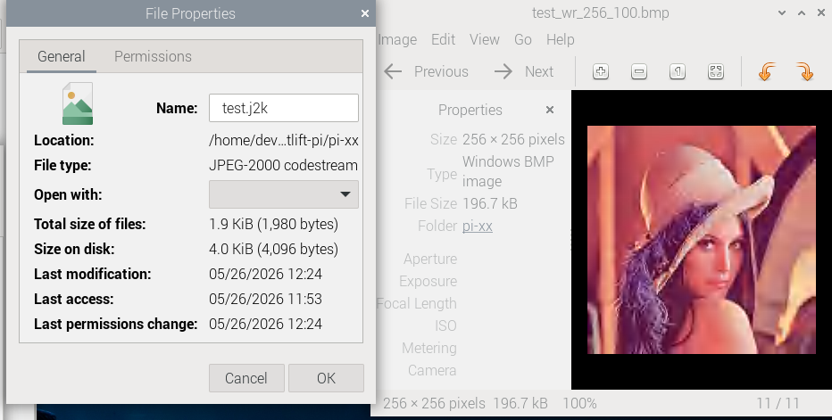

devel@pi5-70:~/dwtlift-pi/pi-xx $ diff test_256_25.j2k test.j2k

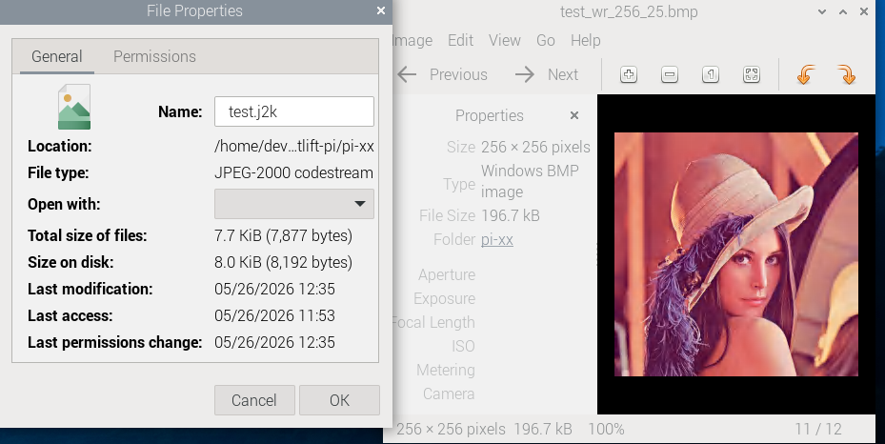

end

