https://github.com/develone/filter-c.git which was forked from
https://github.com/adis300/filter-c

git clone https://github.com/develone/filter-c.git
cp example.c.low example.c
make clean; make
./example > aa.txt

static int gensindata(double *ptrsignal) from example.c

*ptrsignal = (double)10*(sin(2*pi*50*t[i]) + sin(2*pi*120*t[i]) + sin(2*pi*300*t[i])); //no DC

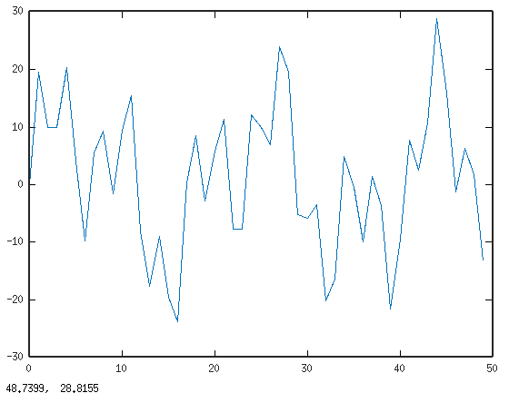

FFT computed in octave from mysig.

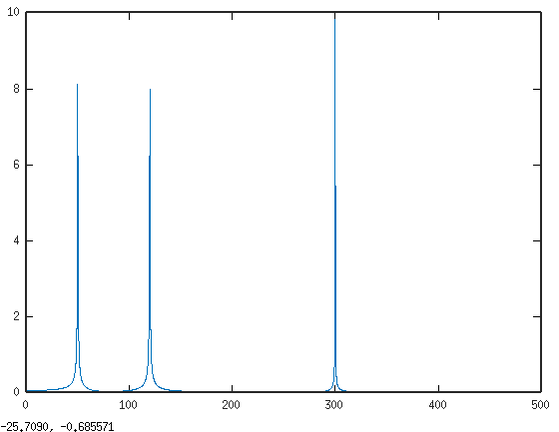

printf("%f,", bw_low_pass(filter, signal[i]));

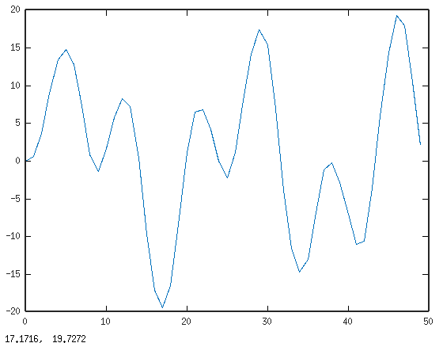

FFT computed from signal myfilt create with example.c

