******************Default******************
Step to fix-bpm
when compiled with
-Wall -Werror
06/01/26
******************Default******************

Adding -Wall -Werror these 2 gcc flags to the scipts/compile.sh found several errors.

#!/bin/bash
gcc -g -Wall -Werror src/bmp.c -o bmp

devel@pi5-80:~ $ git clone https://github.com/develone/fix-bmp.git
devel@pi5-80:~ $ cd fix-bmp/
devel@pi5-80:~/fix-bmp $ ./scipts/compile.sh
devel@pi5-80:~/fix-bmp $ ./bmp "test-files/lena_rgb_2048.bmp" "out.bmp"
input test-files/lena_rgb_2048.bmp output out.bmp
number of header points 1
n 1
sizeof(bitmap_header) 54
hp->bitmapsize 12582912
number of data points 12582912
loop 0 data 39 data 57
loop 1 data 16 data 22
loop 2 data 52 data 82
loop 3 data 39 data 57
loop 4 data 16 data 22
loop 5 data 52 data 82
loop 6 data 39 data 57
loop 7 data 16 data 22
loop 8
Restoring data subtracting the size of loop
hp->bitmapsize 12582912
width 2048 height 2048
hp->planes 1
hp->bitsperpixel 24
hp->bitmapsize 12582912
hp->horizontalres 2835
hp->verticalres 2835
hp->numcolors 0
hp->importantcolors 0

devel@pi5-80:~/fix-bmp $ od -x test-files/lena_rgb_2048.bmp | less
0000000 4d42 007a 00c0 0000 0000 007a 0000 006c
0000020 0000 0800 0000 0800 0000 0001 0018 0000
0000040 0000 0000 00c0 0b13 0000 0b13 0000 0000
0000060 0000 0000 0000 4742 7352 0000 0000 0000
0000100 0000 0000 0000 0000 0000 0000 0000 0000
*
0000140 0000 0000 0000 0000 0000 0002 0000 0000
0000160 0000 0000 0000 0000 0000 1639 3952 5216
0000200 1639 3952 5116 1539 3951 5116 1739 3b53

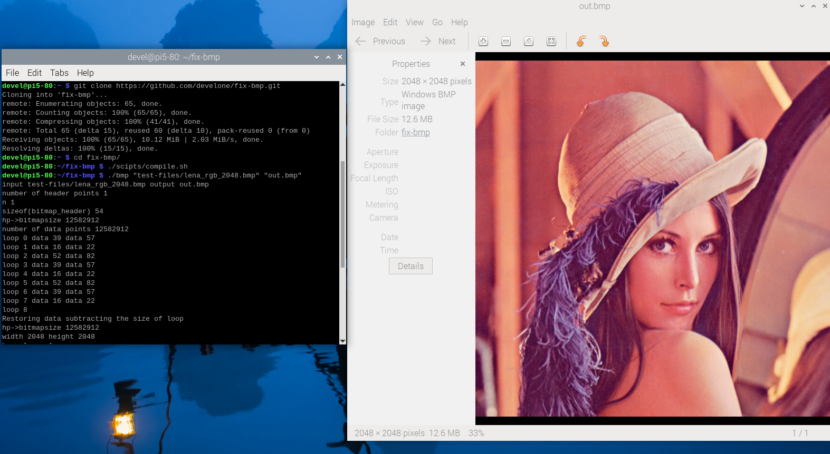

devel@pi5-80:~/fix-bmp $ ./bmp "test-files/lena_rgb_256.bmp" "out.bmp"
number of header points 1
n 1
sizeof(bitmap_header) 54
hp->bitmapsize 196608
number of data points 196608
loop 0 data 38 data 56
loop 1 data 15 data 21
loop 2 data 50 data 80
loop 3 data 3e data 62
loop 4 data 1e data 30
loop 5 data 5f data 95
loop 6 data 3c data 60
loop 7 data 19 data 25
loop 8
Restoring data subtracting the size of loop
hp->bitmapsize 196608
width 256 height 256
hp->planes 1
hp->bitsperpixel 24
hp->bitmapsize 196608
hp->horizontalres 2835
hp->verticalres 2835
hp->numcolors 0
hp->importantcolors 0

devel@pi5-80:~/fix-bmp $ od -x test-files/lena_rgb_256.bmp | less
0000000 4d42 007a 0003 0000 0000 007a 0000 006c
0000020 0000 0100 0000 0100 0000 0001 0018 0000
0000040 0000 0000 0003 0b13 0000 0b13 0000 0000
0000060 0000 0000 0000 4742 7352 0000 0000 0000
0000100 0000 0000 0000 0000 0000 0000 0000 0000
*
0000140 0000 0000 0000 0000 0000 0002 0000 0000
0000160 0000 0000 0000 0000 0000 1538 3e50 5f1e
0000200 193c 3d5f 5c1a 2043 3c60 5a16 1947 655d

xx
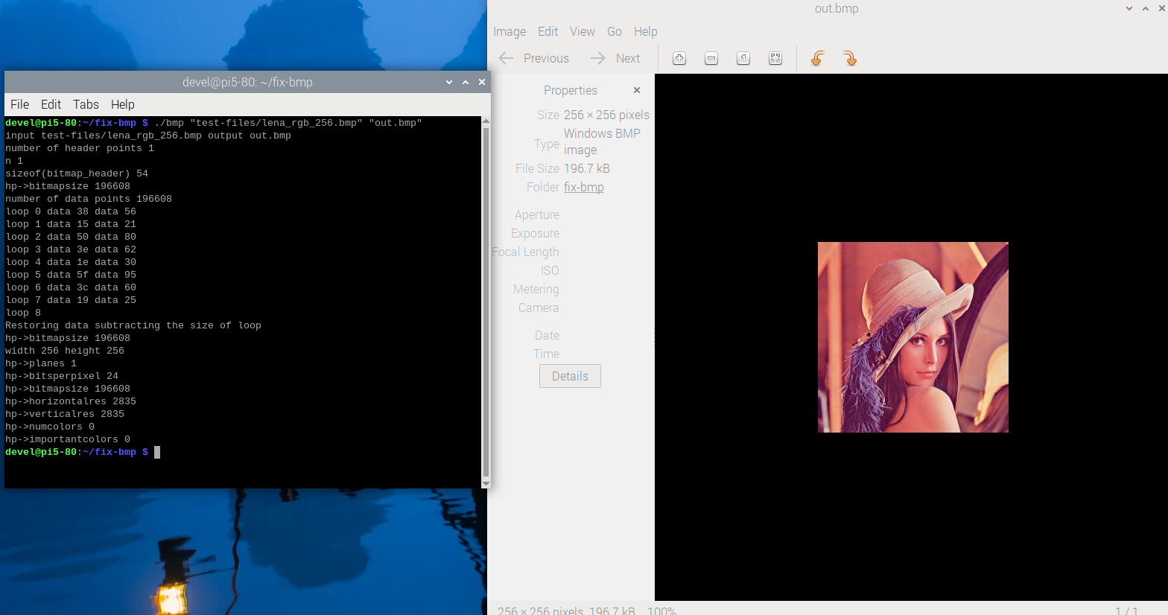
xx

