Conversion of Verilog
depp.v
Digilent Asynchronous Parallel
Interface
With MyHDL& RHEA to
para_rpi2B & xula2.v
05/09/16

Goal: To increase the data rate between the XuLA2-LX9 and RPi2B. The parallel should provide considerable increase the over UART that is currenly working on the XuLA2-LX9 with the RPi2B.
The package PIGPIO[7] will be used to READ/WRITE the GPIO pins on the RPi2B.

Functional Description

The Digilent Asynchronous Parallel Interface is patterned after the EPP mode of the IEEE-1284
parallel port interface on IBM PC type computers. The interface consists of an 8-bit bi-directional data
bus and four control signals. The data transfer speed that can be achieved depends on the particular
communication subsystem and firmware version being used. [1].

Status: The initial Verilog code obtained [6] has been converted to MyHDL{5] and a simulation is working. In addition, a bit file and user constraints file are created with the package Xilinx ISE WebPack [3] and rhea[4]. The Verilog has been Synthesized and a bit file has been created. Need to from 8 bits out and 8 bits to Tri-State signals.

Myhdl

commit 97dd4e3767082b31a18aecce763005ae374cf79d
Author: Jan Decaluwe <jan@jandecaluwe.com>
Date: Sun Oct 25 16:54:08 2015 +0100

The starting code was located at [6]
Developed by F.M.Zhu
commit 458f3ddcf2628e78079c4fd28c91e2619cf44b70
Author: feng <greedgenius@gmail.com>
Date: Sat Aug 17 20:43:48 2013 +0800

rhea
commit 605348b2570f83da341bef8b8a13596e2b8eccd9
Author: Christopher Felton <chris.felton@gmail.com>
Date: Sun Apr 3 16:35:02 2016 -0500

The file “depp.py” is a Python program that can provide both Verilog or VHDL files. The file “depp.v” is found a Appendix A.

To create “para_rpi2B.v”. The command to create the file “para_rpi2B.v” from the file “depp.py” is “python depp.py –convert”. The file “para_rpi2B.v” is at Appendix B. para_rpi2B.v

In addition, MyHDL can simulate the Verilog. The command “python depp –trace” is used to generate a Value Change DUMP VCD “tb.vcd” . The can be viewed with the command “gtkwave tb.vcd”.

Writing 10 random values to a_addr_reg & 10 random values to a_data_reg. The depp code uses fr_rpi2B as the input and to_rpi2B as the output.

Note: This will require 16 GPIO lines plus 4 GPIO lines used to control the async data transfer.
If Tristate signals can be used the 16 GPIO lines used for data in/data out can be reduced to 8 GPIO
plus 4 GPIO lines used to control the async data transfer.

This is how the original code was written.

wire a_db = (a_write) ? a_data_reg : 8'bZZZZ_ZZZZ;

and only a_db was used for both the input/output.

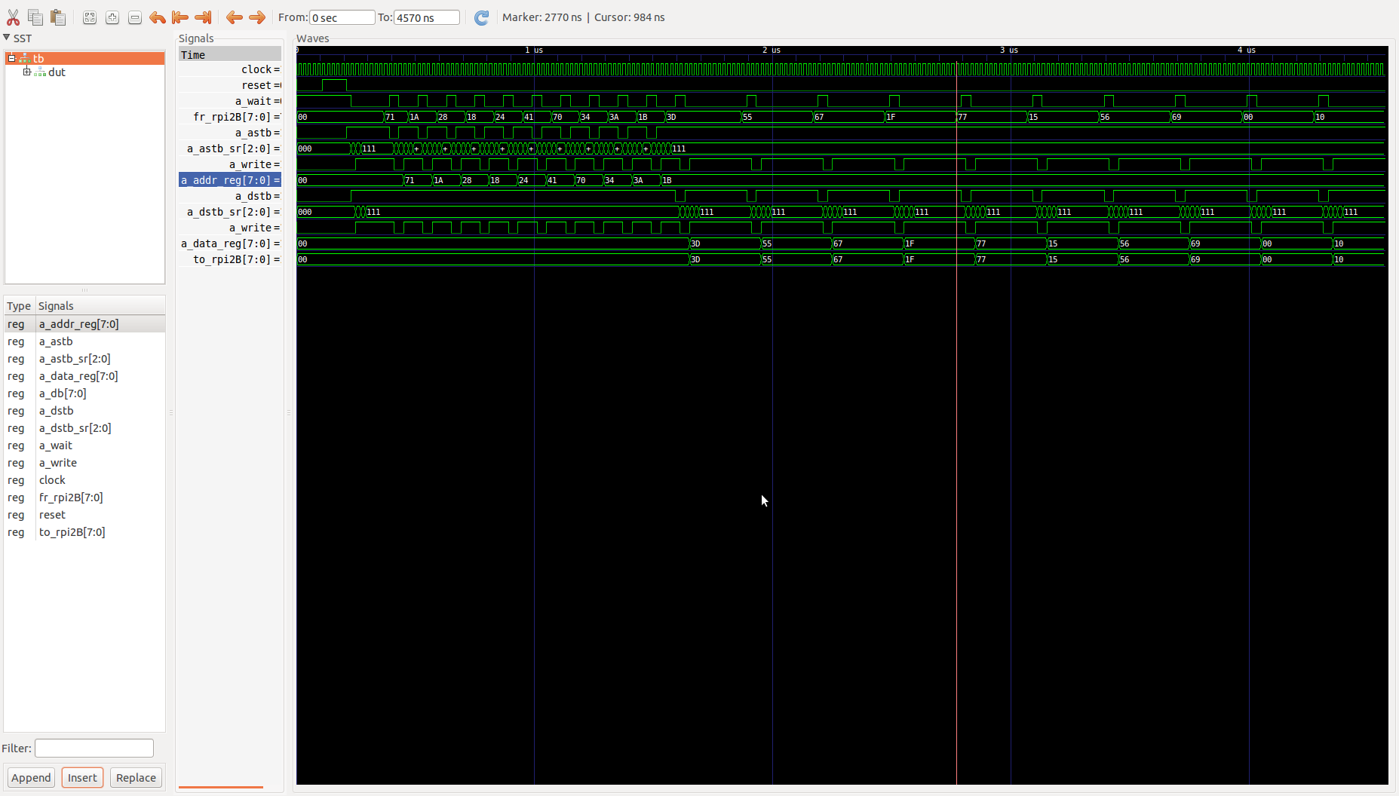
Writing to a_addr_reg

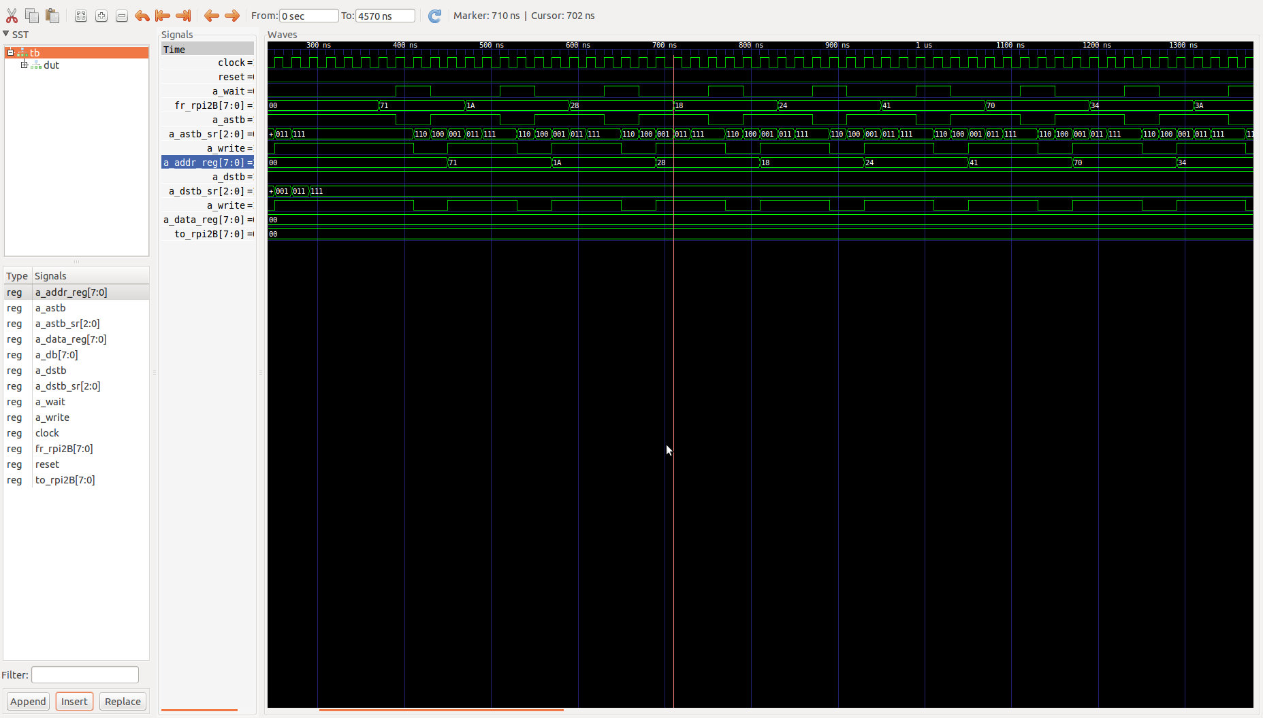
Writing to a_data_reg

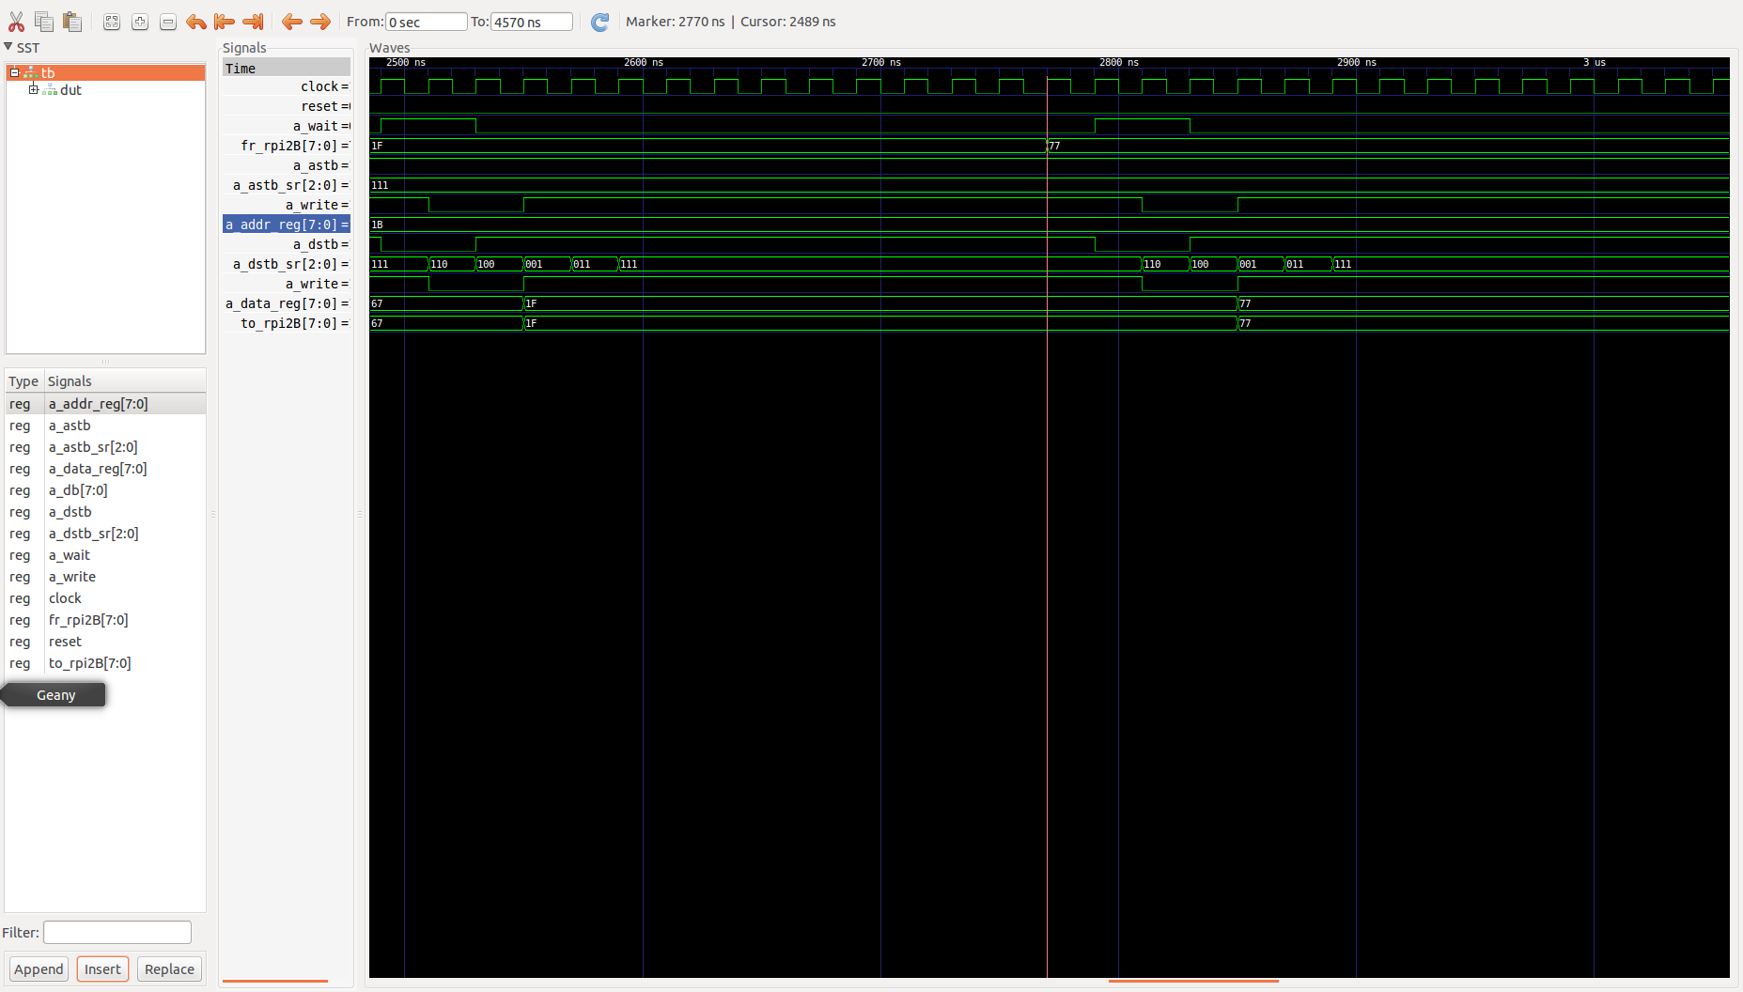

brd.add_port('a_astb', 'A2') XuLA2 CH31 BCM 2 SDA
brd.add_port('a_dstb', 'B2') CXuLA2 H30 BCM 3 SCL
brd.add_port('a_write', 'B1') XuLA2 CH29 BCM 4
brd.add_port('a_wait', 'C1') XuLA2 CH28 BCM 17
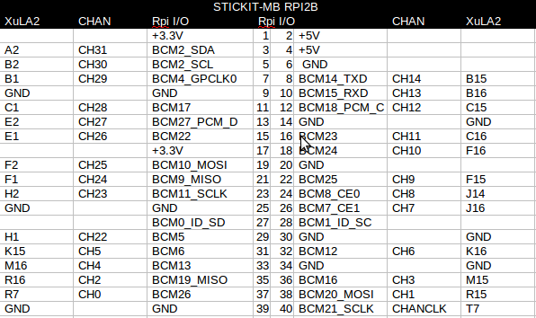
XuLA2
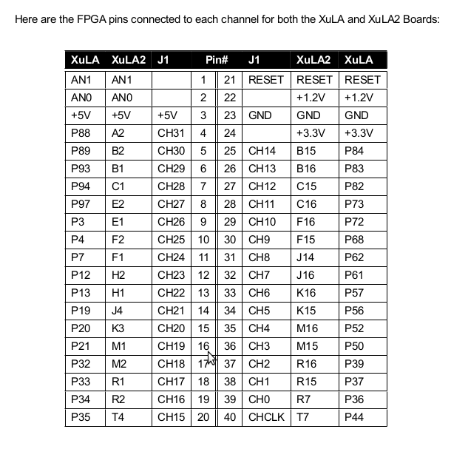

RPi_GPIO

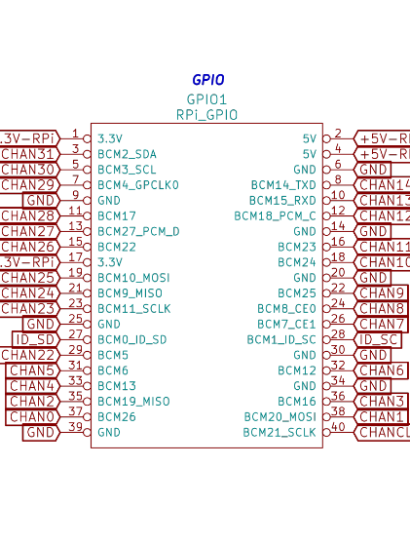

Using Python with MyHDL and “rhea” package developed by Chris. Felton. The software rhea is found at https://github.com/cfelton/rhea. With the command “python depp.py –build” the files “xilinx/xula2.ucf”, “xula2.v”, “build_ise.log” and “xula2.tcl” are created.
This invokes the Xilinx ISE Web Pack to create the “xula2.bit” file. The current “xula2.ucf” file is shown below.

xula2.ucf
#
NET "to_rpi2B<0>" LOC = "T4" ;
NET "to_rpi2B<1>" LOC = "R1" ;
NET "to_rpi2B<2>" LOC = "M1" ;
NET "to_rpi2B<3>" LOC = "J4" ;
NET "to_rpi2B<4>" LOC = "R2" ;
NET "to_rpi2B<5>" LOC = "M2" ;
NET "to_rpi2B<6>" LOC = "K3" ;
NET "to_rpi2B<7>" LOC = "H1" ;
NET "clock" LOC = "A9" ;
NET "fr_rpi2B<0>" LOC = "T4" ;
NET "fr_rpi2B<1>" LOC = "R1" ;
NET "fr_rpi2B<2>" LOC = "M1" ;
NET "fr_rpi2B<3>" LOC = "J4" ;
NET "fr_rpi2B<4>" LOC = "R2" ;
NET "fr_rpi2B<5>" LOC = "M2" ;
NET "fr_rpi2B<6>" LOC = "K3" ;
NET "fr_rpi2B<7>" LOC = "H1" ;
NET "a_dstb" LOC = "B2" ;
NET "a_astb" LOC = "A2" ;
NET "a_write" LOC = "B1" ;
NET "a_wait" LOC = "C1" ;
#
NET "clock" TNM_NET = "clock";
TIMESPEC "TS_clock" = PERIOD "clock" 83.3333333 ns HIGH 50%;
#
The current “xula2.tcl” file is shown below.

xula2.tcl
#
#
# ISE implementation script
# create: Mon, 09 May 2016 15:50:05 +0000
# by: depp.py
#
#
# set compile directory:
set compile_directory .
set top_name xula2
set top xula2
# set Project:
set proj xula2
# change to the directory:
cd xilinx/
# set ucf file:
set constraints_file xula2.ucf
# set variables:
project new xula2.xise
project set family spartan6
project set device XC6SLX9
project set package FTG256
project set speed -2

# add hdl files:
xfile add xula2.ucf
xfile add xula2.v
# test if set_source_directory is set:
if { ! [catch {set source_directory $source_directory}]} {
project set "Macro Search Path"
$source_directory -process Translate
}
project set "Create Binary Configuration File" "true" -process "Generate Programming File"
project set "FPGA Start-Up Clock" "JTAG Clock" -process "Generate Programming File"
# run the implementation:
process run "Synthesize"
process run "Translate"
process run "Map"
process run "Place & Route"
process run "Generate Programming File"
# close the project:
project close

[1] Digilent Asynchronous Parallel Interface (DEPP)
Revision: September 2, 2010

[2} https://github.com/greedgenius/FPGA_Projects.git

[3] http://www.xilinx.com/products/design-tools/ise-design-suite/ise-webpack.html

[4] https://github.com/cfelton/rhea

[5] https://github.com/jandecaluwe/myhdl

[6] https://github.com/greedgenius/FPGA_Projects.git

[7] http://abyz.co.uk/rpi/pigpio/

