****************Draft****************
Describing FFT
GPU FFT
05/03/17
****************Draft****************

https://en.wikipedia.org/wiki/Fourier_transform

The Fourier transform decomposes a function of time (a signal) into the frequencies that make it up, in a way similar to how a musical chord can be expressed as the frequencies (or pitches) of its constituent notes. The Fourier transform of a function of time itself is a complex-valued function of frequency, whose absolute value represents the amount of that frequency present in the original function, and whose complex argument is the phase offset of the basic sinusoid in that frequency. The Fourier transform is called the frequency domain representation of the original signal. The term Fourier transform refers to both the frequency domain representation and the mathematical operation that associates the frequency domain representation to a function of time. The Fourier transform is not limited to functions of time, but in order to have a unified language, the domain of the original function is commonly referred to as the time domain. For many functions of practical interest, one can define an operation that reverses this: theinverse Fourier transformation, also called Fourier synthesis, of a frequency domain representation combines the contributions of all the different frequencies to recover the original function of time.
Linear operations performed in one domain (time or frequency) have corresponding operations in the other domain, which are sometimes easier to perform. The operation of differentiation in the time domain corresponds to multiplication by the frequency,[remark 1] so some differential equations are easier to analyze in the frequency domain. Also, convolution in the time domain corresponds to ordinary multiplication in the frequency domain. Concretely, this means that any linear time-invariant system, such as a filter applied to a signal, can be expressed relatively simply as an operation on frequencies.[remark 2] After performing the desired operations, transformation of the result can be made back to the time domain. Harmonic analysis is the systematic study of the relationship between the frequency and time domains, including the kinds of functions or operations that are "simpler" in one or the other, and has deep connections to almost all areas of modern mathematics.

An octave example was found at https://gist.github.com/akiatoji/5649907.

Created a new repository https://github.com/develone/gpu_programming.git
Take 100Hz signal, amplitude modulate it with 2.5KHz, then run it through FFT

This example can be downloaded with the git clone command.

git clone https://github.com/develone/gpu_programming.git

The octave code for spectrum is found at Appendix A Octave code to generate a sine wave, modulate the signal, and compute and fft.

Execute the command “cd gpu_programming/octave/”

Execute the command “octave”.

GNU Octave, version 3.8.2
Copyright (C) 2014 John W. Eaton and others.
This is free software; see the source code for copying conditions.
There is ABSOLUTELY NO WARRANTY; not even for MERCHANTABILITY or
FITNESS FOR A PARTICULAR PURPOSE. For details, type 'warranty'.

Octave was configured for "arm-unknown-linux-gnueabihf".

Additional information about Octave is available at http://www.octave.org.

Please contribute if you find this software useful.
For more information, visit http://www.octave.org/get-involved.html

Read http://www.octave.org/bugs.html to learn how to submit bug reports.
For information about changes from previous versions, type 'news'.

octave:1>
load spectrum.m This loads the octave code from the file spectrum.m
spectrum This runs the octave code. A sin wave is displayed. The period of 100Hz is
t = 1/f
t = 1/100
t = .01 sec this means that the from 0 to .01 sec 1 cycle of the sin wave is done.

100Hz signal. Press any key to continue

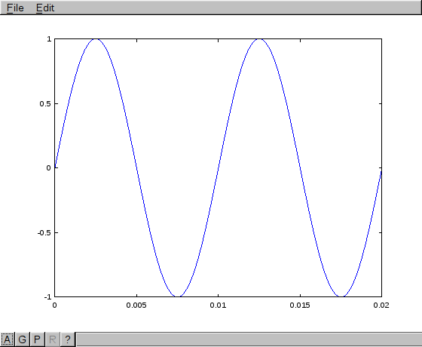
Modulation is the product of 1 signal times the 2nd signal.
Modulated with 2.5KHz signal. Press any key to continue

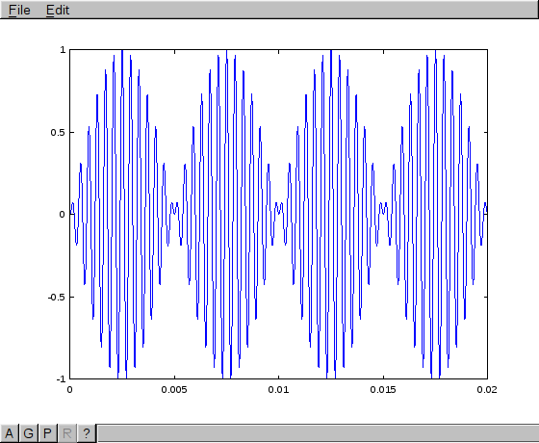
Frequency spectrum with FFT. Press any key to continue

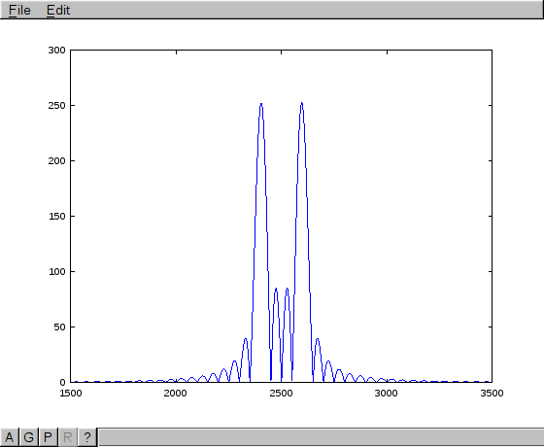
C code.
N = 256
Freq1 = 400 2.5msec
period1 = (float)1 / freq1
w1 = 2 * PI * freq1
num_periods = 48
num_tsteps = N
tstep = ((num_periods * period1) / (double)num_tsteps) 469 usec 0.000469
looping k from 0 to N
v[k].Re = sin(w1*k*tstep)

looping i from 0 to N
mag[i]= (float)d_ptr[i].Re
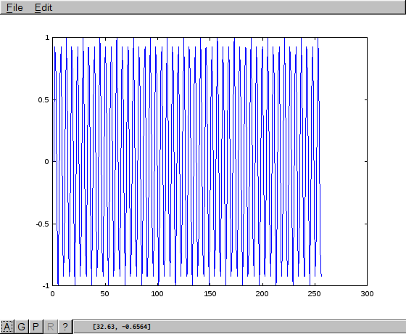
fft The Peaks at –48 or 48.

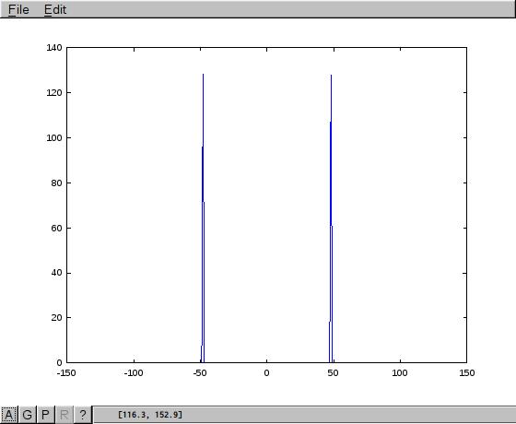
Appendix A Octave code to generate a sine wave, modulate the signal, and compute and fft.
clear ; close all; clc

freq1 = 100;
period1 = 1 / freq1;
w1 = 2 * pi * freq1;
num_tsteps = 1000;
num_periods = 2;
tstep = num_periods * period1 / num_tsteps;
t = 0:tstep:(num_periods * period1);
x1 = sin(w1 * t); plot(t, x1);

disp(['100Hz signal. Press any key to continue']);
pause;

freq2 = 2500;
period2 = 1 / freq2;
w2 = 2 * pi * freq2;

x2 = sin(w2 * t);

x3 = x1 .* x2;
plot(t, x3);

disp(['Modulated with 2.5KHz signal. Press any key to continue']);
pause;

n = 2**16;
f_s = num_tsteps / (period1*num_periods);

y = abs(fft(x3, n));
y = fftshift(y);
f = f_s*(-n/2:n/2-1)/n;
plot(f, y);
axis([1500, 3500]);

disp(['Frequency spectrum with FFT. Press any key to continue']);
pause;

Appendix B.
Below are the results of computing the fft using the GPU on the Raspberry Pi 3B Rpi3B.
pi@raspberrypi3:~/userland/host_applications/linux/apps/hello_pi/hello_fft $ sudo ./hello_fft.bin 16 16
0000: 0x0000001c
0004: 0x80000000
0008: 0x00030012
000c: 0x00000004
0010: 0x80000004
0014: 0x00000000
0018: 0x00000000
0000: 0x00000024
0004: 0x80000000
0008: 0x0003000c
000c: 0x0000000c
0010: 0x80000004
0014: 0x00000010
0018: 0x00001000
001c: 0x00000004
0020: 0x00000000
base=0x3f000000, mem=0x75ccc000
0000: 0x0000001c
0004: 0x80000000
0008: 0x0003000d
000c: 0x00000004
0010: 0x80000004
0014: 0xfc263000
0018: 0x00000000
base=0x3c263000, mem=0x74ca8000
0000: 0x00000028
0004: 0x80000000
0008: 0x00030011
000c: 0x00000010
0010: 0x80000004
0014: 0x00000000
0018: 0xfd286e00
001c: 0x00000001
0020: 0x000007d0
0024: 0x00000000
rel_rms_err = 9e-07, usecs = 5815, k = 0
0000: 0x0000001c
0004: 0x80000000
0008: 0x0003000e
000c: 0x00000004
0010: 0x80000004
0014: 0x00000000
0018: 0x00000000
0000: 0x0000001c
0004: 0x80000000
0008: 0x0003000f
000c: 0x00000004
0010: 0x80000004
0014: 0x00000000
0018: 0x00000000
0000: 0x0000001c
0004: 0x80000000
0008: 0x00030012
000c: 0x00000004
0010: 0x80000004
0014: 0x00000000
0018: 0x00000000

