************************************Default************************************
Testing pico-examples/spi/spi_master_slave/spi_master/spi_master.c on the left pico.
Testing pico-examples/spi/spi_master_slave/spi_slave/spi_slave .c on the right pico.
09/16/24
************************************Default************************************

With the spi master on the left and spi slave on the right. The uart connection of the spi master is connected to “/dev/ttyUSB1”. The uart connection of the spi slave is connected to “/dev/ttyUSB0”.

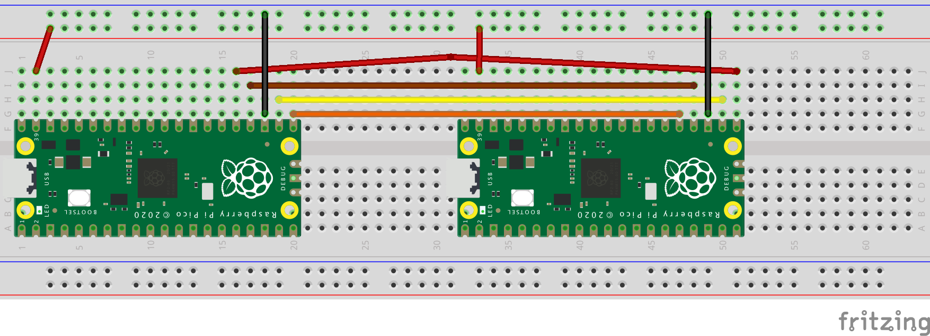
“/dev/ttyUSB1”
SPI master says: read page 118 from the MISO line:
ff fe fd fc fb fa f9 f8 f7 f6 f5 f4 f3 f2 f1 f0
ef ee ed ec eb ea e9 e8 e7 e6 e5 e4 e3 e2 e1 e0
df de dd dc db da d9 d8 d7 d6 d5 d4 d3 d2 d1 d0
cf ce cd cc cb ca c9 c8 c7 c6 c5 c4 c3 c2 c1 c0
bf be bd bc bb ba b9 b8 b7 b6 b5 b4 b3 b2 b1 b0
af ae ad ac ab aa a9 a8 a7 a6 a5 a4 a3 a2 a1 a0
9f 9e 9d 9c 9b 9a 99 98 97 96 95 94 93 92 91 90
8f 8e 8d 8c 8b 8a 89 88 87 86 85 84 83 82 81 80
7f 7e 7d 7c 7b 7a 79 78 77 76 75 74 73 72 71 70
6f 6e 6d 6c 6b 6a 69 68 67 66 65 64 63 62 61 60
5f 5e 5d 5c 5b 5a 59 58 57 56 55 54 53 52 51 50
4f 4e 4d 4c 4b 4a 49 48 47 46 45 44 43 42 41 40
3f 3e 3d 3c 3b 3a 39 38 37 36 35 34 33 32 31 30
2f 2e 2d 2c 2b 2a 29 28 27 26 25 24 23 22 21 20
1f 1e 1d 1c 1b 1a 19 18 17 16 15 14 13 12 11 10
0f 0e 0d 0c 0b 0a 09 08 07 06 05 04 03 02 01 00

“/dev/ttyUSB0”
SPI slave says: read page 137 from the MOSI line:
00 01 02 03 04 05 06 07 08 09 0a 0b 0c 0d 0e 0f
10 11 12 13 14 15 16 17 18 19 1a 1b 1c 1d 1e 1f
20 21 22 23 24 25 26 27 28 29 2a 2b 2c 2d 2e 2f
30 31 32 33 34 35 36 37 38 39 3a 3b 3c 3d 3e 3f
40 41 42 43 44 45 46 47 48 49 4a 4b 4c 4d 4e 4f
50 51 52 53 54 55 56 57 58 59 5a 5b 5c 5d 5e 5f
60 61 62 63 64 65 66 67 68 69 6a 6b 6c 6d 6e 6f
70 71 72 73 74 75 76 77 78 79 7a 7b 7c 7d 7e 7f
80 81 82 83 84 85 86 87 88 89 8a 8b 8c 8d 8e 8f
90 91 92 93 94 95 96 97 98 99 9a 9b 9c 9d 9e 9f
a0 a1 a2 a3 a4 a5 a6 a7 a8 a9 aa ab ac ad ae af
b0 b1 b2 b3 b4 b5 b6 b7 b8 b9 ba bb bc bd be bf
c0 c1 c2 c3 c4 c5 c6 c7 c8 c9 ca cb cc cd ce cf
d0 d1 d2 d3 d4 d5 d6 d7 d8 d9 da db dc dd de df
e0 e1 e2 e3 e4 e5 e6 e7 e8 e9 ea eb ec ed ee ef
f0 f1 f2 f3 f4 f5 f6 f7 f8 f9 fa fb fc fd fe ff

