Testing delay of a signal using the DelayLine from the XESS VHDL_lib.
It appears that the left requires a delay after the 4th pass. This is because, on the 4th and higher passes, the left is actually the right since, the not left is not read from SDram. This was determined with program found at Appendix A " model_fsm.py"
0 left
1 sam
2 right left
3 sam
4 right left
5 sam
6 right left
7 sam
8 right left
9 sam
10 right left
11 sam
12 right left
13 sam
14 right left
15 sam
16 right left

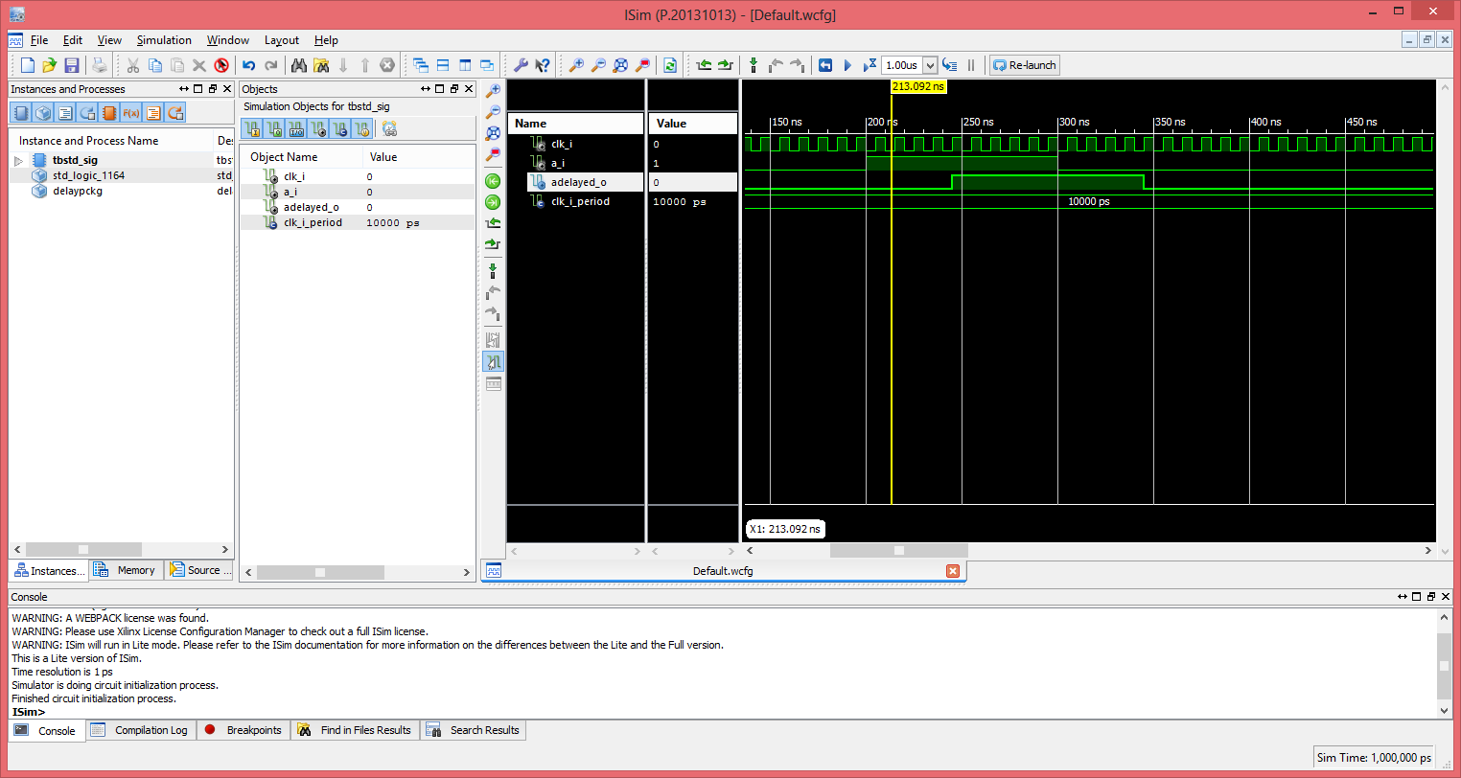

With change of 1 line "generic map (NUM_DELAY_CYCLES_G => 5)" to "generic map (NUM_DELAY_CYCLES_G => 1)".

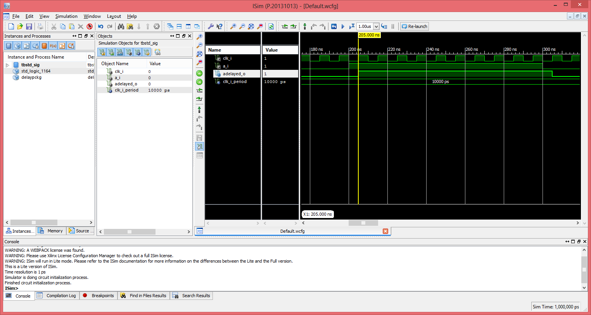

Next a bus will be Delayed instead of a single bit. In this example the value binary "0000000011111010" by 1 clock.

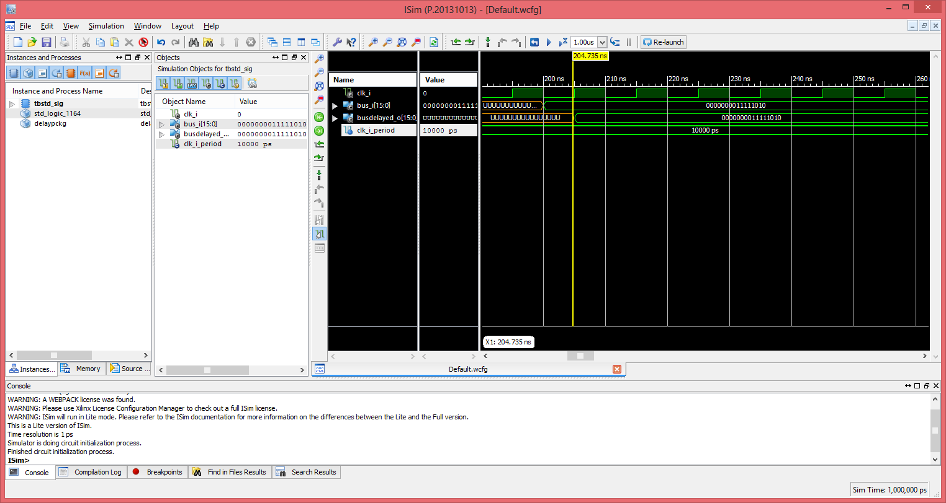

As with the single bit changing a single line "generic map (NUM_DELAY_CYCLES_G => 1)" to "generic map (NUM_DELAY_CYCLES_G => 3)". Now the value is delayed 3 clocks.

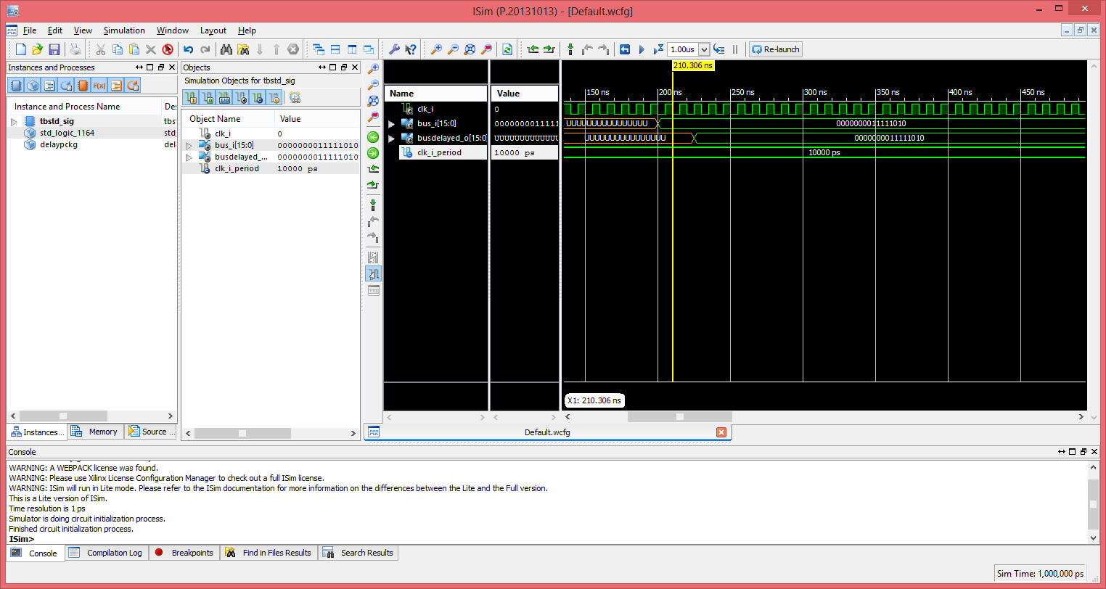

A capability to determine when to use the non delayed or delayed signal is needed. This will require the jpeg module to be modified to determine which signal to be used.

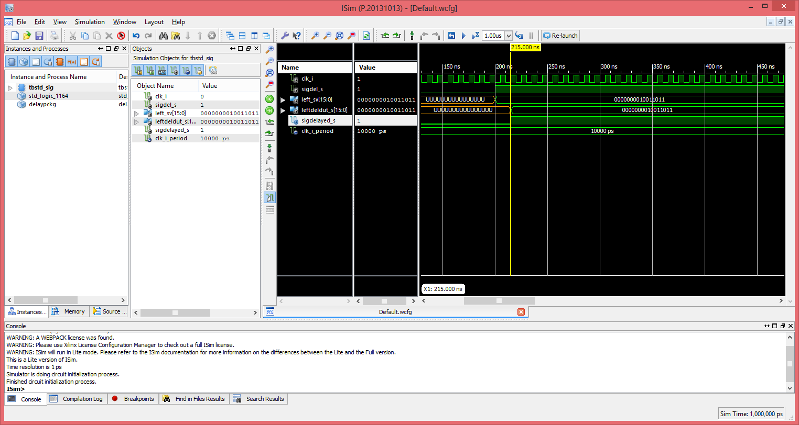
Using a DelayLine & DelayBus with NUM_DELAY_CYCLES_G => 2 the same will provide the capability required.
DelayBus_u0 : DelayBus
generic map (NUM_DELAY_CYCLES_G => 2)
port map (
clk_i => clk_i,
bus_i => left_sv,
busDelayed_o => leftDelDut_s
);
DelayLine_u1 : DelayLine
generic map (NUM_DELAY_CYCLES_G => 2)
port map (
clk_i => clk_i,
a_i => siDel_s,
aDelayed_o => sigDelayed_s
);

Added the jpeg.v to std_sig.vhd

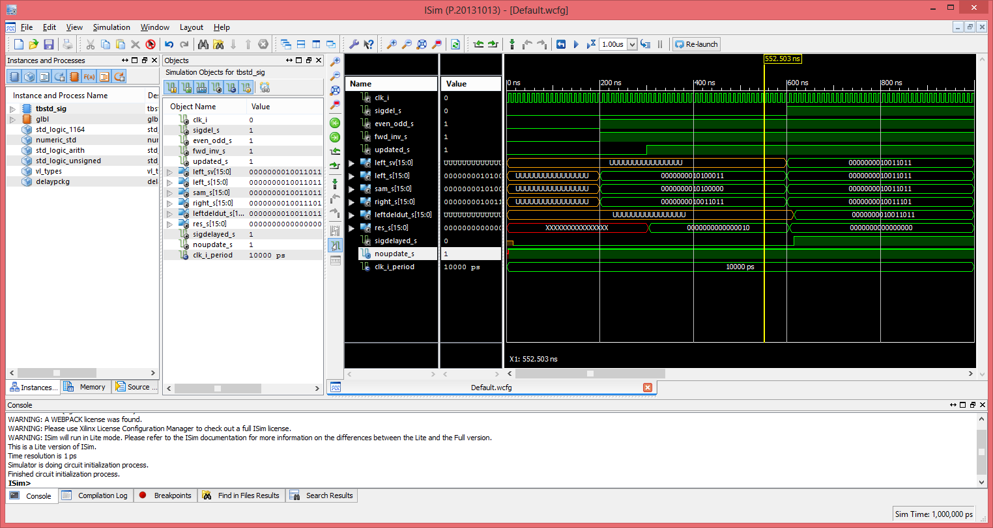
Appendix A " model_fsm.py"

sam_addr = 1

useleft = 0
for i in range(17):

if i == (sam_addr - 1):
print i, 'left'
else:
if i == ( sam_addr ):
print i, 'sam'
else:
if i == ( sam_addr + 1 ):
print i, 'right', 'left'
sam_addr = sam_addr + 2

444444444

