Starting a new project using the VHDL_LIB with a
This library was downloaded on ws009:/run/media/vidal/ef /xess/VHDL_LIB and copied to samba drive for transfer to Windows 8

commit 7aa96d35b07619f5401c669277272d5280f4bbb1
Author: Dave Vandenbout <devb@xess.com>
Date: Tue Aug 26 13:33:48 2014 -0400

Added a version of HostIoComm with a Wishbone interface to the rest of the FPGA.
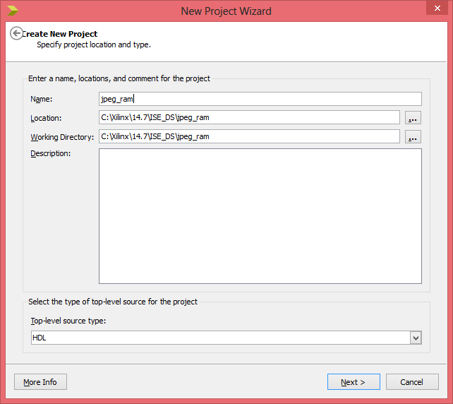

Depress Next

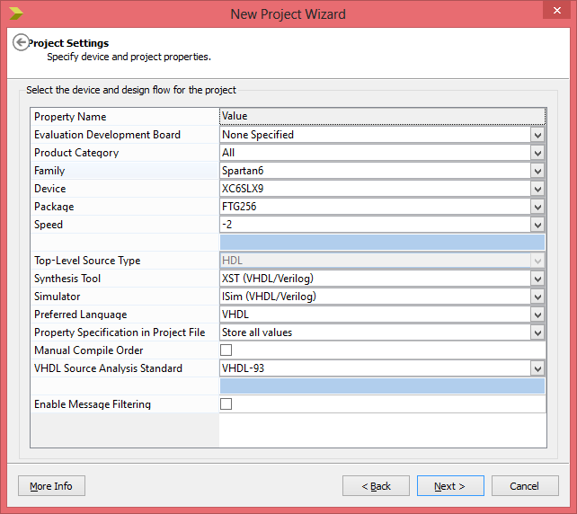

Depress Next

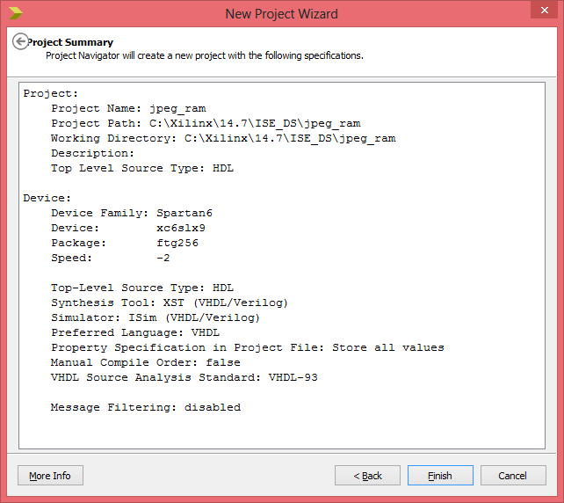

Depress Finish.
Select the **Project => New VHDL Library...** menu item.
In the **New VHDL Library** window, enter ``XESS`` as the name of the library.
Then enter the directory where these VHDL files are stored as the library location.
Finally, click **OK**.
A list of the files will be displayed.

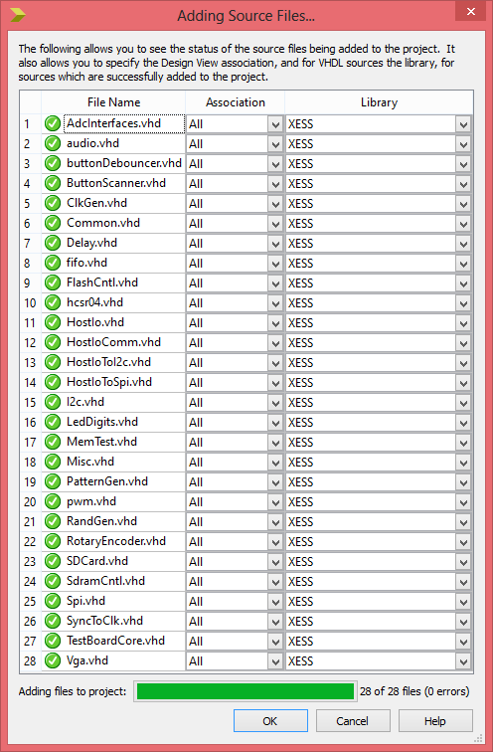
Depress OK

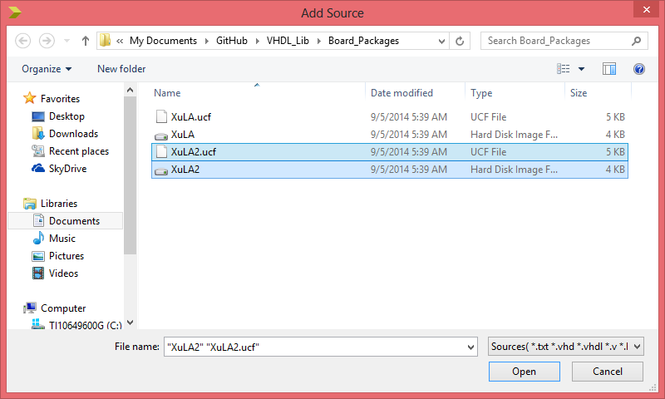Depress Open

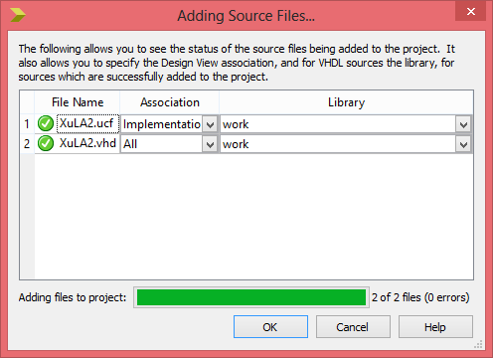

Add the top module
Then add the jpeg.vhd & pck_myhdl_09.vhd
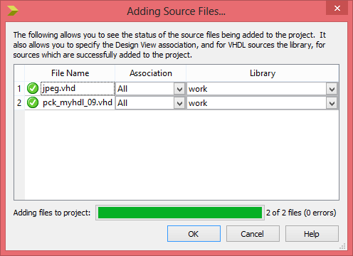

Using the XulA2.ucf from the VHDL_LIB caused many errors.
Commented out name lines in XulA2.ucf file.
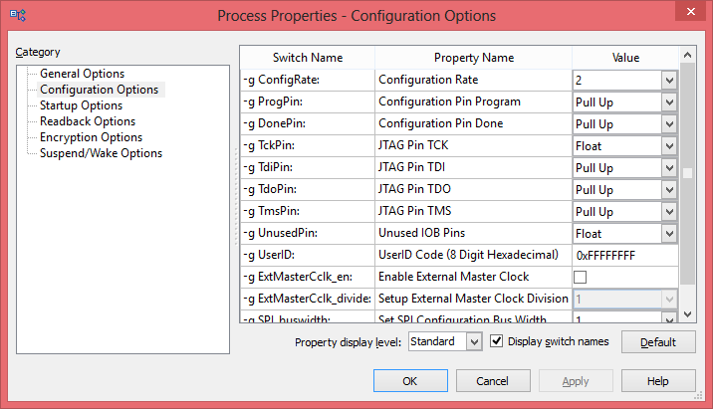

Need to set Unused IOB Pins to float.
Need to set JTAG Pin TCK to float.
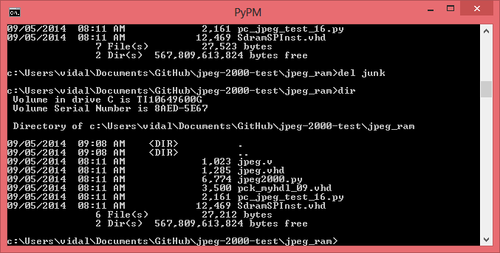

##################################################################
# This program tests the interface between the host PC and the FPGA
# on the XuLA board that has been programmed to act as a jpeg_lifting .
##################################################################

463 161 65 1 1
351
351 0

