In the simulation below:
ww = (26,18) This provides a word length of 26, 18 bits for the integer word length, and 7 bits for the fraction word length with a sign bit.
x2 = fixbv(100)[ww]
x3 = fixbv(110)[ww]
ca3 = fixbv(0.8829110762)[ww]
even_odd True
fwd_inv True
p True
d3 = (x2 + x3) * ca3
x2 = 100 = 0x3200
x3 = 110 = 0x3700
ca3 = 0.8829110762
d3 = 157.5 = 0x0276000
line 189 mult_sig.py pix.d3.next = (pix.x2 + pix.x3)*ca3
pix.x2 = 0x3200 pix.x3 = 0x3700 pix.d3 = 0x0276000
2nd example
x2 = 100 = 0x3280
x3 = 110 = 0x3780
pix.x2 = 0x3280 pix.x3 = 0x3780 pix.d3 = 0x027C000

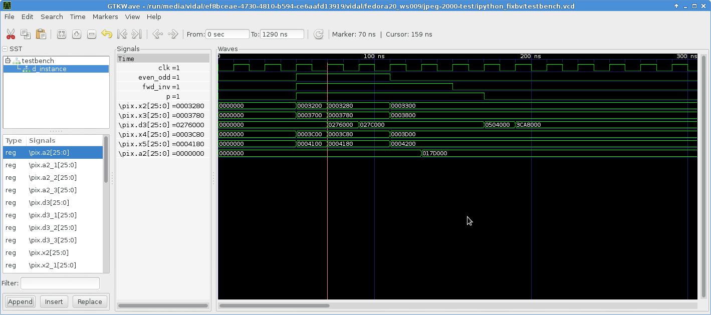
In the simulation below:
ww = (26,18) This provides a word length of 26, 18 bits for the integer word length, and 7 bits for the fraction word length with a sign bit.
x4 = fixbv(122)[ww]
x5 = fixbv(132)[ww]
ca4 = fixbv(0.4435068522)[ww]
even_odd False
fwd_inv True
p True
a2 = (x4 + x5) * ca4
x4 = 122 = 0x3D00
x5 = 132 = 0x4200

ca4 = 0.4435068522
a2 = 95.25 = 0x017D000
line 204 mult_sig.py pix.a2.next = (pix.x4 + pix.x5)*ca4

