Starting with lena_256.png


With d_a.py
Now using these equations
D[2n+1] = X[2n+1] – 0.5( X[2n] + X[2n+2])

A[2n] = X[2n] + 0.25(D[2n-1] + D[2n+1]

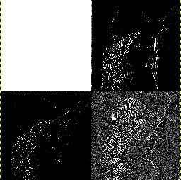

The code in d_a.py started d_a_new.py 7b98e74dca5b7d388d22504c265c2b74861a265c This attempted add the flag which separates the row processing and column processing. This improved noticed that the size was not reduced.

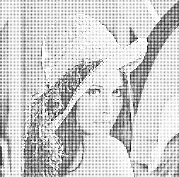

Adding the saving of s each time resulted in another improvement and the image to desired size.

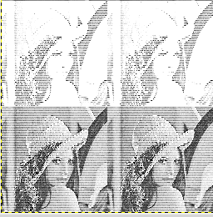

temp_bank = [[0]*width for i in range(height)]
for row in range(height):
for col in range(width):

if row % 2 == 0: # even

temp_bank[col][row/2] = s[row][col]
else: # odd

temp_bank[col][row/2 + height/2] = s[row][col]
# write temp_bank to s:
for row in range(width):
for col in range(height):
s[row][col] = temp_bank[row][col]
The follow 2 steps are the core processing.
Row processing
odd samples
s[row+2][col] += s[row+2][col] + (-0.5 * ((s[row+1][col] + s[row+3][col])))
even samples
s[row+2][col] += s[row+2][col] + .25* (s[row+1][col] + s[row+3][col])
Column processing
odd samples
s[row][col+2] += s[row][col+2] + (-0.5 * ((s[row][col+1] + s[row][col+3])))
even samples
s[row][col+2] += s[row][col+2] + .25* (s[row][col+1] + s[row][col+3])
From lifting scheme wavelet transform equations, it is
noticed that hardware design requires only adders and shifters
instead of multiply.
add_shift.py
from myhdl import *

DATA_WIDTH = 262144
d3 = Signal(intbv(0, min = -DATA_WIDTH, max = DATA_WIDTH))
a2 = Signal(intbv(0, min = -DATA_WIDTH, max = DATA_WIDTH))

x2 = Signal(intbv(164, min = -DATA_WIDTH, max = DATA_WIDTH))
x4 = Signal(intbv(156, min = -DATA_WIDTH, max = DATA_WIDTH))
x3 = Signal(intbv(164, min = -DATA_WIDTH, max = DATA_WIDTH))

print bin(x2), bin(x3), bin(x4)

def add_shift(d3,a2,x2,x3,x4):
t1 = intbv(0, min = -DATA_WIDTH, max = DATA_WIDTH)
t2 = intbv(0, min = -DATA_WIDTH, max = DATA_WIDTH)
t3 = intbv(0, min = -DATA_WIDTH, max = DATA_WIDTH)
@always_comb
def eq_logic():
t1 = x2 + x4
t1 = t1 >> 1
t2 = x3 - t1
t1 = x4 >> 2
t3 = x2 + t1 + t2

d3.next = t2
a2.next = t3

return eq_logic

d_instance = add_shift(d3,a2,x2,x3,x4)

add_shift.v
toVerilog(add_shift,d3,a2,x2,x3,x4)
// File: add_shift.v
// Generated by MyHDL 0.9dev
// Date: Sat Jun 14 08:55:26 2014

`timescale 1ns/10ps

module add_shift (
d3,
a2,
x2,
x3,
x4
);

output signed [18:0] d3;
reg signed [18:0] d3;
output signed [18:0] a2;
reg signed [18:0] a2;
input signed [18:0] x2;
input signed [18:0] x3;
input signed [18:0] x4;

always @(x2, x3, x4) begin: ADD_SHIFT_EQ_LOGIC
integer t2;
integer t3;
integer t1;
t1 = (x2 + x4);
t1 = $signed(t1 >>> 1);
t2 = (x3 - t1);
t1 = $signed(x4 >>> 2);
t3 = ((x2 + t1) + t2);
d3 = t2;
a2 = t3;
end

endmodule

