Comparing Lossy jpeg-2000
RPi2B, (RPi2B + XulA2-LX9 + ZipCpu+Xulalx25soc), AMD 2 Core, AMD 6 Core
Python, C, and
Verilog Xulalx25soc ZipCpu
06/02/16
************DRAFT************

The Python code has used has taken the appoarch of reading the data to a row x col image and processing the even samples follow by odd samples 1 column at time.
This requires 2 passes with de-interleave occuring between pass 1 and 2.

Before the next level of decomposition the resulting lower right corner needs to transferred from the lower right corner to the upper left hand corner.

Starting with a RGB image 512 x 512.
-rw-r--r-- 1 pi pi 476235 May 28 21:19 ../jpeg2k/parallel_jpeg/lena_rgb_512.png

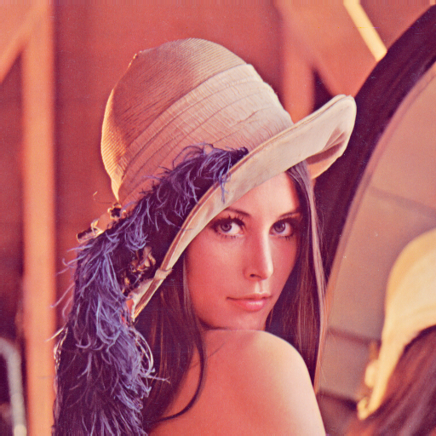
raspbian jessie RPi2B.

pi@raspberrypi2-146:~/jpeg-2000-test/ipython_fixbv $ date ; python test_jpegEnc.py ; date
Thu 2 Jun 10:54:41 UTC 2016
../jpeg2k/parallel_jpeg/lena_rgb_512.png
RGB 512 512
forward dwt using file ../jpeg2k/parallel_jpeg/lena_rgb_512.png dwt_level 3 dwt_filter [5, 3]
(512, 512)
262144
Thu 2 Jun 10:55:07 UTC 2016

Ubuntu 12.04 AMD 2 core processor

vidal@vidal-MX6438:~/wkg/jpeg-2000-test/ipython_fixbv$ date ; python test_jpegEnc.py ; date
Thu Jun 2 05:20:41 MDT 2016
../jpeg2k/parallel_jpeg/lena_rgb_512.png
RGB 512 512
forward dwt using file ../jpeg2k/parallel_jpeg/lena_rgb_512.png dwt_level 3 dwt_filter [5, 3]
(512, 512)
262144
Thu Jun 2 05:20:50 MDT 2016

Ubuntu 12.04 AMD 6 core processor
vidal@ws009:~/wkg/jpeg-2000-test/ipython_fixbv$ date ; python test_jpegEnc.py ; date
Thu Jun 2 05:47:47 MDT 2016
../jpeg2k/parallel_jpeg/lena_rgb_512.png
RGB 512 512
forward dwt using file ../jpeg2k/parallel_jpeg/lena_rgb_512.png dwt_level 3 dwt_filter [5, 3]
(512, 512)
262144
Thu Jun 2 05:47:50 MDT 2016

vidal@vidal-MX6438:~/wkg/jpeg-2000-test/ipython_fixbv$ ls -la test1_256_fwt.png -rw-rw-r-- 1 vidal vidal 11592 Jun 2 05:20 test1_256_fwt.png

