MyHDL & ISE Simulation
of signed2twoscomplement
10/23/15

The code signed2twoscomplement.py is used to convert 9 bit signed numbers to 8 bit unsigned numbers. In the test below res_o is varied from -256 to 255
signed2twoscomplement in python simulation requires steps

t.next = i

yield clk.posedge

res_o.next = t[W0:]

when negative values are used

i = 125 9 bits 001111101 8 bits 001111101

res_o = 125 z.signed() = 124 z = 124 9 bits 001111101 8 bits 01111100

i = 126 9 bits 001111110 8 bits 001111110

res_o = 126 z.signed() = 125 z = 125 9 bits 001111110 8 bits 01111101

i = 127 9 bits 001111111 8 bits 001111111

res_o = 127 z.signed() = 126 z = 126 9 bits 001111111 8 bits 01111110

i = 128 9 bits 010000000 8 bits 010000000

res_o = 128 z.signed() = 127 z = 127 9 bits 010000000 8 bits 01111111

i = 129 9 bits 010000001 8 bits 010000001

res_o = 129 z.signed() = -128 z = 128 9 bits 010000001 8 bits 10000000

i = 130 9 bits 010000010 8 bits 010000010

res_o = 130 z.signed() = -127 z = 129 9 bits 010000010 8 bits 10000001

i = 131 9 bits 010000011 8 bits 010000011

res_o = 131 z.signed() = -126 z = 130 9 bits 010000011 8 bits 10000010

In the timing chart below generated with myhdl on signed2twoscomplement.py

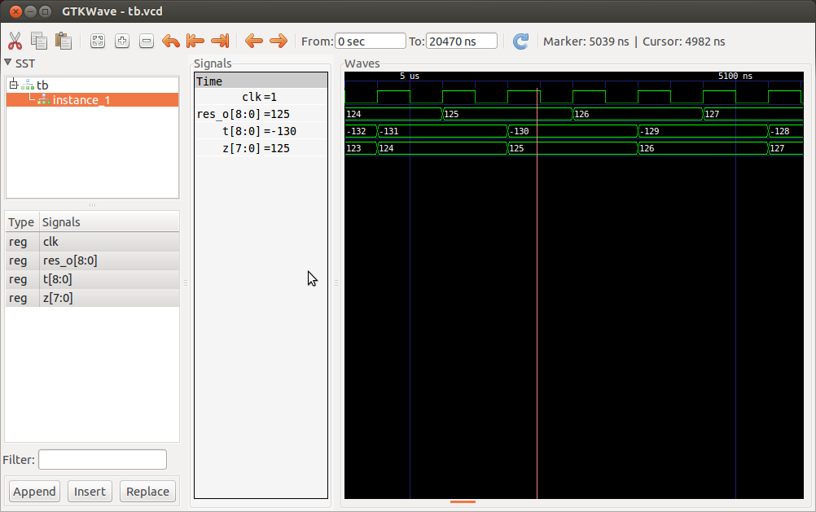
In the timing chart below generated with ISE on signed2twoscomplement_tb.v
When the values of res_o are positive the values of z are the same as the res_o values. When the values of res_o are –1 (111111111 9-bits) the value of z is 255 (11111111 8-bits), –2 (111111110 9-bits) the value of z is 254 (11111110 8-bits), –3 (111111101 9-bits) the value of z is 253 (11111101 8-bits) , and –4 (111111100 9-bits) the value of z is 252 (11111100 8-bits).

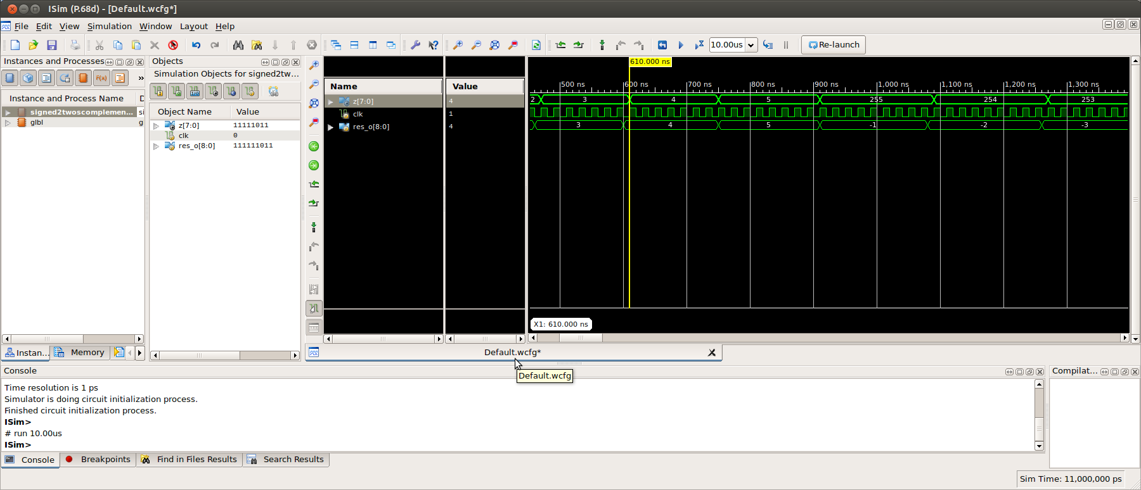
Looking at the timing chart with decimal numbers.

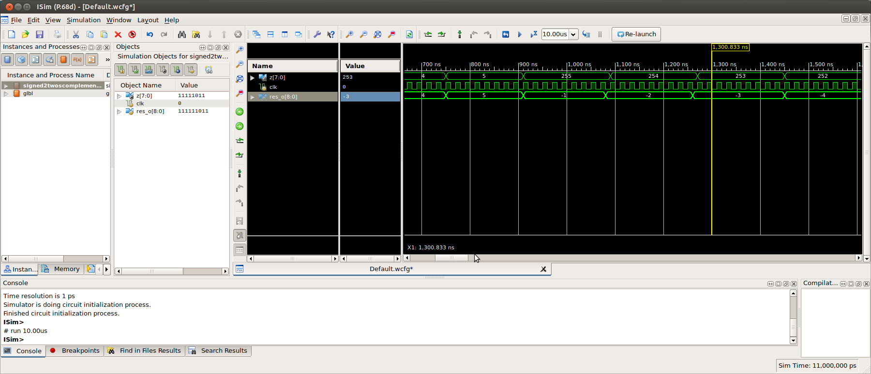

Testing Lifting Step
USB on Rpi2B XulA2
on 64 x 64 image.

Starting with the image “lena_64.png”



Load the bit file on the XulA2. The command to transfer
xsload --usb 0 --fpga pc_fast_blinker_jpeg/pc_fast_blinker_jpeg.bit
Success: Bitstream in pc_fast_blinker_jpeg/pc_fast_blinker_jpeg.bit downloaded to FPGA on XuLA2-LX9!

python fpga_img.py > log

gimp test1_64_fwt.png

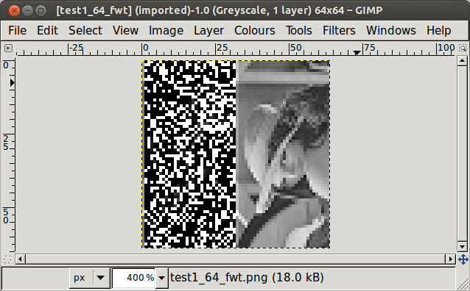
Adding the steps for the 2nd half.

even_odd(width, height)
de_interleave(height,width)
lower_upper(width, height)
If the transfer between the Rpi2B and XulA2 had worked correctly. The upper quarter would have been the image.

