SPI_Slave
XulA2-LX9 + StickIt!-MB
Raspberry Pi 2B (RPi2B)
04/09/16

Raspberry Pi 2B RPi2B provides connections to the StickIt!-MB which provides the signals needed to communicate with the XulA2-LX9 or XulA2-LX25.

An external led is connected to T4 PM2 chan 15.

Four signals provide the SPI interface to the RPi2B, pin 19 GPIO10(SPI_MOSI), pin 21 GPIO09 (SPI_MISO), pin 23 GPIO11 (SPI_CLK) and (ss) pin 29 GPIO05.
In addition the rhea package creates the xula2.ucf below.

#
NET "miso" LOC = "F1" ;
NET "led" LOC = "T4" ;
NET "sck" LOC = "H2" ;
NET "clock" LOC = "A9" ;
NET "ss" LOC = "H1" ;
NET "mosi" LOC = "F2" ;
#
NET "clock" TNM_NET = "clock";
TIMESPEC "TS_clock" = PERIOD "clock" 83.3333333 ns HIGH 50%;
#
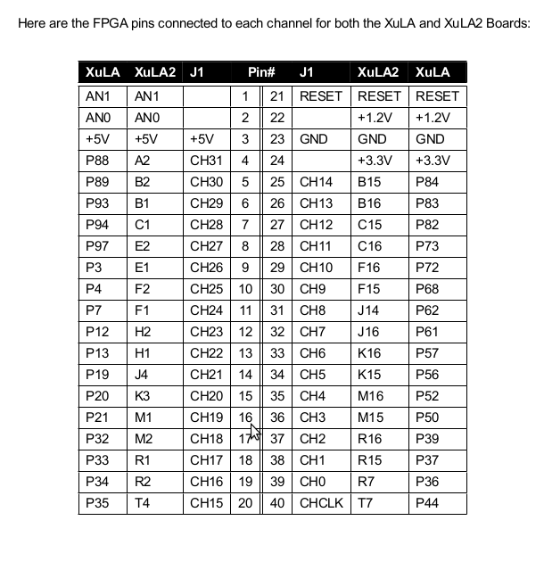

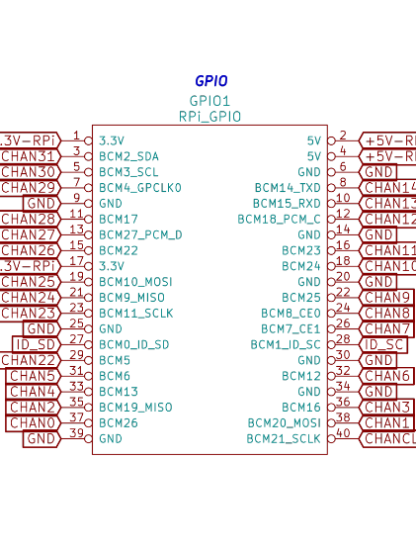
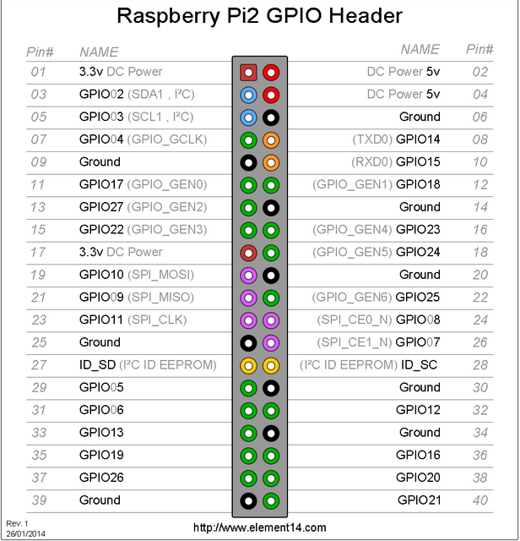
Creating a software reset for the XulA2-LX with StickIt!-MB.

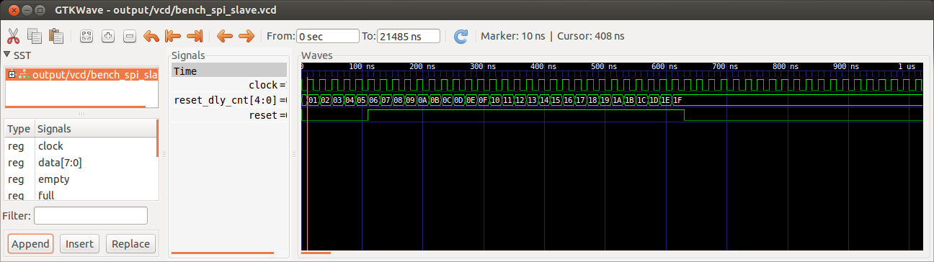
SPI_Slave software is provided with rhea package.

from rhea.system import Global, Clock, Reset, FIFOBus, Signals
/home/vidal/wkg/rhea/rhea/system/glbl.py
Global
/home/vidal/wkg/rhea/rhea/system/clock.py
Clock
/home/vidal/wkg/rhea/rhea/system/reset.py
Reset
/home/vidal/wkg/rhea/rhea/system/stream/fifobus.py
FIFOBus
/home/vidal/wkg/rhea/rhea/system/hwtypes.py
Signals
from rhea.cores.spi import SPIBus, spi_slave_fifo
/home/vidal/wkg/rhea/rhea/cores/spi/spi.py
SPIBus
/home/vidal/wkg/rhea/rhea/cores/spi/spi_fifo_slave.py
spi_slave_fifo
from rhea.cores.spi import spi_controller
/home/vidal/wkg/rhea/rhea/cores/spi/spi.py
spi_controller

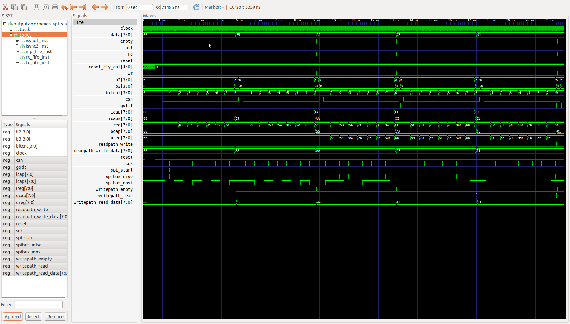

The StickIt!-MB provides a 3 PMOD connectors a 40 pin connector to the RPi2B. In addition the a socket to support either a XulA2-LX9 or XulA2-LX25 FPGA.

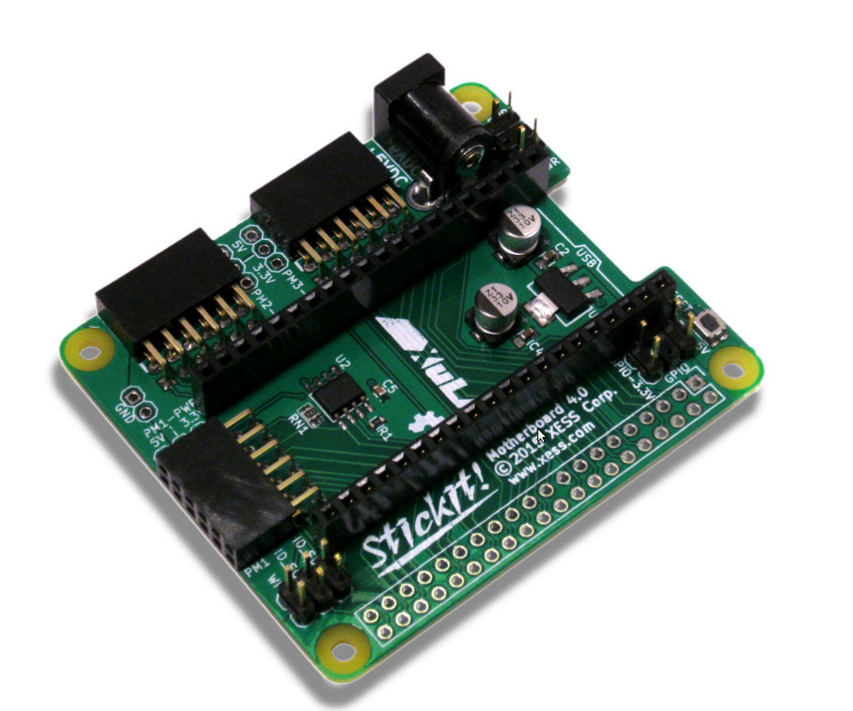
XulA2 mounted on StickIt!-MB.

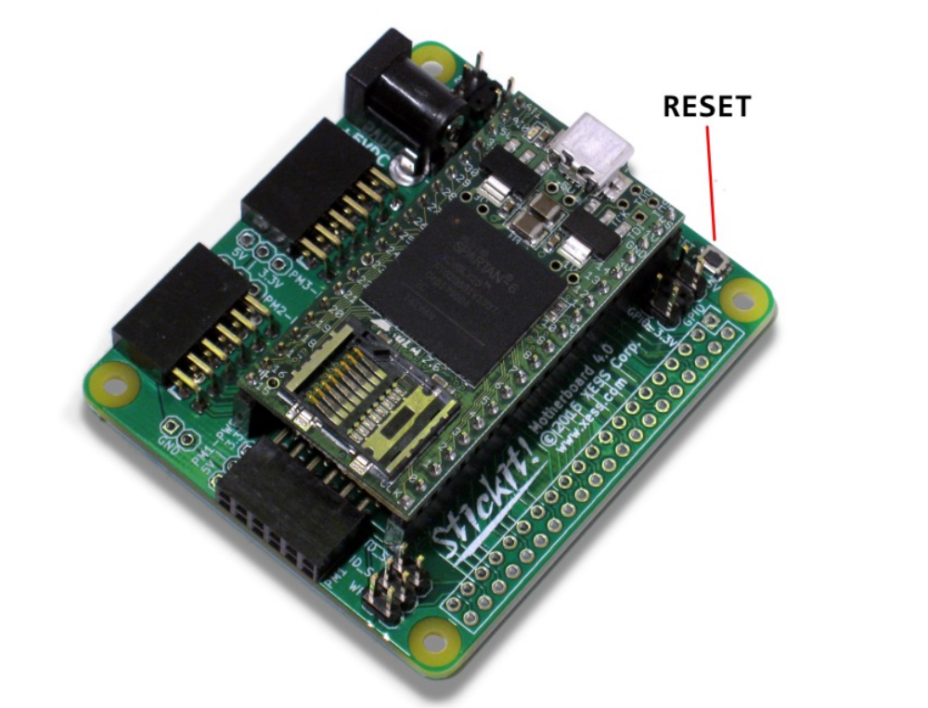

Create a bit file to make the xula2 FPGA provide a jumper on
pins 19 GPIO10(SPI_MOSI) & pin 21 GPIO09 (SPI_MISO).

Set the PATH to ISE WEB PACK

. /opt/Xilinx/14.6/ISE_DS/settings64.sh

vidal@ws009:~/wkg/jpeg-2000-test/xula2_fpga/jumper_tests/spi$
python jumper_xula2_spi.py –build

vidal@ws009:~/wkg/jpeg-2000-test/xula2_fpga/jumper_tests/spi$ cp xilinx/xula2.bit xilinx/jumper_spi.bit

vidal@ws009:~/wkg/jpeg-2000-test/xula2_fpga/jumper_tests/spi$
python jumper_xula2_spi.py –build

pi@raspberrypi2-146 ~/bcm2835-1.45/examples/spi $
xsload --usb 0 --fpga ~/jpeg-2000/xula2_fpga/
jumper_tests/spi/xilinx/jumper_spi.bit

pi@raspberrypi2-146 ~/bcm2835-1.45/examples/spi $
gcc -o spi spi.c -l bcm2835

pi@raspberrypi2-146 ~/bcm2835-1.45/examples/spi $ sudo ./spi
Sent to SPI: 0x23. Read back from SPI: 0x23.
pi@raspberrypi2-146 ~/bcm2835-1.45/examples/spi

Appendix C. XulA2-LX25 & XulA2-LX9 freatures.
LX25
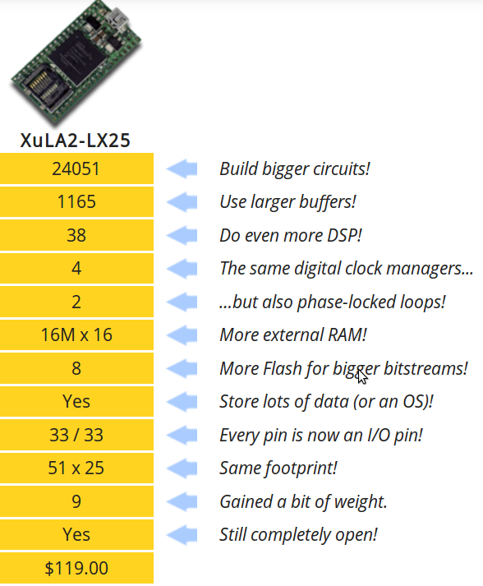

LX9

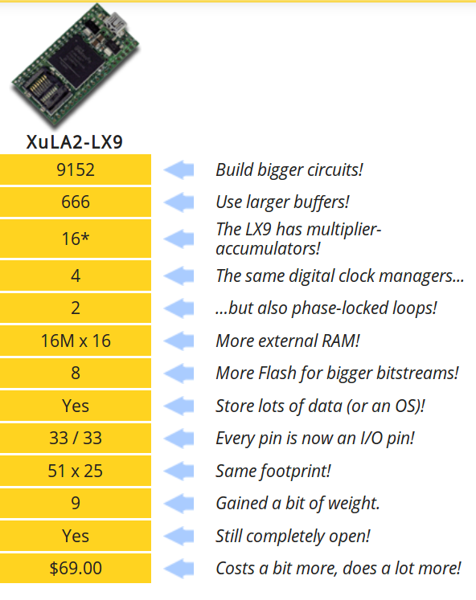

LX25

- Open-source design
- XC6SLX25 FPGA
- 32 MByte SDRAM
- 8 Mbit Flash
- microSD card socket
- 3.3 & 1.2V regulators
- 40-pin interface
- 12 MHz oscillator
- PIC 18F14K50 micro
- USB 2.0 port
- Auxiliary JTAG port
- Works with the XSTOOLs software
- Works with XILINX ISE and WebPACK
- Works with XILINX iMPACT and ChipScope (requires Xilinx JTAG cable)

LX9

- Open-source design
- XC6SLX9 FPGA
- 32 MByte SDRAM
- 8 Mbit Flash
- microSD card socket
- 3.3 & 1.2V regulators
- 40-pin interface
- 12 MHz oscillator
- PIC 18F14K50 micro
- USB 2.0 port
- Auxiliary JTAG port
- Works with the XSTOOLs software
- Works with XILINX ISE and WebPACK
- Works with XILINX iMPACT and ChipScope (requires Xilinx JTAG cable)

