TFTP Data Transfer Test
between Rpi3B running Ultibo & Rpi2B
01/12/17

Retrieve the code from github. “git clone https://github.com/pjde/ultibo-tftp.git”

Add the fpc ultibo edition path to your PATH..

“export PATH=/home/pi/ultibo/core/fpc/bin:$PATH”

Compile the Pascal code uTFTP.pas found at Appendix A and TFTPTest.lpr found at Appendix B.

“fpc -B -Tultibo -Parm -CpARMV7A -WpRPI3B @/home/pi/ultibo/core/fpc/bin/rpi3.cfg -O2 TFTPTest.lpr”

Boot the Rpi3 with TFTP program.

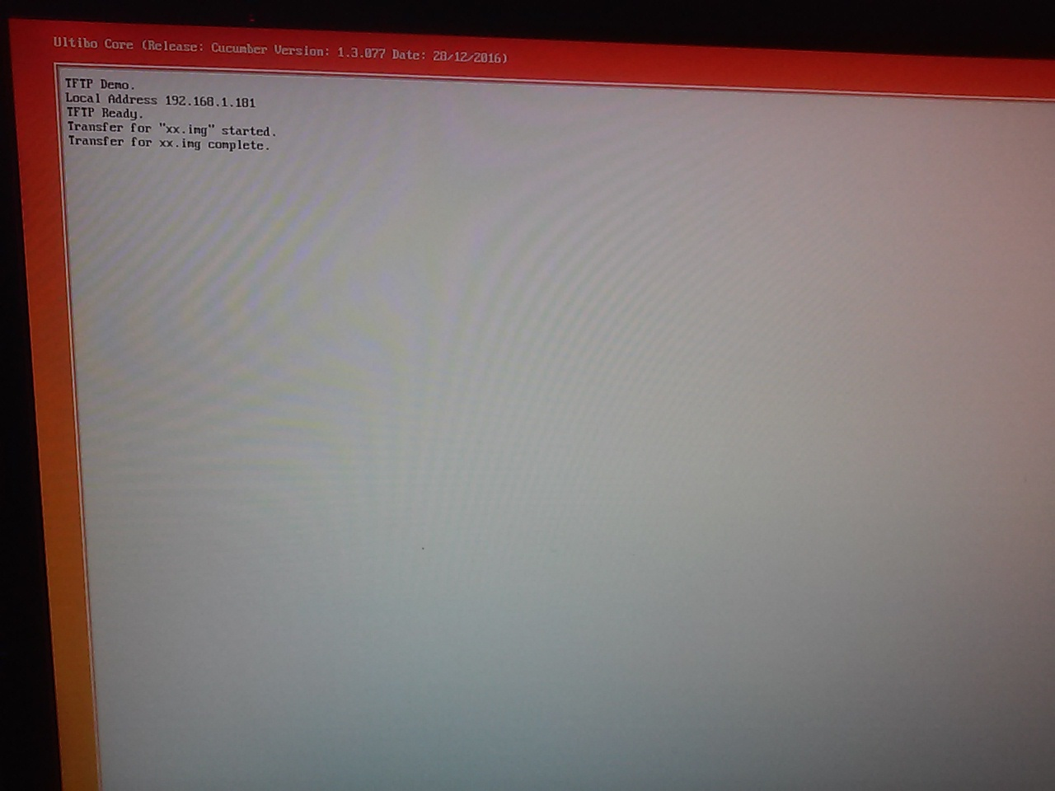

pi@raspberrypi2-142:~/test_ultibo/ultibo-tftp $ tftp 192.168.1.181
tftp> binary
tftp> trace
Packet tracing on.
tftp> put kernel7.img xx.img
sent WRQ <file=xx.img, mode=octet>
received ACK <block=0>
sent DATA <block=1, 512 bytes>
received ACK <block=1>
sent DATA <block=2, 512 bytes>

sent DATA <block=4518, 32 bytes>
received ACK <block=4518>
Sent 2312736 bytes in 160.0 seconds

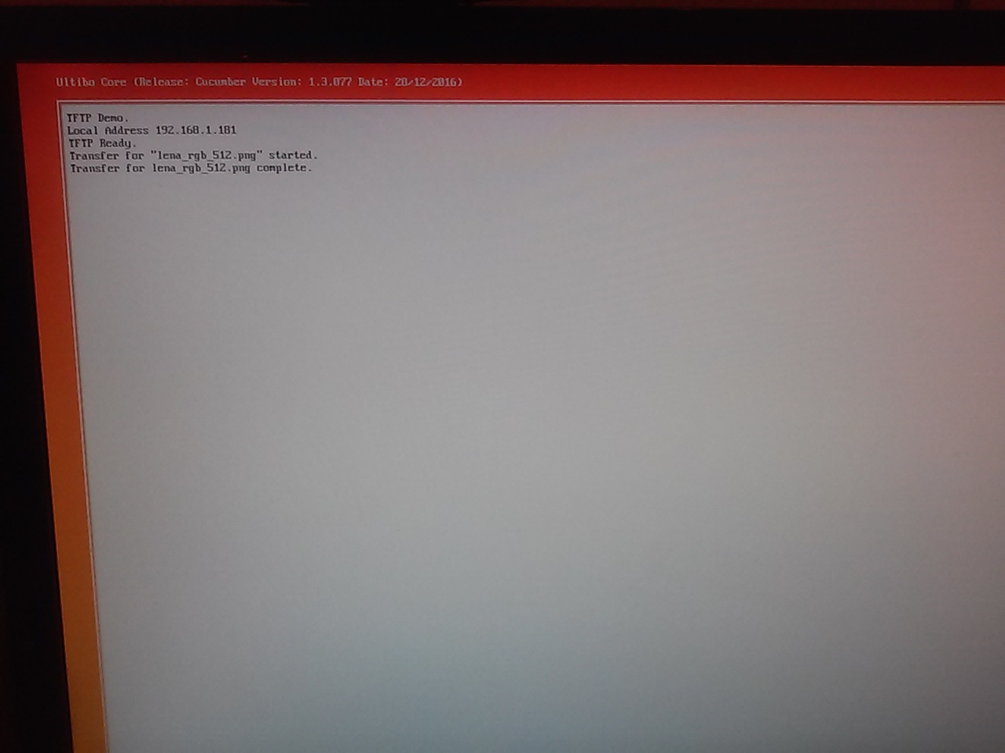
pi@raspberrypi2-142:~/test_ultibo/LiBc $ tftp 192.168.1.181
tftp> binary
tftp> put lena_rgb_512.png
Sent 476235 bytes in 54.4 seconds

Compressed the image lena_rgb_512.png
pi@raspberrypi2-142:~/test_ultibo/LiBc $ opj_compress -r 80 -mct 1 -i lena_rgb_512.png -o 512.jp2

[INFO] tile number 1 / 1
[INFO] Generated outfile 512.jp2
encode time: 4040 ms
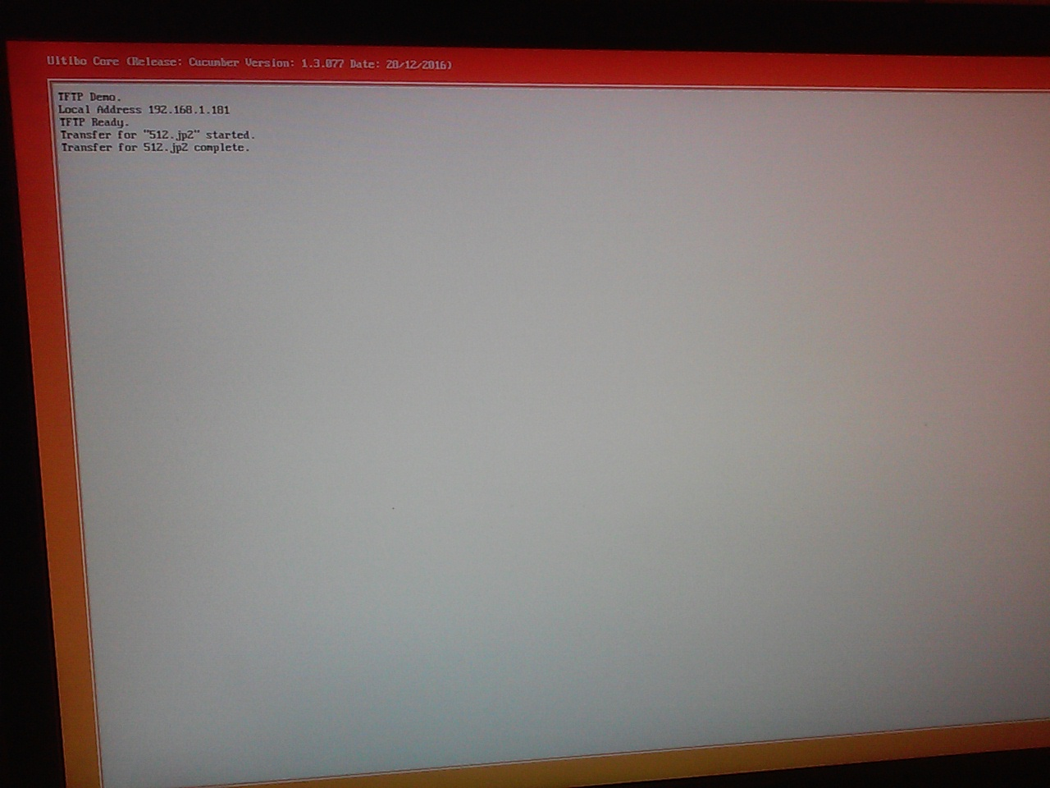

pi@raspberrypi2-142:~/test_ultibo/LiBc $ tftp 192.168.1.181
tftp> binary
tftp> put 512.jp2
Sent 9746 bytes in 5.1 seconds

Appendix A

unit uTFTP;

{$mode objfpc}{$H+}

{ Simple Trival FTP Server based on RFC 1350

Ultibo (C) 2015 - SoftOz Pty Ltd. LGPLv2.1 with static linking exception
FPC (c) 1993-2015 Free Pascal Team. Modified Library GNU Public License
Lazarus (c) 1993-2015 Lazarus and Free Pascal Team. Modified Library GNU Public License

Other bits (c) 2016 pjde LGPLv2.1 with static linking exception
}

interface

uses
GlobalConfig,
GlobalConst,
Platform,
Threads,
SysUtils,
Classes,
Winsock2;

const
// TFTP opcodes
TFTP_RRQ = 1;
TFTP_WRQ = 2;
TFTP_DATA = 3;
TFTP_ACK = 4;
TFTP_ERROR = 5;
TFTP_OACK = 6;

// TFTP error codes
erUNDEFINED = 0;
erFILE_NOT_FOUND = 1;
erACCESS_VIOLATION = 2;
erALLOCATION_EXCEEDED = 3;
erILLEGAL_OPERATION = 4;
erUNKNOWN_TRANSFER_ID = 5;
erFILE_ALREADY_EXISTS = 6;
erNO_SUCH_USER = 7;
erOPTION_NEGOTIATION_FAILED = 8;

type
TMsgEvent = procedure (Sender : TObject; s : string);

TTFTPListener = class;

{ TFTPTransferThread }

TFTPTransferThread = class (TWinsock2UDPServerThread)
FStream : TMemoryStream;
function ReadByte : byte;
function ReadWord : Word;
function ReadString : string;
function Remaining : int64;
constructor Create (aListener : TWinsock2UDPServer);
destructor Destroy; override;
end;

{ TTransfer }

TTransfer = class
FileName : string;
FStream : TMemoryStream;
FListener : TTFTPListener;
Op : word;
TID : Word;
BlockNo : Word;
SockAddr : PSockAddr;
SockAddrLength : integer;
constructor Create (aListener : TTFTPListener);
destructor Destroy; override;
end;

{ TTFTPListener }

TTFTPListener = class (TWinsock2UDPListener)
FOnMsg : TMsgEvent;
FRebootOnImg : boolean;
private
TxStream : TMemoryStream;
procedure SetOnMsg (Value : TMsgEvent);
procedure AddByte (b : byte);
procedure AddWord (w : Word);
procedure AddString (s : string);
protected
Transfers : TList;
function GetTransfer (byID : Word) : TTransfer;
procedure RemoveTransfer (byID : Word); overload;
procedure RemoveTransfer (byTransfer : TTransfer); overload;
procedure DoMsg (s : string);
function DoExecute (aThread : TWinsock2UDPServerThread) : Boolean; override;
procedure DoCreateThread (aServer : TWinsock2UDPServer; var aThread : TWinsock2UDPServerThread);
public
constructor Create;
destructor Destroy; override;
procedure SendError (aTransfer : TTransfer; ErrCode : Word; ErrMsg : string); overload;
procedure SendError (aServer : TWinsock2UDPServer; ErrCode : Word; ErrMsg : string); overload;
procedure SendAck (aTransfer : TTransfer; BlockNo : Word);
procedure SendDataBlock (aTransfer : TTransfer; BlockNo : Word);
property OnMsg : TMsgEvent read FOnMsg write SetOnMsg;
property RebootOnImg : boolean read FRebootOnImg write FRebootOnImg;
end;

procedure SetOnMsg (MsgProc : TMsgEvent);

var
TFTP : TTFTPListener = nil;

implementation

procedure SetOnMsg (MsgProc : TMsgEvent);
begin
if Assigned (TFTP) then TFTP.OnMsg := MsgProc;
end;

{ TTransfer }

constructor TTransfer.Create (aListener : TTFTPListener);
begin
FStream := TMemoryStream.Create;
FListener := aListener;
FileName := '';
Op := 0;
TID := 0;
BlockNo := 0;
SockAddr := nil;
SockAddrLength := 0;
end;

destructor TTransfer.Destroy;
begin
FStream.Free;
if SockAddr <> nil then
begin
if FListener <> nil then FListener.ReleaseAddress (SockAddr, SockAddrLength);
SockAddr := nil;
end;
inherited Destroy;
end;

{ TFTPTransferThread }

function TFTPTransferThread.ReadByte: byte;
begin
Result := 0;
if Remaining > 0 then FStream.Read (Result, 1);
end;

function TFTPTransferThread.ReadWord : Word;
begin
Result := ReadByte * $100 + ReadByte;
end;

function TFTPTransferThread.ReadString : string;
var
ch : Char;
begin
Result := '';
ch := '~';
while (Remaining > 0) and (ch <> #0) do
begin
FStream.Read (ch, 1);
if ch <> #0 then Result := Result + ch;
end;
end;

function TFTPTransferThread.Remaining: int64;
begin
Result := FStream.Size - FStream.Position;
end;

constructor TFTPTransferThread.Create (aListener : TWinsock2UDPServer);
begin
inherited Create (aListener);
FStream := TMemoryStream.Create;
end;

destructor TFTPTransferThread.Destroy;
begin
FStream.Free;
inherited Destroy;
end;

constructor TTFTPListener.Create;
begin
inherited Create;
Threads.Min := 5;
Threads.Max := 10;
BufferSize := 1024;
BoundPort := 69;
Transfers := TList.Create;
FRebootOnImg := true;
FOnMsg := nil;
{ Define custom thread }
OnCreateThread := @DoCreateThread;
TxStream := TMemoryStream.Create;
end;

destructor TTFTPListener.Destroy;
var
i : integer;
begin
for i := 0 to Transfers.Count - 1 do
TTransfer (Transfers[i]).Free;
Transfers.Free;
TxStream.Free;
inherited Destroy;
end;

procedure TTFTPListener.SendError (aTransfer : TTransfer; ErrCode : Word;
ErrMsg : string);
var
count : integer;
begin
TxStream.Clear;
count := 0;
AddWord (TFTP_ERROR);
AddWord (ErrCode);
AddString (ErrMsg);
SendToSocket (aTransfer.SockAddr, aTransfer.SockAddrLength, TxStream.Memory, TxStream.Size, count);
end;

procedure TTFTPListener.SendError (aServer : TWinsock2UDPServer; ErrCode : Word;
ErrMsg : string);
begin
TxStream.Clear;
AddWord (TFTP_ERROR);
AddWord (ErrCode);
AddString (ErrMsg);
SendDataTo (aServer.PeerAddress, aServer.PeerPort, TxStream.Memory, TxStream.Size);
end;

procedure TTFTPListener.SendAck (aTransfer : TTransfer; BlockNo : Word);
var
count : integer;
begin
TxStream.Clear;
count := 0;
AddWord (TFTP_ACK);
AddWord (BlockNo);
aTransfer.BlockNo := BlockNo;
SendToSocket (aTransfer.SockAddr, aTransfer.SockAddrLength, TxStream.Memory, TxStream.Size, count);
end;

procedure TTFTPListener.SendDataBlock (aTransfer: TTransfer; BlockNo : Word);
var
count : integer;
x, l : int64;
begin
TxStream.Clear;
count := 0;
AddWord (TFTP_DATA);
AddWord (BlockNo);
x := (int64 (BlockNo) - 1) * 512;
if (x >= 0) and (x < aTransfer.FStream.Size) then
begin
aTransfer.FStream.Seek (x, soFromBeginning);
l := aTransfer.FStream.Size - aTransfer.FStream.Position;
if l > 512 then l := 512;
TxStream.CopyFrom (aTransfer.FStream, l);
end;
aTransfer.BlockNo := BlockNo;
SendToSocket (aTransfer.SockAddr, aTransfer.SockAddrLength, TxStream.Memory, TxStream.Size, count);
end;

function display_string (s : string) : string;
var
i : integer;
begin
Result := '';
for i := 1 to length (s) do
if s[i] in [' '..'~'] then
Result := Result + s[i]
else
Result := Result + '[' + IntToHex (ord (s[i]), 2) + ']';
end;

function ErToStr (er : Word) : string;
begin
case er of
erUNDEFINED : Result := 'Undefined';
erFILE_NOT_FOUND : Result := 'File not found';
erACCESS_VIOLATION : Result := 'Access violation';
erALLOCATION_EXCEEDED : Result := 'Allocation exceeded';
erILLEGAL_OPERATION : Result := 'Illegal Operation';
erUNKNOWN_TRANSFER_ID : Result := 'Unknown transfer id';
erFILE_ALREADY_EXISTS : Result := 'File already exists';
erNO_SUCH_USER : Result := 'No such user';
erOPTION_NEGOTIATION_FAILED : Result := 'Option negotiation failed';
else Result := 'Unknown ' + IntToStr (er);
end;
end;

procedure TTFTPListener.SetOnMsg (Value : TMsgEvent);
begin
FOnMsg := Value;
DoMsg ('TFTP Ready.');
end;

procedure TTFTPListener.AddByte (b: byte);
begin
TxStream.Write (b, 1);
end;

procedure TTFTPListener.AddWord (w : Word);
begin
AddByte (w div $100);
AddByte (w mod $100);
end;

procedure TTFTPListener.AddString (s : string);
begin
TxStream.Write (s[1], length (s));
AddByte (0);
end;

function TTFTPListener.GetTransfer (byID : Word): TTransfer;
var
i : integer;
begin
for i := 0 to Transfers.Count - 1 do
begin
Result := TTransfer (Transfers[i]);
if Result.TID = byID then exit;
end;
Result := nil;
end;

procedure TTFTPListener.RemoveTransfer (byID : Word);
var
aTransfer : TTransfer;
begin
aTransfer := GetTransfer (byID);
RemoveTransfer (aTransfer);
end;

procedure TTFTPListener.RemoveTransfer (byTransfer : TTransfer);
begin
if byTransfer <> nil then
begin
Transfers.Remove (byTransfer);
byTransfer.Free;
end;
end;

procedure TTFTPListener.DoMsg (s: string);
begin
if Assigned (FOnMsg) then FOnMsg (Self, s);
end;

function TTFTPListener.DoExecute (aThread : TWinsock2UDPServerThread) : Boolean;
var
op, er, bn : Word;
rm : int64;
fn, mode, msg : string;
aTransferThread : TFTPTransferThread;
aTransfer : TTransfer;
aFile : TFileStream;
begin
Result := inherited DoExecute (aThread);
if not Result then exit;
if aThread.Server.Count > 0 then
begin
aTransfer := GetTransfer (aThread.Server.PeerPort);
aTransferThread := TFTPTransferThread (aThread);
aTransferThread.FStream.Clear;
aTransferThread.FStream.Write (aThread.Server.Data^, aThread.Server.Count);
aTransferThread.FStream.Seek (0, soFromBeginning);
op := aTransferThread.ReadWord;
case op of
TFTP_RRQ :
begin
fn := aTransferThread.ReadString;
mode := aTransferThread.ReadString;
DoMsg ('Transfer for ' + fn + ' started.');
if aTransfer = nil then
begin
aTransfer := TTransfer.Create (Self);
aTransfer.TID := aThread.Server.PeerPort;
Transfers.Add (aTransfer);
end;
aTransfer.SockAddrLength := 0;
aTransfer.SockAddr := AddressToSockAddr (aThread.Server.PeerAddress, aTransfer.SockAddrLength);
PortToSockAddr (aThread.Server.PeerPort, aTransfer.SockAddr, aTransfer.SockAddrLength);
if FileExists (fn) then
begin
aTransfer.Op := op;
aTransfer.FileName := fn;
aTransfer.FStream.Clear;
try
aFile := TFileStream.Create (fn, fmOpenRead);
aTransfer.FStream.CopyFrom (aFile, 0);
aFile.Free;
aTransfer.FStream.Seek (0, soFromBeginning);
SendDataBlock (aTransfer, 1)
except
DoMsg ('Transfer for ' + fn + ' failed. - error opening file.');
SendError (aTransfer, erACCESS_VIOLATION, 'error opening ' + fn);
end;
end
else
begin
SendError (aTransfer, erFILE_NOT_FOUND, fn);
DoMsg ('Transfer for ' + fn + ' failed. - file for found.');
end;
end;
TFTP_WRQ :
begin
fn := aTransferThread.ReadString;
mode := aTransferThread.ReadString;
DoMsg ('Transfer for "' + fn + '" started.');
if aTransfer = nil then
begin
aTransfer := TTransfer.Create (Self);
aTransfer.TID := aThread.Server.PeerPort;
Transfers.Add (aTransfer);
end;
aTransfer.SockAddrLength := 0;
aTransfer.SockAddr := AddressToSockAddr (aThread.Server.PeerAddress, aTransfer.SockAddrLength);
PortToSockAddr (aThread.Server.PeerPort, aTransfer.SockAddr, aTransfer.SockAddrLength);
if mode = 'octet' then
begin
aTransfer.Op := op;
aTransfer.FileName := fn;
aTransfer.FStream.Clear;
aTransfer.BlockNo := 0;
SendAck (aTransfer, 0);
end
else
SendError (aTransfer, erOPTION_NEGOTIATION_FAILED, mode);
end;
TFTP_DATA :
begin
bn := aTransferThread.ReadWord;
rm := aTransferThread.Remaining;
if aTransfer = nil then
SendError (aThread.Server, erUNKNOWN_TRANSFER_ID, IntToStr (aThread.Server.PeerPort))
else
begin
aTransfer.BlockNo := bn;
aTransfer.FStream.CopyFrom (aTransferThread.FStream, rm);
SendAck (aTransfer, bn);
if rm < 512 then
begin
aTransfer.FStream.Seek (0, soFromBeginning);
DoMsg ('Transfer for ' + aTransfer.FileName + ' complete.');
if FileExists (aTransfer.FileName) then DeleteFile (aTransfer.FileName);
try
aFile := TFileStream.Create (aTransfer.FileName, fmCreate);
aTransfer.FStream.Seek (0, soFromBeginning);
aFile.CopyFrom (aTransfer.FStream, aTransfer.FStream.Size);
aFile.Free;
if (aTransfer.FileName = 'kernel7.img') or (aTransfer.FileName = 'kernel.img') then
begin
DoMsg ('Restarting.');
SystemRestart (0);
end;
except
SendError (aTransfer, erACCESS_VIOLATION, 'error creating ' + aTransfer.FileName);
end;
RemoveTransfer (aTransfer);
end;
end;
end;
TFTP_ACK :
begin
bn := aTransferThread.ReadWord;
if aTransfer = nil then
SendError (aThread.Server, erUNKNOWN_TRANSFER_ID, IntToStr (aThread.Server.PeerPort))
else
begin
if (int64 (bn) * 512) >= aTransfer.FStream.Size then
begin
DoMsg ('Transfer for ' + aTransfer.FileName + ' complete.');
RemoveTransfer (aTransfer); // maybe should dally
end
else
SendDataBlock (aTransfer, bn + 1);
end;
end;
TFTP_ERROR :
begin
er := aTransferThread.ReadWord;
msg := aTransferThread.ReadString;
DoMsg ('Error ' + ErToStr (er) + ' - ' + msg);
RemoveTransfer (aTransfer);
end
else
SendError (aThread.Server, erILLEGAL_OPERATION, IntToStr (op)); // unknown opcode
end;
end;
end;

procedure TTFTPListener.DoCreateThread (aServer: TWinsock2UDPServer;
var aThread: TWinsock2UDPServerThread);
begin
aThread := TFTPTransferThread.Create (aServer);
end;

procedure TFTPStart;
var
WSAData : TWSAData;
begin
WSADATA.wVersion := 0; // prevent not initialsed warning
FillChar (WSAData, SizeOf (TWSAData), 0);
if WSAStartup (WINSOCK_VERSION, WSAData) = ERROR_SUCCESS then
begin
TFTP := TTFTPListener.Create;
TFTP.Active := true;
end;
end;

initialization

TFTPStart;

end.

Appendix B

program TFTPTest;

{$mode objfpc}{$H+}

uses
RaspberryPi3,
GlobalConfig,
GlobalConst,
GlobalTypes,
Platform,
Threads,
SysUtils,
Classes,
Ultibo,
Console,
Winsock2,
Shell,
uTFTP;

var
IPAddress : string;
WindowHandle : TWindowHandle;

function WaitForIPComplete : string;
var
TCP : TWinsock2TCPClient;
begin
TCP := TWinsock2TCPClient.Create;
Result := TCP.LocalAddress;
if (Result = '') or (Result = '0.0.0.0') or (Result = '255.255.255.255') then
begin
while (Result = '') or (Result = '0.0.0.0') or (Result = '255.255.255.255') do
begin
sleep (1000);
Result := TCP.LocalAddress;
end;
end;
TCP.Free;
end;

procedure Msg (Sender : TObject; s : string);
begin
ConsoleWindowWriteLn (WindowHandle, s);
end;

procedure WaitForSDDrive;
begin
while not DirectoryExists ('C:\') do sleep (500);
end;

begin
// open console window
WindowHandle := ConsoleWindowCreate (ConsoleDeviceGetDefault, CONSOLE_POSITION_FULL, false);
ConsoleWindowWriteLn (WindowHandle, 'TFTP Demo.');
// wait for IP address and SD Card to be initialised.
WaitForSDDrive;
IPAddress := WaitForIPComplete;
ConsoleWindowWriteLn (WindowHandle, 'Local Address ' + IPAddress);
SetOnMsg (@Msg);
ThreadHalt (0);
end.

