Modifications to x ver 53 xulalx25soc UART
and ver 137 zipcpu
for Connections to RPi2B UART
06/01/16

Starting with ver 53 xulalx25soc and ver 137 zipcpu

Path: .
URL: http://opencores.org/ocsvn/xulalx25soc/xulalx25soc/trunk
Repository Root: http://opencores.org/ocsvn/xulalx25soc
Repository UUID: 6dd62048-26e6-457e-a111-74efc207c9ac
Revision: 53
Node Kind: directory
Schedule: normal
Last Changed Author: dgisselq
Last Changed Rev: 53
Last Changed Date: 2016-04-21 18:35:56 -0600 (Thu, 21 Apr 2016)
The xulalx25soc xula.ucf was configured to use the pins needed to work with RPi2B UART.
RPi2B UART pins
BCM14_TXD CH14 B15 RPi_GPIO 8 is the signal from the RPi2B. [1] pg.14
BCM15_RXD CH13 B16 RPi_GPIO 10 is the signal to the RPi2B. [1] pg.14

Path: .
URL: http://opencores.org/ocsvn/zipcpu/zipcpu/trunk
Repository Root: http://opencores.org/ocsvn/zipcpu
Repository UUID: 753a1494-afa9-4eb1-9a3f-b6aaa4ffd0d3
Revision: 137
Node Kind: directory
Schedule: normal
Last Changed Author: dgisselq
Last Changed Rev: 137
Last Changed Date: 2016-04-22 15:23:26 -0600 (Fri, 22 Apr 2016)
xula2.v
output bcm15_rxd;
input bcm14_txd;

xula2.ucf
NET "bcm15_rxd" LOC = "B16" ;
NET "bcm14_txd" LOC = "B15" ;

The original xula.ucf

NET i_rx_uart LOC = R7;
NET o_tx_uart LOC = R2;
NET i_gpio<12> LOC = B16;
NET i_gpio<13> LOC = B15;

toplevel.v
input i_rx_uart;
output wire o_tx_uart;

Required changes to xula.ucf

NET i_rx_uart LOC = B15;
NET o_tx_uart LOC = B16;
NET i_gpio<12> LOC = R2;
NET i_gpio<13> LOC = R7;

. setzipcpuPath.sh

sudo stty -F /dev/ttyAMA0 9600 -ixon -crtscts

xsload --usb 0 --fpga ~/toplevel_B15_i_rx_uartB16_o_tx_uart.bit

minicom -b 9600 -o -D /dev/ttyAMA0

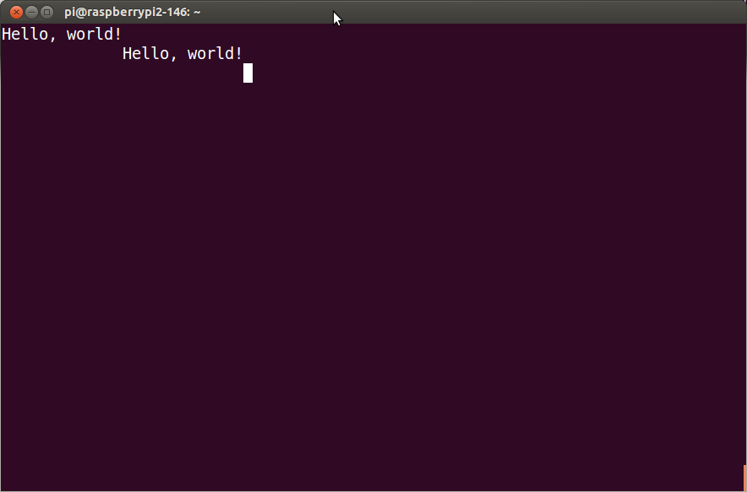
The Hello world! Starts following the commands below.

cd test_zipcpu

ziprun h2

wbregs cpu 0

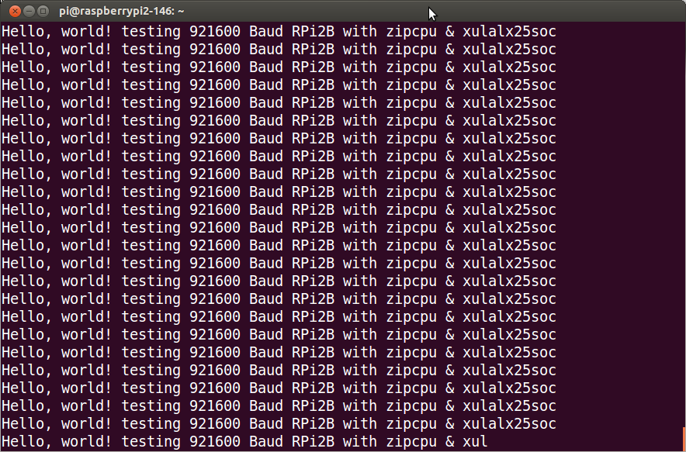
Modifing the h2.c code increases the UART Baud rate to 921600 by changing sys->io_uart_ctrl = 87;
Adding additional text and carriage return to the line
const char msg[] = "Hello, world! testing 921600 Baud RPi2B with zipcpu & xulalx25soc \r\n";

The final change was to comment out wait for the top of the second code.

pi@raspberrypi2-146:~/test_zipcpu053116 $ zip-gcc -fno-builtin -c -O3 h2.c -o h2.o

pi@raspberrypi2-146:~/test_zipcpu053116 $ zip-gcc -fno-builtin -O3 h2.o -o h2 -T xulalink.x

Appendix A h2.c A C program that runs on zipcpu sending Hello, world on the zipcpu UART at 9600 Baud.

asm("\t.section\t.start\n"
"\t.global\t_start\n"
"\t.type\t_start,@function\n"
"_start:\n"
"LDI\t_top_of_stack,SP\n"
"\tBRA\tentry\n"
"\t.section\t.text");

#define INT_RTC 0x002
#define INT_FLASH 0x004
#define INT_SCOPE 0x008
#define INT_GPIO 0x010
#define INT_PWM 0x020
#define INT_UARTRX 0x040
#define INT_UARTTX 0x080

typedef struct {
volatile int io_reserved, io_version, io_pic;
volatile unsigned *io_buserr;
volatile unsigned io_bustimer;
volatile unsigned io_rtcdate;
volatile unsigned io_gpio;
volatile unsigned io_uart_ctrl;
volatile unsigned io_pwm_audio, io_pwm_timer;
volatile unsigned io_uart_rx, io_uart_tx;
volatile unsigned io_flash_ereg, io_flash_config,
io_flash_status, io_flash_devid;
volatile unsigned io_rtc_clock, io_rtc_timer, io_rtc_stopwatch,
io_rtc_alarm;
} IOSPACE;

const char msg[] = "Hello, world!\n";

void entry(void) {
register IOSPACE *sys = (IOSPACE *)0x0100;
int counts = 0;

// Let's set ourselves up for 9600 baud, 8-bit characters, no parity,
// and one stop bit.
sys->io_uart_ctrl = 8333;

while(1) {
const char *ptr;

ptr = msg;
while(*ptr) {
// Wait while our transmitter is busy
while(sys->io_uart_tx)
;
sys->io_uart_tx = *ptr++; // Transmit our character
}

// Now, wait for the top of the second
unsigned secv = sys->io_rtc_clock;
while(secv == sys->io_rtc_clock)
;

// And repeat, saying Hello, World! once each second

// Let's keep track of how many times we do this too ... so we
// can know that the program is still working
counts++;
}
}

[1] https://github.com/develone/raspberrypi2_yocto/blob/master/doc/StickIt-manual-v4_0_1.pdf

Appendix B Chgs to rev 53 a new uartdev.v and modifications to xula.ucf
Index: xula.ucf
===================================================================
--- xula.ucf (revision 53)
+++ xula.ucf (working copy)
@@ -76,7 +76,8 @@
# Prototyping Header
##############################
# NET io_chan_clk LOC = T7; # L32N
-NET i_rx_uart LOC = R7; # L32P
+#NET i_rx_uart LOC = R7; # L32P
+NET i_rx_uart LOC = B15; # L32P
NET i_gpio<0> LOC = R15; # L49P
NET i_gpio<1> LOC = R16; # L49N
NET i_gpio<2> LOC = M15; # L46P
@@ -89,10 +90,13 @@
NET i_gpio<9> LOC = F16; # L35N
NET i_gpio<10> LOC = C16; # L33N
NET i_gpio<11> LOC = C15; # L33P
-NET i_gpio<12> LOC = B16; # L29N
-NET i_gpio<13> LOC = B15; # L29P
+#NET i_gpio<12> LOC = B16; # L29N
+NET i_gpio<12> LOC = R2; # L29N
+#NET i_gpio<13> LOC = B15; # L29P
+NET i_gpio<13> LOC = R7; # L29P
NET o_pwm LOC = T4; # L63N (No differential pair!)
-NET o_tx_uart LOC = R2; # L32P
+#NET o_tx_uart LOC = R2; # L32P
+NET o_tx_uart LOC = B16; # L32P
NET o_gpio<0> LOC = R1; # L32N
NET o_gpio<1> LOC = M2; # L35P
NET o_gpio<2> LOC = M1; # L35N
Index: rtl/builddate.v
===================================================================
--- rtl/builddate.v (revision 53)
+++ rtl/builddate.v (working copy)
@@ -1 +1 @@
-link ../20160315-build.v
\ No newline at end of file
+link ../20160421-build.v
\ No newline at end of file
Index: rtl/busmaster.v
===================================================================
--- rtl/busmaster.v (revision 53)
+++ rtl/busmaster.v (working copy)
@@ -1,4 +1,4 @@
-`define XULA25
+//`define XULA25
///////////////////////////////////////////////////////////////////////////
//
// Filename: busmaster.v
Index: rtl/uartdev.v
===================================================================
--- rtl/uartdev.v (revision 53)
+++ rtl/uartdev.v (working copy)
@@ -44,7 +44,7 @@
i_wb_cyc, i_wb_stb, i_wb_we, i_wb_addr, i_wb_data,
o_wb_ack, o_wb_stall, o_wb_data,
o_rx_int, o_tx_int);
- parameter DEFAULT_SETUP = { 2'b00, 1'b0, 1'b0, 2'b00, 24'd10417 };
+ parameter DEFAULT_SETUP = { 2'b00, 1'b0, 1'b0, 2'b00, 24'd8333 };
input i_clk, i_rx_uart;
output wire o_tx_uart;
input i_wb_cyc, i_wb_stb, i_wb_we;
@@ -65,7 +65,7 @@

initial r_tx_stb = 1'b0;
always @(posedge i_clk)
- if ((i_wb_cyc)&&(i_wb_stb)&&(i_wb_we)&&(i_wb_addr == 2'b10))
+ if ((i_wb_cyc)&&(i_wb_stb)&&(i_wb_we)&&(i_wb_addr == 2'b11))
begin
// Note: there's no check for overflow here.
// You're on your own: verify that the device
@@ -100,12 +100,12 @@
case(i_wb_addr)
2'b00: o_wb_data <= { 2'b00, r_setup };
2'b01: o_wb_data <= { 2'b00, r_setup };
- 2'b10: o_wb_data <= { 31'h00,tx_busy };
- 2'b11: begin
+ 2'b10: begin
if ((i_wb_cyc)&&(i_wb_stb)&&(~i_wb_we))
rx_rdy <= rx_stb;
o_wb_data <= { 20'h00, rx_break, rx_frame_err, rx_parity_err, ~rx_rdy, r_data };
end
+ 2'b11: o_wb_data <= { 31'h00,tx_busy };
endcase
o_wb_ack <= (i_wb_cyc)&&(i_wb_stb); // Read or write, we ack
end

