**********DRAFT**********
Testing C code with Ultibo Bare Metal, Ultibo TFTP and Ultibo Bitmaps
02/18/17
**********DRAFT**********

Goal: This is in hopes of improving the speed of computing the JPEG 2000. The RPi2B or RPi3B will run Ultibo Bare Metal.
To transfer images over an Ethernet connection to a RPi2B or RPi3B.
Perform the JPEG 2000 lifting step which is the first step in the JPEG 2000.
The C code which which performs the Lifting step was develop by

Dan Gisselquist, Ph.D.
Gisselquist Technology, LLC

The C code that performs the DWT Lifting Step runs on x86_64 6 core is considerably faster.
The /proc/cpuinfo for the 3 tests is found at Appendix A. CPU info for x86_64 six core, x86_64 dual core, and RPi3B.

Number of cores and clock appears to improve the overall performance.
The cpu MHz 800.000 for both the x86_64 dual & x86_64 six core. While the clock of the RPi3B is 1.2GHz.

time ./liftmain lena_rgb_512.png

real 0m0.090s
user 0m0.043s
sys 0m0.009s

The C code that performs the DWT Lifting Step runs on the x86_64 dual core and RPi3B is approximately the same.
On x86_64 dual core
time ./liftmain lena_rgb_512.png

real 0m0.356s
user 0m0.209s
sys 0m0.040s

On a RPi3B
./ltime ./liftmain lena_rgb_512.png

real 0m0.380s
user 0m0.230s
sys 0m0.010s

C library, and provides a TFTP server.
Original 256 x 256 image



Dwt 1 lvl

H vertical H horizonatal in upper left quadant of image below.

H vertical L horizonatal in upper right quadant of image below.

L vertical H horizonatal in lower left quadant of image below.

L vertical L horizonatal in lower right quadant of image below.



1 lvl lifting step dwt. The default is set to 3 LVLS
line 193 test.c
const int LVLS = 3;
In the above image line 192 in test.c is set to 1 const int LVLS = 1;
Dwt 2 lvls



The rgb to yuv further adds to compression of the image
Given rgb.bmp & yuv.bmp both of 196662 bytes. The arithmetic encoder
wil further reduced by 13.16% for 256x256 & 7.92% for 1024x1024.

Embedded Block Coding with Optimal Truncation EBCOT will provide improved results over Arithmetic Encoding

Dwt 3 lvls



Dwt 3 lvls with rgb to yuv

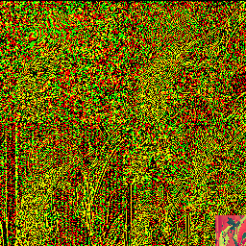

256 x 256

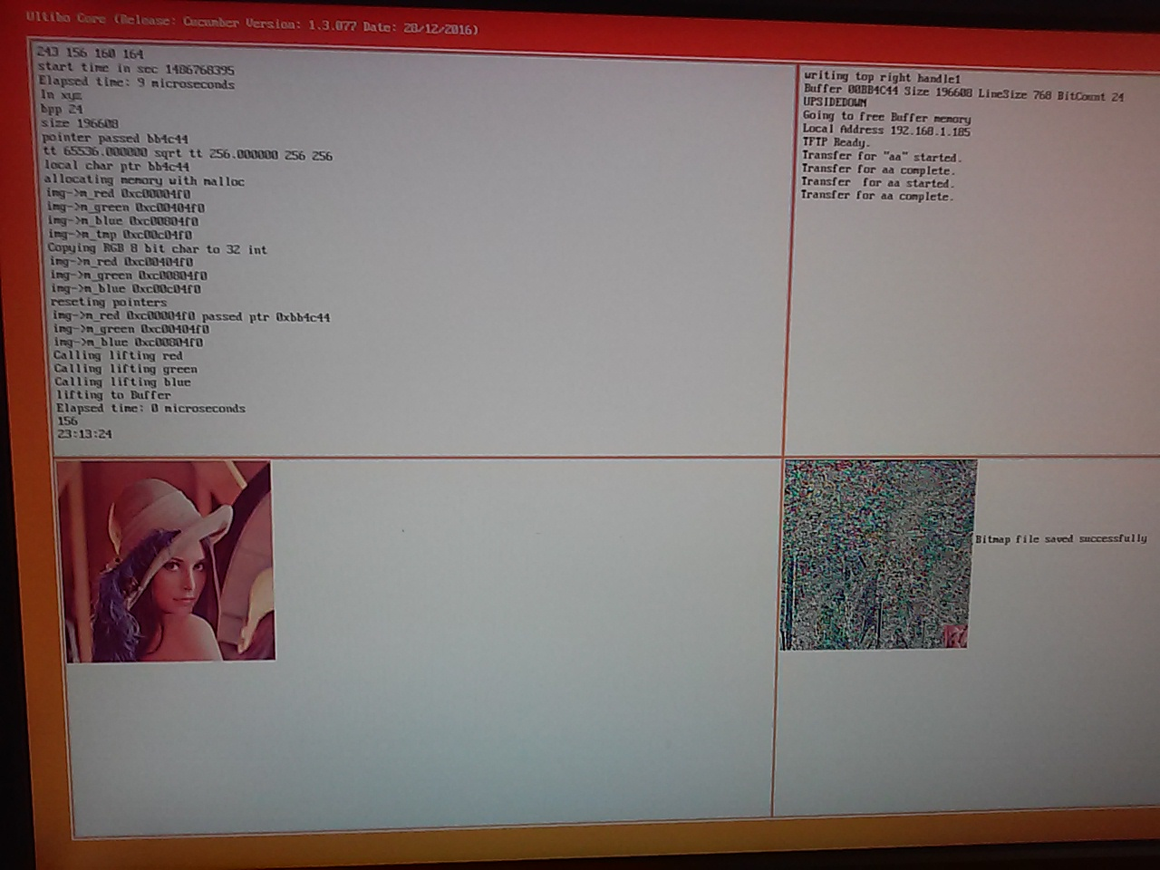

512 x 512

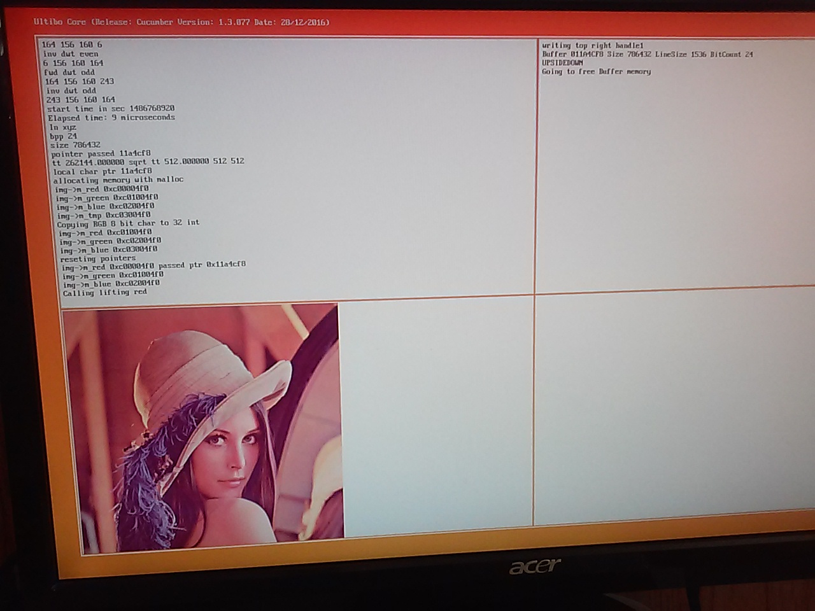

1024 x 1024
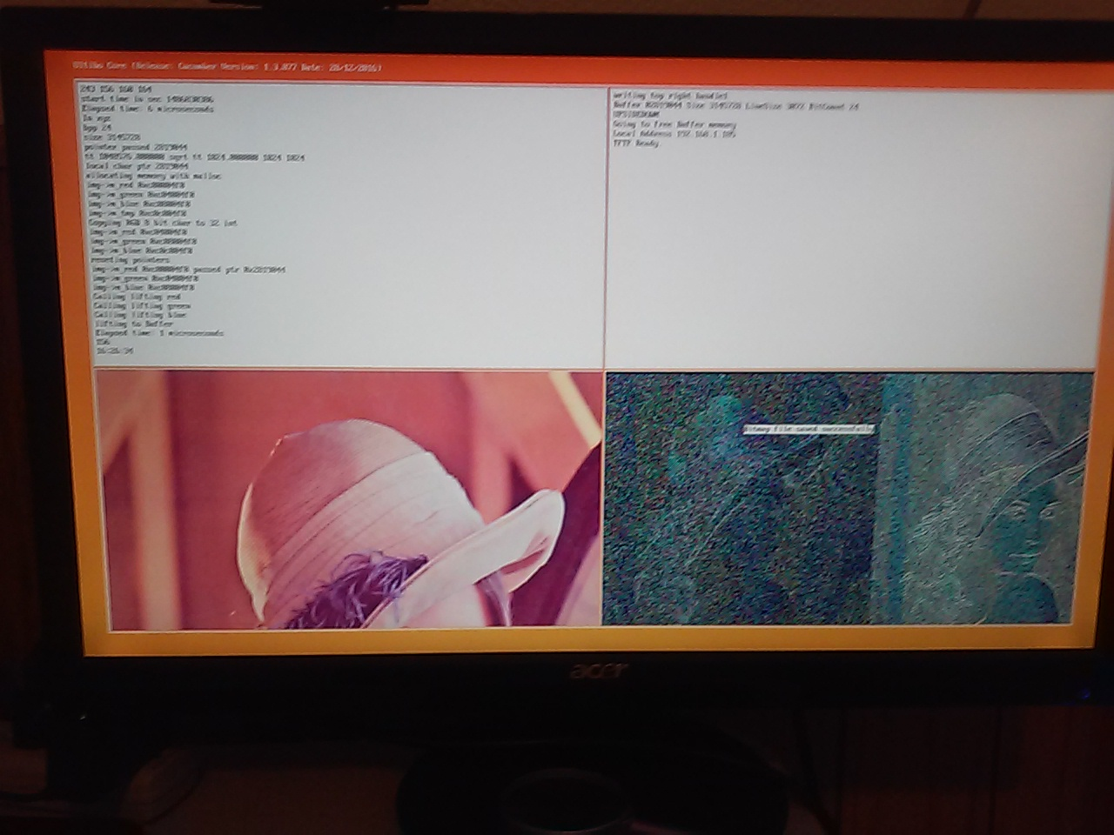

xxx
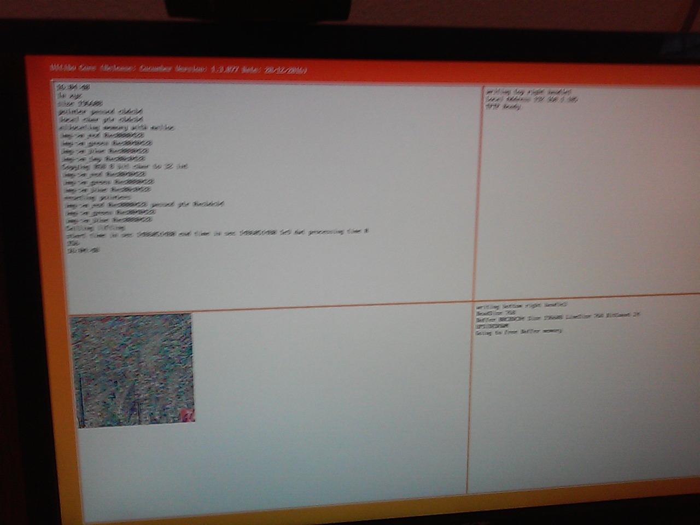

3 lvls lifting step dwt.

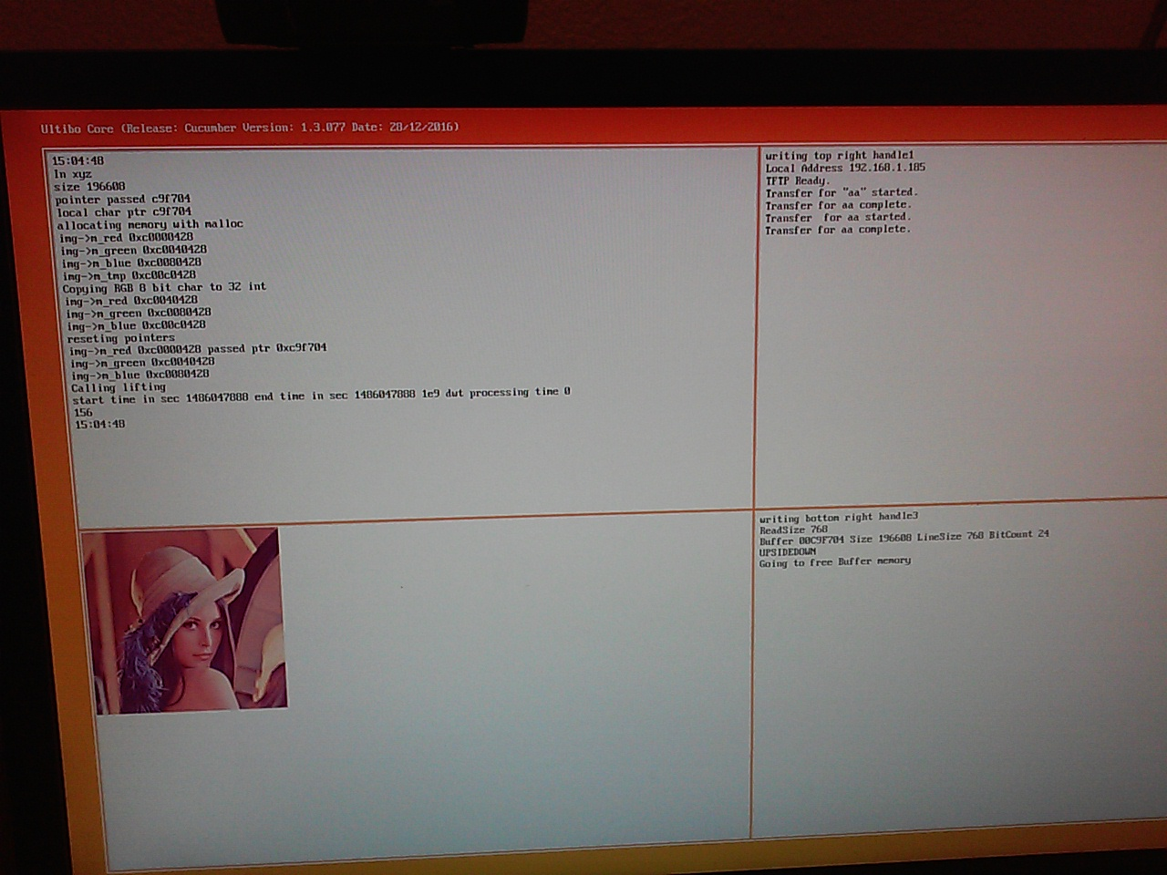

In the current test Size & Buffer pointer in Pascal are passed to C. Four areas are created with mallioc.
Each area is 256 x 256 which is 65536 locations.

typedef struct {
int m_w, m_h;
int *m_red, *m_green, *m_blue, *m_tmp;
int data[1];

} IMAGE, *IMAGEP;
double tt;
if(bp==8) tt = (double)ss;
else tt = (double)(ss/3.0);
int ww, hh;
ww = (int)sqrt(tt);
hh = ww;

IMAGEP img;
//int ww = 256;
//int hh = 256;
printf("allocating memory with malloc \n");
img = (IMAGEP)malloc(sizeof(IMAGE)+4*ww*hh*sizeof(int));
img->m_w = ww;
img->m_h = hh;
img->m_red = img->data;
img->m_green = &img->data[ww*hh];
img->m_blue = &img->data[2*ww*hh];
img->m_tmp = &img->data[3*ww*hh];
//printf("the size of malloc %x \n",sizeof(img));
printf("img->m_red 0x%x \n",img->m_red);
printf("img->m_green 0x%x \n",img->m_green);
printf("img->m_blue 0x%x \n",img->m_blue);
printf("img->m_tmp 0x%x \n",img->m_tmp);

The R 8 bit is copied to the img->m_red 32 bits.
The G 8 bit is copied to the img->m_green 32 bits.
The B 8 bit is copied to the img->m_blue 32 bits.

for (loop=0; loop < ss/3; loop++) {
*img->m_red = lclip[0];
lclip++;
img->m_red++;
*img->m_green = lclip[0];
lclip++;
img->m_green++;
*img->m_blue = lclip[0];
lclip++;
img->m_blue++;
}

printf("img->m_red 0x%x \n",img->m_red);
printf("img->m_green 0x%x \n",img->m_green);
printf("img->m_blue 0x%x \n",img->m_blue);

printf("reseting pointers \n");

img->m_red = img->data;
img->m_green = &img->data[ww*hh];
img->m_blue = &img->data[2*ww*hh];

lclip = (char *)*xx;

printf("img->m_red 0x%x passed ptr 0x%x\n",img->m_red, &lclip[0]);
printf("img->m_green 0x%x \n",img->m_green);
printf("img->m_blue 0x%x \n",img->m_blue);

printf("Calling lifting red\n");

//img->m_red = img->data;
lifting(ww, img->m_red, img->m_tmp);
img->m_tmp = &img->data[3*ww*hh];
printf("Calling lifting green\n");

//img->m_green = &img->data[ww*hh];
lifting(ww, img->m_green, img->m_tmp);
img->m_tmp = &img->data[3*ww*hh];
printf("Calling lifting blue\n");

//img->m_blue = &img->data[2*ww*hh];
lifting(ww, img->m_blue, img->m_tmp);
printf("lifting to Buffer\n");
for (loop=0; loop < ss/3; loop++) {
lclip[0] = *img->m_red ;
lclip++;
img->m_red++;
lclip[0] = *img->m_green ;
lclip++;
img->m_green++;
lclip[0] = *img->m_blue ;
lclip++;
img->m_blue++;
}

gettimeofday(&end, NULL);

seconds = end.tv_sec - start.tv_sec;
useconds = end.tv_usec - start.tv_usec;

mtime = seconds + useconds;

printf("Elapsed time: %ld microseconds\n", mtime);
free(img);

In the above example 0xc0000424, 0xc0100424, and 0xc020424 are the memory start.

Now displaying the 256 x 256 image.
Created two units uPointersToC.pas & uBufferToC.pas. This allows function to call the C code
Pbuff which xyz in test.c. The Pointer is being passed correctly by the size appears in error.

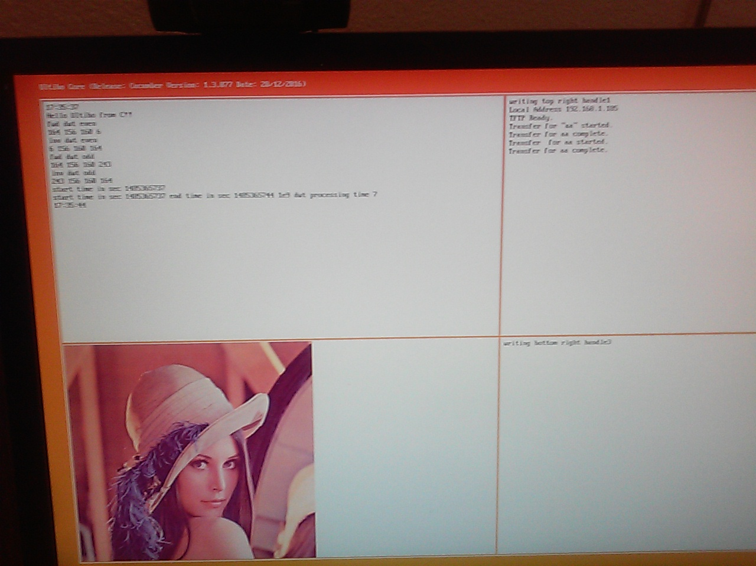
Processing time on Raspbian takes over 10 times more than Ultibo

./epochtime
time sec 1485366551
start time in sec 1485366551 end time in sec 1485366624 1e9 dwt processing time 73

This only takes 7 sec to perform the 1e9 dwt on Ultibo

Topleft is where the C routine is being called. Bottomleft is a 512 x 512 bitmap
In the file test.c the contents of lifing.c
In the topright is the tftp process.
# ultibo-tftp

A reasonably quick method of transferring files in an Ultibo project.
It uses Trival FTP based on RFC 1350

Approx upload times around 16 secs for kernel7.img of approx 2.2 MB

https://github.com/pjde/ultibo-tftp.git

tftp 192.168.1.185tftp> binary
tftp> put grn-out.32t aa
Sent 1048576 bytes in 5.0 seconds 1.67MBits/s
tftp> get aa bb
Received 1048580 bytes in 4.1 seconds 2.04MBits/s
tftp> quit

extern void singlelift(int rb, int w, int * const ibuf, int * const obuf);
extern void ilift(int rb, int w, int * const ibuf, int * const obuf);
extern void lifting(int w, int *ibuf, int *tmpbuf);

Updating the kernel7.img Dynamically. First sending the image to a dummy file and retieving the dummy file to a new name. Testing the md5sum of the retrieved file and kernel7.img sent.

Adding the following uses allows a remote system to telnet into a running Ultibo RPi.
{ needed for telnet }
Shell,
ShellFilesystem,
ShellUpdate,
RemoteShell,
{ needed for telnet }
Transfer a new image to Ultibo RPi.
pi@raspberrypi3:~/jpeg-2000-test/bare-metal/LibC $ tftp 192.168.1.185
tftp> binary
tftp> put kernel7.img tt
Sent 2548944 bytes in 10.8 seconds
tftp> get tt ss
Received 2548944 bytes in 9.2 seconds
tftp> quit
pi@raspberrypi3:~/jpeg-2000-test/bare-metal/LibC $ md5sum kernel7.img ss
df2a3aaf79570eb16f344655fae65357 kernel7.img
df2a3aaf79570eb16f344655fae65357 ss

On a remote system “telnet 192.168.1.185” where the 192.168.1.185 is the IP of the RPi2B running Ultibo.
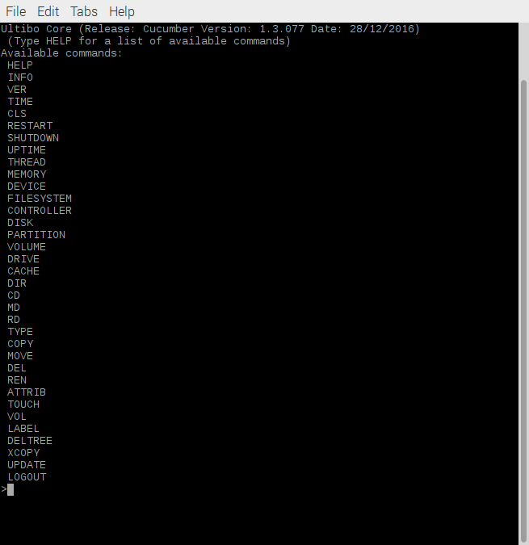

Need to delete the kernel7.img.
Need to copy the dummy file to the kernel7.img,
Need to restart for the new kernel to start.

telnet 192.168.1.185
Trying 192.168.1.185...
Connected to 192.168.1.185.
Escape character is '^]'.

Ultibo Core (Release: Cucumber Version: 1.3.077 Date: 28/12/2016)
(Type HELP for a list of available commands)
Directory of C:\

22-1-17 17:24:24 17932 bootcode.bin
22-1-17 17:24:24 6621 fixup.dat
28-1-17 17:33:54 2548944 kernel7.img
28-1-17 17:33:54 2548944 tt
22-1-17 17:24:24 786554 MyBitmap.bmp
22-1-17 17:24:24 2817796 start.elf
23-1-17 23:41:54 <DIR> kernelDbitmap
9-1-17 18:03:38 <DIR> kerneldemo
9-1-17 18:05:00 <DIR> kernelLibCTest
11-1-17 17:09:20 <DIR> kernelTFTP
12-1-17 11:49:44 <DIR> kernelUDPServer
24-1-17 15:39:18 4 lena_rgb_512.bmp
13-1-17 20:03:06 <DIR> My Files
22-1-17 17:23:54 <DIR> old_files
7 file(s) 8726795 bytes
7 dir(s)

C:\>del kernel7.img
Directory of C:\

22-1-17 17:24:24 17932 bootcode.bin
22-1-17 17:24:24 6621 fixup.dat
28-1-17 17:33:54 2548944 tt
22-1-17 17:24:24 786554 MyBitmap.bmp
22-1-17 17:24:24 2817796 start.elf
23-1-17 23:41:54 <DIR> kernelDbitmap
9-1-17 18:03:38 <DIR> kerneldemo
9-1-17 18:05:00 <DIR> kernelLibCTest
11-1-17 17:09:20 <DIR> kernelTFTP
12-1-17 11:49:44 <DIR> kernelUDPServer
24-1-17 15:39:18 4 lena_rgb_512.bmp
13-1-17 20:03:06 <DIR> My Files
22-1-17 17:23:54 <DIR> old_files
6 file(s) 6177851 bytes
7 dir(s)

C:\ttopy tt kernel7.img
1 file(s) copied

Directory of C:\

22-1-17 17:24:24 17932 bootcode.bin
22-1-17 17:24:24 6621 fixup.dat
28-1-17 17:33:54 2548944 tt
22-1-17 17:24:24 786554 MyBitmap.bmp
22-1-17 17:24:24 2817796 start.elf
23-1-17 23:41:54 <DIR> kernelDbitmap
9-1-17 18:03:38 <DIR> kerneldemo
9-1-17 18:05:00 <DIR> kernelLibCTest
11-1-17 17:09:20 <DIR> kernelTFTP
12-1-17 11:49:44 <DIR> kernelUDPServer
24-1-17 15:39:18 4 lena_rgb_512.bmp
13-1-17 20:03:06 <DIR> My Files
22-1-17 17:23:54 <DIR> old_files
28-1-17 17:33:54 2548944 kernel7.img
7 file(s) 8726795 bytes
7 dir(s)

Restarting in 1000 milliseconds
C:\>

This is needed to add the fpc compiler to the PATH.

export PATH=/home/pi/ultibo/core/fpc/bin:$PATH
echo $PATH
/home/pi/ultibo/core/fpc/bin:/usr/local/sbin:/usr/local/bin:/usr/sbin:/usr/bin:/sbin:/bin:/usr/local/games:/usr/games

arm-none-eabi-gcc -O2 -mabi=aapcs -marm -march=armv7-a -mfpu=vfpv3-d16 -mfloat-abi=hard -c test.c

arm-none-eabi-ar rcs libtest.a test.o

fpc -vi -B -Tultibo -Parm -CpARMV7A -WpRPI2B @/home/pi/ultibo/core/fpc/bin/rpi2.cfg -O2 LibCTestRPi2.lpr

./build_liftmain.sh compiles lifting.c & liftmain.c --> liftmain

iftmain lena_rgb_512.png
red-out.32t

line 101 lifting.c const int LVLS = 1; performs 1 level forward DWT

lines 230-246 in lifting.c when commented does not perform the inverse DWT.
/*
for(lvl=(LVLS-1); lvl>=0; lvl--) {
int offset;

w <<= 1;

if (lvl)
offset = ov[lvl-1];
else
offset = 0;
ip = &ibuf[offset];
tp = &tmpbuf[offset];

ilift(rb, w, ip, tp);
ilift(rb, w, tp, ip);
}
*/
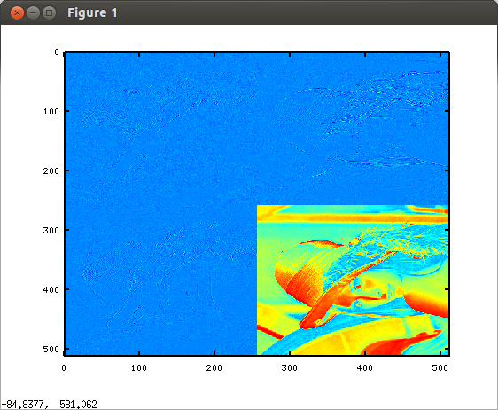

The image above is 1 level forward DWT red subband
The file red-out.32t

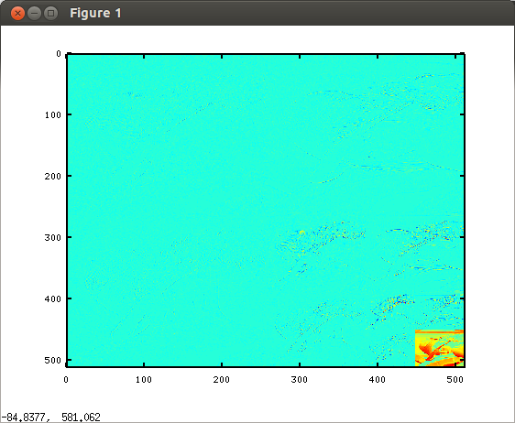

The image above is 3 levels forward DWT red subband
The file red-out.32t

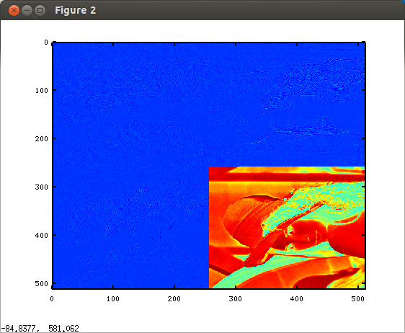
The image above is 1 level forward DWT grn subband
The file grn-out.32t
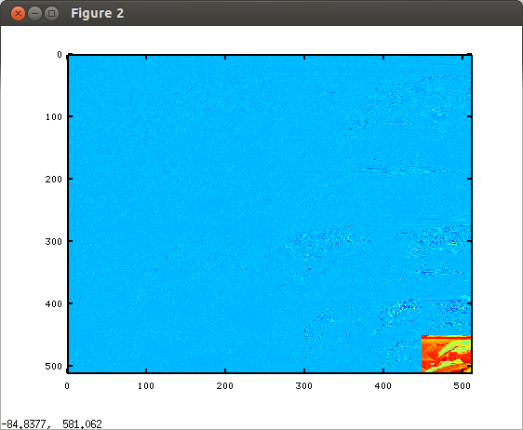
The image above is 3 levels forward DWT grn subband
The file grn-out.32t

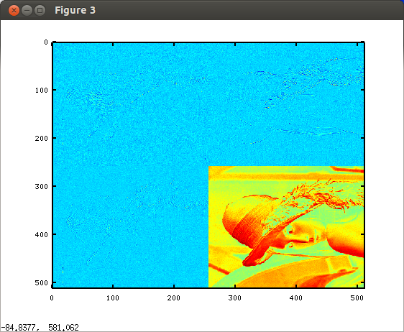

The image above is 1 level forward DWT blu subband
The file blu-out.32t

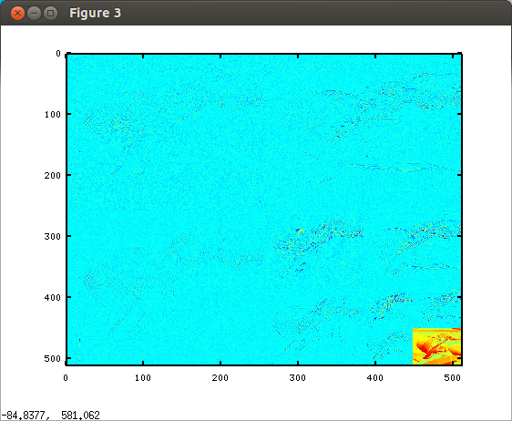

The image above is 3 levels forward DWT blu subband
The file blu-out.32t
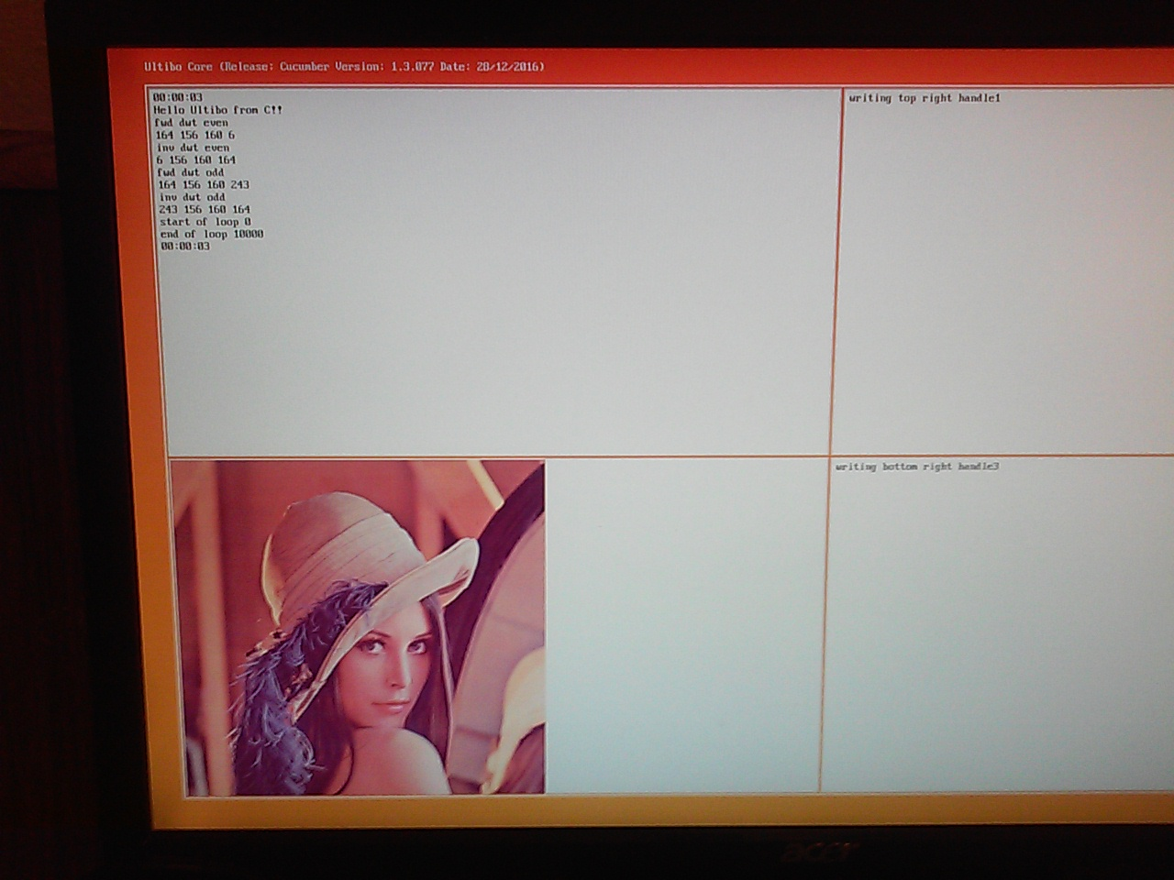
The above image is the running on RPi3B as compiled for RPi2B on 01/23/17.

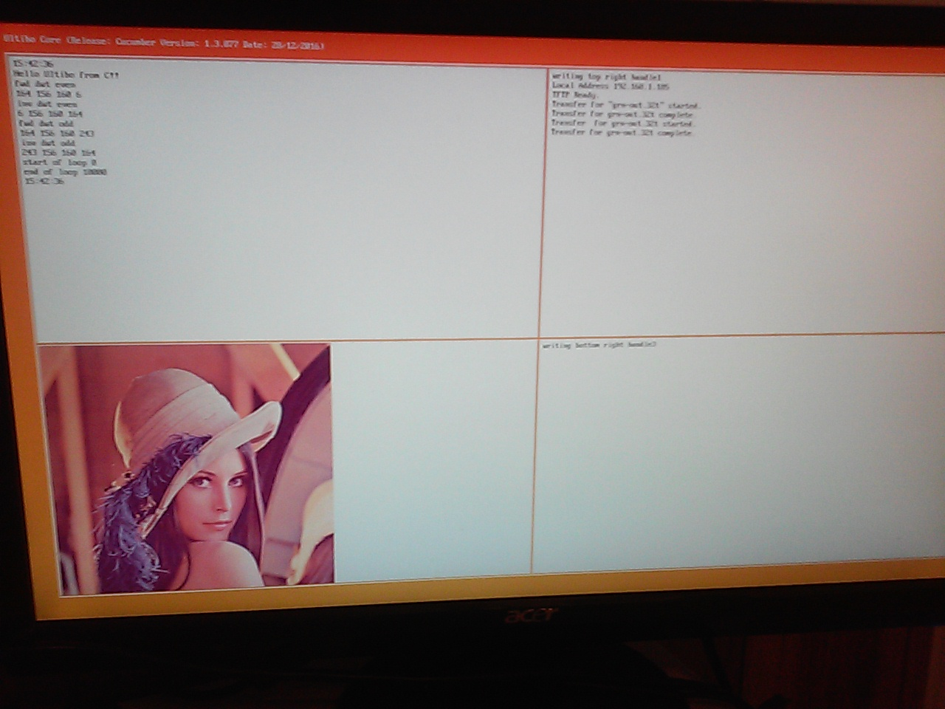
Appendix A. CPU infor for x86_64 six core, x86_64 dual core, and RPi3B.
CPUINFO X86_64 six core
processor : 0
vendor_id : AuthenticAMD
cpu family : 16
model : 10
model name : AMD Phenom(tm) II X6 1090T Processor
stepping : 0
microcode : 0x10000dc
cpu MHz : 800.000
cache size : 512 KB
physical id : 0
siblings : 6
core id : 0
cpu cores : 6
apicid : 0
initial apicid : 0
fpu : yes
fpu_exception : yes
cpuid level : 6
wp : yes
flags : fpu vme de pse tsc msr pae mce cx8 apic sep mtrr pge mca cmov pat pse36 clflush mmx fxsr sse sse2 ht syscall nx mmxext fxsr_opt pdpe1gb rdtscp lm 3dnowext 3dnow constant_tsc rep_good nopl nonstop_tsc extd_apicid aperfmperf pni monitor cx16 popcnt lahf_lm cmp_legacy svm extapic cr8_legacy abm sse4a misalignsse 3dnowprefetch osvw ibs skinit wdt cpb hw_pstate npt lbrv svm_lock nrip_save pausefilter
bogomips : 6400.28
TLB size : 1024 4K pages
clflush size : 64
cache_alignment : 64
address sizes : 48 bits physical, 48 bits virtual
power management: ts ttp tm stc 100mhzsteps hwpstate cpb

processor : 1
vendor_id : AuthenticAMD
cpu family : 16
model : 10
model name : AMD Phenom(tm) II X6 1090T Processor
stepping : 0
microcode : 0x10000dc
cpu MHz : 800.000
cache size : 512 KB
physical id : 0
siblings : 6
core id : 1
cpu cores : 6
apicid : 1
initial apicid : 1
fpu : yes
fpu_exception : yes
cpuid level : 6
wp : yes
flags : fpu vme de pse tsc msr pae mce cx8 apic sep mtrr pge mca cmov pat pse36 clflush mmx fxsr sse sse2 ht syscall nx mmxext fxsr_opt pdpe1gb rdtscp lm 3dnowext 3dnow constant_tsc rep_good nopl nonstop_tsc extd_apicid aperfmperf pni monitor cx16 popcnt lahf_lm cmp_legacy svm extapic cr8_legacy abm sse4a misalignsse 3dnowprefetch osvw ibs skinit wdt cpb hw_pstate npt lbrv svm_lock nrip_save pausefilter
bogomips : 6400.28
TLB size : 1024 4K pages
clflush size : 64
cache_alignment : 64
address sizes : 48 bits physical, 48 bits virtual
power management: ts ttp tm stc 100mhzsteps hwpstate cpb

processor : 2
vendor_id : AuthenticAMD
cpu family : 16
model : 10
model name : AMD Phenom(tm) II X6 1090T Processor
stepping : 0
microcode : 0x10000dc
cpu MHz : 800.000
cache size : 512 KB
physical id : 0
siblings : 6
core id : 2
cpu cores : 6
apicid : 2
initial apicid : 2
fpu : yes
fpu_exception : yes
cpuid level : 6
wp : yes
flags : fpu vme de pse tsc msr pae mce cx8 apic sep mtrr pge mca cmov pat pse36 clflush mmx fxsr sse sse2 ht syscall nx mmxext fxsr_opt pdpe1gb rdtscp lm 3dnowext 3dnow constant_tsc rep_good nopl nonstop_tsc extd_apicid aperfmperf pni monitor cx16 popcnt lahf_lm cmp_legacy svm extapic cr8_legacy abm sse4a misalignsse 3dnowprefetch osvw ibs skinit wdt cpb hw_pstate npt lbrv svm_lock nrip_save pausefilter
bogomips : 6400.28
TLB size : 1024 4K pages
clflush size : 64
cache_alignment : 64
address sizes : 48 bits physical, 48 bits virtual
power management: ts ttp tm stc 100mhzsteps hwpstate cpb

processor : 3
vendor_id : AuthenticAMD
cpu family : 16
model : 10
model name : AMD Phenom(tm) II X6 1090T Processor
stepping : 0
microcode : 0x10000dc
cpu MHz : 800.000
cache size : 512 KB
physical id : 0
siblings : 6
core id : 3
cpu cores : 6
apicid : 3
initial apicid : 3
fpu : yes
fpu_exception : yes
cpuid level : 6
wp : yes
flags : fpu vme de pse tsc msr pae mce cx8 apic sep mtrr pge mca cmov pat pse36 clflush mmx fxsr sse sse2 ht syscall nx mmxext fxsr_opt pdpe1gb rdtscp lm 3dnowext 3dnow constant_tsc rep_good nopl nonstop_tsc extd_apicid aperfmperf pni monitor cx16 popcnt lahf_lm cmp_legacy svm extapic cr8_legacy abm sse4a misalignsse 3dnowprefetch osvw ibs skinit wdt cpb hw_pstate npt lbrv svm_lock nrip_save pausefilter
bogomips : 6400.28
TLB size : 1024 4K pages
clflush size : 64
cache_alignment : 64
address sizes : 48 bits physical, 48 bits virtual
power management: ts ttp tm stc 100mhzsteps hwpstate cpb

processor : 4
vendor_id : AuthenticAMD
cpu family : 16
model : 10
model name : AMD Phenom(tm) II X6 1090T Processor
stepping : 0
microcode : 0x10000dc
cpu MHz : 800.000
cache size : 512 KB
physical id : 0
siblings : 6
core id : 4
cpu cores : 6
apicid : 4
initial apicid : 4
fpu : yes
fpu_exception : yes
cpuid level : 6
wp : yes
flags : fpu vme de pse tsc msr pae mce cx8 apic sep mtrr pge mca cmov pat pse36 clflush mmx fxsr sse sse2 ht syscall nx mmxext fxsr_opt pdpe1gb rdtscp lm 3dnowext 3dnow constant_tsc rep_good nopl nonstop_tsc extd_apicid aperfmperf pni monitor cx16 popcnt lahf_lm cmp_legacy svm extapic cr8_legacy abm sse4a misalignsse 3dnowprefetch osvw ibs skinit wdt cpb hw_pstate npt lbrv svm_lock nrip_save pausefilter
bogomips : 6400.28
TLB size : 1024 4K pages
clflush size : 64
cache_alignment : 64
address sizes : 48 bits physical, 48 bits virtual
power management: ts ttp tm stc 100mhzsteps hwpstate cpb

processor : 5
vendor_id : AuthenticAMD
cpu family : 16
model : 10
model name : AMD Phenom(tm) II X6 1090T Processor
stepping : 0
microcode : 0x10000dc
cpu MHz : 800.000
cache size : 512 KB
physical id : 0
siblings : 6
core id : 5
cpu cores : 6
apicid : 5
initial apicid : 5
fpu : yes
fpu_exception : yes
cpuid level : 6
wp : yes
flags : fpu vme de pse tsc msr pae mce cx8 apic sep mtrr pge mca cmov pat pse36 clflush mmx fxsr sse sse2 ht syscall nx mmxext fxsr_opt pdpe1gb rdtscp lm 3dnowext 3dnow constant_tsc rep_good nopl nonstop_tsc extd_apicid aperfmperf pni monitor cx16 popcnt lahf_lm cmp_legacy svm extapic cr8_legacy abm sse4a misalignsse 3dnowprefetch osvw ibs skinit wdt cpb hw_pstate npt lbrv svm_lock nrip_save pausefilter
bogomips : 6400.28
TLB size : 1024 4K pages
clflush size : 64
cache_alignment : 64
address sizes : 48 bits physical, 48 bits virtual
power management: ts ttp tm stc 100mhzsteps hwpstate cpb

CPUINFO x86_64 dual core
processor : 0
vendor_id : AuthenticAMD
cpu family : 15
model : 36
model name : AMD Turion(tm) 64 Mobile Technology ML-32
stepping : 2
cpu MHz : 800.000
cache size : 512 KB
fpu : yes
fpu_exception : yes
cpuid level : 1
wp : yes
flags : fpu vme de pse tsc msr pae mce cx8 apic sep mtrr pge mca cmov pat pse36 clflush mmx fxsr sse sse2 syscall nx mmxext fxsr_opt lm 3dnowext 3dnow rep_good nopl pni lahf_lm
bogomips : 1591.68
TLB size : 1024 4K pages
clflush size : 64
cache_alignment : 64
address sizes : 40 bits physical, 48 bits virtual
power management: ts fid vid ttp tm stc

CPUINFO RPi3B
processor : 0
model name : ARMv7 Processor rev 4 (v7l)
BogoMIPS : 76.80
Features : half thumb fastmult vfp edsp neon vfpv3 tls vfpv4 idiva idivt vfpd32 lpae evtstrm crc32
CPU implementer : 0x41
CPU architecture: 7
CPU variant : 0x0
CPU part : 0xd03
CPU revision : 4

processor : 1
model name : ARMv7 Processor rev 4 (v7l)
BogoMIPS : 76.80
Features : half thumb fastmult vfp edsp neon vfpv3 tls vfpv4 idiva idivt vfpd32 lpae evtstrm crc32
CPU implementer : 0x41
CPU architecture: 7
CPU variant : 0x0
CPU part : 0xd03
CPU revision : 4

processor : 2
model name : ARMv7 Processor rev 4 (v7l)
BogoMIPS : 76.80
Features : half thumb fastmult vfp edsp neon vfpv3 tls vfpv4 idiva idivt vfpd32 lpae evtstrm crc32
CPU implementer : 0x41
CPU architecture: 7
CPU variant : 0x0
CPU part : 0xd03
CPU revision : 4

processor : 3
model name : ARMv7 Processor rev 4 (v7l)
BogoMIPS : 76.80
Features : half thumb fastmult vfp edsp neon vfpv3 tls vfpv4 idiva idivt vfpd32 lpae evtstrm crc32
CPU implementer : 0x41
CPU architecture: 7
CPU variant : 0x0
CPU part : 0xd03
CPU revision : 4

Hardware : BCM2709
Revision : a22082
Serial : 0000000071ada62c
Status: Several Ultibo examples have been merged into a 4 program which displays a bitmap, calls a

