Development Plan
Start with the DRamSPinf simulation
Need to modifiy the ram from 16-word x 8 bit to 48-word x 16 bit
Synthesizing (advanced) Unit <DRamSPInf>.
The following registers are absorbed into accumulator <sum_r>: 1 register on signal <sum_r>.
INFO:Xst:3231 - The small RAM <Mram_ram_r> will be implemented on LUTs in order to maximize performance and save block RAM resources. If you want to force its implementation on block, use option/constraint ram_style.
-----------------------------------------------------------------------
| ram_type | Distributed | |
-----------------------------------------------------------------------
| Port A |
| aspect ratio | 16-word x 8-bit | |
| clkA | connected to signal <clk_i> | rise |
| weA | connected to signal <wr_s> | high |
| addrA | connected to signal <addr_r> | |
| diA | connected to signal <dataToRam_r> | |
| doA | connected to internal node | |
-----------------------------------------------------------------------
Unit <DRamSPInf> synthesized (advanced).
Modifying lines 19 and 20
constant RAM_SIZE_C : natural := 48; -- Number of words in RAM.
constant RAM_WIDTH_C : natural := 16; -- Width of RAM words.
Running the Synthesize and looking at the Synthesize Report shows the ram has chg'ed
from 16-word x 8 bit to 48-word x 16 bit

Synthesizing (advanced) Unit <DRamSPInf>.
The following registers are absorbed into accumulator <sum_r>: 1 register on signal <sum_r>.
INFO:Xst:3231 - The small RAM <Mram_ram_r> will be implemented on LUTs in order to maximize performance and save block RAM resources. If you want to force its implementation on block, use option/constraint ram_style.
-----------------------------------------------------------------------
| ram_type | Distributed | |
-----------------------------------------------------------------------
| Port A |
| aspect ratio | 48-word x 16-bit | |
| clkA | connected to signal <clk_i> | rise |
| weA | connected to signal <wr_s> | high |
| addrA | connected to signal <addr_r> | |
| diA | connected to signal <dataToRam_r> | |
| doA | connected to internal node | |
-----------------------------------------------------------------------
Unit <DRamSPInf> synthesized (advanced).

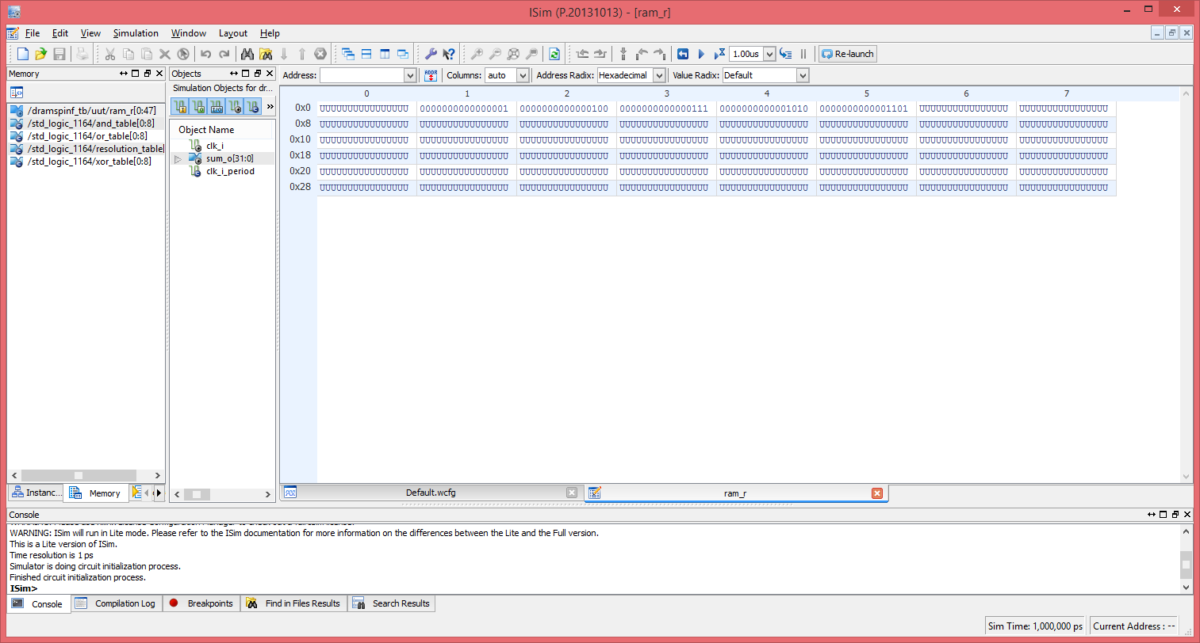

In image above we see that we have 0000-002F ram locations. The locations 1 to have 16 bit values 1, 4, 10, and 13.
Initialize the ram with fileIo/file_read.vhd & fileIo/txt_util.vhd

Need to modify fileIo/file_read.vhd to read 16 bit numbers instead
of 5 bit numbers.
Need to generate 48 16 bit values using python

