liftmain. & lifting.c
12/05/16

./build_liftmain.sh
The script build_liftmain.sh can be run on the RPi2B, RPi3B or Ubuntu 12.04
The script will remove liftmain and compile the programs creating the executeable
liftmain.

The 256 x 256

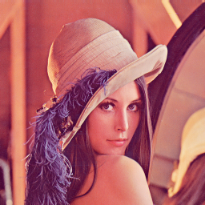

The 512 x 512

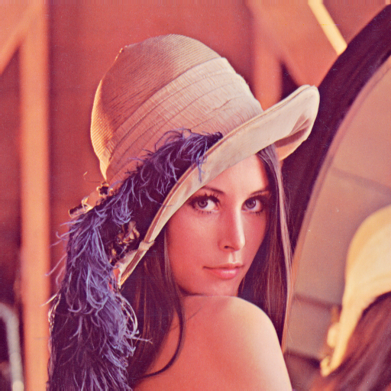

./liftmain ../../../jpeg2k/parallel_jpeg/lena_rgb_512.png
or ./liftmain ../../../jpeg2k/parallel_jpeg/lena_rgb_256.png

The image lena_rgb_512.png or lena_rgb_256.png will be split into RGB and
forward and inverse dwt using the lifting step will be performed.
3 files are created
red-out.32t
grn-out.32t
blu-out.32t
Using octave the images can be displayed.

octave
load disprgb.m

w = 512 since the initial image used was lena_rgb_512.png
w = 256 since the initial image used was lena_rgb_256.png

disprgb

The images will be displayed.

