Testing the "RamCtrl.v" FSM. After the reset the state goes from state 00001 (INIT) to state 00010 (RD_AND_JPEG_DATA). The addrsam_r was set 1 and the addrjeg_r was set 8193 during the the reset. The rd_r is goes to 1 and the addrsam_r is incremented to 19 in steps of 2. The rd_r goes to 0 and wr_r goes to 1. Now in state 00100 and the addrjpeg is
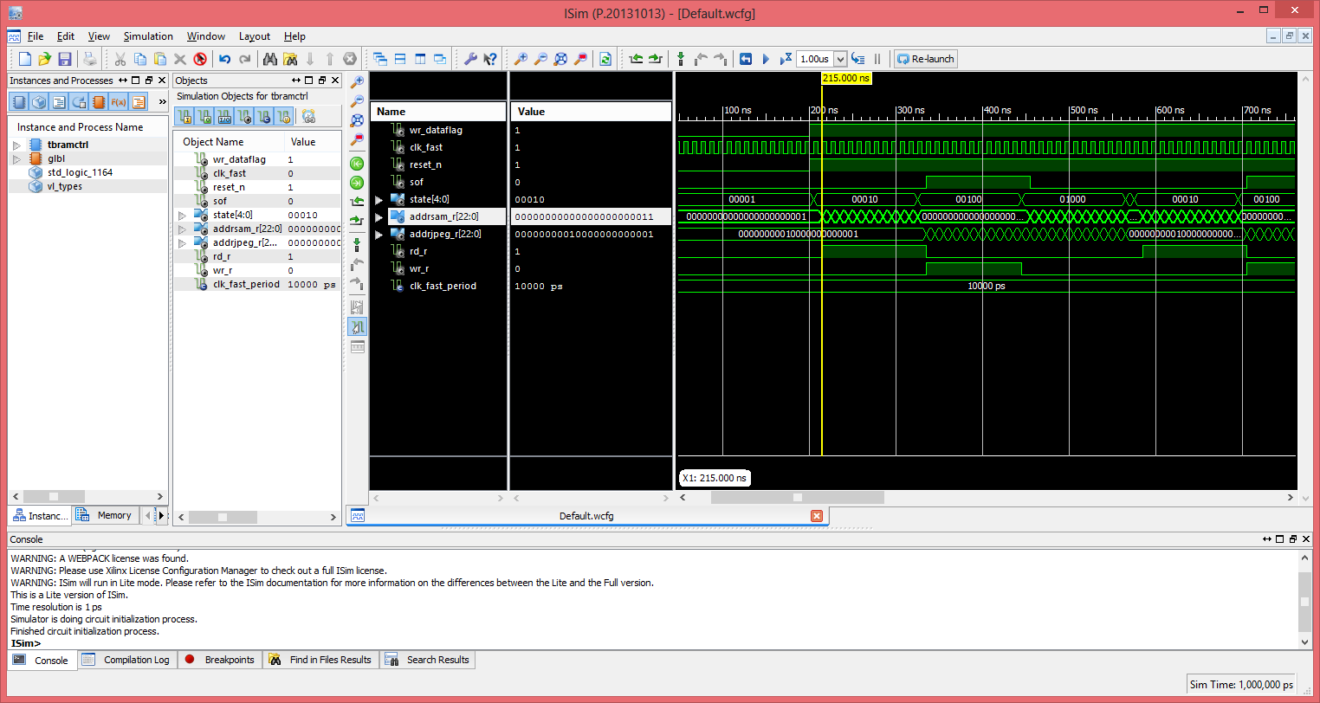

incremented to 8211as the state goes to state 01000 (INTERLACE).
