First the ram needs to be initialized.
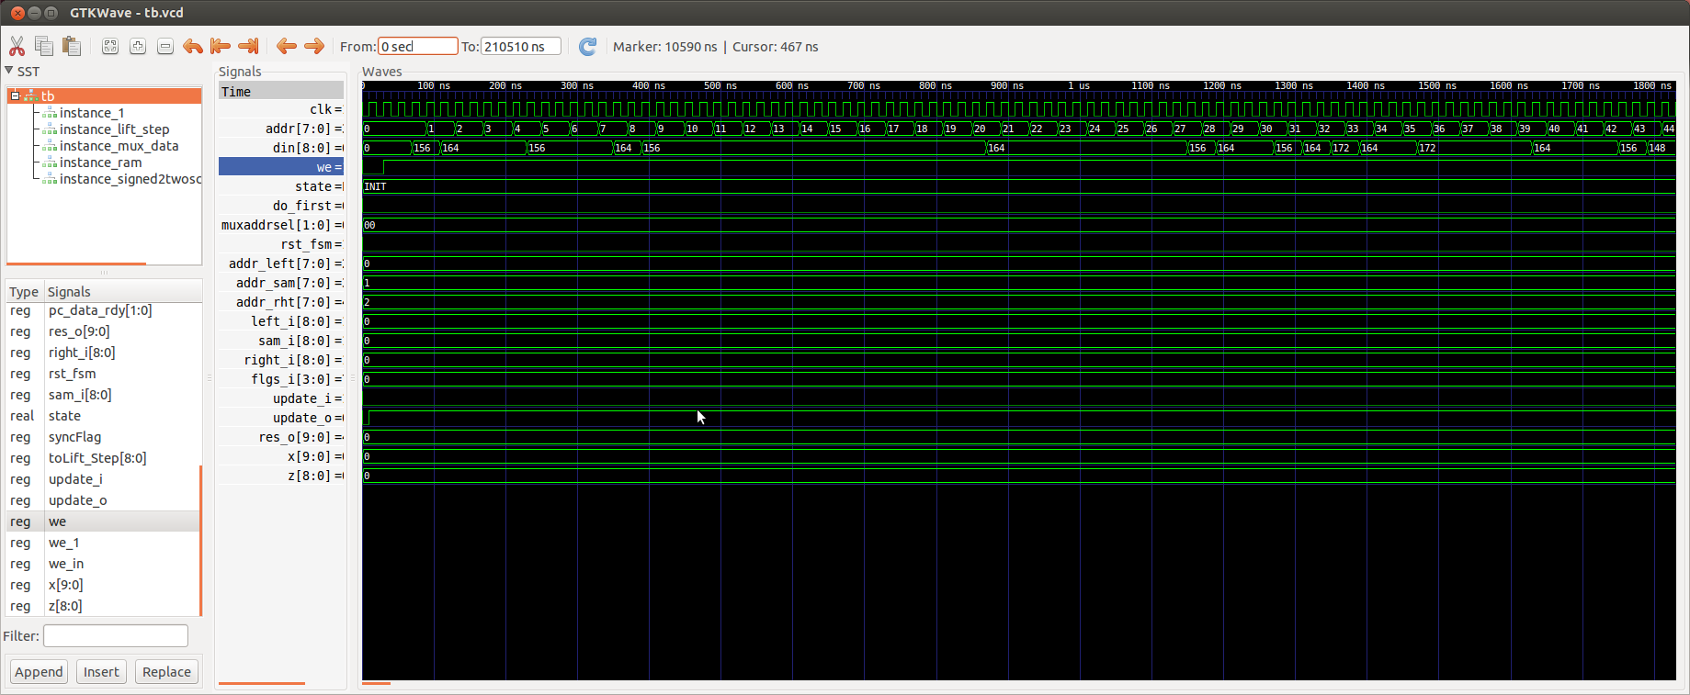
This continues until the 256 locations as been initialize.

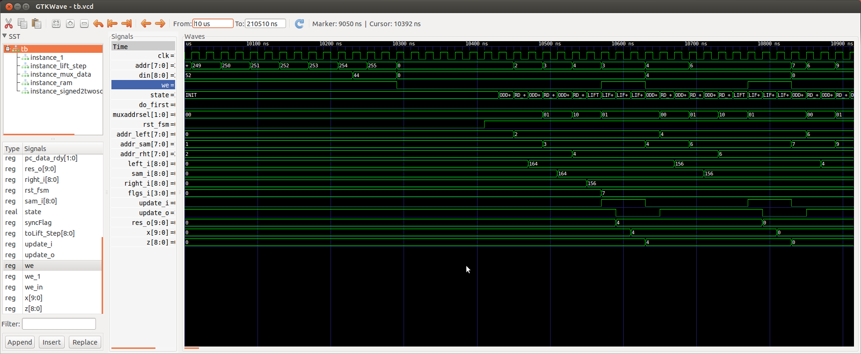
Six inputs are need to perform the lift_step (left_i, sam_i, right_i, flgs_i, update_i, clk,)
The lift_step has 2 outputs (res_o, update_o)
The output of lift_step is the input of the module signed2twoscomplement which converts 10 bits signed to 9 bits unsigned. This is need since the data is stored in RAM as unsigned.

The odd_even_fsm initializes the ram and steps through the address extracting (left_i, sam_i, right_i).
During the odd samples the values at addresses 2, 3, 4 … 252, 253, 254 then 0, 1, 2 which where the first of the odd sample series.
In image below the (left_i, sam_i, right_i) (164, 156, 164) result in a lift_step of -8 which is stored at address 27 as 504.

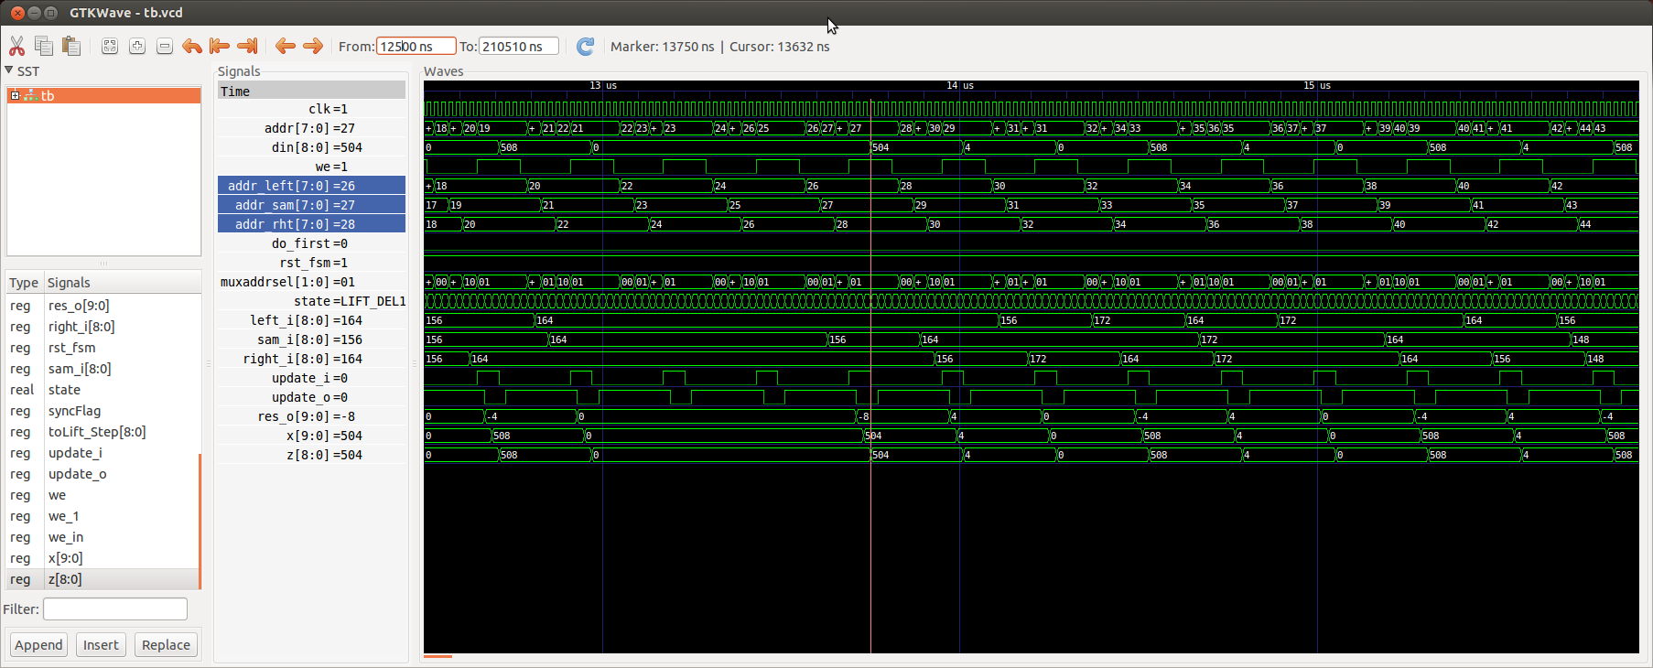
The last step in the odd samples is 0, 1, 2.

