Simulation.

/home/vidal/wkg/jpeg-2000-test/xula2_fpga/parallel/tb/wbdeppsimple.v
/home/vidal/wkg/jpeg-2000-test/xula2_fpga/parallel/wbdeppsimple/wbdeppsimple_tb.v

#103 i_int = 1;
#104 i_write_n = 1;
#105 i_dstb_n = 1;
#106 i_astb_n = 1;
#108 i_depp = 208;
#110 i_write_n = 0;
#112 i_astb_n = 0;
#113 i_dstb_n = 0;
#114 i_write_n = 1;
#115 i_depp = 164;
#116 i_astb_n = 1;
#117 i_dstb_n = 1;
#118 i_write_n = 1;
#119 i_write_n = 0;
#120 i_astb_n = 0;
#121 i_dstb_n = 0;

#123 i_astb_n = 1;
#124 i_dstb_n = 1;
#126 i_write_n = 1;
#128 i_astb_n = 0;
#130 i_dstb_n = 0;
#132 i_write_n = 0;
#134 i_astb_n = 1;
#136 i_dstb_n = 1;
#138 i_write_n = 1;

end
always i_clk = #5 ~i_clk; // 100 MHz
endmodule

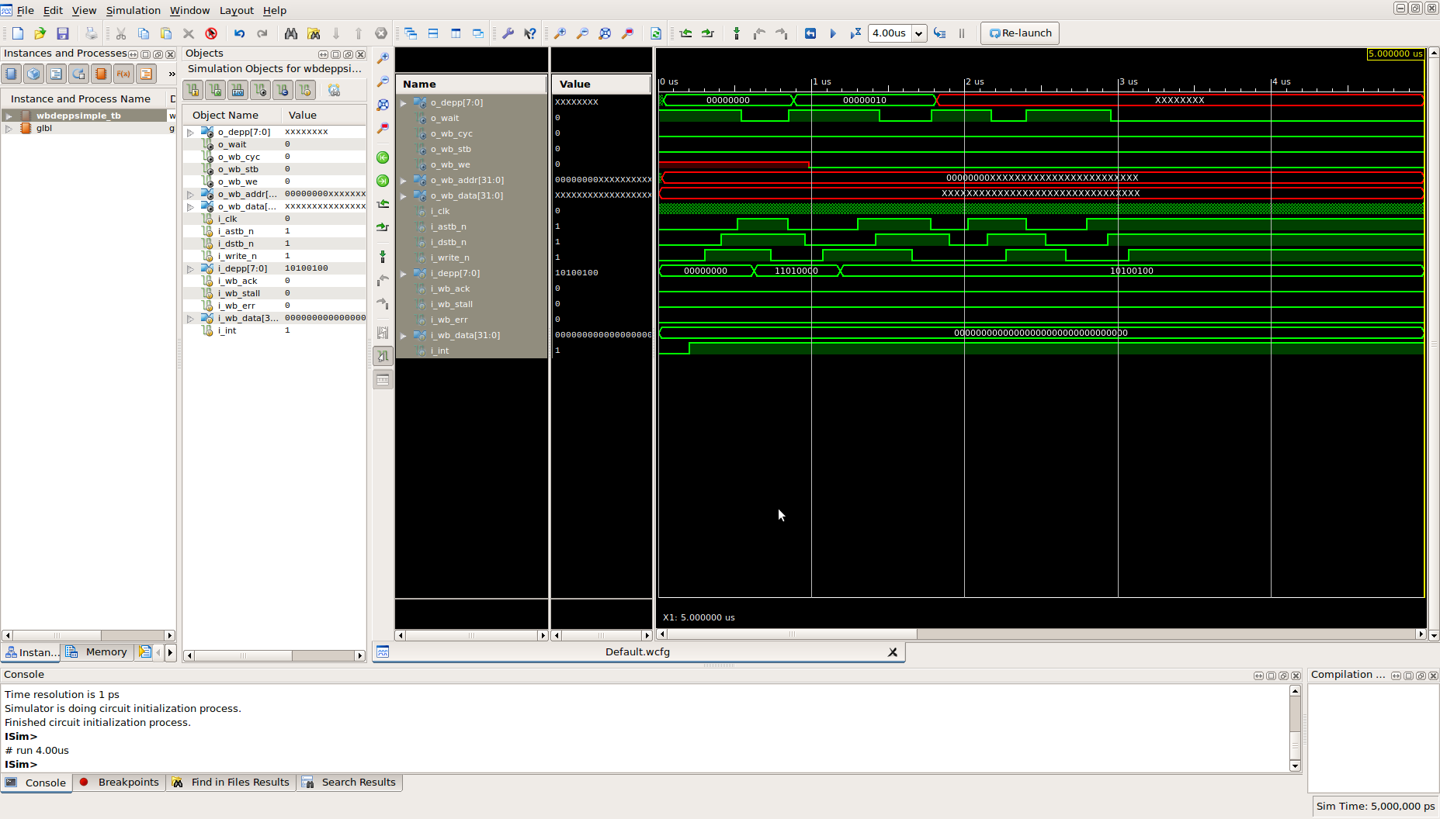
Steps needed for myhdl co-simulation

Note: The myhdl.vpi must be in the current directory.
The folder tb/vcd must be created.

python dr_wbdepp.py --convert

python dr_wbdepp.py --cosimtrace

gtkwave tb/vcd/wbdeppsimple1.vcd

Ran a Python Co-Simulation toggled the i_b0 to i_b7 bits by changing o_depp values.

