Tristate Python Code & Verilog developed by Dave Vandenbout
for the Cat-Board
05/10/16

Running the command “python led_digits_display.py” creates the simulation below viewed with the command “gtkwave led_digits_scroll_tb.vcd” and the Verilog file “led_digits_scroll.v”.

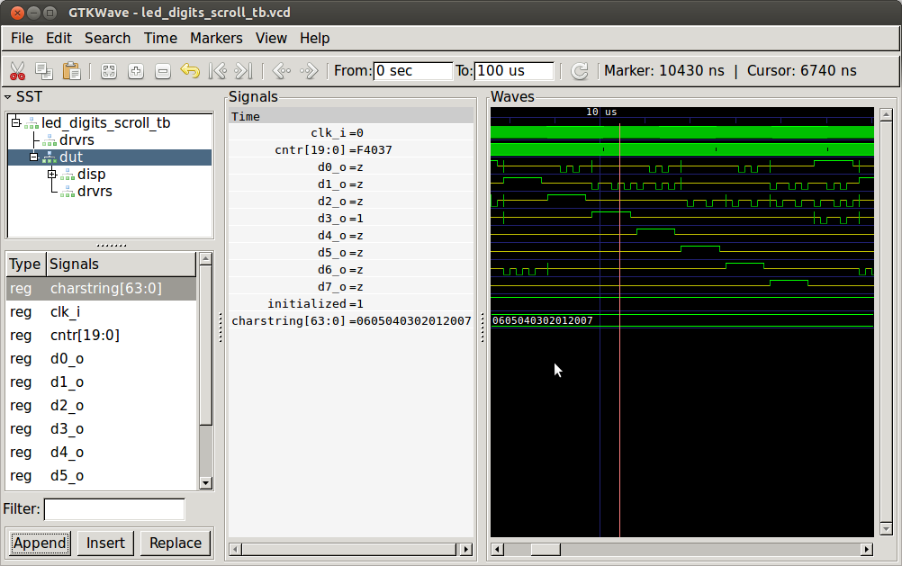
Test bench code creates 8 Tristate signals which are the drvrs of the LedDigit Array.
The 8 Tristate signals are created with the “drvrs = [TristateSignal(bool(0)) for _ in range(8)]'.
This creates a list of signals
[Signal(None), Signal(None), Signal(None), Signal(None), Signal(None), Signal(None), Signal(None), Signal(None)]. The difference between a Tristate signal and a normal is that the does not have a next.

The drvrs are declared as wire drvrs [0:8-1]; in generated Verilog.

def led_digits_scroll_tb():
'''Testbench for the LED digits scroller.'''
clk = Signal(bool(0))
drvrs = [TristateSignal(bool(0)) for _ in range(8)]
dut = led_digits_scroll(drvrs[0].driver(),
drvrs[1].driver(),
drvrs[2].driver(),
drvrs[3].driver(),
drvrs[4].driver(),
drvrs[5].driver(),
drvrs[6].driver(),
drvrs[7].driver(),
clk,
enable_ascii_to_7seg=False,
freq_g=100e4)

@instance
def clk_gen():
for i in range(10000):
clk.next = not clk
yield delay(10)
raise StopSimulation

return instances()

def tristate_driver(o, i, enbl):
''' Tristate driver module.
o: 3-state output (high, low, Z). Must be declared TriStateSignal().
i: input.
enbl: When low, o is Z, otherwise o is i.
'''

o_drvr = o.driver() # Get ShadowSignal for driving output.

@always_comb
def drvr_logic():
if enbl == 1:
o_drvr.next = i # Drive output with value on input.
else:
o_drvr.next = None # Equivalent to Z.

# Dummy signal driven by o so MyHDL recognizes it as an inout.
dummy = Signal(bool(0))

@always_comb
def dummy_logic():
dummy.next = bool(o)

return instances()
# Attach tristate drivers. The bits where drvr_enbls has 1s will be enabled,
# while the rest will be Z. Of the enabled bits, the bit driving the anode
# of the active digit will be high and the rest (connected to the cathodes)
# will be low.
d = [d0_o, d1_o, d2_o, d3_o, d4_o, d5_o, d6_o, d7_o]
for i in range(len(d)):
inst.append(tristate_driver(d[i], digit_shf(i), drvr_enbls(i)))

return instances()

always @(disp_digit_shf[1], disp_drvr_enbls[1]) begin: CATBOARD_DISP_INST_2_DRVR_LOGIC
if ((disp_drvr_enbls[1] == 1)) begin
disp_inst_2_o_drvr = disp_digit_shf[1];
end
else begin
disp_inst_2_o_drvr = 'bz;
end
end

always @(disp_digit_shf[1], disp_drvr_enbls[1]) begin: CATBOARD_DISP_INST_2_DRVR_LOGIC
if ((disp_drvr_enbls[1] == 1)) begin
disp_inst_2_o_drvr = disp_digit_shf[1];
end
else begin
disp_inst_2_o_drvr = 'bz;
end
end

