JPEG Signal Generation
and JPEG Lifting Scheme
The signals needed to compute the lifting scheme of the dwt are made up of 3 16 bit signed vectors. In addition, 3 flags are needed, to determine if the signal is even or odd, if the dwt transform is a forward or inverse, and if the signals have been updated. This requires 52 bits one of which is not used. In the simulation below 0x00a3 0x00a0 0x009b are the signals have been updated (bit position 50) , the forward dwt (bit position 49) is to be performed and the signal is even (bit position 48) .
0111 0000000010100011 0000000010100000 0000000010011011
The 16 bit signed vectors are stored in SDram or during the simulation in ROM.

Step1 Signal generation
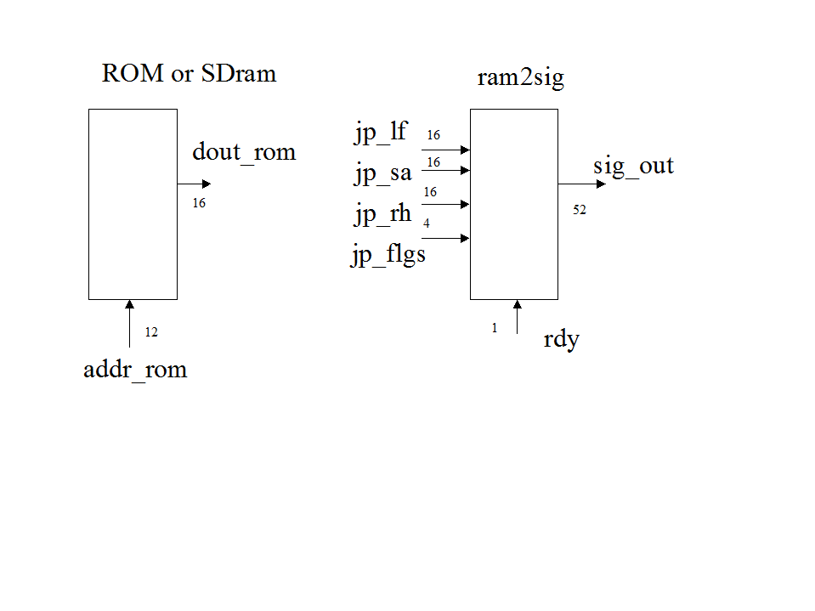
Step2 Jpeg
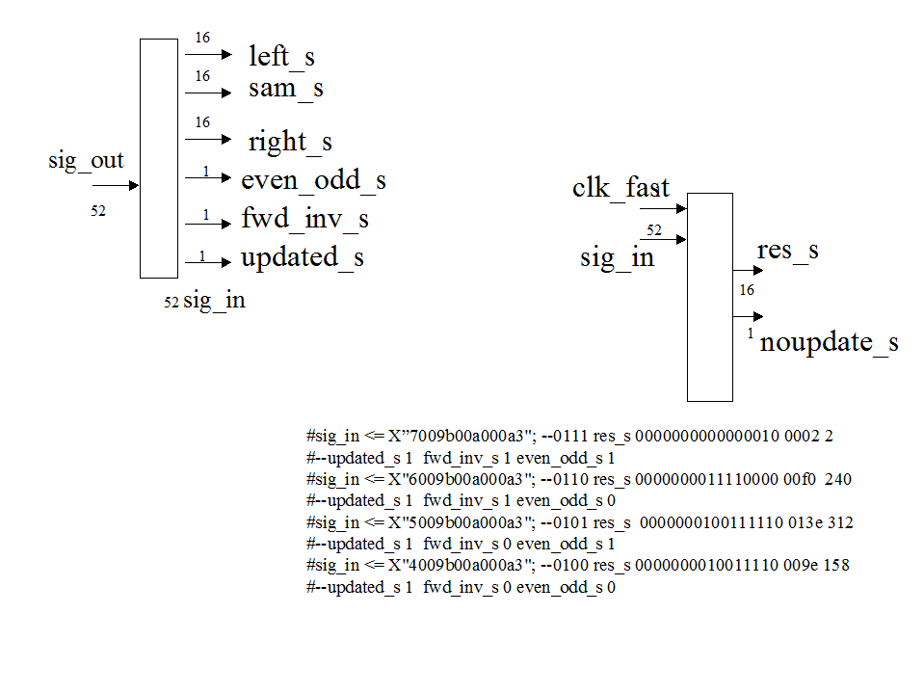
Step3 Saving results to RAM

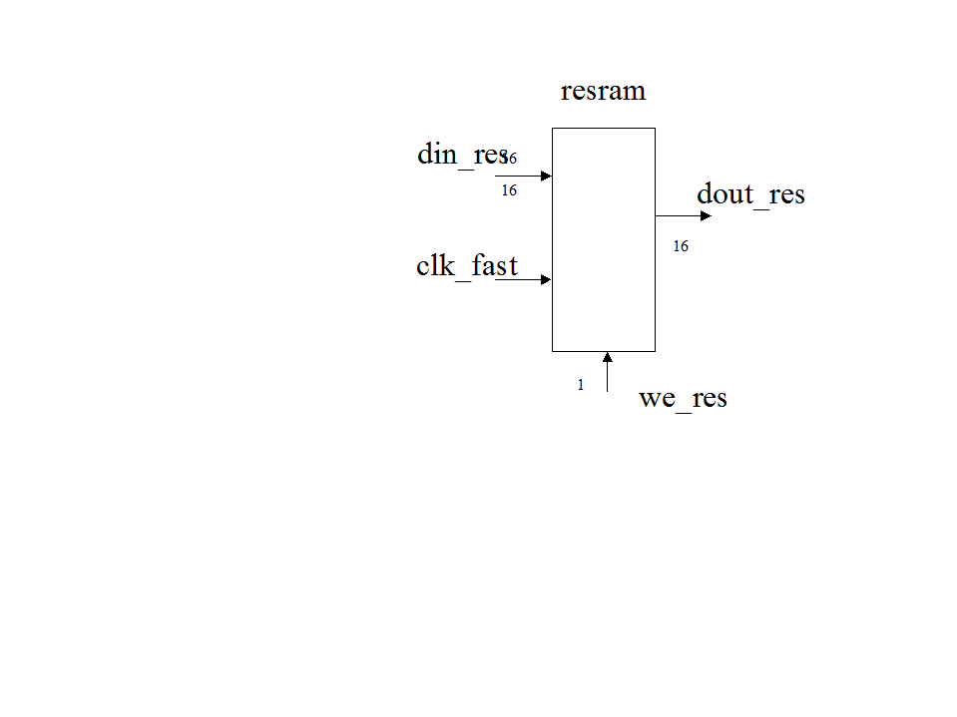

Simulation
The rdy signal must go hi for at least 2 clock pulse. The first the concatenation occurs and then on the 2nd the sig_out is transferred to the jpeg_process.

The sig_out is transferred to sig_in.

Then on the next clock the jpeg_process is performed.

