RPi2B UART to zipcpu at 1MBaud
DWT Lifting Step on
RGB images
converted to YUV
09/13/16

Goal: To send RGB pixels extracted from file “/home/pi/jpeg-2000-test/jpeg2k/parallel_jpeg/lena_rgb_256.png”. Using the UART on a Raspberry Pi 2B and XuLA2-LX9 FPGA running xulax25soc with StickIt-MB.

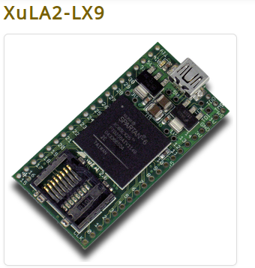

The StickIt!-MB will accept either a XulA2-LX9 or XulA2-LX25 and provides the connections needed between the RPi2B and XulA2-LX9.

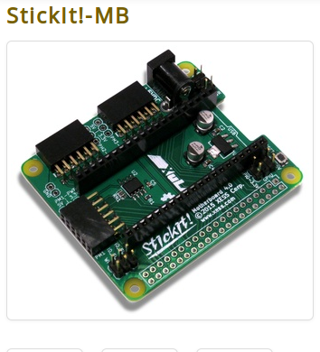

Raspberry Pi 2B or Raspberry Pi 3B (RPi2B or RPi3B) is a 4 core processor.

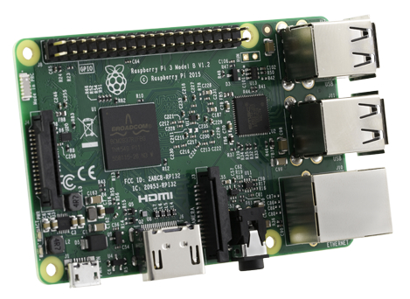

Processing the RGB images with the dwt lifting step in the fwd and inverse.

The image is 256 x 256 RGB.


YUV reduces the range of dwt lifting. The top row fig 1, 2, and 3 are the YUV. With the lower row are
the RGB fig 4, 5, and 6. This reduction will help with the next steps which is MQ coder & EBCOT encoder reduing the number of bits.

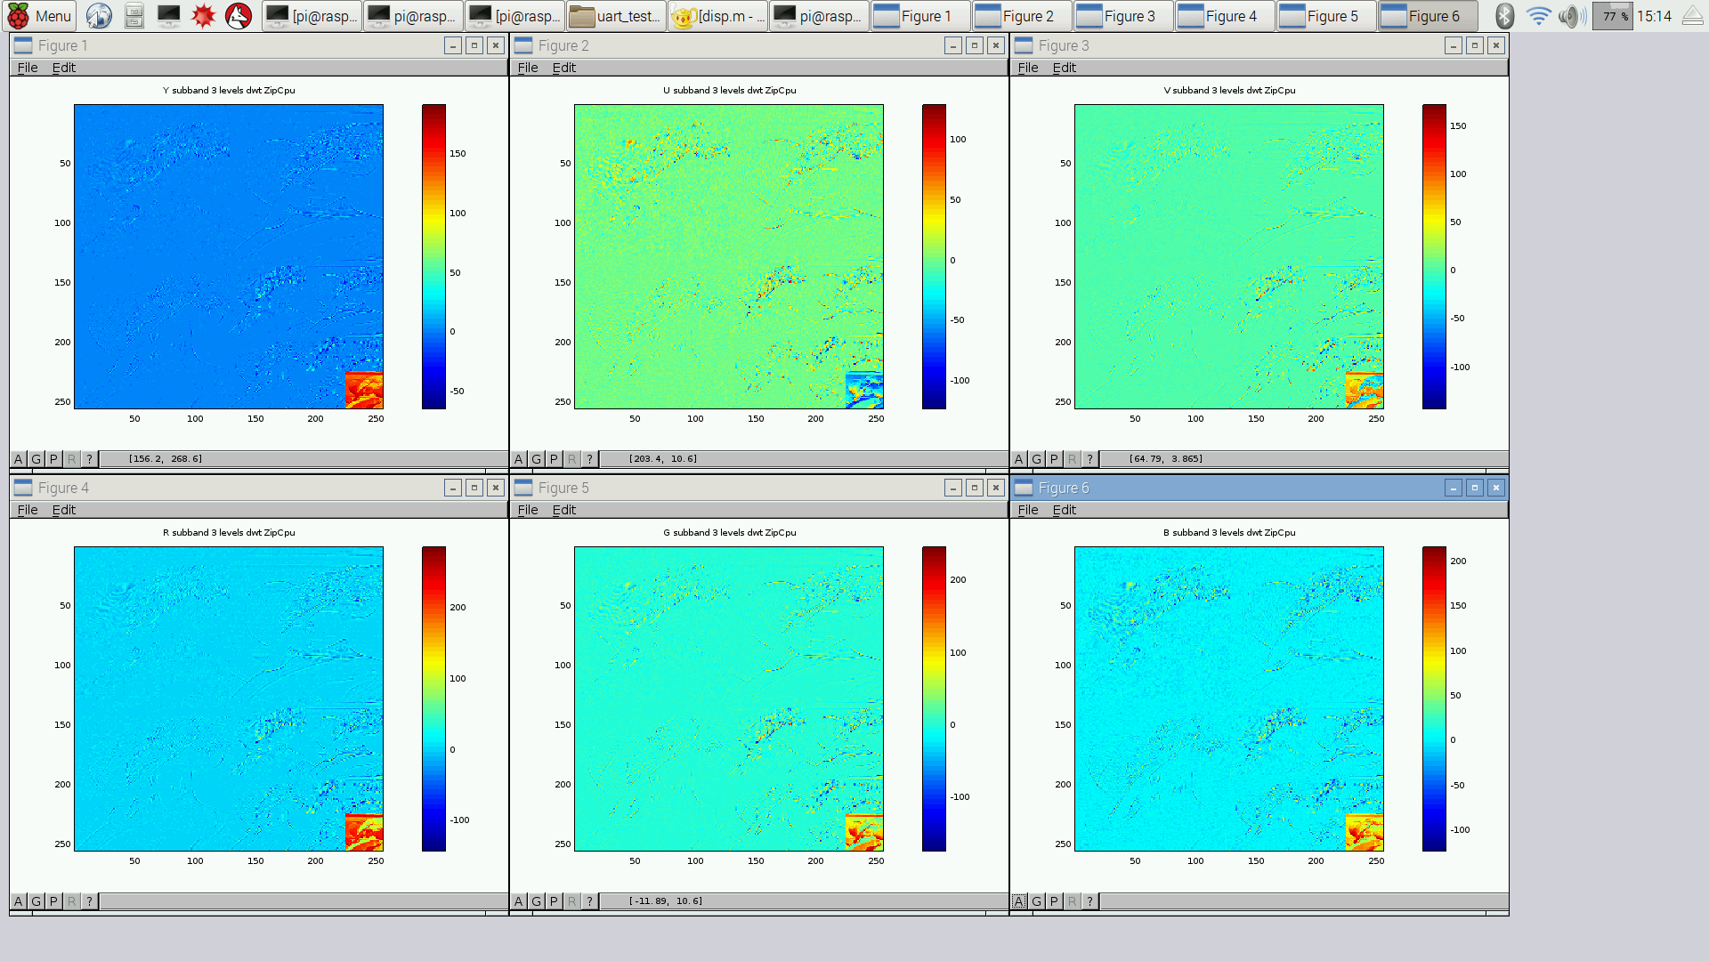

Xilinx 14.6 was used to create toplevel.bit on Ubuntu 12.4 AMD 6 core.

xsload 0.1.31 Is used to load toplevel.bit in XulA2-LX9.

The current version can be obtained using wbregs version
00000101 ( VERSION) : [...'] 20160727

The RGB data was extracted from the file from png file and written to “rgb.bin”.

pi@raspberrypi2-146:~/jpeg-2000-test/zipcpu/uart_test_code $ uname -a
Linux raspberrypi2-146 4.4.11-v7+ #2 SMP Mon May 30 19:00:11 UTC 2016 armv7l GNU/Linux

pi@raspberrypi2-146:~ $ cd jpeg-2000-test/zipcpu/uart_test_code/

pi@raspberrypi2-146:~/jpeg-2000-test/zipcpu/uart_test_code $ . setzipcpuPath.sh PATH,/usr/local/sbin:/usr/local/bin:/usr/sbin:/usr/bin:/sbin:/bin:/usr/local/games:/usr/games:/home/pi/zipcpu/trunk/sw/install/cross-tools/bin:/home/pi/xulalx25soc/trunk/sw

pi@raspberrypi2-146:~/jpeg-2000-test/zipcpu/uart_test_code $ make clean
rm -rf obj-zip/ h2

pi@raspberrypi2-146:~/jpeg-2000-test/zipcpu/uart_test_code $ make

All files are located at
https://github.com/develone/jpeg-2000-test/tree/master/zipcpu/uart_test_code

http://opencores.org/project,zipcpu

http://opencores.org/project,xulalx25soc

The ZipCpu is running at 80MHz.
Several C files which are compiled and linked for the ZipCpu.
The Makefile will clean with make clean and compile and
link with make. This calls zip-gcc
A listing of the disassemble code is found in the
file dis_h2.txt with the map file in h2.map
h2.c
Main

pushtozipcpu.c
Receives the RGB data from the UART and unpacks
the 3 bytes into a 32 bit word stored in SDRAM
starting at address
red 0x8600000.
green 0x8800000.
blue 0x8a00000.
At 1MBaud 1.97205591202 sec to transfer
196608 bytes

clr_sdram.c

my_malloc.c

rd_dwt_wr.c
y 0x8300000
u 0x8400000
v 0x8500000
red 0x8600000.
green 0x8800000.
blue 0x8a00000.
calls zip_read_image
calls yprime
calls yuv
calls lifting
calls zip_write

0.172196275 processing r g b
0.17220115 sec or 57.4 msec per band R U V
included.
red_subband.png
red_1lvl_dwt.png
red_2lvls_dwt.png
red_3lvls_dwt.png
gr_subbang.png
gr_1lvl_dwt.png
gr_2lvls_dwt.png
gr_3lvls_dwt.png
bl_subband.png
bl_1lvl_dwt.png
bl_2lvls_dwt.png
bl_3lvls_dwt.png
lifting.c
Performs lifting step 3 levels of decompoistion.
yuv.c
Y computed RPi2B

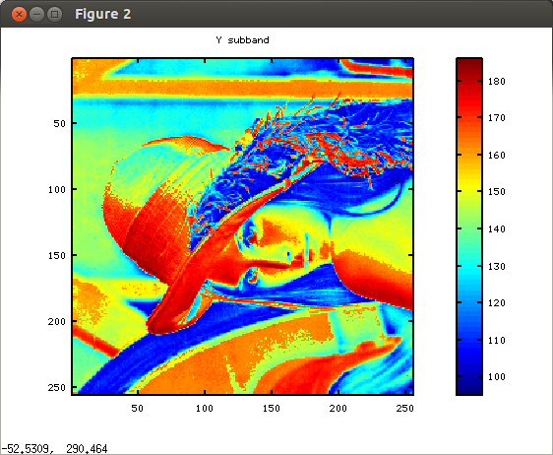

Y dwt RPI2B

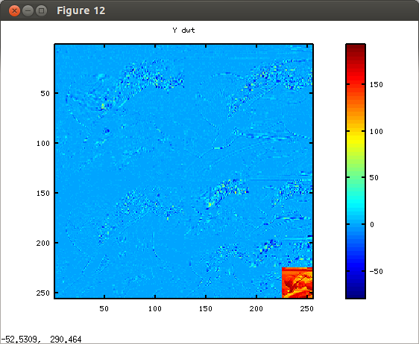

U computed RPi2B.

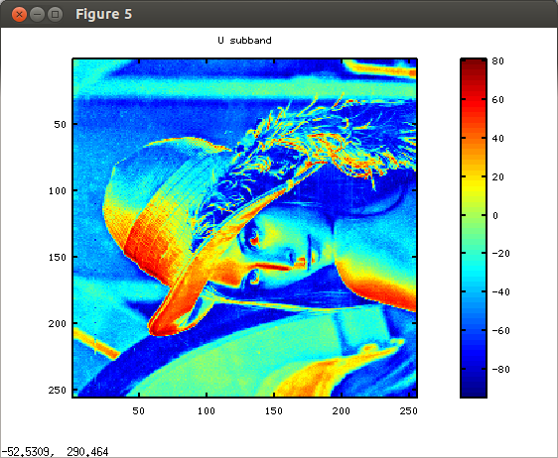

U dwt RPI2B

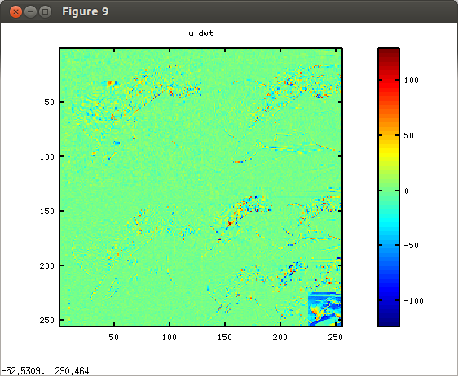

V computed RPi2B.

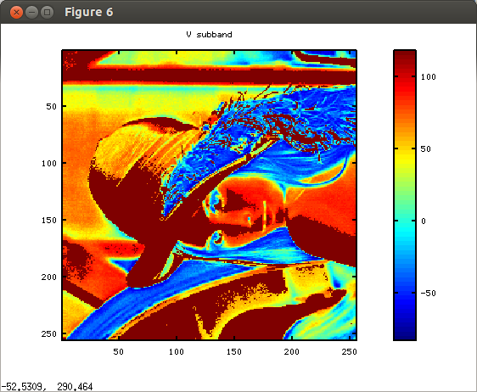

Vdwt RPI2B

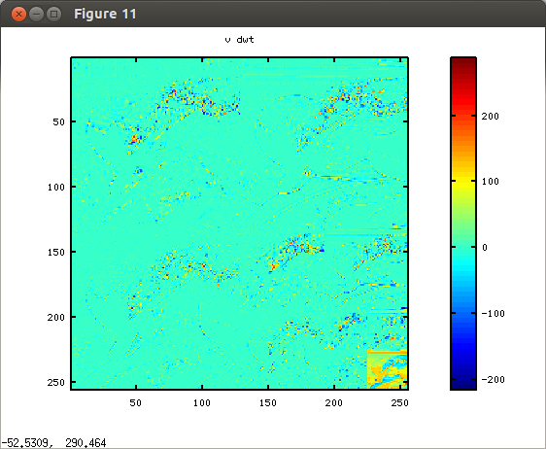

Y fwd inv zipcpu

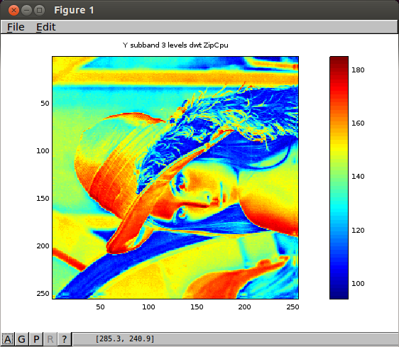

U fwd inv zipcpu

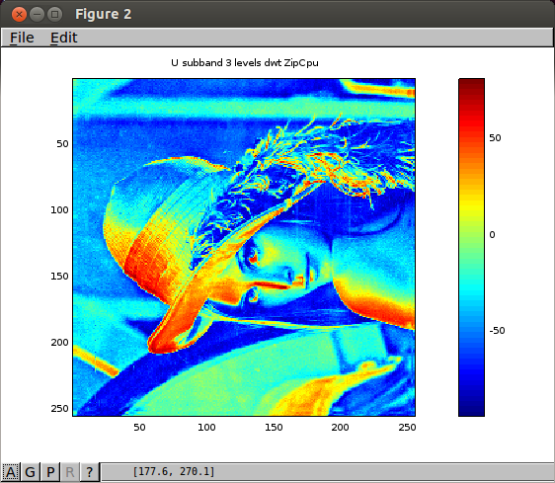

V fwd inv zipcpu

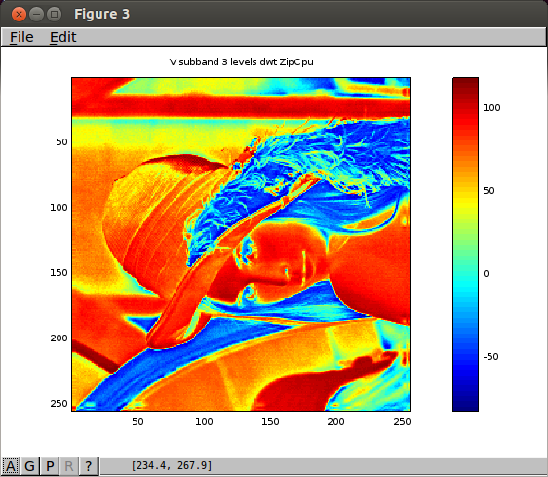

Y fwd zipcpu

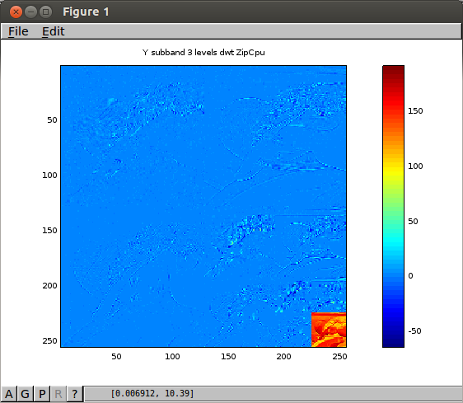

U fwd zipcpu

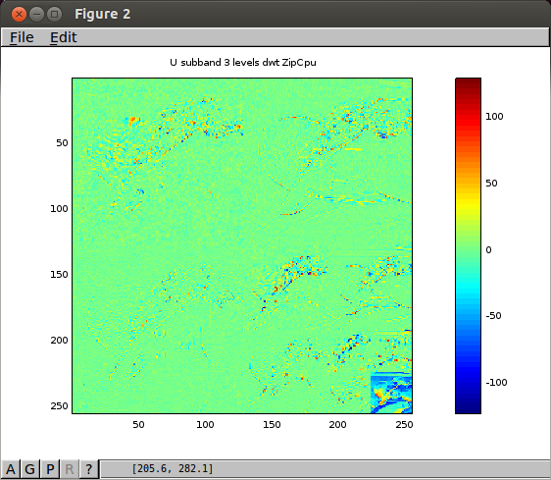

V fwd zipcpu

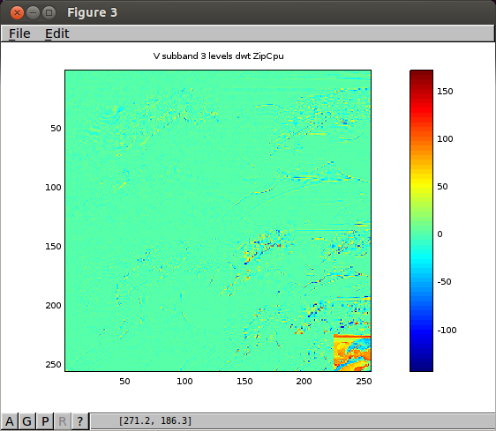

These were found in the Forward reversible MCT & Inverse reversible MCT
mct.c from openjpeg

yuv
y = (r + (g * 2) + b) >> 2;
u = b - g;
v = r – g;

invyuv
g = y - ((u + v) >> 2);
r = v + g;
b = u + g;

Transferred a 256 x 256 RGB image from the Rasberry Pi 2B RPi2B.
The data was transferred to the XuLA2-LX9 using the UART at 1MBaud.
The XuLA2-LX was running the Xulalx25soc & ZipCpu by
Creator: Dan Gisselquist, Ph.D.
Gisselquist Technology, LLC

The programming of the ZipCpu is done in C with zip-gcc
which was also developed by Dan Gisselquist, Ph.D.

zip-gcc -v
Using built-in specs.
COLLECT_GCC=zip-gcc
COLLECT_LTO_WRAPPER=/home/pi/zipcpu/trunk/sw/install/cross-tools/libexec/gcc/zip/5.3.0/lto-wrapper
Target: zip
Configured with: ../gcc-5.3.0-zip/configure --with-gas --prefix=/home/pi/zipcpu/trunk/sw/install/cross-tools
--target=zip --host=x86_64-cross-linux-gnu --with-sysroot=/home/pi/zipcpu/trunk/sw/install
--with-lib-path=/home/pi/zipcpu/trunk/sw/install/tools/lib
--with-local-prefix=/home/pi/zipcpu/trunk/sw/install/usr --with-pkgversion=zip-gcc-160609
--disable-shared --disable-multilib --disable-threads --disable-tls --disable-libada
--disable-libsanitizer --disable-libssp --disable-libquadmath --disable-libgomp --disable-libvtv
--enable-checking --disable-nls --disable-sjlj-exceptions --disable-decimal-float
--disable-fixed-point --disable-lto --disable-canonical-system-headers
Thread model: single
gcc version 5.3.0 (zip-gcc-160609)
binutils-2.25 is also availble for the zipcpu.

The file “lifting.c” is used both by the ZipCpu and the Rpi2B. In the Rpi2B it is called by
The file “build_call_even.sh” compiles and links the files lifting.c & call_even_odd_de_inter.c

#!/bin/bash
rm -f call_even_odd_de_inter
gcc -c lifting.c -o lifting.o
gcc call_even_odd_de_inter.c lifting.o -o call_even_odd_de_inter

Red subband

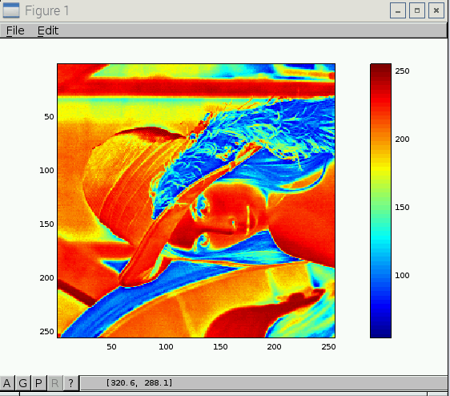

red 1 level of dwt results in 128 x 128 zipcpu.

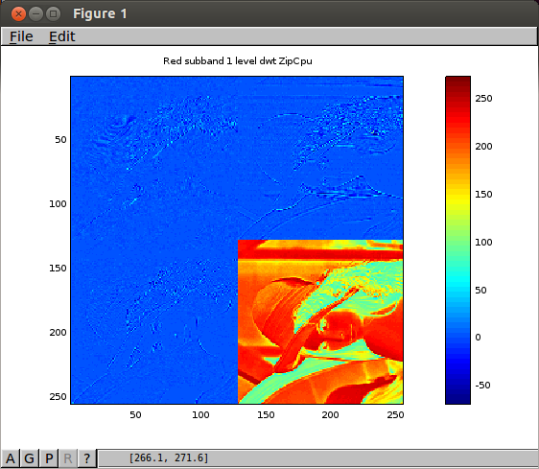

red 2 levels dwt results 64 x 64 zipcpu
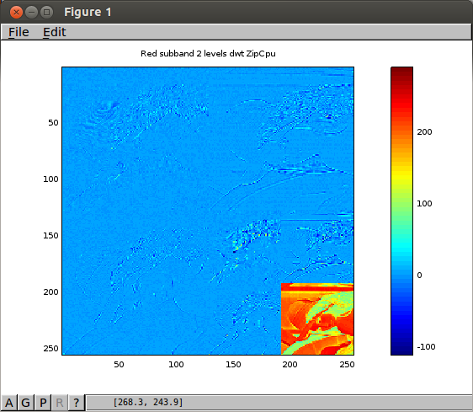

red 3 levels of dwt results in 32 x 32 zipcpu.

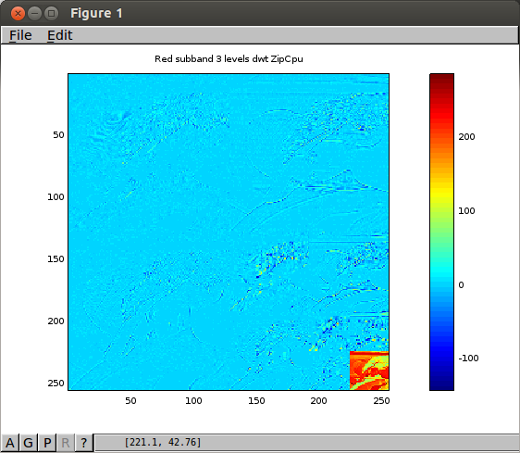

green subband

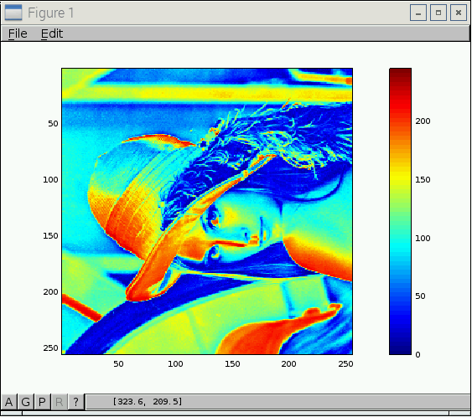

green 1 level of dwt results in 128 x 128 zipcpu

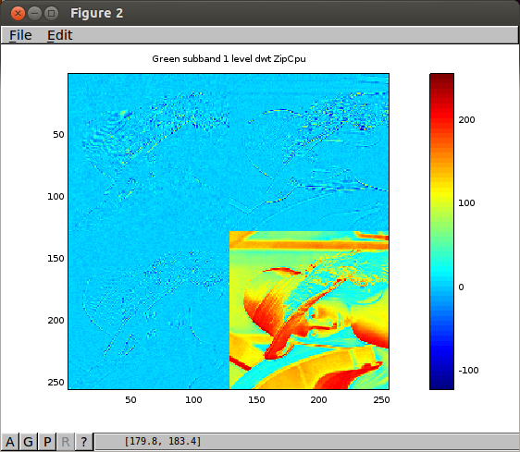

green 2 levels of dwt results in 64 x 64 zipcpu.

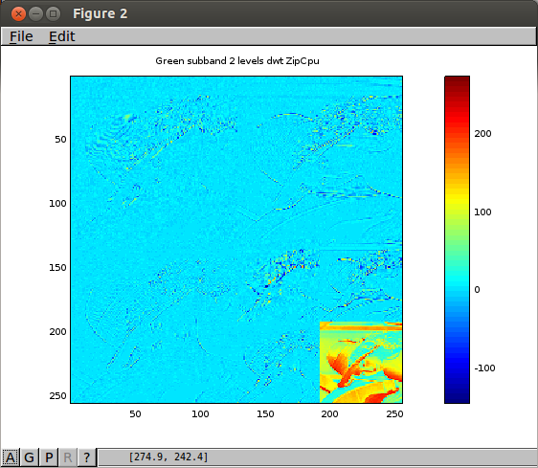

green 3 levels of dwt results in 32 x 32 zipcpu

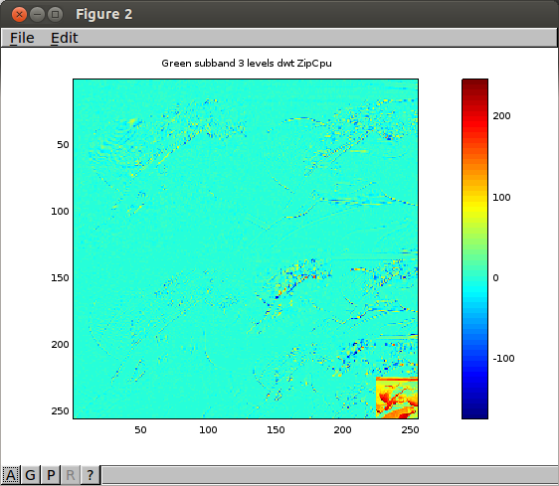
blue subband

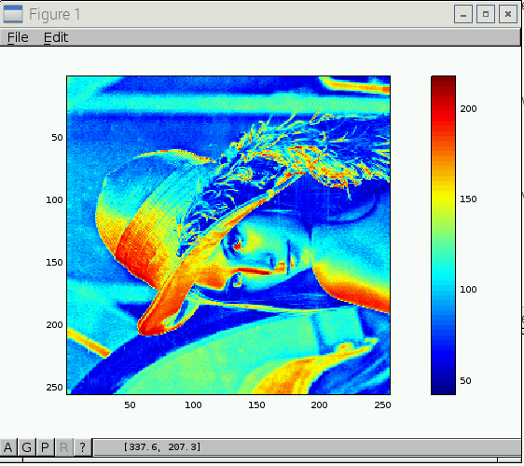

blue 1 level of dwt results in 128 x 128 zipcpu

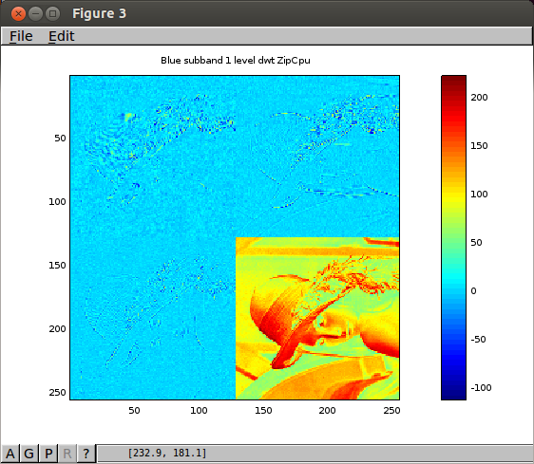

blue 2 levels of dwt results in 64 x 64 zipcpu

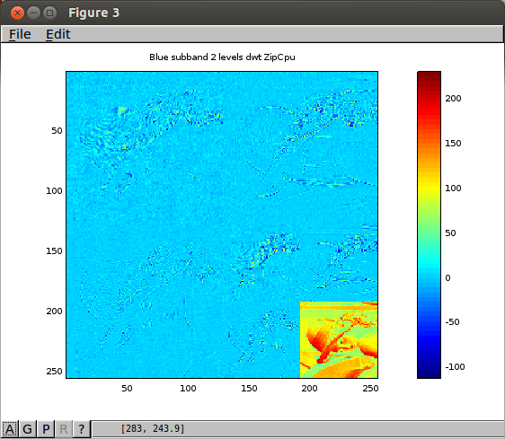

blue 3 levels of dwt results in 32 x 32 zipcpu

