These 3 states are for testing the Sdram is functioning correctly.
During the INIT state writes to addr_x 0x010000 0x0000.
During the WRITE state writes to addr_x 0x010001 to 0x010005 the values 0x0001 to 0x0005.

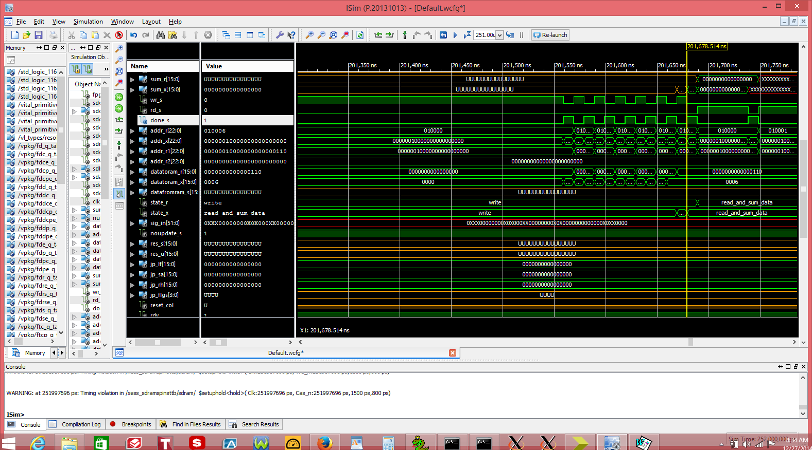

During the READ_AND_SUM_DATA state the data that was written during the INIT and WRITE states is read and a summed.

0x0000 + 0x0001 + 0x0002 + 0x0003 + 0x0004 + 0x0005 = 0x000f
During the EVEN_SAMPLES the offset_x starts at 0x000000 to 0x00ff00 and is increased by 256 when the reset_col is hi. To go thur the 256 col and 256 row it takes 3.974 ms.
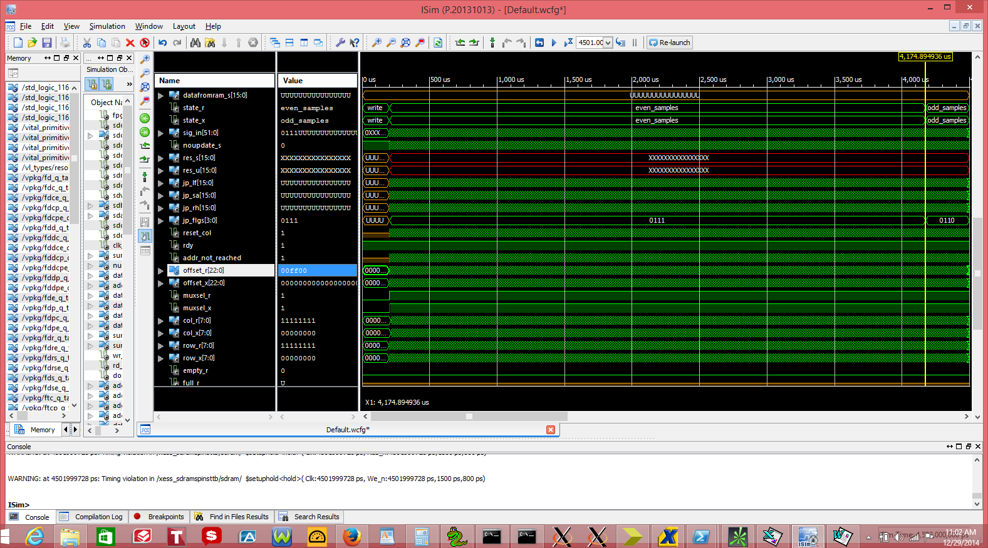

During the reset_col hi the values of jp_lf, jp_sa, and jp_rh are reset to 0x0000 and the addr_r is set 1 plus the offset_r when jp_flgs equals 0x7 or 0 + plus the offset_r when jp_flgs equals 0x6.
 |  | even
1 | 3 | 3 | 5 | 5 | 251 | 253 | 253 | 255 | 255
257 |  | 259 |  | 261 | 507 |  | 509 |  | 511
513 |  | 515 |  | 517 | 763 |  | 765 |  | 767
769 |  | 771 |  | 773 | 1019 |  | 1021 |  | 1023
1025 |  | 1027 |  | 1029 | 1275 |  | 1277 |  | 1279
1281 |  | 1283 |  | 1285 | 1531 |  | 1533 |  | 1535
1537 |  | 1539 |  | 1541 | 1787 |  | 1789 |  | 1791
1793 |  | 1795 |  | 1797 | 2043 |  | 2045 |  | 2047
2049 |  | 2051 |  | 2053 | 2299 |  | 2301 |  | 2303
2305 |  | 2307 |  | 2309 | 2555 |  | 2557 |  | 2559
2561 |  | 2563 |  | 2565 | 2811 |  | 2813 |  | 2815
2817 |  | 2819 |  | 2821 | 3067 |  | 3069 |  | 3071
3073 |  | 3075 |  | 3077 | 3323 |  | 3325 |  | 3327
3329 |  | 3331 |  | 3333 | 3579 |  | 3581 |  | 3583
3585 |  | 3587 |  | 3589 | 3835 |  | 3837 |  | 3839
3841 |  | 3843 |  | 3845 | 4091 |  | 4093 |  | 4095
4097 |  | 4099 |  | 4101 | 4347 |  | 4349 |  | 4351
4353 |  | 4355 |  | 4357 | 4603 |  | 4605 |  | 4607
4609 |  | 4611 |  | 4613 | 4859 |  | 4861 |  | 4863
4865 |  | 4867 |  | 4869 | 5115 |  | 5117 |  | 5119
5121 |  | 5123 |  | 5125 | 5371 |  | 5373 |  | 5375
5377 |  | 5379 |  | 5381 | 5627 |  | 5629 |  | 5631
5633 |  | 5635 |  | 5637 | 5883 |  | 5885 |  | 5887
5889 |  | 5891 |  | 5893 | 6139 |  | 6141 |  | 6143
6145 |  | 6147 |  | 6149 | 6395 |  | 6397 |  | 6399
6401 |  | 6403 |  | 6405 | 6651 |  | 6653 |  | 6655
6657 |  | 6659 |  | 6661 | 6907 |  | 6909 |  | 6911
6913 |  | 6915 |  | 6917 | 7163 |  | 7165 |  | 7167
7169 |  | 7171 |  | 7173 | 7419 |  | 7421 |  | 7423
7425 |  | 7427 |  | 7429 | 7675 |  | 7677 |  | 7679
7681 |  | 7683 |  | 7685 | 7931 |  | 7933 |  | 7935
7937 |  | 7939 |  | 7941 | 8187 |  | 8189 |  | 8191
8193 |  | 8195 |  | 8197 | 8443 |  | 8445 |  | 8447
8449 |  | 8451 |  | 8453 | 8699 |  | 8701 |  | 8703
8705 |  | 8707 |  | 8709 | 8955 |  | 8957 |  | 8959
8961 |  | 8963 |  | 8965 | 9211 |  | 9213 |  | 9215
9217 |  | 9219 |  | 9221 | 9467 |  | 9469 |  | 9471
9473 |  | 9475 |  | 9477 | 9723 |  | 9725 |  | 9727
9729 |  | 9731 |  | 9733 | 9979 |  | 9981 |  | 9983
9985 |  | 9987 |  | 9989 | 10235 |  | 10237 |  | 10239
10241 |  | 10243 |  | 10245 | 10491 |  | 10493 |  | 10495
10497 |  | 10499 |  | 10501 | 10747 |  | 10749 |  | 10751
10753 |  | 10755 |  | 10757 | 11003 |  | 11005 |  | 11007
11009 |  | 11011 |  | 11013 | 11259 |  | 11261 |  | 11263
11265 |  | 11267 |  | 11269 | 11515 |  | 11517 |  | 11519
11521 |  | 11523 |  | 11525 | 11771 |  | 11773 |  | 11775
11777 |  | 11779 |  | 11781 | 12027 |  | 12029 |  | 12031
12033 |  | 12035 |  | 12037 | 12283 |  | 12285 |  | 12287
12289 |  | 12291 |  | 12293 | 12539 |  | 12541 |  | 12543
12545 |  | 12547 |  | 12549 | 12795 |  | 12797 |  | 12799
12801 |  | 12803 |  | 12805 | 13051 |  | 13053 |  | 13055
13057 |  | 13059 |  | 13061 | 13307 |  | 13309 |  | 13311
13313 |  | 13315 |  | 13317 | 13563 |  | 13565 |  | 13567
13569 |  | 13571 |  | 13573 | 13819 |  | 13821 |  | 13823
13825 |  | 13827 |  | 13829 | 14075 |  | 14077 |  | 14079
14081 |  | 14083 |  | 14085 | 14331 |  | 14333 |  | 14335
14337 |  | 14339 |  | 14341 | 14587 |  | 14589 |  | 14591
14593 |  | 14595 |  | 14597 | 14843 |  | 14845 |  | 14847
14849 |  | 14851 |  | 14853 | 15099 |  | 15101 |  | 15103
15105 |  | 15107 |  | 15109 | 15355 |  | 15357 |  | 15359
15361 |  | 15363 |  | 15365 | 15611 |  | 15613 |  | 15615
15617 |  | 15619 |  | 15621 | 15867 |  | 15869 |  | 15871
15873 |  | 15875 |  | 15877 | 16123 |  | 16125 |  | 16127
16129 |  | 16131 |  | 16133 | 16379 |  | 16381 |  | 16383
16385 |  | 16387 |  | 16389 | 16635 |  | 16637 |  | 16639
16641 |  | 16643 |  | 16645 | 16891 |  | 16893 |  | 16895
16897 |  | 16899 |  | 16901 | 17147 |  | 17149 |  | 17151
17153 |  | 17155 |  | 17157 | 17403 |  | 17405 |  | 17407
17409 |  | 17411 |  | 17413 | 17659 |  | 17661 |  | 17663
17665 |  | 17667 |  | 17669 | 17915 |  | 17917 |  | 17919
17921 |  | 17923 |  | 17925 | 18171 |  | 18173 |  | 18175
18177 |  | 18179 |  | 18181 | 18427 |  | 18429 |  | 18431
18433 |  | 18435 |  | 18437 | 18683 |  | 18685 |  | 18687
18689 |  | 18691 |  | 18693 | 18939 |  | 18941 |  | 18943
18945 |  | 18947 |  | 18949 | 19195 |  | 19197 |  | 19199
19201 |  | 19203 |  | 19205 | 19451 |  | 19453 |  | 19455
19457 |  | 19459 |  | 19461 | 19707 |  | 19709 |  | 19711
19713 |  | 19715 |  | 19717 | 19963 |  | 19965 |  | 19967
19969 |  | 19971 |  | 19973 | 20219 |  | 20221 |  | 20223
20225 |  | 20227 |  | 20229 | 20475 |  | 20477 |  | 20479
20481 |  | 20483 |  | 20485 | 20731 |  | 20733 |  | 20735
20737 |  | 20739 |  | 20741 | 20987 |  | 20989 |  | 20991
20993 |  | 20995 |  | 20997 | 21243 |  | 21245 |  | 21247
21249 |  | 21251 |  | 21253 | 21499 |  | 21501 |  | 21503
21505 |  | 21507 |  | 21509 | 21755 |  | 21757 |  | 21759
21761 |  | 21763 |  | 21765 | 22011 |  | 22013 |  | 22015
22017 |  | 22019 |  | 22021 | 22267 |  | 22269 |  | 22271
22273 |  | 22275 |  | 22277 | 22523 |  | 22525 |  | 22527
22529 |  | 22531 |  | 22533 | 22779 |  | 22781 |  | 22783
22785 |  | 22787 |  | 22789 | 23035 |  | 23037 |  | 23039
23041 |  | 23043 |  | 23045 | 23291 |  | 23293 |  | 23295
23297 |  | 23299 |  | 23301 | 23547 |  | 23549 |  | 23551
23553 |  | 23555 |  | 23557 | 23803 |  | 23805 |  | 23807
23809 |  | 23811 |  | 23813 | 24059 |  | 24061 |  | 24063
24065 |  | 24067 |  | 24069 | 24315 |  | 24317 |  | 24319
24321 |  | 24323 |  | 24325 | 24571 |  | 24573 |  | 24575
24577 |  | 24579 |  | 24581 | 24827 |  | 24829 |  | 24831
24833 |  | 24835 |  | 24837 | 25083 |  | 25085 |  | 25087
25089 |  | 25091 |  | 25093 | 25339 |  | 25341 |  | 25343
25345 |  | 25347 |  | 25349 | 25595 |  | 25597 |  | 25599
25601 |  | 25603 |  | 25605 | 25851 |  | 25853 |  | 25855
25857 |  | 25859 |  | 25861 | 26107 |  | 26109 |  | 26111
26113 |  | 26115 |  | 26117 | 26363 |  | 26365 |  | 26367
26369 |  | 26371 |  | 26373 | 26619 |  | 26621 |  | 26623
26625 |  | 26627 |  | 26629 | 26875 |  | 26877 |  | 26879
26881 |  | 26883 |  | 26885 | 27131 |  | 27133 |  | 27135
27137 |  | 27139 |  | 27141 | 27387 |  | 27389 |  | 27391
27393 |  | 27395 |  | 27397 | 27643 |  | 27645 |  | 27647
27649 |  | 27651 |  | 27653 | 27899 |  | 27901 |  | 27903
27905 |  | 27907 |  | 27909 | 28155 |  | 28157 |  | 28159
28161 |  | 28163 |  | 28165 | 28411 |  | 28413 |  | 28415
28417 |  | 28419 |  | 28421 | 28667 |  | 28669 |  | 28671
28673 |  | 28675 |  | 28677 | 28923 |  | 28925 |  | 28927
28929 |  | 28931 |  | 28933 | 29179 |  | 29181 |  | 29183
29185 |  | 29187 |  | 29189 | 29435 |  | 29437 |  | 29439
29441 |  | 29443 |  | 29445 | 29691 |  | 29693 |  | 29695
29697 |  | 29699 |  | 29701 | 29947 |  | 29949 |  | 29951
29953 |  | 29955 |  | 29957 | 30203 |  | 30205 |  | 30207
30209 |  | 30211 |  | 30213 | 30459 |  | 30461 |  | 30463
30465 |  | 30467 |  | 30469 | 30715 |  | 30717 |  | 30719
30721 |  | 30723 |  | 30725 | 30971 |  | 30973 |  | 30975
30977 |  | 30979 |  | 30981 | 31227 |  | 31229 |  | 31231
31233 |  | 31235 |  | 31237 | 31483 |  | 31485 |  | 31487
31489 |  | 31491 |  | 31493 | 31739 |  | 31741 |  | 31743
31745 |  | 31747 |  | 31749 | 31995 |  | 31997 |  | 31999
32001 |  | 32003 |  | 32005 | 32251 |  | 32253 |  | 32255
32257 |  | 32259 |  | 32261 | 32507 |  | 32509 |  | 32511
32513 |  | 32515 |  | 32517 | 32763 |  | 32765 |  | 32767
32769 |  | 32771 |  | 32773 | 33019 |  | 33021 |  | 33023
33025 |  | 33027 |  | 33029 | 33275 |  | 33277 |  | 33279
33281 |  | 33283 |  | 33285 | 33531 |  | 33533 |  | 33535
33537 |  | 33539 |  | 33541 | 33787 |  | 33789 |  | 33791
33793 |  | 33795 |  | 33797 | 34043 |  | 34045 |  | 34047
34049 |  | 34051 |  | 34053 | 34299 |  | 34301 |  | 34303
34305 |  | 34307 |  | 34309 | 34555 |  | 34557 |  | 34559
34561 |  | 34563 |  | 34565 | 34811 |  | 34813 |  | 34815
34817 |  | 34819 |  | 34821 | 35067 |  | 35069 |  | 35071
35073 |  | 35075 |  | 35077 | 35323 |  | 35325 |  | 35327
35329 |  | 35331 |  | 35333 | 35579 |  | 35581 |  | 35583
35585 |  | 35587 |  | 35589 | 35835 |  | 35837 |  | 35839
35841 |  | 35843 |  | 35845 | 36091 |  | 36093 |  | 36095
36097 |  | 36099 |  | 36101 | 36347 |  | 36349 |  | 36351
36353 |  | 36355 |  | 36357 | 36603 |  | 36605 |  | 36607
36609 |  | 36611 |  | 36613 | 36859 |  | 36861 |  | 36863
36865 |  | 36867 |  | 36869 | 37115 |  | 37117 |  | 37119
37121 |  | 37123 |  | 37125 | 37371 |  | 37373 |  | 37375
37377 |  | 37379 |  | 37381 | 37627 |  | 37629 |  | 37631
37633 |  | 37635 |  | 37637 | 37883 |  | 37885 |  | 37887
37889 |  | 37891 |  | 37893 | 38139 |  | 38141 |  | 38143
38145 |  | 38147 |  | 38149 | 38395 |  | 38397 |  | 38399
38401 |  | 38403 |  | 38405 | 38651 |  | 38653 |  | 38655
38657 |  | 38659 |  | 38661 | 38907 |  | 38909 |  | 38911
38913 |  | 38915 |  | 38917 | 39163 |  | 39165 |  | 39167
39169 |  | 39171 |  | 39173 | 39419 |  | 39421 |  | 39423
39425 |  | 39427 |  | 39429 | 39675 |  | 39677 |  | 39679
39681 |  | 39683 |  | 39685 | 39931 |  | 39933 |  | 39935
39937 |  | 39939 |  | 39941 | 40187 |  | 40189 |  | 40191
40193 |  | 40195 |  | 40197 | 40443 |  | 40445 |  | 40447
40449 |  | 40451 |  | 40453 | 40699 |  | 40701 |  | 40703
40705 |  | 40707 |  | 40709 | 40955 |  | 40957 |  | 40959
40961 |  | 40963 |  | 40965 | 41211 |  | 41213 |  | 41215
41217 |  | 41219 |  | 41221 | 41467 |  | 41469 |  | 41471
41473 |  | 41475 |  | 41477 | 41723 |  | 41725 |  | 41727
41729 |  | 41731 |  | 41733 | 41979 |  | 41981 |  | 41983
41985 |  | 41987 |  | 41989 | 42235 |  | 42237 |  | 42239
42241 |  | 42243 |  | 42245 | 42491 |  | 42493 |  | 42495
42497 |  | 42499 |  | 42501 | 42747 |  | 42749 |  | 42751
42753 |  | 42755 |  | 42757 | 43003 |  | 43005 |  | 43007
43009 |  | 43011 |  | 43013 | 43259 |  | 43261 |  | 43263
43265 |  | 43267 |  | 43269 | 43515 |  | 43517 |  | 43519
43521 |  | 43523 |  | 43525 | 43771 |  | 43773 |  | 43775
43777 |  | 43779 |  | 43781 | 44027 |  | 44029 |  | 44031
44033 |  | 44035 |  | 44037 | 44283 |  | 44285 |  | 44287
44289 |  | 44291 |  | 44293 | 44539 |  | 44541 |  | 44543
44545 |  | 44547 |  | 44549 | 44795 |  | 44797 |  | 44799
44801 |  | 44803 |  | 44805 | 45051 |  | 45053 |  | 45055
45057 |  | 45059 |  | 45061 | 45307 |  | 45309 |  | 45311
45313 |  | 45315 |  | 45317 | 45563 |  | 45565 |  | 45567
45569 |  | 45571 |  | 45573 | 45819 |  | 45821 |  | 45823
45825 |  | 45827 |  | 45829 | 46075 |  | 46077 |  | 46079
46081 |  | 46083 |  | 46085 | 46331 |  | 46333 |  | 46335
46337 |  | 46339 |  | 46341 | 46587 |  | 46589 |  | 46591
46593 |  | 46595 |  | 46597 | 46843 |  | 46845 |  | 46847
46849 |  | 46851 |  | 46853 | 47099 |  | 47101 |  | 47103
47105 |  | 47107 |  | 47109 | 47355 |  | 47357 |  | 47359
47361 |  | 47363 |  | 47365 | 47611 |  | 47613 |  | 47615
47617 |  | 47619 |  | 47621 | 47867 |  | 47869 |  | 47871
47873 |  | 47875 |  | 47877 | 48123 |  | 48125 |  | 48127
48129 |  | 48131 |  | 48133 | 48379 |  | 48381 |  | 48383
48385 |  | 48387 |  | 48389 | 48635 |  | 48637 |  | 48639
48641 |  | 48643 |  | 48645 | 48891 |  | 48893 |  | 48895
48897 |  | 48899 |  | 48901 | 49147 |  | 49149 |  | 49151
49153 |  | 49155 |  | 49157 | 49403 |  | 49405 |  | 49407
49409 |  | 49411 |  | 49413 | 49659 |  | 49661 |  | 49663
49665 |  | 49667 |  | 49669 | 49915 |  | 49917 |  | 49919
49921 |  | 49923 |  | 49925 | 50171 |  | 50173 |  | 50175
50177 |  | 50179 |  | 50181 | 50427 |  | 50429 |  | 50431
50433 |  | 50435 |  | 50437 | 50683 |  | 50685 |  | 50687
50689 |  | 50691 |  | 50693 | 50939 |  | 50941 |  | 50943
50945 |  | 50947 |  | 50949 | 51195 |  | 51197 |  | 51199
51201 |  | 51203 |  | 51205 | 51451 |  | 51453 |  | 51455
51457 |  | 51459 |  | 51461 | 51707 |  | 51709 |  | 51711
51713 |  | 51715 |  | 51717 | 51963 |  | 51965 |  | 51967
51969 |  | 51971 |  | 51973 | 52219 |  | 52221 |  | 52223
52225 |  | 52227 |  | 52229 | 52475 |  | 52477 |  | 52479
52481 |  | 52483 |  | 52485 | 52731 |  | 52733 |  | 52735
52737 |  | 52739 |  | 52741 | 52987 |  | 52989 |  | 52991
52993 |  | 52995 |  | 52997 | 53243 |  | 53245 |  | 53247
53249 |  | 53251 |  | 53253 | 53499 |  | 53501 |  | 53503
53505 |  | 53507 |  | 53509 | 53755 |  | 53757 |  | 53759
53761 |  | 53763 |  | 53765 | 54011 |  | 54013 |  | 54015
54017 |  | 54019 |  | 54021 | 54267 |  | 54269 |  | 54271
54273 |  | 54275 |  | 54277 | 54523 |  | 54525 |  | 54527
54529 |  | 54531 |  | 54533 | 54779 |  | 54781 |  | 54783
54785 |  | 54787 |  | 54789 | 55035 |  | 55037 |  | 55039
55041 |  | 55043 |  | 55045 | 55291 |  | 55293 |  | 55295
55297 |  | 55299 |  | 55301 | 55547 |  | 55549 |  | 55551
55553 |  | 55555 |  | 55557 | 55803 |  | 55805 |  | 55807
55809 |  | 55811 |  | 55813 | 56059 |  | 56061 |  | 56063
56065 |  | 56067 |  | 56069 | 56315 |  | 56317 |  | 56319
56321 |  | 56323 |  | 56325 | 56571 |  | 56573 |  | 56575
56577 |  | 56579 |  | 56581 | 56827 |  | 56829 |  | 56831
56833 |  | 56835 |  | 56837 | 57083 |  | 57085 |  | 57087
57089 |  | 57091 |  | 57093 | 57339 |  | 57341 |  | 57343
57345 |  | 57347 |  | 57349 | 57595 |  | 57597 |  | 57599
57601 |  | 57603 |  | 57605 | 57851 |  | 57853 |  | 57855
57857 |  | 57859 |  | 57861 | 58107 |  | 58109 |  | 58111
58113 |  | 58115 |  | 58117 | 58363 |  | 58365 |  | 58367
58369 |  | 58371 |  | 58373 | 58619 |  | 58621 |  | 58623
58625 |  | 58627 |  | 58629 | 58875 |  | 58877 |  | 58879
58881 |  | 58883 |  | 58885 | 59131 |  | 59133 |  | 59135
59137 |  | 59139 |  | 59141 | 59387 |  | 59389 |  | 59391
59393 |  | 59395 |  | 59397 | 59643 |  | 59645 |  | 59647
59649 |  | 59651 |  | 59653 | 59899 |  | 59901 |  | 59903
59905 |  | 59907 |  | 59909 | 60155 |  | 60157 |  | 60159
60161 |  | 60163 |  | 60165 | 60411 |  | 60413 |  | 60415
60417 |  | 60419 |  | 60421 | 60667 |  | 60669 |  | 60671
60673 |  | 60675 |  | 60677 | 60923 |  | 60925 |  | 60927
60929 |  | 60931 |  | 60933 | 61179 |  | 61181 |  | 61183
61185 |  | 61187 |  | 61189 | 61435 |  | 61437 |  | 61439
61441 |  | 61443 |  | 61445 | 61691 |  | 61693 |  | 61695
61697 |  | 61699 |  | 61701 | 61947 |  | 61949 |  | 61951
61953 |  | 61955 |  | 61957 | 62203 |  | 62205 |  | 62207
62209 |  | 62211 |  | 62213 | 62459 |  | 62461 |  | 62463
62465 |  | 62467 |  | 62469 | 62715 |  | 62717 |  | 62719
62721 |  | 62723 |  | 62725 | 62971 |  | 62973 |  | 62975
62977 |  | 62979 |  | 62981 | 63227 |  | 63229 |  | 63231
63233 |  | 63235 |  | 63237 | 63483 |  | 63485 |  | 63487
63489 |  | 63491 |  | 63493 | 63739 |  | 63741 |  | 63743
63745 |  | 63747 |  | 63749 | 63995 |  | 63997 |  | 63999
64001 |  | 64003 |  | 64005 | 64251 |  | 64253 |  | 64255
64257 |  | 64259 |  | 64261 | 64507 |  | 64509 |  | 64511
64513 |  | 64515 |  | 64517 | 64763 |  | 64765 |  | 64767
64769 |  | 64771 |  | 64773 | 65019 |  | 65021 |  | 65023
65025 |  | 65027 |  | 65029 | 65275 |  | 65277 |  | 65279
65281 |  | 65283 |  | 65285 | 65531 |  | 65533 |  | 65535
For the even_sa and odd_sa it takes approximately8ms when performing the jpeg process on the columns.
This time will increase since we need to save the results in a DualPort Sdram or a Fifo before performing a similar on the rows.

