Xilinx ISE with XESS XulA2-LX9 FPGA

The lifting scheme is the major component of the jpeg 2000. The document at https://github.com/develone/jpeg-2000-test/blob/master/ipython_fixbv/Paper_30-FPGA_Implementation_of_53_Integer_DWT_for_Image_Compression.pdf describes the lifting scheme.
In the View Raw the paper can be opened or downloaded.

Given 3 16 bit numbers left_s 00a3 163, sam_s 00a0 160, and right_s 009b 155. With the updated_s 1, even_odd_s 1, and fwd_inv_1 the result res_s is 2. The verilog code is found at Appendix A.
The left_s is multiplied by 0.5 and right_s is multiplied by 0.5 then the results are summed. Instead of multiplication the function is perform by shifting. The summed value is subtracted from the sam_s in the forward DWT and added in the inverse DWT.
In the example below the data was written to the SDram.
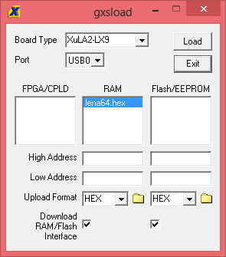

0x00a3 0x00a0 0x009b using the program gxsload.

This can be called from a wr.bat. cd "c:\Program Files (x86)\XSTOOLs"
xsload.exe -usb 0 -f hex -ram "c:\Users\vidal\My Documents\GitHub\jpeg-2000-test\ipython_fixbv\lena64.hex".

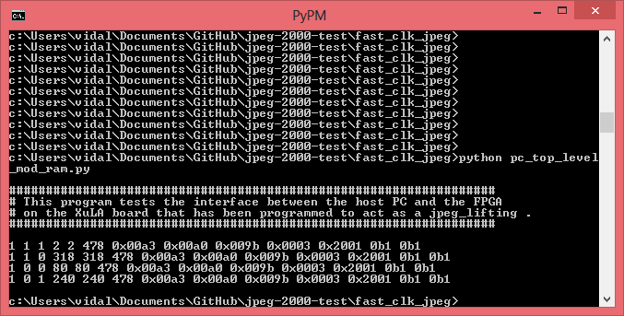

The results above are running on the fpga using the usb to communicate with the fpga.

A simulation can be run to test the verilog code.

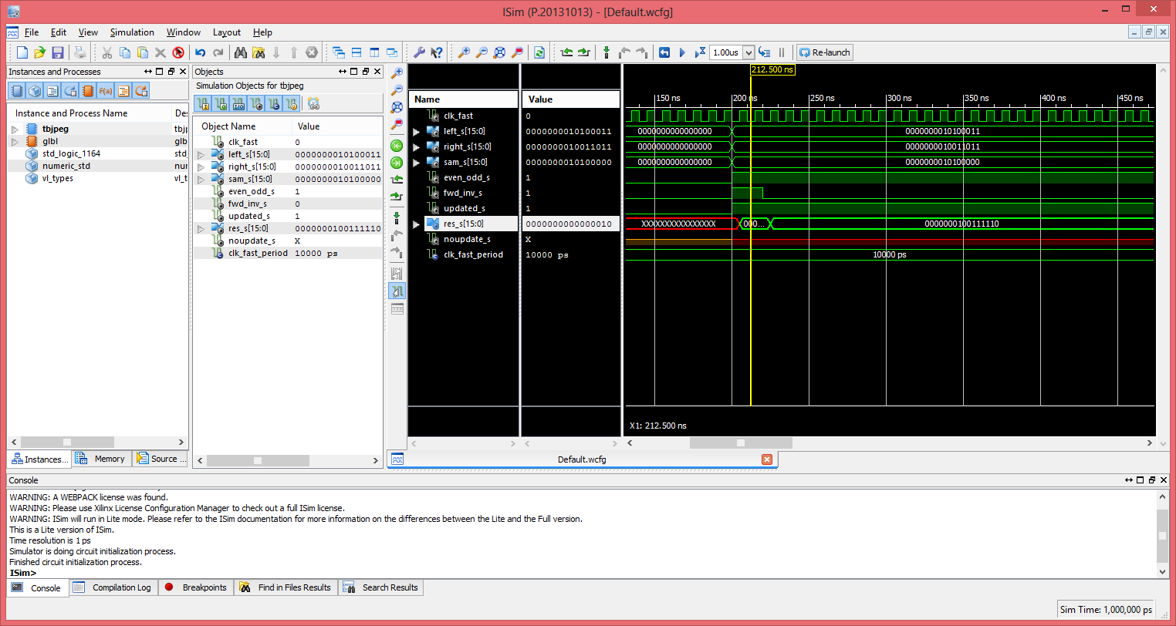

When the fwd_inv_s is changed to 0 the res_s changes to 318.
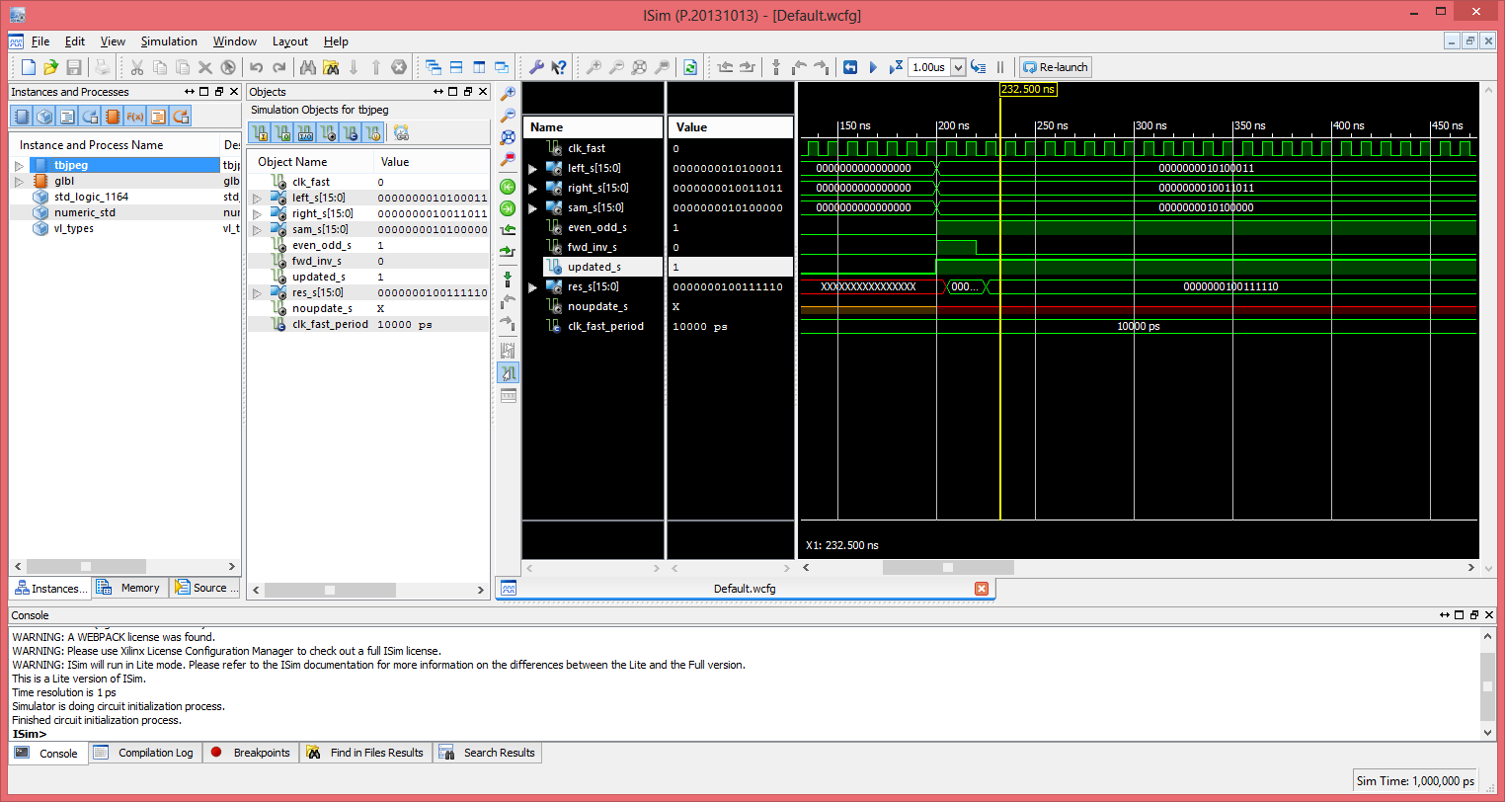

Appendix A

// File: jpeg.v
// Generated by MyHDL 0.9dev
// Date: Sat Sep 20 01:39:13 2014

`timescale 1ns/10ps

module jpeg (
clk_fast,
left_s,
right_s,
sam_s,
res_s,
even_odd_s,
fwd_inv_s,
updated_s,
noupdate_s
);

input clk_fast;
input signed [15:0] left_s;
input signed [15:0] right_s;
input signed [15:0] sam_s;
output signed [15:0] res_s;
reg signed [15:0] res_s;
input even_odd_s;
input fwd_inv_s;
input updated_s;
output noupdate_s;
reg noupdate_s;

always @(posedge clk_fast) begin: JPEG_HDL
if (updated_s) begin
if (even_odd_s) begin
if (fwd_inv_s) begin
res_s <= (sam_s - ($signed(left_s >>> 1) + $signed(right_s >>> 1)));
end
else begin
res_s <= (sam_s + ($signed(left_s >>> 1) + $signed(right_s >>> 1)));
end
end
else begin
if (fwd_inv_s) begin
res_s <= (sam_s + $signed(((left_s + right_s) + 2) >>> 2));
end
else begin
res_s <= (sam_s - $signed(((left_s + right_s) + 2) >>> 2));
end
end
end
else begin
noupdate_s <= 1;
end
end

endmodule

