XESS_SdramSPInst.vhd & XESS_SdramSPInstTB.vhd

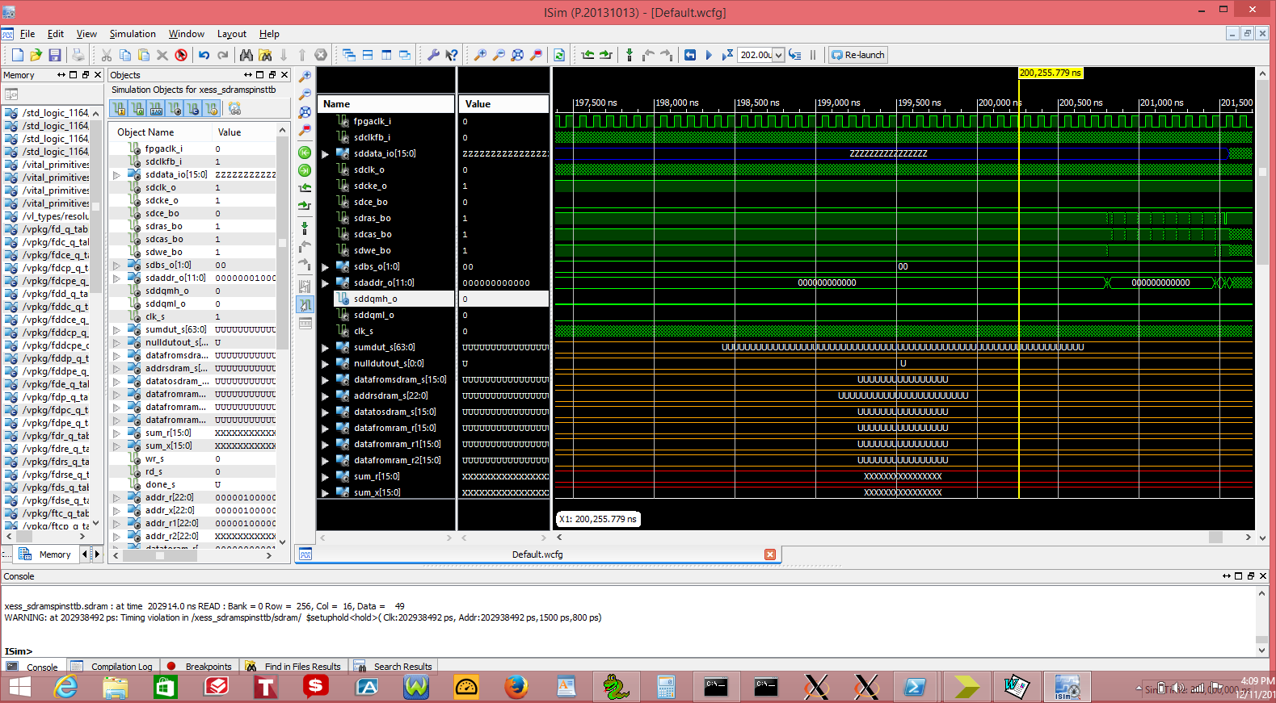

sdram signals

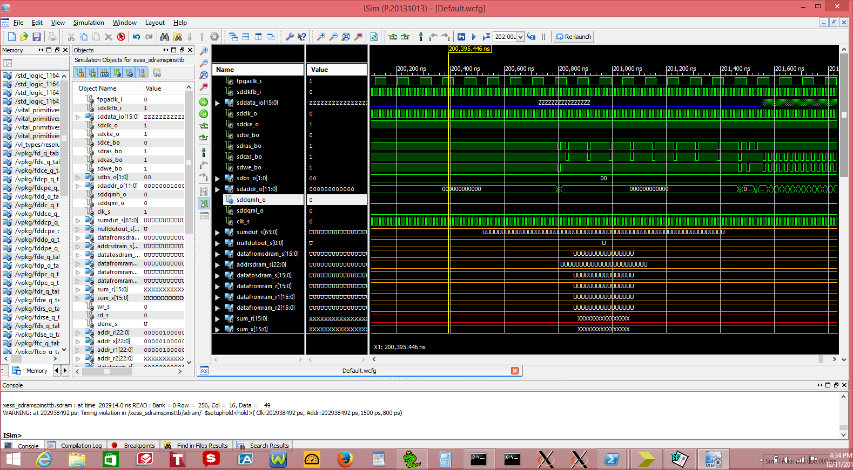

done_s not being toggled. as it was in SdramSPInst.

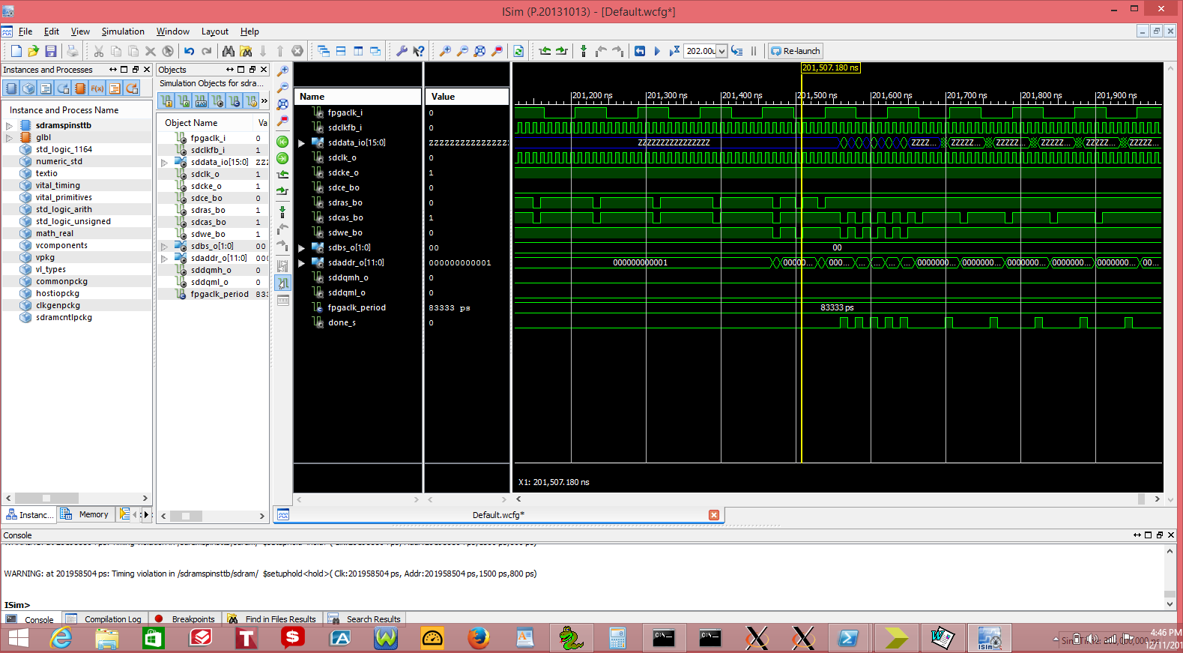

Adding the
--*********************************************************************
-- Instantiate the SDRAM controller that connects to the FSM
-- and interfaces to the external SDRAM chip.
--*********************************************************************
SdramCntl_u0 : SdramCntl and constants
Added the done_s and other signals toggling as expected.

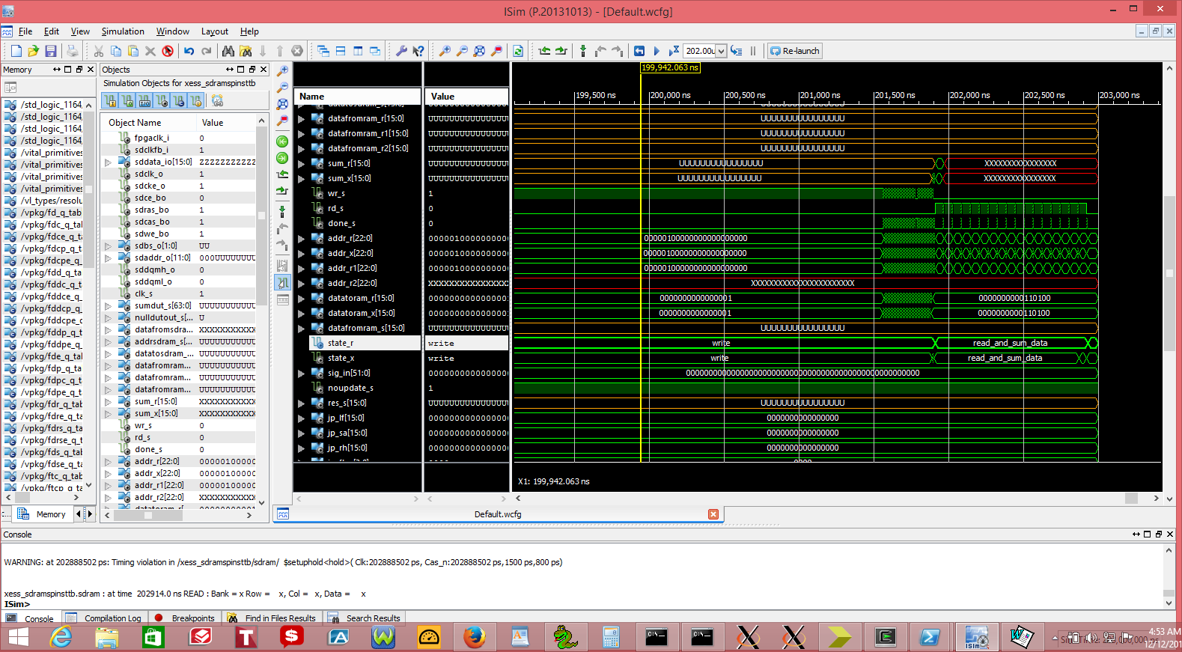

Testing FIFO that was recently added
The following signals are define in the xess_jpeg_top packaage
These appear to be Gobal Signals
You do not need component xess_jpeg_top is
port ( or a xess_jpeg_top_u0 : xess_jpeg_top
port map ( to use these only the signals below.

--signal needed by FIFO***************************
signal instance_6_dn_interface_rd_en: std_logic;
signal instance_6_up_interface_wr_en: std_logic;
signal instance_14_dout: unsigned(15 downto 0);
signal instance_14_empty: std_logic;
signal instance_13_full: std_logic;
signal instance_13_din: unsigned(15 downto 0);
--signal needed by FIFO***************************

Writing 1 to 4 in the FIFO

