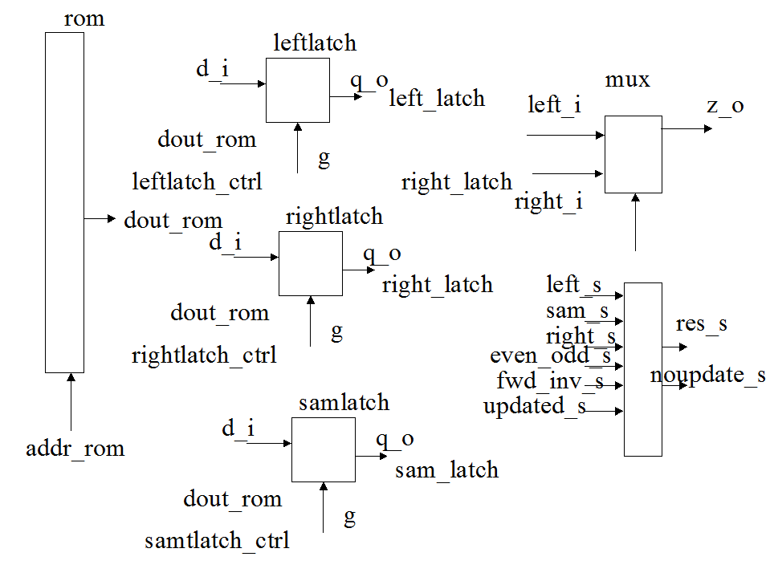
simulation left_s = 00A3 sam_s = 00A0 right_s = 009B dout_res = 00F0
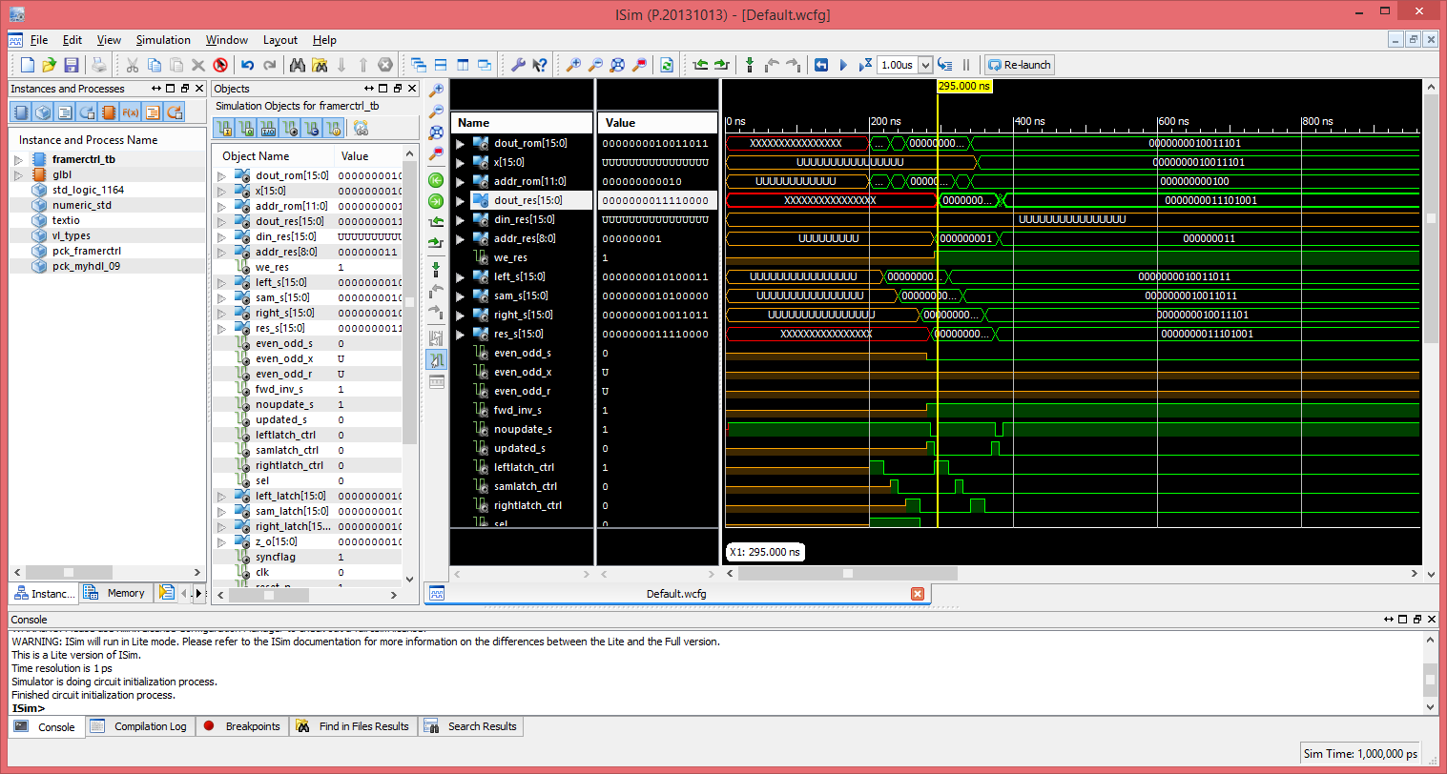

simulation left_s = 009B sam_s = 009B right_s = 009D dout_res = 00E9
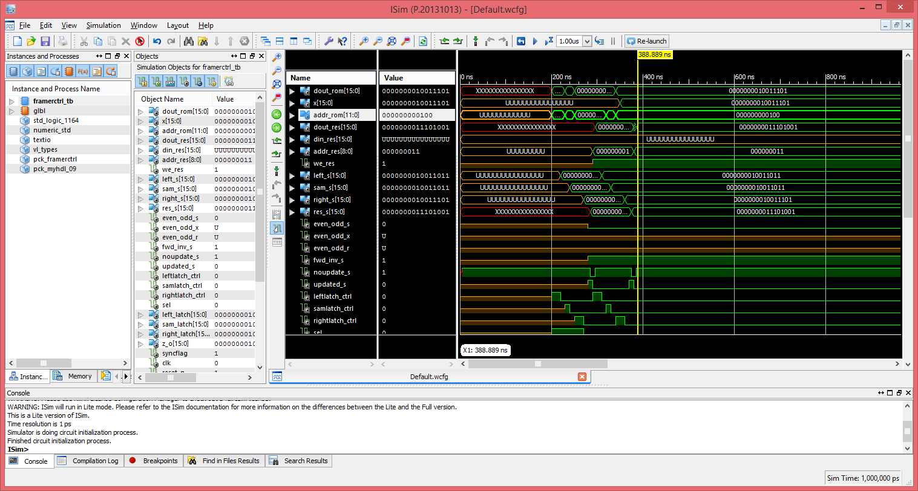
These files jpeg.v, latch.v, mux.v, rom.v, and ram.v were generated with jpeg2000.py.
COMPONENT mux
PORT(
z_o: out std_logic_vector(15 downto 0);
left_i: in std_logic_vector(15 downto 0);
right_i: in std_logic_vector(15 downto 0);
sel : IN std_logic
);
END COMPONENT;
COMPONENT latch
port (
q_o : out std_logic_vector(15 downto 0);
d_i : in std_logic_vector(15 downto 0);
g: in std_logic
);
END COMPONENT;
component jpeg is
port (
clk_fast: in std_logic;
left_s: in signed (15 downto 0);
right_s: in signed (15 downto 0);
sam_s: in signed (15 downto 0);
res_s: out signed (15 downto 0);
even_odd_s : in std_logic ;
fwd_inv_s : in std_logic;
updated_s : in std_logic;
noupdate_s : out std_logic
);
end component;
COMPONENT rom is
port (
dout_rom: out unsigned(15 downto 0);
addr_rom: in unsigned(11 downto 0)
);
end component;

COMPONENT ram
PORT(
dout : OUT unsigned(15 downto 0) := (others => '0');
din : IN unsigned(15 downto 0) := (others => '0');
addr : IN unsigned(8 downto 0) := (others => '0');
we : IN std_logic;
clk_fast : IN std_logic
);
END COMPONENT;
leftlatch : latch
port map (
q_o => left_latch,
d_i => std_logic_vector(dout_rom),
g => leftlatch_ctrl
);
samlatch : latch
port map (
q_o => sam_latch,
d_i => std_logic_vector(dout_rom),
g => samlatch_ctrl
);

rightlatch : latch
port map (
q_o => right_latch,
d_i => std_logic_vector(dout_rom),
g => rightlatch_ctrl
);
resram : ram
port map(
dout => dout_res,
din => unsigned(res_s),
addr => addr_res,
we => we_res,
--clk_fast => clk_i
clk_fast => clk
);
urom : rom
port map(
dout_rom => dout_rom,
addr_rom => addr_rom
);

ujpeg: jpeg
port map(
clk_fast => clk,
--clk_fast => clk_i,
left_s => signed(left_latch),
right_s => signed(dout_rom),
sam_s => signed(sam_latch),
res_s => res_s,
even_odd_s => even_odd_s,
fwd_inv_s => fwd_inv_s,
updated_s => updated_s,
noupdate_s => noupdate_s
);

