Testing UDP on Rpi3B Bare Metal with RPi2B Raspbian
01/05/17

Copied ~/Examples/Advanced/UDPServer/ to /home/pi/test_ultibo/RPi3

Note: Changing port from 514 to 5000 was needed too not run the python code as sudo.

In the file InitUnit.pas modified line 44 SYSLOG_PORT_DEFAULT:=514; to SYSLOG_PORT_DEFAULT:=5000;

In the file ServerUnit.pas modified line 147, 148, 214, and 215
//SendDataTo('192.168.123.123',514,PChar(MessageText),Length(MessageText));
SendDataTo('192.168.1.82',5000,PChar(MessageText),Length(MessageText));
{Set the port to listen on (5000 for SysLog)}
DemoUDPListener.BoundPort:=5000;

In the file UDPServer.lpr modified line 22

The following command creates the file kernel7.img

pi@raspberrypi2-142:~/test_ultibo/RPi3/UDPServer/RPi2 $ fpc -B -Tultibo -Parm -CpARMV7A -WpRPI3B @/home/pi/ultibo/core/fpc/bin/rpi3.cfg -O2 UDPServer.lpr

The above command requires fpc ultibo edition on the Rpi2B.

RaspberryPi2 to RaspberryPi3

Created the python program client.py

import socket
port = 5000
s = socket.socket(socket.AF_INET, socket.SOCK_DGRAM)
s.bind(("", port))
print "waiting on port:", port
while 1:
data, addr = s.recvfrom(1024)
print data
print addr

Running the client.py on RPi2B.

pi@raspberrypi2-142:~/test_ultibo/RPi3/UDPServer/RPi2 $ python client.py

pi@raspberrypi2-142:~/test_ultibo/RPi3/UDPServer/RPi2 $ python client.py
waiting on port: 5000
<14>Jan 05 21:47:58 192.168.1.181 00000537 - 00348AFC:0 - Logging message sent by Main at 5-1-17 21:47:58
('192.168.1.181', 5000)
<14>Jan 05 21:47:59 192.168.1.181 00000538 - 00348AFC:0 - Logging message sent by Main at 5-1-17 21:47:59
('192.168.1.181', 5000)
<14>Jan 05 21:48:00 192.168.1.181 00000539 - 00348AFC:0 - Logging message sent by Main at 5-1-17 21:48:00
('192.168.1.181', 5000)
<14>Jan 05 21:48:01 192.168.1.181 0000053A - 00348AFC:0 - Logging message sent by Main at 5-1-17 21:48:01
('192.168.1.181', 5000)

The image below is a picture running on RPi3B

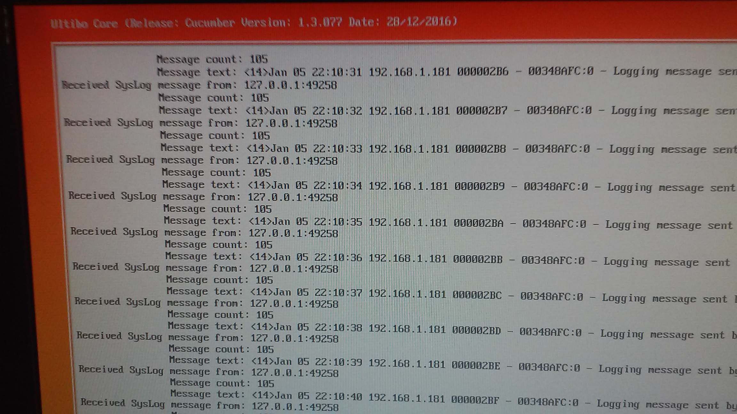
Appendix A InitUnit.pas

unit InitUnit;

{$mode objfpc}{$H+}

{ Advanced example - UDP Server }
{ }
{ This file is used during initialization of the program and allows us to make }
{ some changes to the startup behaviour so the built in SysLog client will send}
{ all logging entries to our example SysLog server. }

interface

uses
GlobalConst,
GlobalConfig;

implementation

initialization
{Disable File Logging}
FILESYS_REGISTER_LOGGING:=False;
FILESYS_LOGGING_DEFAULT:=False;

{Disable Serial Logging}
SERIAL_REGISTER_LOGGING:=False;
SERIAL_LOGGING_DEFAULT:=False;

{Disable Console Logging}
CONSOLE_REGISTER_LOGGING:=False;
CONSOLE_LOGGING_DEFAULT:=False;

{Configure SysLog Client}
{Make sure SysLog will start automatically}
SYSLOG_AUTOSTART:=True;

{Make sure SysLog registers as a logging device}
SYSLOG_REGISTER_LOGGING:=True;

{And make sure it is the default}
SYSLOG_LOGGING_DEFAULT:=True;

{Set SysLog to send logs to our UDP server}
SYSLOG_SERVER_DEFAULT:='127.0.0.1';
SYSLOG_PORT_DEFAULT:=5000;
SYSLOG_PROTOCOL_DEFAULT:=LOGGING_PROTOCOL_UDP;
end.

Appendix B. ServerUnit.pas

unit ServerUnit;

{$mode objfpc}{$H+}

{ Advanced example - UDP Server }
{ }
{ This file contains the main functionality for our UDP server example. }
{ }
{ Here we create a class that defines the behaviour of our server and a couple }
{ of functions to initialize and start our server example. }

interface

uses
GlobalConst,
GlobalTypes,
Platform,
Threads,
SysUtils,
Classes,
Console, {Include the console unit so we can output logging to the screen}
Winsock2; {Include the Winsock2 unit to provide access to the TWinsock2UDPListener class}

{There are primarily two ways to use the TWinsock2UDPListener class to create a UDP server.

The first way is to simply create an instance of the class and register an OnExecute handler
method to control what happens whenever a request is received.

The second way, which we are doing for this example, is to create a class that descends from
TWinsock2UDPListener and override the DoExecute method to define what will happen with each
request received.

Both methods work equally well, in many cases you may want to define a descendant class anyway
in order to add extra functionality and customized behavior}

type
{Create a TDemoUDPListener which descends from TWinsock2UDPListener}
TDemoUDPListener = class(TWinsock2UDPListener)
constructor Create;
destructor Destroy; override;
private
{Add a window handle so we can write to our console window}
FWindowHandle:TWindowHandle;

protected
{Override the DoExecute method to control request handling}
function DoExecute(AThread:TWinsock2UDPServerThread):Boolean; override;
end;

var
{A variable to store an instance of our class}
DemoUDPListener:TDemoUDPListener;

{A couple of simple functions to initialize and start our server}
procedure ServerInit;
procedure ServerStart;

implementation

{The overridden Create method for our class, here all we want to do is create a
console window and store the window handle. We also output a simple ready message}
constructor TDemoUDPListener.Create;
begin
{Call the inherited Create}
inherited Create;

{Create a console window}
FWindowHandle:=ConsoleWindowCreate(ConsoleDeviceGetDefault,CONSOLE_POSITION_FULL,False);

{Output a message}
ConsoleWindowWriteLn(FWindowHandle,'Demo UDP Server ready');
end;

{The destructor for our class, simply destroy the console window before calling the
inherited destroy method}
destructor TDemoUDPListener.Destroy;
begin
{Destroy our console window}
ConsoleWindowDestroy(FWindowHandle);

{Call the inherited Destroy}
inherited Destroy;
end;

{The main part of our UDP server example, the overridden DoExecute method will be
called everytime a request (or message) is received by our server.

The important thing to understand here is that this method will be called by one
of the UDP Server threads that are created for the thread pool.

As each request is received the UDP Listener thread will obtain the next available
UDP Server thread from the pool and allocate the request to it. At that point the
UDP Listener thread will go back to waiting for more requests.

Why is this important? Because using this model of a listener thread and a pool
of worker threads allows many requests to be serviced simultaneously. It is also
important because multiple threads may be calling this function at the same time
so any global variables used should be protected with locks where necessary}
function TDemoUDPListener.DoExecute(AThread:TWinsock2UDPServerThread):Boolean;
var
MessageText:String;
begin
{Call the inherited DoExecute, which will also call the OnExecute handler if one is registered}
Result:=inherited DoExecute(AThread);
if not Result then Exit;

{This function receives only one parameter which is a Thread object (TWinsock2UDPServerThread).
From this we can access everything we need to know about the request and where it came from.

The Thread object contains a Server object, if either one is invalid then we should not proceed}
if AThread = nil then Exit;
if AThread.Server = nil then Exit;

{We can learn the IP address and port of whoever sent us this request using the Server.PeerAddress and PeerPort properties.

The Server object also gives us the request data, the size of the request is found in the Server.Count property}
ConsoleWindowWriteLn(FWindowHandle,'Received SysLog message from: ' + AThread.Server.PeerAddress + ':' + IntToStr(AThread.Server.PeerPort));
ConsoleWindowWriteLn(FWindowHandle,' Message count: ' + IntToStr(AThread.Server.Count));

{If the count is greater than 0 (which it always should be) then we can extract the data and process it}
if AThread.Server.Count > 0 then
begin
{For our example we want the data as a string so we can print it to the console window. In many cases the data will
already be in some predefined structure based on the protocol you are implementing.

Copy the data from the Server.Data property}
SetLength(MessageText,AThread.Server.Count);
Move(AThread.Server.Data^,PChar(MessageText)^,AThread.Server.Count);

{Now we have the SysLog data as a string we can simply write it to the console}
ConsoleWindowWriteLn(FWindowHandle,' Message text: ' + MessageText);

{The TWinsock2UDPListener class also allows sending data as well as receiving. Since we are running here
as one of the pooled server threads we can happily take any amount of time we need to process the request.
If more requests arrive then the listener thread will simply create more server threads to handle them, up
to the maximum numbers we have defined.

So for our SysLog server example we could actually forward the received log message to another external
server by calling the SendDataTo function and passing the address and port to send to.

Try it out yourself by setting the address to something valid}
//SendDataTo('192.168.123.123',5000,PChar(MessageText),Length(MessageText));
SendDataTo('192.168.1.82',5000,PChar(MessageText),Length(MessageText));
end;
end;

{Perform some simple initialization of our server, mainly we want to wait until
the network is up and an IP address has been assigned to avoid any complications
with trying to use the Winsock functions before the network is ready}
procedure ServerInit;
var
IPAddress:String;
Winsock2TCPClient:TWinsock2TCPClient;
begin
{Create a Winsock2TCPClient so that we can get some local information}
Winsock2TCPClient:=TWinsock2TCPClient.Create;

{Get our local IP address which may be invalid at this point}
IPAddress:=Winsock2TCPClient.LocalAddress;

{Check the local IP address}
if (IPAddress = '') or (IPAddress = '0.0.0.0') or (IPAddress = '255.255.255.255') then
begin
{Wait until we have an IP address}
while (IPAddress = '') or (IPAddress = '0.0.0.0') or (IPAddress = '255.255.255.255') do
begin
{Sleep a bit}
Sleep(1000);

{Get the address again}
IPAddress:=Winsock2TCPClient.LocalAddress;
end;
end;

{Free the Winsock2TCPClient object}
Winsock2TCPClient.Free;
end;

{Here we create the instance of our UDP listener class and set some parameters
to customize the way it operates.}
procedure ServerStart;
var
WSAData:TWSAData;
begin
{Perform the normal Winsock startup process}
FillChar(WSAData,SizeOf(TWSAData),0);
if WSAStartup(WINSOCK_VERSION,WSAData) = ERROR_SUCCESS then
begin
{Create our TDemoUDPListener object}
DemoUDPListener:=TDemoUDPListener.Create;

{Set the minimum and maximum number of threads to service requests. The TWinsock2UDPListener
has a pool of threads which can be dynamically expanded to accomodate extra requests and will
also shrink when no requests are happening. The Min and Max values determine the number of
threads for each case}
DemoUDPListener.Threads.Min:=5;
DemoUDPListener.Threads.Max:=10;

{Set the buffer size to 1024 (The maximum for UDP SysLog). The TWinsock2UDPListener also
has a dynamic buffer pool which contains preallocated buffers based on a size you specify.

Since UDP is a connectionless protocol, all communication occurs as messages or datagrams.
Many common services that use UDP will have a fixed length or well defined message size so
buffers can be allocated that suit the required size}
DemoUDPListener.BufferSize:=1024;

{Set the port to listen on (5000 for SysLog)}
DemoUDPListener.BoundPort:=5000;

{Set the server to active (Listener)}
DemoUDPListener.Active:=True;

{At this point our UDP server has been started independently of our current thread and will
continue to run by itself even if this thread terminates. For the sake of the example we will
go into a loop and send logging messages which should be received by our server}
while True do
begin
Sleep(1000);
LoggingOutput('Logging message sent by ' + ThreadGetName(ThreadGetCurrent) + ' at ' + DateTimeToStr(Now));
end;

{Destroy the UDP Listener}
DemoUDPListener.Free;
end;
end;

end.

Appendix C. UDPServer.lpr

program UDPServer;

{$mode objfpc}{$H+}

{ Advanced example - UDP Server }
{ }
{ This example looks at using the TWinsock2UDPListener class in the Winsock2 }
{ unit to create a multithreaded UDP server. For the purpose of this example }
{ we create a very basic SysLog server and set our own logging to be sent to }
{ it. }
{ }
{ Most of the functionality for this example is contained in the ServerUnit.pas}
{ file rather than the program file itself. Open ServerUnit to follow what is }
{ happening with our UDP server. }
{ }
{ This version is for Raspberry Pi 2B and will also work on a 3B. }
{ To create a version for the A/B/A+/B+/Zero simply create a new project and }
{ copy this code into it. }

uses
InitUnit, {Include InitUnit to allow us to change the startup behaviour}
RaspberryPi3, {Include RaspberryPi2 to make sure all standard functions are included}
Threads,
ServerUnit; {Include ServerUnit which contains the main code for our server}

begin
{Like most typical Free Pascal applications, the program file itself doesn't
contain very much. All we do here is some initialization and call the start
function in the ServerUnit. Switch over to there to see what is happening}

{Initialize our UDP Server}
ServerInit;

{Start our UDP Server}
ServerStart;

{Halt the thread if we return}
ThreadHalt(0);
end.

