Trying SdramSPInst. Where does the file mt48lc8m16a2.v get used?
in file SdramSPInst.vhd
sdClkFb_i : in std_logic; -- 100 MHz clock fed back into FPGA.
sdCke_o : out std_logic; -- SDRAM clock enable.
sdCe_bo : out std_logic; -- SDRAM chip-enable.
missing pg 126
sdRas_bo : out std_logic; -- SDRAM row address strobe.
sdRas_bo : out std_logic; -- SDRAM row address strobe.
sdAddr_o : out std_logic_vector(12 downto 0); -- SDRAM address bus.
sdDqmh_o : out std_logic; -- SDRAM high-byte databus qualifier.
sdDqml_o : out std_logic -- SDRAM low-byte databus qualifier.
missing pg 126
);

signal dataToRam_r, dataToRam_x : RamWord_t; -- Data to write to RAM.
signal dataFromRam_s : RamWord_t; -- Data read from RAM.
-- Convert the busses for connection to the SDRAM controller.
signal addrSdram_s : std_logic_vector(23downto 0); –- Address. pg 127 22 downto 0
signal dataToSdram_s : std_logic_vector(sdData_io'range); -- Data.
--*********************************************************************
-- Instantiate the SDRAM controller that connects to the FSM
-- and interfaces to the external SDRAM chip.

-- (The Spartan-6 FPGAs are a bit picky about what their DCM outputs
-- are allowed to drive, so I have to use the clkToLogic_o output to
-- send the clock signal to the output pin of the FPGA and on to the
-- SDRAM chip.) missing pg 127
--*********************************************************************
-- SDRAM side.
sdCke_o => sdCke_o, -- SDRAM clock-enable pin is connected on the XuLA2.
sdCe_bo => sdCe_bo, -- SDRAM chip-enable is connected on the XuLA2.
missing pg 128
sdRas_bo => sdRas_bo,
Good up to pg 130.

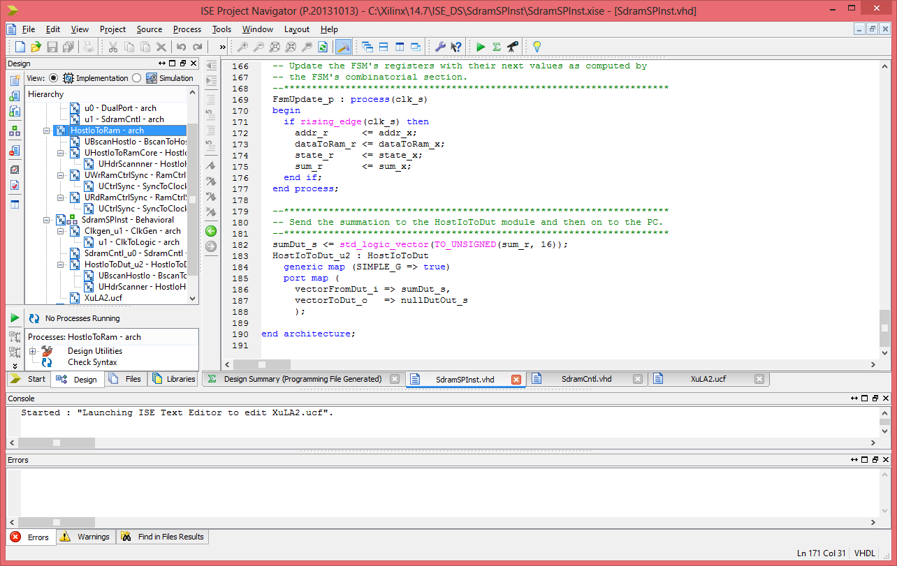
This is the error that I getting
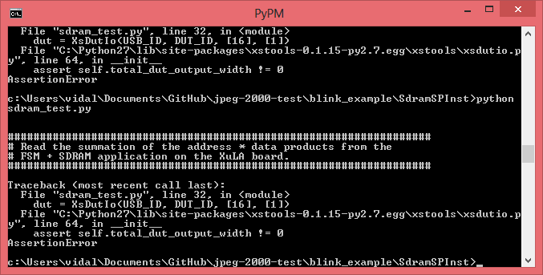
# /***********************************************************************************
# * This program is free software; you can redistribute it and/or
# * modify it under the terms of the GNU General Public License
# * as published by the Free Software Foundation; either version 2
# * of the License, or (at your option) any later version.
# *
# * This program is distributed in the hope that it will be useful,
# * but WITHOUT ANY WARRANTY; without even the implied warranty of
# * MERCHANTABILITY or FITNESS FOR A PARTICULAR PURPOSE. See the
# * GNU General Public License for more details.
# *
# * You should have received a copy of the GNU General Public License
# * along with this program; if not, write to the Free Software
# * Foundation, Inc., 59 Temple Place - Suite 330, Boston, MA
# * 02111-1307, USA.
# *
# * (c)2011 - X Engineering Software Systems Corp. (www.xess.com)
# ***********************************************************************************/

from xstools.xsdutio import * # Import funcs/classes for PC <=> FPGA link.

print '''\n
##################################################################
# Read the summation of the address * data products from the
# FSM + SDRAM application on the XuLA board.
##################################################################
'''
USB_ID = 0 # This is the USB port index for the XuLA board connected to the host PC.
DUT_ID = 255 # This is the default identifier for the DUT in the FPGA.

# Create an interface object to the FPGA with one 16-bit input and one 1-bit output.
dut = XsDutIo(USB_ID, DUT_ID, [16], [1])
sum = dut.Read(); # Read the 16-bit summation from the FPGA.
print 'Sum = %d\r' % sum.unsigned
Need to change from Device XC6SLX25 to Device to XC6SLX9

