Co-Simultion
05/2/16

Steps needed for myhdl co-simulation

Note: The myhdl.vpi must be in the current directory.
The folder tb/vcd must be created.

Note1: Has been tested with iverilog
commit 1ea8a13bf877e6e74d52da5ce923876c8cc98764
Author: Stephen Williams <steve@icarus.com>
Date: Sat Feb 6 17:23:23 2016 -0800

Note2: Has been tested with MyHDL
commit 97dd4e3767082b31a18aecce763005ae374cf79d
Author: Jan Decaluwe <jan@jandecaluwe.com>
Date: Sun Oct 25 16:54:08 2015 +0100

python dr_wbdepp.py –convert_rpi2B_io which is used to create the file rpi2B_io.v

python dr_wbdepp.py --cosimtrace

gtkwave tb/vcd/wbdeppsimple1.vcd

Ran a Python Co-Simulation toggled the i_b0 to i_b7 bits changes to_depp values.
Adding memdev.v required 3 additional signals
i_wb_cyc, i_wb_stb, and i_wb_we.
This also required adding the following reg to the tb/tb_wbdeppsimple.v
reg i_wb_cyc;
reg i_wb_stb;
reg i_wb_we;
In addition the instance of memdev was reguired
tb_memdev(i_clk, i_wb_cyc,
i_wb_stb, i_wb_we, i_wb_addr,
i_wb_data,o_wb_ack, o_wb_stall,
o_wb_data);

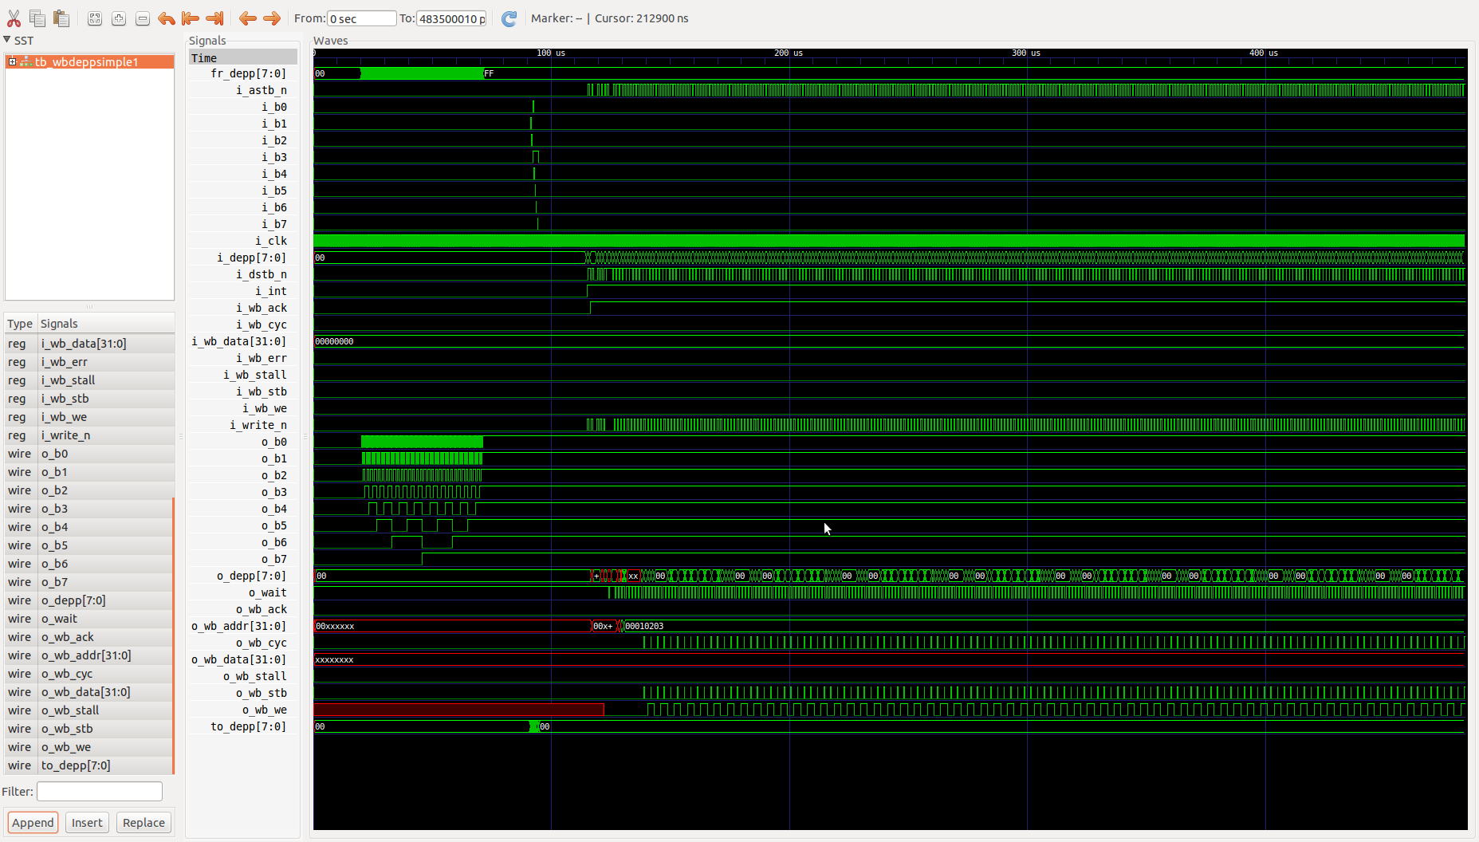

View less memdev
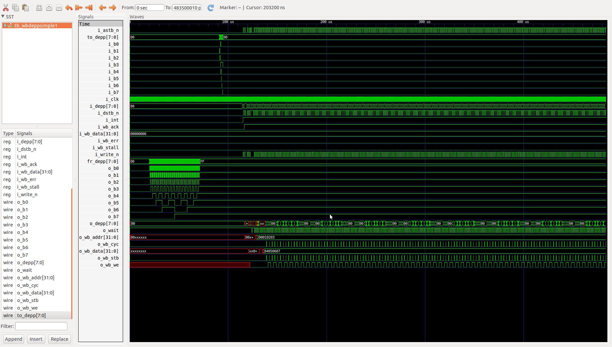
Zooming in where the bits i_b0 to i_b7 drives to_depp. Here you see as bits i_b0 to i_b7 change the values of signal to_depp 0x02, 0x00, 0x04 ...0x88, 0x80, 0x00.

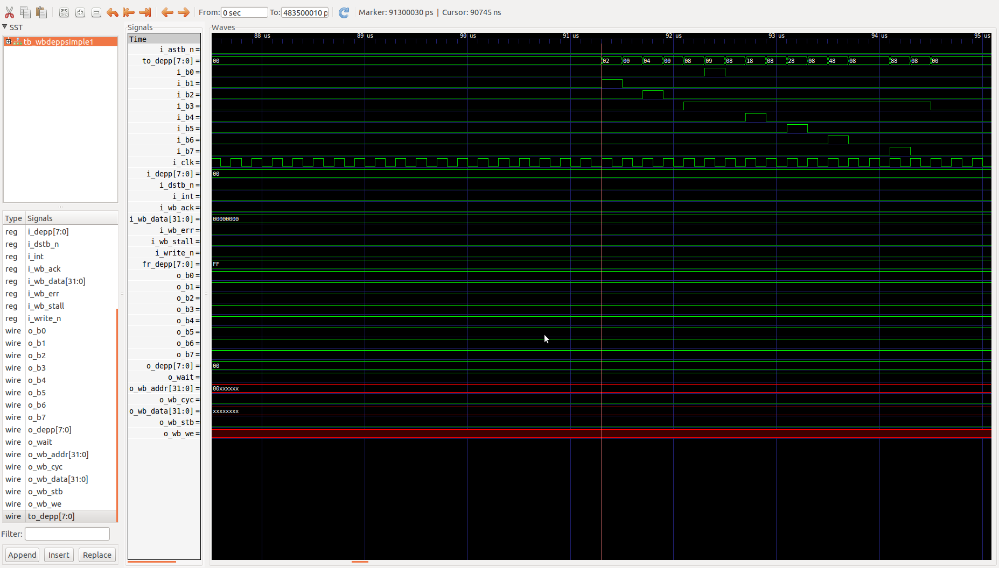
Zooming in where fr_depp drives from 0x00 to 0xff the bits o_b0 to o_b7.
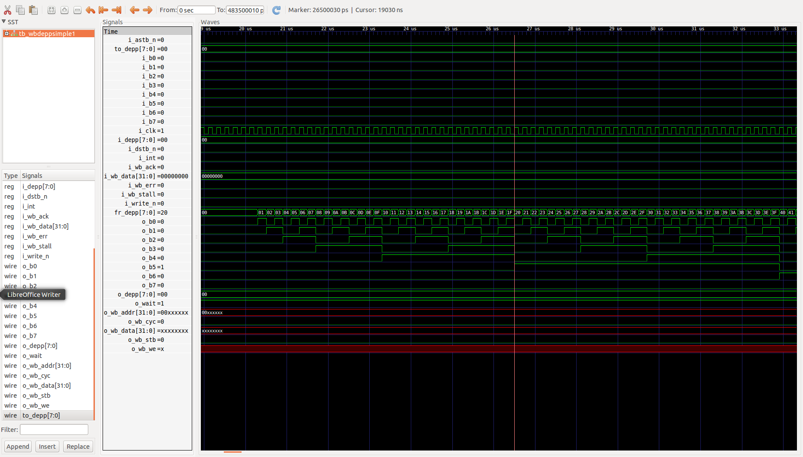

As the values of i_depp are changed 0x00, 0x01, 0x02, and 0x03. o_wb_addr 0x00010203.

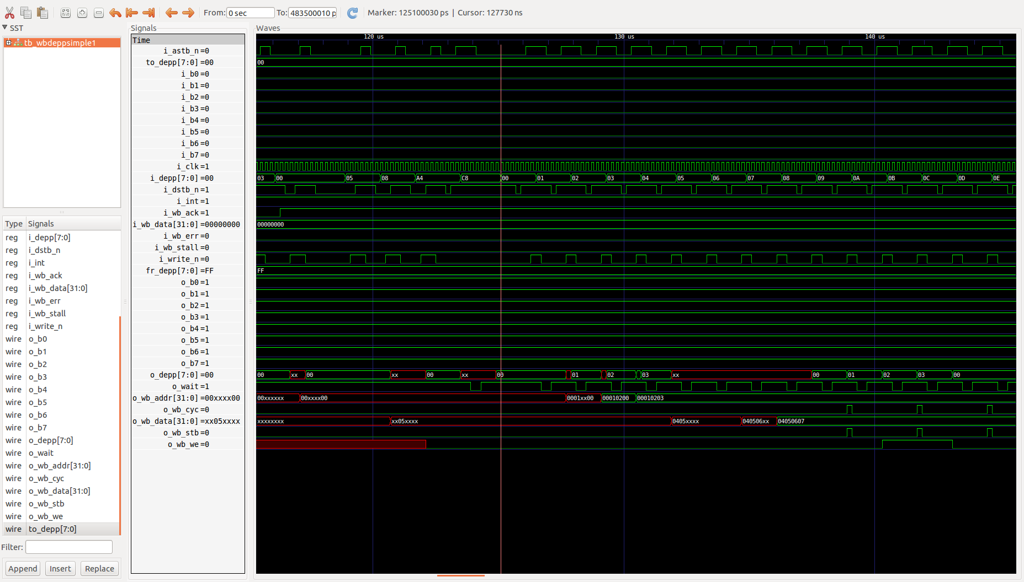
Adding memdev to co-simulation
iverilog -o ifdeppsimple tb/wbdeppsimple.v tb/tb_wbdeppsimple.v rpi2B_io.v tb/memdev.v
tb/tb_wbdeppsimple.v:129: warning: Port 5 (i_wb_addr) of memdev expects 15 bits, got 1.
tb/tb_wbdeppsimple.v:129: : Padding 14 high bits of the port.
tb_wbdeppsimple
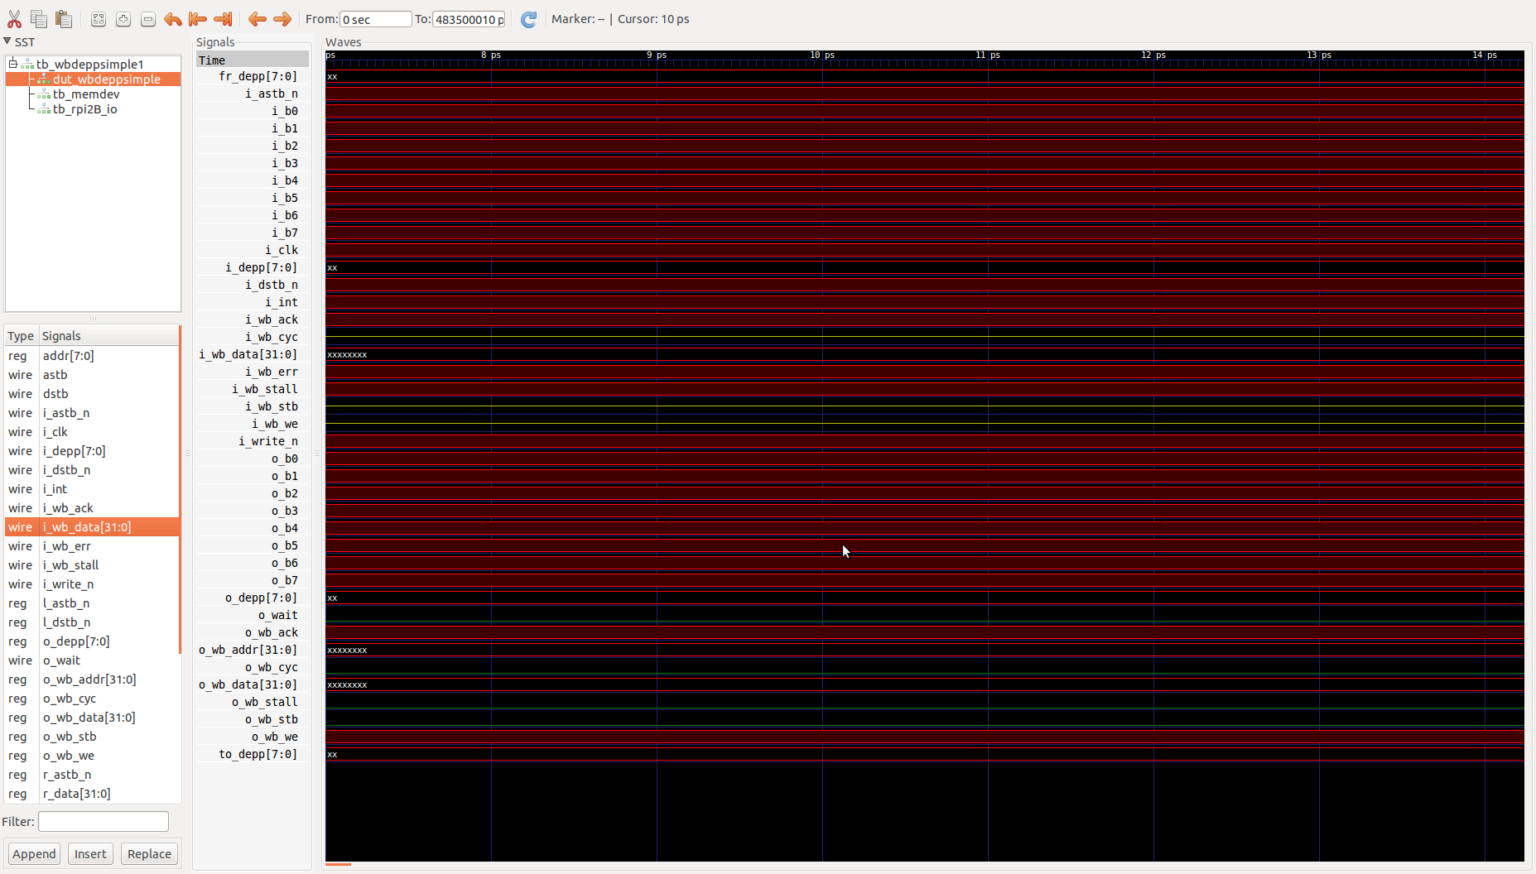
dut_memdev
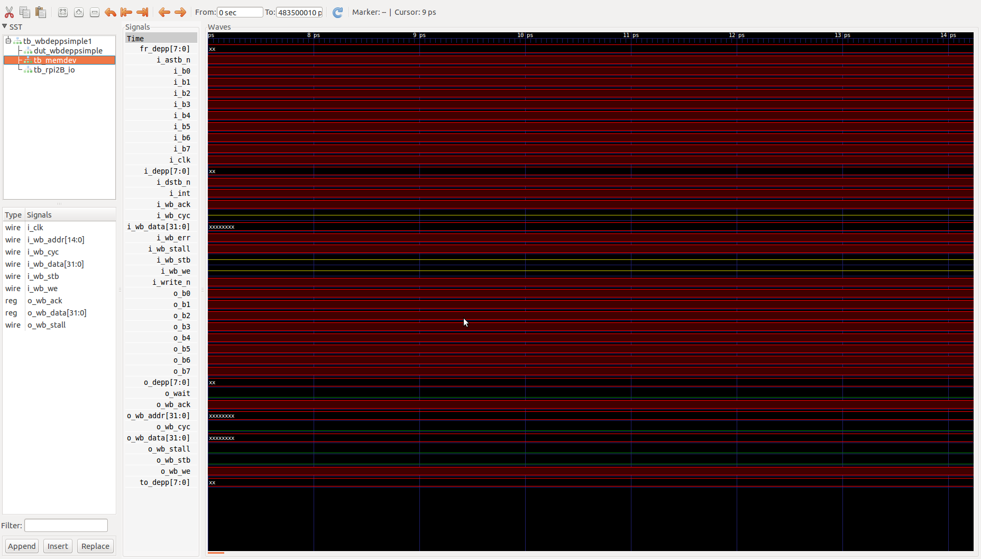
tb_rp2B_io
