This does not use the files from the VHDL_Lib.
sdAddr_o : out std_logic_vector(11 downto 0); -- SDRAM address bus.

addr0_r: inout unsigned(22 downto 0);

DualPortSdram_u0 : DualPortSdram
generic map(
FREQ_G => 100.0, -- Use clock freq. to compute timing parameters.
DATA_WIDTH_G => RAM_WIDTH_C, -- Width of data words.
-- DATA_WIDTH_G => RAM_WIDTH_C, -- Width of data words.
-- PORT_TIME_SLOTS_G => "1111000011110000",
-- PIPE_EN_G => false,
NROWS_G => 4096, -- Number of rows in SDRAM array.
NCOLS_G => 512, -- Number of columns in SDRAM array.
HADDR_WIDTH_G => 23, -- Host-side address width.
SADDR_WIDTH_G => 12 -- SDRAM-side address width.
)
files
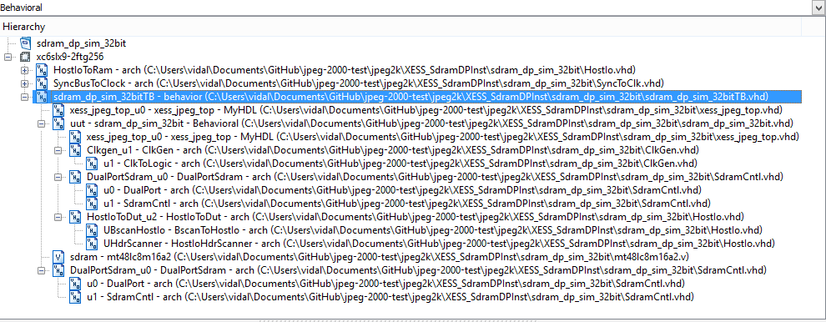
Simulation

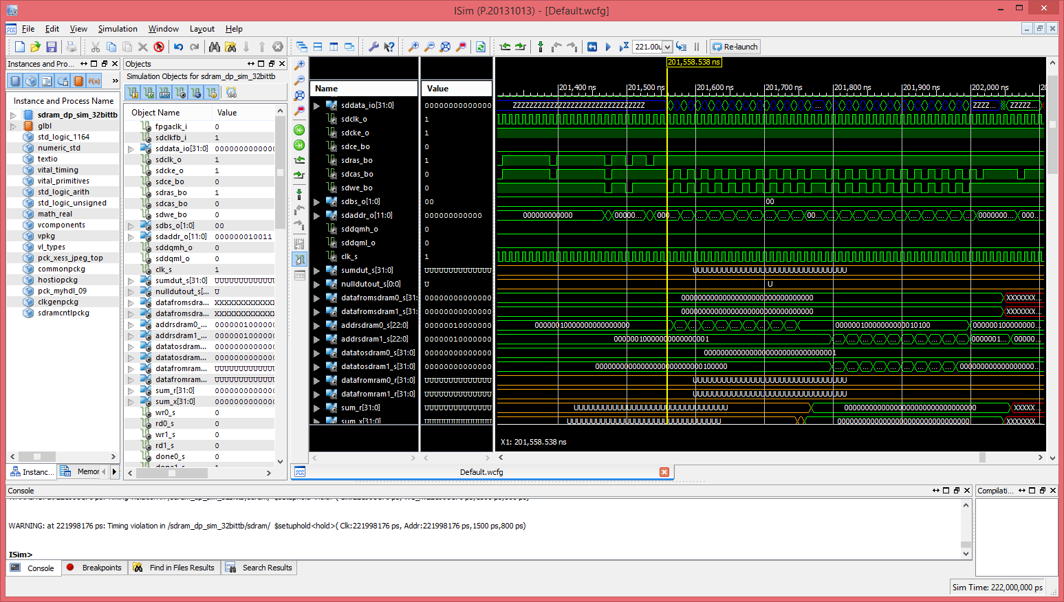
Files with VHDL_Lib
sdAddr_o : out std_logic_vector(12 downto 0); -- SDRAM address bus.
--*********************************************************************
-- Instantiate the SDRAM controller that connects to the FSM
-- and interfaces to the external SDRAM chip.
--*********************************************************************
DualPortSdram_u0 : DualPortSdram
generic map(
FREQ_G => 100.0, -- Use clock freq. to compute timing parameters.
DATA_WIDTH_G => RAM_WIDTH_C -- Width of data words.
-- DATA_WIDTH_G => RAM_WIDTH_C, -- Width of data words.
-- PORT_TIME_SLOTS_G => "1111000011110000",
-- PIPE_EN_G => false,
-- NROWS_G => 4096, -- Number of rows in SDRAM array.
-- NCOLS_G => 512, -- Number of columns in SDRAM array.
-- HADDR_WIDTH_G => 23 -- Host-side address width.
-- SADDR_WIDTH_G => 12 -- SDRAM-side address width.



