Jpeg Lifting Scheme
Testbench Status
The testbench is currently using 3 modules jp_process, rom_flgs, and combine.

With samples from a (red, blue, green) sub band making the signals lft_s_i, sa_s_i, and rht_s_i. Which now can be indexed with row and col not yet defined This first index is the row and 2nd index is the col.

lft_s_i.next = (r[row+31][col] << W0*15) + (r[row+29][col] << W0*14) + (r[row+27][col] << W0*13) +(r[row+25][col] << W0*12) + (r[row+23][col] << W0*11) + (r[row+21][col] << W0*10) + (r[row+19][col] << W0*9) + (r[row+17][col] << W0*8) + (r[row+15][col] << W0*7) + (r[row+13][col] << W0*6) + (r[row+11][col] << W0*5) + (r[row+9][col] << W0*4) + (r[row+7][col] << W0*3) + (r[row+5][col] << W0*2) + (r[row+3][col] << W0*1) + (r[row+1][col] )
sa_s_i.next = (r[row+32][col] << W0*15) + (r[row+30][col] << W0*14) + (r[row+28][col] << W0*13) +(r[row+26][col] << W0*12) + (r[row+24][col] << W0*11) + (r[row+22][col] << W0*10) + (r[row+20][col] << W0*9) + (r[row+18][col] << W0*8) + (r[row+16][col] << W0*7) + (r[row+14][col] << W0*6) + (r[row+12][col] << W0*5) + (r[row+10][col] << W0*4) + (r[row+8][col] << W0*3) + (r[row+6][col] << W0*2) + (r[row+4][col] << W0*1) + (r[row][col] )
rht_s_i.next = (r[row+33][col] << W0*15) + (r[row+31][col] << W0*14) + (r[row+29][col] << W0*13) +(r[row+27][col] << W0*12) + (r[row+25][col] << W0*11) + (r[row+23][col] << W0*10) + (r[row+21][col] << W0*9) + (r[row+19][col] << W0*8) + (r[row+17][col] << W0*7) + (r[row+15][col] << W0*6) + (r[row+13][col] << W0*5) + (r[row+11][col] << W0*4) + (r[row+9][col] << W0*3) + (r[row+7][col] << W0*2) + (r[row+5][col] << W0*1) + (r[row+1][col] )

These signals are concatenated to generate the signals left_com_s, sam_com_s, right_comb_s in the module combine_sam. The concatenation occurs when the signal combine_rdy_s goes high.

The outputs the module combine_sam are the inputs to signals left_s_i, sam_s_i, and right_s_i. These signals and the output of rom_flgs are the inputs to the jp_process module. Currently bits are used for the flgs which determine the following:
update_s needs to be 1
for the res_out_x to be valid
noupdate_s goes lo when a
res_out_x valid
fwd dwt even flgs_s eq 7
inv dwt even flgs_s eq 5
fwd dwt odd flgs_s eq 6
inv dwt odd flgs_s eq 4

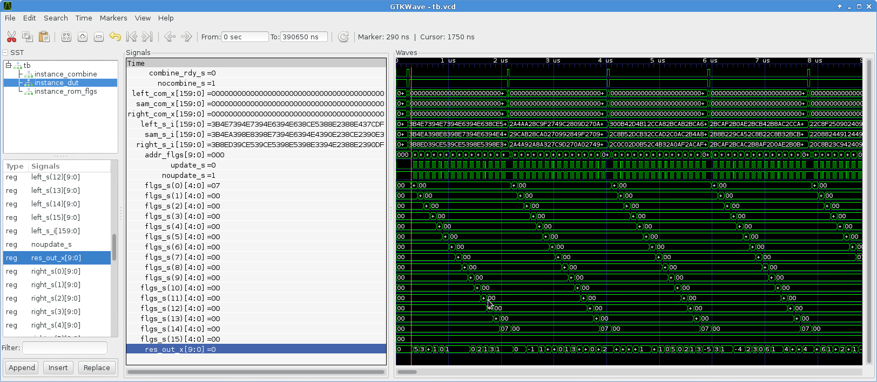
The forward odd & even pass of the image which needs to done 4 times. On a 512 x 512 image each column requires 256 even and 256 odd followed by the same number on the rows. The image needs to be de_interleave and the process repeated.

