Fixbv Simulation Tests

x_sig 3.14159202576 13176792 fixbv(3.141592, format=(32,9,22), ) 0xc90fd8

y_sig 0.5 2097152 fixbv(0.500000, format=(32,9,22), ) 0x200000

sum_sig 3.64159202576 15273944 fixbv(3.641592, format=(33,10,22), ) 0xe90fd8

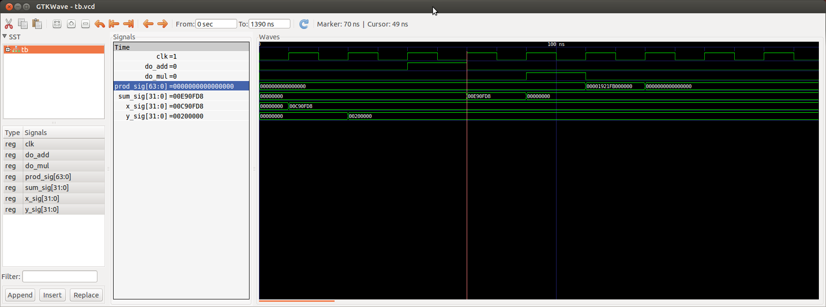
1.57079601288 27633735696384 fixbv(1.570796, format=(64,19,44), ) 0x1921fb000000

