The compressMDver31 was using RCS.
CrossVC was only running on CentOS x86_64 system.

Linux ws009.swbell.net 2.6.32-358.11.1.el6.x86_64 #1 SMP Wed Jun 12 03:34:52 UTC 2013 x86_64 x86_64 x86_64 GNU/Linux
Centos x86_64

Start with compressMDver31 a cvs repository
cvs -d ~/cvsroot init
export CVSROOT=$HOME/cvsroot
CVSROOT
/home/vidal/cvsroot

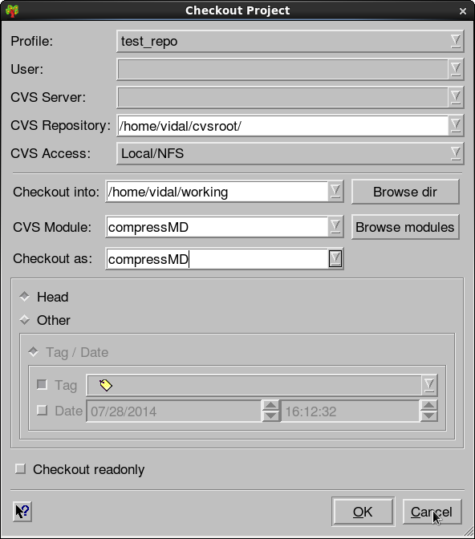

NetBeans 6.8

run options

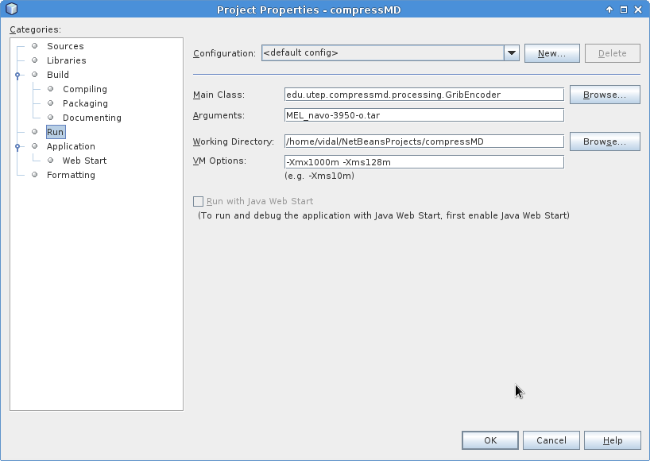

When the program is run. This reads the settings.txt file.
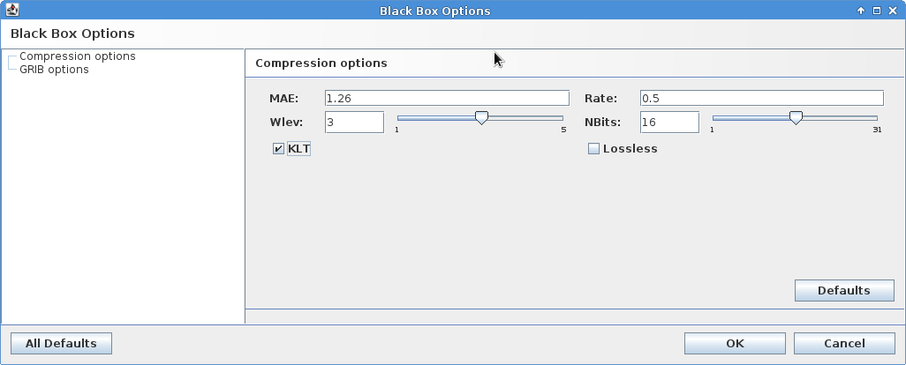

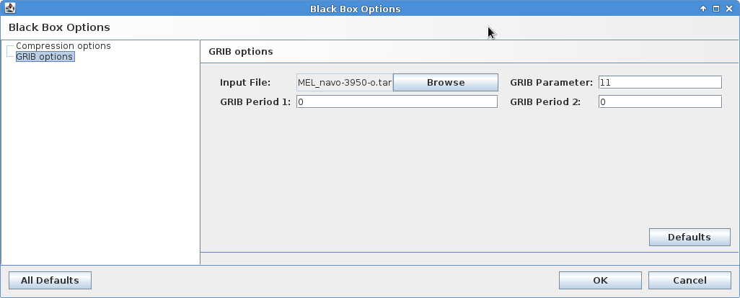
The GRIB options

GRIB (GRIdded Binary or General Regularly-distributed Information in Binary form[1]) is a concise data format commonly used in meteorology to store historical and forecast weather data. It is standardized by the World Meteorological Organization's Commission for Basic Systems, known under number GRIB FM 92-IX, described in WMO Manual on Codes No.306. Currently there are three versions of GRIB. Version 0 was used to a limited extent by projects such as TOGA, and is no longer in operational use. The first edition (current sub-version is 2) is used operationally worldwide by most meteorological centers, for Numerical Weather Prediction output (NWP). A newer generation has been introduced, known as GRIB second edition, and data is slowly changing over to this format. Some of the second-generation GRIB are used for derived product distributed in Eumetcast of Meteosat Second Generation. Another example is the NAM (North American Mesoscale) model.

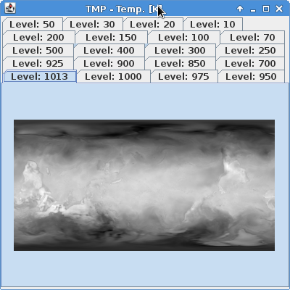

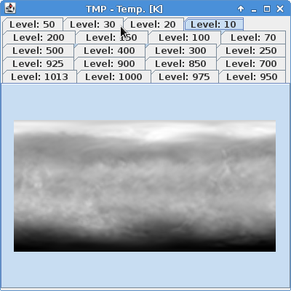

The Bits per level
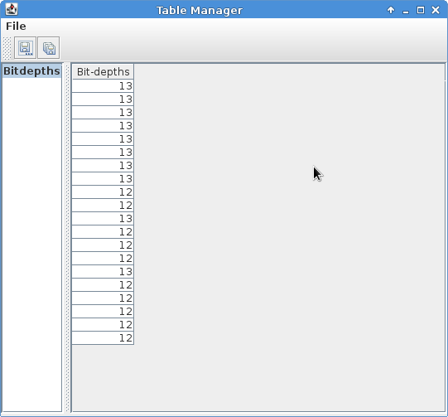

BboxEncoderGUI
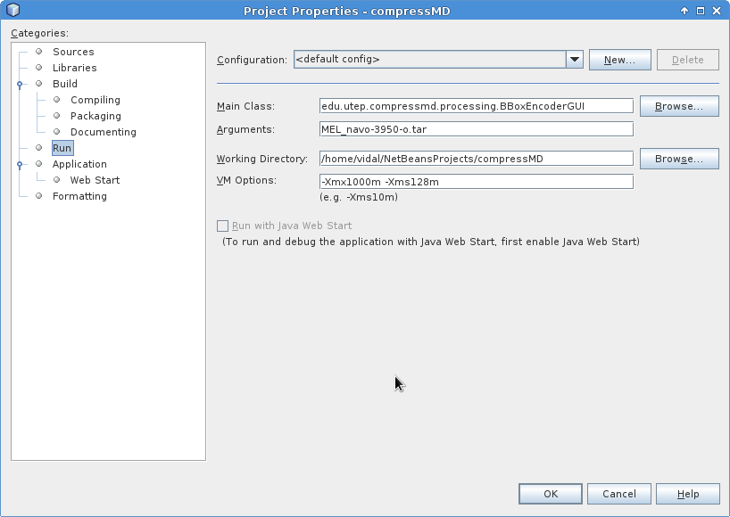

Black Box Options
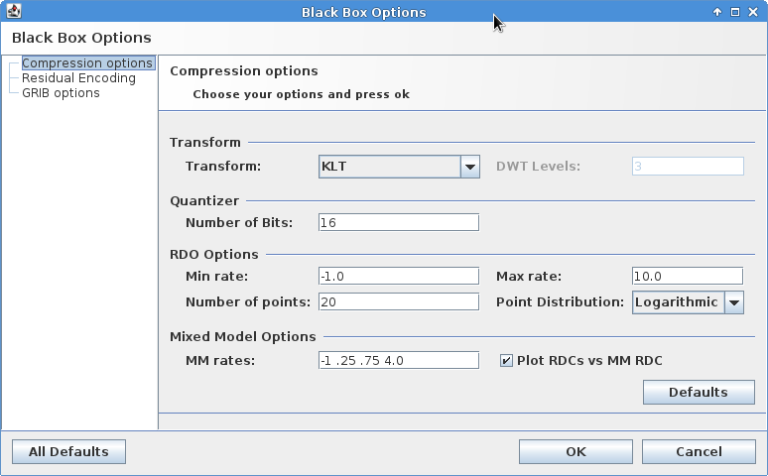

Residual Encoding

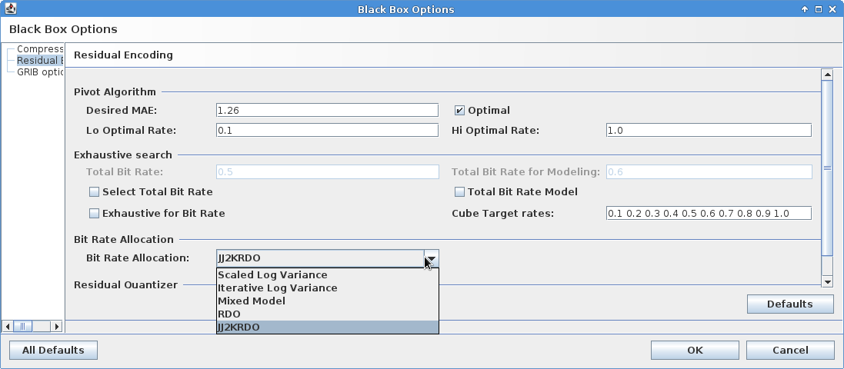

# GribEncoder settings

# Version 2: Modified by Sanjay

# Wed July 1 10:00:00 MDT 2008

# Transform can be 'klt' or 'dwt'

transform=klt

desiredmae=1.26

mae=1.26

rate=.5

wLev=3

nBits=16

loRate=0.1

hiRate=1.0

# File Parameters

level.highest=1013

level.lowest=10

param=11

period1=0

period2=0

# Run Options

debug=true

showImages=true

cvsroot/
|-- compressMD
| |-- lib
| | |-- dom4j-1.5.2.jar,v
| | |-- forms-1.0.7.jar,v
| | |-- freehep-base.jar,v
| | |-- freehep-graphics2d.jar,v
| | |-- freehep-graphicsio-emf.jar,v
| | |-- freehep-graphicsio.jar,v
| | |-- freehep-graphicsio-pdf.jar,v
| | |-- freehep-graphicsio-ps.jar,v
| | |-- GribLib.jar,v
| | |-- gui-commands-1.1.37.jar,v
| | |-- jaxen-1.1-beta-4.jar,v
| | |-- jcommon-1.0.0.jar,v
| | |-- jfreechart-1.0.1.jar,v
| | |-- jh.jar,v
| | |-- looks-2.0.4.jar,v
| | |-- ncCore-2.2.16.jar,v
| | |-- poi-2.5.1-final-20040804.jar,v
| | |-- SPCLAB_colt.jar,v
| | |-- SPCLAB_jj2000.jar,v
| | |-- SPCLAB_UI.jar,v
| | `-- visad.jar,v
| |-- mysettings.txt,v
| `-- src
| |-- compressMD-diff-2008-01-27-06-41-51.patch,v
| |-- compressMD-diff-2008-02-26-17-55-22.patch,v
| |-- edu
| | `-- utep
| | |-- compressmd
| | | |-- analysis2D
| | | | |-- comp1_decompM.java
| | | | |-- comp1_decompM.java,v
| | | | |-- Exhaustive_dMAE_2D.java,v
| | | | |-- Exhaustive_Rate_2D.java,v
| | | | |-- ResidualEncoding2D.java,v
| | | | `-- Residuals_DecompM.java,v
| | | |-- automate
| | | | |-- Abstract_NL_LSQ.java
| | | | |-- Abstract_NL_LSQ.java,v
| | | | |-- AutomateWithEntropy.java,v
| | | | |-- CorrelationCoeffMatrix.java,v
| | | | |-- Entropy_EBCOT.java
| | | | |-- Entropy_EBCOT.java,v
| | | | |-- Generalized_Gaussian_distribution.java,v
| | | | |-- Linear_Approx.java
| | | | |-- Linear_Approx.java,v
| | | | |-- NL_LSQ_MAE.java
| | | | |-- NL_LSQ_MAE.java,v
| | | | |-- NL_LSQ_MSE.java
| | | | |-- NL_LSQ_MSE.java,v
| | | | |-- NL_LSQ_Shape.java
| | | | |-- NL_LSQ_Shape.java,v
| | | | |-- ReadOutliers_test.java,v
| | | | `-- Test_Code_Outlier.java,v
| | | |-- desiredBR
| | | | |-- Comp1DecompM.java,v
| | | | |-- EBCOT_MinimumMAE.java,v
| | | | |-- EBCOT_MinimumMAE_RDC.java,v
| | | | |-- EBCOT_MinimumMAE_SOP.java,v
| | | | |-- EBCOT_MinMAE_Decomp.java,v
| | | | |-- MAE_bit_rate_alloc.java,v
| | | | |-- Marker.java,v
| | | | |-- PivotAlgorithm.java,v
| | | | |-- RunExtensiveNumberBits.java,v
| | | | |-- SliceAnalysisEBCOT.java,v
| | | | `-- testJava.java,v
| | | |-- directApproach
| | | |-- io
| | | | |-- AbstractFileFormatReader.java,v
| | | | |-- Attic
| | | | |-- AttributeNode.java,v
| | | | |-- BitOutputBuffer.java
| | | | |-- BitOutputBuffer.java,v
| | | | |-- ExcelWriter.java
| | | | |-- ExcelWriter.java,v
| | | | |-- FileContentInfo.java,v
| | | | |-- FileFormatReader.java,v
| | | | |-- GribReader.java
| | | | |-- GribReader.java,v
| | | | |-- GribWriter.java
| | | | |-- GribWriter.java,v
| | | | |-- intVector.java,v
| | | | |-- MATWriter.java
| | | | |-- MATWriter.java,v
| | | | |-- NetCDFReader.java
| | | | |-- NetCDFReader.java,v
| | | | |-- NetCDFWriter.java
| | | | |-- NetCDFWriter.java,v
| | | | |-- PackBitBuffer.java,v
| | | | |-- PGXReader.java
| | | | |-- PGXReader.java,v
| | | | |-- PGXWriter.java
| | | | |-- PGXWriter.java,v
| | | | |-- RawReader.java
| | | | |-- RawReader.java,v
| | | | |-- RAWWriter.java,v
| | | | |-- Selection.java,v
| | | | |-- Variable.java
| | | | `-- Variable.java,v
| | | |-- plugin
| | | | |-- AbstractPlugin.java
| | | | |-- AbstractPlugin.java,v
| | | | |-- BuiltInPluginRegistrar.java
| | | | |-- BuiltInPluginRegistrar.java,v
| | | | |-- GenericPlugin.java
| | | | |-- GenericPlugin.java,v
| | | | |-- included_plugins.properties
| | | | |-- included_plugins.properties,v
| | | | |-- Plugin.java
| | | | |-- Plugin.java,v
| | | | |-- PluginLoader.java
| | | | |-- PluginLoader.java,v
| | | | |-- PluginRegistry.java
| | | | |-- PluginRegistry.java,v
| | | | |-- PluginTypes.java
| | | | |-- PluginTypes.java,v
| | | | `-- plugin_types.properties
| | | |-- processing
| | | | |-- BBoxDecoder.java,v
| | | | |-- BBoxEncoderGUI.java,v
| | | | |-- BBoxEncoder.java,v
| | | | |-- ByteVector.java,v
| | | | |-- compression
| | | | | |-- FastJ2KDecoder.java
| | | | | |-- FastJ2KDecoder.java,v
| | | | | |-- FastJ2KEncoder.java
| | | | | |-- FastJ2KEncoder.java,v
| | | | | |-- J2KDecoder.java
| | | | | |-- J2KDecoder.java,v
| | | | | |-- J2KEncoder.java
| | | | | |-- J2KEncoder.java,v
| | | | | |-- JPEG2000Decoder.java
| | | | | |-- JPEG2000Decoder.java,v
| | | | | |-- JPEG2000Encoder.java
| | | | | |-- JPEG2000Encoder.java,v
| | | | | |-- KaDecoder.java,v
| | | | | |-- KaEncoder.java,v
| | | | | |-- KAKADUDecoder.java,v
| | | | | |-- KAKADUEncoder.java,v
| | | | | `-- PrintStreamPiper.java
| | | | |-- DefaultVariableImpl.java,v
| | | | |-- ExperimentResults.java
| | | | |-- ExperimentResults.java,v
| | | | |-- GribDecoder.java,v
| | | | |-- GribEncoder.java,v
| | | | |-- GribIntVector.java,v
| | | | |-- History.java,v
| | | | |-- MeanRemover.java
| | | | |-- MeanRemover.java,v
| | | | |-- metrics
| | | | | |-- L1_norm.java
| | | | | |-- L1_norm.java,v
| | | | | |-- MAE.java
| | | | | |-- MAE.java,v
| | | | | |-- MAX1DataSet.java,v
| | | | | |-- MAXR.java,v
| | | | | |-- Metric1D1D.java
| | | | | |-- Metric1D1D.java,v
| | | | | |-- Metric1D.java,v
| | | | | |-- Metric2D2D.java
| | | | | |-- Metric2D2D.java,v
| | | | | |-- Metric2D.java,v
| | | | | |-- Metric3D3D.java
| | | | | |-- Metric3D3D.java,v
| | | | | |-- Metric3D.java,v
| | | | | |-- Metric.java
| | | | | |-- Metric.java,v
| | | | | |-- MetricsSuite.java
| | | | | |-- MetricsSuite.java,v
| | | | | |-- MINR.java,v
| | | | | |-- MSE.java
| | | | | |-- MSE.java,v
| | | | | |-- RMSE.java
| | | | | |-- RMSE.java,v
| | | | | |-- SNR.java
| | | | | |-- SNR.java,v
| | | | | `-- VAR.java,v
| | | | |-- PrePostProcess.java
| | | | |-- PrePostProcess.java,v
| | | | |-- ProcessingModule.java,v
| | | | |-- quantizer
| | | | | |-- AbstractQuantizer.java
| | | | | |-- AbstractQuantizer.java,v
| | | | | |-- DeadZoneQuantizer3D.java
| | | | | |-- DeadZoneQuantizer3D.java,v
| | | | | |-- DeadZoneSliceQuantizer.java
| | | | | |-- DeadZoneSliceQuantizer.java,v
| | | | | |-- GlobalQuantizer.java
| | | | | |-- GlobalQuantizer.java,v
| | | | | |-- GlobalZeroPreservedQuantizer.java
| | | | | |-- GlobalZeroPreservedQuantizer.java,v
| | | | | |-- Quantizer.java
| | | | | |-- Quantizer.java,v
| | | | | |-- SliceQuantizer.java
| | | | | |-- SliceQuantizer.java,v
| | | | | |-- SliceZeroPreservedQuantizer.java
| | | | | |-- SliceZeroPreservedQuantizer.java,v
| | | | | |-- UniformQuantizer.java,v
| | | | | |-- UniformScalarQuantOpt.java,v
| | | | | `-- UniformScalarTest.java,v
| | | | |-- rate
| | | | | |-- AbstractSliceRateAllocator.java
| | | | | |-- AbstractSliceRateAllocator.java,v
| | | | | |-- IterativeLogVarianceRateAllocator.java
| | | | | |-- IterativeLogVarianceRateAllocator.java,v
| | | | | |-- J2KRDO.java
| | | | | |-- J2KRDO.java,v
| | | | | |-- MixedModelRateAllocator.java
| | | | | |-- MixedModelRateAllocator.java,v
| | | | | |-- MSEMixedModel.java
| | | | | |-- MSEMixedModel.java,v
| | | | | |-- RatesFactory.java
| | | | | |-- RatesFactory.java,v
| | | | | |-- RDO.java
| | | | | |-- RDO.java,v
| | | | | |-- ScaledLogVarianceRateAllocator.java
| | | | | |-- ScaledLogVarianceRateAllocator.java,v
| | | | | |-- SliceRateAllocator.java
| | | | | `-- SliceRateAllocator.java,v
| | | | |-- RateDistortionCompilation.java
| | | | |-- RateDistortionCompilation.java,v
| | | | |-- RateDistortionCurve.java,v
| | | | |-- RDCvsMM.java
| | | | |-- RDCvsMM.java,v
| | | | |-- RdGrib4D.java,v
| | | | |-- SliceAlgorithm.java
| | | | |-- SliceAlgorithm.java,v
| | | | |-- transform
| | | | | |-- DWT9X7Transform2.java
| | | | | |-- DWT9X7Transform2.java,v
| | | | | |-- DWT9X7Transform.java
| | | | | |-- DWT9X7Transform.java,v
| | | | | |-- KLTransform.java
| | | | | |-- KLTransform.java,v
| | | | | |-- SliceTransform.java
| | | | | `-- SliceTransform.java,v
| | | | |-- Units.java,v
| | | | |-- Util.java
| | | | |-- Util.java,v
| | | | `-- Variable.java,v
| | | |-- remote
| | | | |-- ConnectionHandler.java
| | | | |-- ConnectionHandler.java,v
| | | | |-- DataBrowser.java
| | | | |-- DataBrowser.java,v
| | | | |-- DataBrowserListener.java
| | | | |-- DataBrowserListener.java,v
| | | | |-- DataServer.java
| | | | |-- DataServer.java,v
| | | | |-- DataTransmissionProtocol.java
| | | | `-- DataTransmissionProtocol.java,v
| | | |-- spline
| | | | |-- CubicSplineFunction.java,v
| | | | |-- CubicSpline.java,v
| | | | |-- LinearSplineFunction.java,v
| | | | |-- LinearSpline.java,v
| | | | |-- QuadraticSplineFunction.java,v
| | | | |-- QuadraticSpline.java,v
| | | | `-- testSpline.java,v
| | | |-- temp
| | | | |-- app.properties
| | | | |-- app.properties,v
| | | | |-- BitAllocationComparisonGUI.java
| | | | |-- BitAllocationComparisonGUI.java,v
| | | | |-- BitAllocationComparisonGUI_NAPC.java,v
| | | | |-- BitAllocationComparison.java
| | | | |-- BitAllocationComparison.java,v
| | | | |-- BitAllocationComparison_NAPC.java,v
| | | | |-- BlackBoxDecoder.java,v
| | | | |-- BlackBoxEncoderGUI.java,v
| | | | |-- BlackBoxEncoder.java,v
| | | | |-- ByteVector.java,v
| | | | |-- DataReader.java,v
| | | | |-- default.properties
| | | | |-- default.properties,v
| | | | |-- ExitCommand.java
| | | | |-- ExitCommand.java,v
| | | | |-- general-commands.xml
| | | | |-- general-commands.xml,v
| | | | |-- icons.properties
| | | | |-- icons.properties,v
| | | | |-- ResidualEncoding_asof11_08_06.java,v
| | | | |-- ResidualEncodingGUI.java
| | | | |-- ResidualEncodingGUI.java,v
| | | | |-- ResidualEncoding.java
| | | | |-- ResidualEncoding.java,v
| | | | |-- StartCommandBBEnc.java,v
| | | | |-- StartCommand.java
| | | | |-- StartCommand.java,v
| | | | |-- StartCommand_NAPC.java,v
| | | | |-- StartCommandREnc.java
| | | | `-- StartCommandREnc.java,v
| | | |-- ui
| | | | |-- adapters
| | | | | |-- BarSeries.java
| | | | | |-- BarSeries.java,v
| | | | | |-- Matrix1DTableModel.java
| | | | | |-- Matrix1DTableModel.java,v
| | | | | |-- Matrix2DTableModel.java
| | | | | |-- Matrix2DTableModel.java,v
| | | | | |-- XYBarDatasetAdapter.java
| | | | | |-- XYBarDatasetAdapter.java,v
| | | | | |-- XYDatasetAdapter.java
| | | | | |-- XYDatasetAdapter.java,v
| | | | | |-- XYSeries.java
| | | | | `-- XYSeries.java,v
| | | | |-- app.properties
| | | | |-- app.properties,v
| | | | |-- commands
| | | | | |-- AboutCommand.java,v
| | | | | |-- AddPluginsPathCommand.java,v
| | | | | |-- ClearRecentFilesCommand.java,v
| | | | | |-- ClientConnectCommand.java,v
| | | | | |-- CloseAllCommand.java,v
| | | | | |-- CloseAllWindowsCommand.java,v
| | | | | |-- CloseCommand.java,v
| | | | | |-- CloseWindowCommand.java,v
| | | | | |-- CompressCommand.java,v
| | | | | |-- CompressDecompressCommand.java,v
| | | | | |-- CopyCommand.java,v
| | | | | |-- CreatePluginJarCommand.java,v
| | | | | |-- CutCommand.java,v
| | | | | |-- DecompressCommand.java,v
| | | | | |-- DefaultWorkspaceCommand.java,v
| | | | | |-- DisplayCommand.java,v
| | | | | |-- DockUndockWindowCommand.java,v
| | | | | |-- DWTCommand.java,v
| | | | | |-- ExitCommand.java,v
| | | | | |-- FileOpener.java,v
| | | | | |-- HelpContentsCommand.java,v
| | | | | |-- ImportRawCommand.java,v
| | | | | |-- KLTCommand.java,v
| | | | | |-- MaxRestoreWindowCommand.java,v
| | | | | |-- NewCommand.java,v
| | | | | |-- NewPluginCommand.java,v
| | | | | |-- OpenCommand.java,v
| | | | | |-- OpenRecentFileCommand.java,v
| | | | | |-- OptionsCommand.java,v
| | | | | |-- PasteCommand.java,v
| | | | | |-- PluginInspectorCommand.java,v
| | | | | |-- PrintCommand.java,v
| | | | | |-- RDCCommand.java,v
| | | | | |-- RecentFilesEntry.java,v
| | | | | |-- RecentFilesListEvent.java,v
| | | | | |-- RecentFilesList.java,v
| | | | | |-- RecentFilesListListener.java,v
| | | | | |-- RedoCommand.java,v
| | | | | |-- RunPluginCommand.java,v
| | | | | |-- RunServerCommand.java,v
| | | | | |-- SaveAllCommand.java,v
| | | | | |-- SaveAsCommand.java,v
| | | | | |-- SaveCommand.java,v
| | | | | |-- ServeCommand.java,v
| | | | | |-- ShowPluginRegistryCommand.java,v
| | | | | |-- ShowWindowCommand.java,v
| | | | | |-- StopServerCommand.java,v
| | | | | |-- TipsCommand.java,v
| | | | | |-- TransformCommand.java,v
| | | | | |-- UndoCommand.java,v
| | | | | |-- UpdateCommand.java,v
| | | | | |-- WorkspaceLoadCommand.java,v
| | | | | `-- WorkspaceSaveCommand.java,v
| | | | |-- CommandsExporter.java
| | | | |-- CommandsExporter.java,v
| | | | |-- commands.xml
| | | | |-- commands.xml,v
| | | | |-- default.properties
| | | | |-- default.properties,v
| | | | |-- editor
| | | | | |-- DataAnalysisPluginTemplate.txt,v
| | | | | |-- FileFormatReaderPluginTemplate.txt,v
| | | | | |-- FileFormatWriterPluginTemplate.txt,v
| | | | | |-- GeneralPluginTemplate.txt,v
| | | | | |-- MatrixTransformPluginTemplate.txt,v
| | | | | |-- MultiComponentTransformPluginTemplate.txt,v
| | | | | |-- QuantizerPluginTemplate.txt,v
| | | | | |-- RateAllocatorPluginTemplate.txt,v
| | | | | |-- Template.java,v
| | | | | |-- TemplateManager.java,v
| | | | | `-- templates.properties,v
| | | | |-- forms
| | | | | |-- ComputersList.java,v
| | | | | |-- ConnectedForm.java,v
| | | | | |-- ConnectingForm.java,v
| | | | | |-- ConnectionSettingsForm.java,v
| | | | | |-- DataRetreivingForm.java,v
| | | | | |-- EncoderForm.java,v
| | | | | |-- OptionsForm.java,v
| | | | | |-- PluginTemplateForm.java,v
| | | | | |-- RawImportForm.java,v
| | | | | `-- WizardSelectionForm.java,v
| | | | |-- IconFactory.java
| | | | |-- IconFactory.java,v
| | | | |-- icons-table.properties
| | | | |-- icons-table.properties,v
| | | | |-- plot
| | | | | |-- Colors.java,v
| | | | | |-- ImageManager.java,v
| | | | | |-- LineStyles.java,v
| | | | | |-- PlotManager.java,v
| | | | | |-- PlotSettings.java,v
| | | | | |-- Shapes.java,v
| | | | | |-- TableManager.java,v
| | | | | `-- XYDataPlot.java,v
| | | | |-- REHelpBroker.java
| | | | |-- REHelpBroker.java,v
| | | | |-- ResearchEdAppLauncher.java
| | | | |-- ResearchEdAppLauncher.java,v
| | | | |-- ResearchEditionApp.java
| | | | |-- ResearchEditionApp.java,v
| | | | |-- status
| | | | | |-- Profiler.java,v
| | | | | |-- StateManager.java,v
| | | | | |-- StatusManager.java,v
| | | | | `-- StatusManagerListener.java,v
| | | | |-- tree
| | | | | |-- CollectionNode.java,v
| | | | | |-- CompressedDataNode.java,v
| | | | | |-- Data1DNode.java,v
| | | | | |-- Data2DNode.java,v
| | | | | |-- Data3DNode.java,v
| | | | | |-- Data4DNode.java,v
| | | | | |-- DataTree.java,v
| | | | | |-- DataTreeListener.java,v
| | | | | |-- FileContentInfoNode.java,v
| | | | | |-- GraphNode.java,v
| | | | | |-- IconNode.java,v
| | | | | |-- IconTreeCellRenderer.java,v
| | | | | |-- InfoNode.java,v
| | | | | `-- TableNode.java,v
| | | | |-- windows
| | | | | |-- ConsoleWindow.java,v
| | | | | |-- DataTreeWindow.java,v
| | | | | `-- WelcomeWindow.java,v
| | | | `-- wizards
| | | | |-- ConnectWizard.java,v
| | | | |-- EncodingWizard.java,v
| | | | |-- NewPluginWizard.java,v
| | | | |-- NewWizard.java,v
| | | | `-- RawImportWizard.java,v
| | | `-- visad
| | | |-- Cube.java,v
| | | |-- dataManipEval.java,v
| | | |-- dataManip.java,v
| | | |-- Display3DContourSlice.java,v
| | | |-- Display3DSlice.java,v
| | | |-- Display3DSliceNext.java,v
| | | |-- Display3DSliceTrpt.java,v
| | | |-- DisplayContImage.java,v
| | | |-- DisplayContour.java,v
| | | |-- DisplaySlice.java,v
| | | |-- java3DSlices.java,v
| | | `-- Surface.java,v
| | `-- spclab
| | `-- math
| | |-- Histogram.java
| | |-- Histogram.java,v
| | |-- RootFinder.java
| | |-- RootFinder.java,v
| | |-- SlopesConvexHull.java
| | |-- SlopesConvexHull.java,v
| | |-- Statistics.java
| | `-- Statistics.java,v
| |-- overview.html
| |-- overview.html,v
| |-- resources
| | |-- help
| | | |-- contact.html,v
| | | |-- faq.html,v
| | | |-- guide
| | | | |-- features.html,v
| | | | |-- introduction.html_old,v
| | | | |-- introduction.html,v
| | | | |-- preferences.html,v
| | | | |-- printing.html,v
| | | | `-- userinterface.html,v
| | | |-- Help.hs,v
| | | |-- HelpTOC.xml,v
| | | |-- images
| | | | |-- back.gif,v
| | | | |-- chapter.gif,v
| | | | |-- forward.gif,v
| | | | |-- help_topic.gif,v
| | | | |-- home.gif,v
| | | | |-- page_setup.gif,v
| | | | |-- print.gif,v
| | | | |-- reload.gif,v
| | | | |-- search.gif,v
| | | | |-- toc.gif,v
| | | | `-- topic.gif,v
| | | |-- license.html,v
| | | |-- Map.jhm,v
| | | |-- release
| | | | |-- limitations.html,v
| | | | |-- requirements.html,v
| | | | `-- security.html,v
| | | `-- style.css,v
| | `-- icons
| | |-- about.gif,v
| | |-- analyze_data.gif,v
| | |-- ant_buildfile.gif,v
| | |-- app_obj.gif,v
| | |-- back.gif,v
| | |-- binary_file.gif,v
| | |-- class_file.gif,v
| | |-- client_connect.gif,v
| | |-- close_all_windows.gif,v
| | |-- close_window.gif,v
| | |-- collapseall.gif,v
| | |-- collection.gif,v
| | |-- collection_same.gif,v
| | |-- compile.gif,v
| | |-- compile_register.gif,v
| | |-- compress_decompress.gif,v
| | |-- compress.gif,v
| | |-- compressmd_icon_16X16_1bit_alpha.png,v
| | |-- compressmd_icon_16X16.png,v
| | |-- compressmd_icon_32X32.png,v
| | |-- compressMD_re_splash.jpg,v
| | |-- compressMD_re_title_ball.png,v
| | |-- copy.gif,v
| | |-- cut.gif,v
| | |-- data_1d.gif,v
| | |-- data_2d.gif,v
| | |-- data_3d.gif,v
| | |-- data_4d.gif,v
| | |-- decompress.gif,v
| | |-- dialog_question.png,v
| | |-- down.gif,v
| | |-- drag_ok.gif,v
| | |-- drag_rejected.gif,v
| | |-- dwt.gif,v
| | |-- editor.gif,v
| | |-- error.gif,v
| | |-- expandall.gif,v
| | |-- exp_deployfeat.gif,v
| | |-- exp_deployplug.gif,v
| | |-- experiments_window.gif,v
| | |-- export.gif,v
| | |-- export_log.gif,v
| | |-- forward.gif,v
| | |-- function.gif,v
| | |-- graph.gif,v
| | |-- help.gif,v
| | |-- home_nav.gif,v
| | |-- import_folder.gif,v
| | |-- import.gif,v
| | |-- info.gif,v
| | |-- klt.gif,v
| | |-- message_window.gif,v
| | |-- monitor.gif,v
| | |-- network.gif,v
| | |-- newbprj_wiz.gif,v
| | |-- new_collection.gif,v
| | |-- new_experiment.gif,v
| | |-- new.gif,v
| | |-- newpprj_wiz.gif,v
| | |-- open.gif,v
| | |-- open_recent.gif,v
| | |-- options.gif,v
| | |-- output_folder_attrib.gif,v
| | |-- paste.gif,v
| | |-- pause.gif,v
| | |-- pin.gif,v
| | |-- play.gif,v
| | |-- plugin_addpath.gif,v
| | |-- plugin.gif,v
| | |-- plugin_inspector.gif,v
| | |-- plugin_jar2.gif,v
| | |-- plugin_jar.gif,v
| | |-- plugin_new.gif,v
| | |-- plugin_registry.gif,v
| | |-- plugin_run.gif,v
| | |-- print.gif,v
| | |-- rdc22.gif,v
| | |-- rdc2.gif,v
| | |-- rdc.gif,v
| | |-- redo.gif,v
| | |-- saveall.gif,v
| | |-- saveas.gif,v
| | |-- save.gif,v
| | |-- scalar.gif,v
| | |-- script_wiz.gif,v
| | |-- selection.gif,v
| | |-- server_add.gif,v
| | |-- server_run.gif,v
| | |-- server_serve.gif,v
| | |-- server_stop.gif,v
| | |-- stop.gif,v
| | |-- table.gif,v
| | |-- task.gif,v
| | |-- template.gif,v
| | |-- terminate_all_co.gif,v
| | |-- text_file.gif,v
| | |-- tips.gif,v
| | |-- toc_closed.gif,v
| | |-- toc_open.gif,v
| | |-- topic.gif,v
| | |-- transform.gif,v
| | |-- tree_view.gif,v
| | |-- undo.gif,v
| | |-- update.gif,v
| | |-- up.gif,v
| | |-- warning.gif,v
| | |-- w_close.gif,v
| | |-- w_dock.gif,v
| | |-- window_display.gif,v
| | |-- window_welcome.gif,v
| | |-- w_maximize.gif,v
| | |-- w_restore.gif,v
| | |-- w_undock.gif,v
| | `-- zoom.gif,v
| `-- sanjay.patch,v
|-- cvsexample
| |-- cartilage
| | |-- abnormimages.eps,v
| | |-- abstract.tex,v
| | |-- body.tex,v
| | |-- normimages.eps,v
| | |-- p.tex,v
| | `-- title.tex,v
| |-- sample.1,v
| |-- sample.2,v
| |-- sample.3,v
| `-- sample.tex,v
`-- CVSROOT
|-- checkoutlist
|-- checkoutlist,v
|-- commitinfo
|-- commitinfo,v
|-- config
|-- config,v
|-- cvsexample
| |-- cartilage
| | |-- abnormimages.eps
| | |-- abstract.tex
| | |-- body.tex
| | |-- normimages.eps
| | |-- p.tex
| | `-- title.tex
| |-- sample.1
| |-- sample.2
| |-- sample.3
| `-- sample.tex
|-- cvswrappers
|-- cvswrappers,v
|-- editinfo
|-- editinfo,v
|-- Emptydir
|-- history
|-- loginfo
|-- loginfo,v
|-- modules
|-- modules,v
|-- notify
|-- notify,v
|-- rcsinfo
|-- rcsinfo,v
|-- taginfo
|-- taginfo,v
|-- val-tags
|-- verifymsg
`-- verifymsg,v

47 directories, 617 files

compressMD
|-- CVS
| |-- Entries
| |-- Repository
| `-- Root
|-- lib
| |-- CVS
| | |-- Entries
| | |-- Repository
| | `-- Root
| |-- dom4j-1.5.2.jar
| |-- forms-1.0.7.jar
| |-- freehep-base.jar
| |-- freehep-graphics2d.jar
| |-- freehep-graphicsio-emf.jar
| |-- freehep-graphicsio.jar
| |-- freehep-graphicsio-pdf.jar
| |-- freehep-graphicsio-ps.jar
| |-- GribLib.jar
| |-- gui-commands-1.1.37.jar
| |-- jaxen-1.1-beta-4.jar
| |-- jcommon-1.0.0.jar
| |-- jfreechart-1.0.1.jar
| |-- jh.jar
| |-- looks-2.0.4.jar
| |-- ncCore-2.2.16.jar
| |-- poi-2.5.1-final-20040804.jar
| |-- SPCLAB_colt.jar
| |-- SPCLAB_jj2000.jar
| |-- SPCLAB_UI.jar
| `-- visad.jar
|-- mysettings.txt
`-- src
|-- compressMD-diff-2008-01-27-06-41-51.patch
|-- compressMD-diff-2008-02-26-17-55-22.patch
|-- CVS
| |-- Entries
| |-- Repository
| `-- Root
|-- edu
| |-- CVS
| | |-- Entries
| | |-- Repository
| | `-- Root
| `-- utep
| |-- compressmd
| | |-- analysis2D
| | | |-- comp1_decompM.java
| | | |-- CVS
| | | | |-- Entries
| | | | |-- Repository
| | | | `-- Root
| | | |-- Exhaustive_dMAE_2D.java
| | | |-- Exhaustive_Rate_2D.java
| | | |-- ResidualEncoding2D.java
| | | `-- Residuals_DecompM.java
| | |-- automate
| | | |-- Abstract_NL_LSQ.java
| | | |-- AutomateWithEntropy.java
| | | |-- CorrelationCoeffMatrix.java
| | | |-- CVS
| | | | |-- Entries
| | | | |-- Repository
| | | | `-- Root
| | | |-- Entropy_EBCOT.java
| | | |-- Generalized_Gaussian_distribution.java
| | | |-- Linear_Approx.java
| | | |-- NL_LSQ_MAE.java
| | | |-- NL_LSQ_MSE.java
| | | |-- NL_LSQ_Shape.java
| | | |-- ReadOutliers_test.java
| | | `-- Test_Code_Outlier.java
| | |-- CVS
| | | |-- Entries
| | | |-- Repository
| | | `-- Root
| | |-- desiredBR
| | | |-- Comp1DecompM.java
| | | |-- CVS
| | | | |-- Entries
| | | | |-- Repository
| | | | `-- Root
| | | |-- EBCOT_MinimumMAE.java
| | | |-- EBCOT_MinimumMAE_RDC.java
| | | |-- EBCOT_MinimumMAE_SOP.java
| | | |-- EBCOT_MinMAE_Decomp.java
| | | |-- MAE_bit_rate_alloc.java
| | | |-- Marker.java
| | | |-- PivotAlgorithm.java
| | | |-- RunExtensiveNumberBits.java
| | | |-- SliceAnalysisEBCOT.java
| | | `-- testJava.java
| | |-- io
| | | |-- AbstractFileFormatReader.java
| | | |-- AttributeNode.java
| | | |-- BitOutputBuffer.java
| | | |-- CVS
| | | | |-- Entries
| | | | |-- Repository
| | | | `-- Root
| | | |-- ExcelWriter.java
| | | |-- FileContentInfo.java
| | | |-- FileFormatReader.java
| | | |-- GribReader.java
| | | |-- GribWriter.java
| | | |-- intVector.java
| | | |-- MATWriter.java
| | | |-- NetCDFReader.java
| | | |-- NetCDFWriter.java
| | | |-- PackBitBuffer.java
| | | |-- PGXReader.java
| | | |-- PGXWriter.java
| | | |-- RawReader.java
| | | |-- RAWWriter.java
| | | |-- Selection.java
| | | `-- Variable.java
| | |-- plugin
| | | |-- AbstractPlugin.java
| | | |-- BuiltInPluginRegistrar.java
| | | |-- CVS
| | | | |-- Entries
| | | | |-- Repository
| | | | `-- Root
| | | |-- GenericPlugin.java
| | | |-- included_plugins.properties
| | | |-- Plugin.java
| | | |-- PluginLoader.java
| | | |-- PluginRegistry.java
| | | `-- PluginTypes.java
| | |-- processing
| | | |-- BBoxDecoder.java
| | | |-- BBoxEncoderGUI.java
| | | |-- BBoxEncoder.java
| | | |-- ByteVector.java
| | | |-- compression
| | | | |-- CVS
| | | | | |-- Entries
| | | | | |-- Repository
| | | | | `-- Root
| | | | |-- FastJ2KDecoder.java
| | | | |-- FastJ2KEncoder.java
| | | | |-- J2KDecoder.java
| | | | |-- J2KEncoder.java
| | | | |-- JPEG2000Decoder.java
| | | | |-- JPEG2000Encoder.java
| | | | |-- KaDecoder.java
| | | | |-- KaEncoder.java
| | | | |-- KAKADUDecoder.java
| | | | `-- KAKADUEncoder.java
| | | |-- CVS
| | | | |-- Entries
| | | | |-- Repository
| | | | `-- Root
| | | |-- DefaultVariableImpl.java
| | | |-- ExperimentResults.java
| | | |-- GribDecoder.java
| | | |-- GribEncoder.java
| | | |-- GribIntVector.java
| | | |-- History.java
| | | |-- MeanRemover.java
| | | |-- metrics
| | | | |-- CVS
| | | | | |-- Entries
| | | | | |-- Repository
| | | | | `-- Root
| | | | |-- L1_norm.java
| | | | |-- MAE.java
| | | | |-- MAX1DataSet.java
| | | | |-- MAXR.java
| | | | |-- Metric1D1D.java
| | | | |-- Metric1D.java
| | | | |-- Metric2D2D.java
| | | | |-- Metric2D.java
| | | | |-- Metric3D3D.java
| | | | |-- Metric3D.java
| | | | |-- Metric.java
| | | | |-- MetricsSuite.java
| | | | |-- MINR.java
| | | | |-- MSE.java
| | | | |-- RMSE.java
| | | | |-- SNR.java
| | | | `-- VAR.java
| | | |-- PrePostProcess.java
| | | |-- ProcessingModule.java
| | | |-- quantizer
| | | | |-- AbstractQuantizer.java
| | | | |-- CVS
| | | | | |-- Entries
| | | | | |-- Repository
| | | | | `-- Root
| | | | |-- DeadZoneQuantizer3D.java
| | | | |-- DeadZoneSliceQuantizer.java
| | | | |-- GlobalQuantizer.java
| | | | |-- GlobalZeroPreservedQuantizer.java
| | | | |-- Quantizer.java
| | | | |-- SliceQuantizer.java
| | | | |-- SliceZeroPreservedQuantizer.java
| | | | |-- UniformQuantizer.java
| | | | |-- UniformScalarQuantOpt.java
| | | | `-- UniformScalarTest.java
| | | |-- rate
| | | | |-- AbstractSliceRateAllocator.java
| | | | |-- CVS
| | | | | |-- Entries
| | | | | |-- Repository
| | | | | `-- Root
| | | | |-- IterativeLogVarianceRateAllocator.java
| | | | |-- J2KRDO.java
| | | | |-- MixedModelRateAllocator.java
| | | | |-- MSEMixedModel.java
| | | | |-- RatesFactory.java
| | | | |-- RDO.java
| | | | |-- ScaledLogVarianceRateAllocator.java
| | | | `-- SliceRateAllocator.java
| | | |-- RateDistortionCompilation.java
| | | |-- RateDistortionCurve.java
| | | |-- RDCvsMM.java
| | | |-- RdGrib4D.java
| | | |-- SliceAlgorithm.java
| | | |-- transform
| | | | |-- CVS
| | | | | |-- Entries
| | | | | |-- Repository
| | | | | `-- Root
| | | | |-- DWT9X7Transform2.java
| | | | |-- DWT9X7Transform.java
| | | | |-- KLTransform.java
| | | | `-- SliceTransform.java
| | | |-- Units.java
| | | |-- Util.java
| | | `-- Variable.java
| | |-- remote
| | | |-- ConnectionHandler.java
| | | |-- CVS
| | | | |-- Entries
| | | | |-- Repository
| | | | `-- Root
| | | |-- DataBrowser.java
| | | |-- DataBrowserListener.java
| | | |-- DataServer.java
| | | `-- DataTransmissionProtocol.java
| | |-- spline
| | | |-- CubicSplineFunction.java
| | | |-- CubicSpline.java
| | | |-- CVS
| | | | |-- Entries
| | | | |-- Repository
| | | | `-- Root
| | | |-- LinearSplineFunction.java
| | | |-- LinearSpline.java
| | | |-- QuadraticSplineFunction.java
| | | |-- QuadraticSpline.java
| | | `-- testSpline.java
| | |-- temp
| | | |-- app.properties
| | | |-- BitAllocationComparisonGUI.java
| | | |-- BitAllocationComparisonGUI_NAPC.java
| | | |-- BitAllocationComparison.java
| | | |-- BitAllocationComparison_NAPC.java
| | | |-- BlackBoxDecoder.java
| | | |-- BlackBoxEncoderGUI.java
| | | |-- BlackBoxEncoder.java
| | | |-- ByteVector.java
| | | |-- CVS
| | | | |-- Entries
| | | | |-- Repository
| | | | `-- Root
| | | |-- DataReader.java
| | | |-- default.properties
| | | |-- ExitCommand.java
| | | |-- general-commands.xml
| | | |-- icons.properties
| | | |-- ResidualEncoding_asof11_08_06.java
| | | |-- ResidualEncodingGUI.java
| | | |-- ResidualEncoding.java
| | | |-- StartCommandBBEnc.java
| | | |-- StartCommand.java
| | | |-- StartCommand_NAPC.java
| | | `-- StartCommandREnc.java
| | |-- ui
| | | |-- adapters
| | | | |-- BarSeries.java
| | | | |-- CVS
| | | | | |-- Entries
| | | | | |-- Repository
| | | | | `-- Root
| | | | |-- Matrix1DTableModel.java
| | | | |-- Matrix2DTableModel.java
| | | | |-- XYBarDatasetAdapter.java
| | | | |-- XYDatasetAdapter.java
| | | | `-- XYSeries.java
| | | |-- app.properties
| | | |-- commands
| | | | |-- AboutCommand.java
| | | | |-- AddPluginsPathCommand.java
| | | | |-- ClearRecentFilesCommand.java
| | | | |-- ClientConnectCommand.java
| | | | |-- CloseAllCommand.java
| | | | |-- CloseAllWindowsCommand.java
| | | | |-- CloseCommand.java
| | | | |-- CloseWindowCommand.java
| | | | |-- CompressCommand.java
| | | | |-- CompressDecompressCommand.java
| | | | |-- CopyCommand.java
| | | | |-- CreatePluginJarCommand.java
| | | | |-- CutCommand.java
| | | | |-- CVS
| | | | | |-- Entries
| | | | | |-- Repository
| | | | | `-- Root
| | | | |-- DecompressCommand.java
| | | | |-- DefaultWorkspaceCommand.java
| | | | |-- DisplayCommand.java
| | | | |-- DockUndockWindowCommand.java
| | | | |-- DWTCommand.java
| | | | |-- ExitCommand.java
| | | | |-- FileOpener.java
| | | | |-- HelpContentsCommand.java
| | | | |-- ImportRawCommand.java
| | | | |-- KLTCommand.java
| | | | |-- MaxRestoreWindowCommand.java
| | | | |-- NewCommand.java
| | | | |-- NewPluginCommand.java
| | | | |-- OpenCommand.java
| | | | |-- OpenRecentFileCommand.java
| | | | |-- OptionsCommand.java
| | | | |-- PasteCommand.java
| | | | |-- PluginInspectorCommand.java
| | | | |-- PrintCommand.java
| | | | |-- RDCCommand.java
| | | | |-- RecentFilesEntry.java
| | | | |-- RecentFilesListEvent.java
| | | | |-- RecentFilesList.java
| | | | |-- RecentFilesListListener.java
| | | | |-- RedoCommand.java
| | | | |-- RunPluginCommand.java
| | | | |-- RunServerCommand.java
| | | | |-- SaveAllCommand.java
| | | | |-- SaveAsCommand.java
| | | | |-- SaveCommand.java
| | | | |-- ServeCommand.java
| | | | |-- ShowPluginRegistryCommand.java
| | | | |-- ShowWindowCommand.java
| | | | |-- StopServerCommand.java
| | | | |-- TipsCommand.java
| | | | |-- TransformCommand.java
| | | | |-- UndoCommand.java
| | | | |-- UpdateCommand.java
| | | | |-- WorkspaceLoadCommand.java
| | | | `-- WorkspaceSaveCommand.java
| | | |-- CommandsExporter.java
| | | |-- commands.xml
| | | |-- CVS
| | | | |-- Entries
| | | | |-- Repository
| | | | `-- Root
| | | |-- default.properties
| | | |-- editor
| | | | |-- CVS
| | | | | |-- Entries
| | | | | |-- Repository
| | | | | `-- Root
| | | | |-- DataAnalysisPluginTemplate.txt
| | | | |-- FileFormatReaderPluginTemplate.txt
| | | | |-- FileFormatWriterPluginTemplate.txt
| | | | |-- GeneralPluginTemplate.txt
| | | | |-- MatrixTransformPluginTemplate.txt
| | | | |-- MultiComponentTransformPluginTemplate.txt
| | | | |-- QuantizerPluginTemplate.txt
| | | | |-- RateAllocatorPluginTemplate.txt
| | | | |-- Template.java
| | | | |-- TemplateManager.java
| | | | `-- templates.properties
| | | |-- forms
| | | | |-- ComputersList.java
| | | | |-- ConnectedForm.java
| | | | |-- ConnectingForm.java
| | | | |-- ConnectionSettingsForm.java
| | | | |-- CVS
| | | | | |-- Entries
| | | | | |-- Repository
| | | | | `-- Root
| | | | |-- DataRetreivingForm.java
| | | | |-- EncoderForm.java
| | | | |-- OptionsForm.java
| | | | |-- PluginTemplateForm.java
| | | | |-- RawImportForm.java
| | | | `-- WizardSelectionForm.java
| | | |-- IconFactory.java
| | | |-- icons-table.properties
| | | |-- plot
| | | | |-- Colors.java
| | | | |-- CVS
| | | | | |-- Entries
| | | | | |-- Repository
| | | | | `-- Root
| | | | |-- ImageManager.java
| | | | |-- LineStyles.java
| | | | |-- PlotManager.java
| | | | |-- PlotSettings.java
| | | | |-- Shapes.java
| | | | |-- TableManager.java
| | | | `-- XYDataPlot.java
| | | |-- REHelpBroker.java
| | | |-- ResearchEdAppLauncher.java
| | | |-- ResearchEditionApp.java
| | | |-- status
| | | | |-- CVS
| | | | | |-- Entries
| | | | | |-- Repository
| | | | | `-- Root
| | | | |-- Profiler.java
| | | | |-- StateManager.java
| | | | |-- StatusManager.java
| | | | `-- StatusManagerListener.java
| | | |-- tree
| | | | |-- CollectionNode.java
| | | | |-- CompressedDataNode.java
| | | | |-- CVS
| | | | | |-- Entries
| | | | | |-- Repository
| | | | | `-- Root
| | | | |-- Data1DNode.java
| | | | |-- Data2DNode.java
| | | | |-- Data3DNode.java
| | | | |-- Data4DNode.java
| | | | |-- DataTree.java
| | | | |-- DataTreeListener.java
| | | | |-- FileContentInfoNode.java
| | | | |-- GraphNode.java
| | | | |-- IconNode.java
| | | | |-- IconTreeCellRenderer.java
| | | | |-- InfoNode.java
| | | | `-- TableNode.java
| | | |-- windows
| | | | |-- ConsoleWindow.java
| | | | |-- CVS
| | | | | |-- Entries
| | | | | |-- Repository
| | | | | `-- Root
| | | | |-- DataTreeWindow.java
| | | | `-- WelcomeWindow.java
| | | `-- wizards
| | | |-- ConnectWizard.java
| | | |-- CVS
| | | | |-- Entries
| | | | |-- Repository
| | | | `-- Root
| | | |-- EncodingWizard.java
| | | |-- NewPluginWizard.java
| | | |-- NewWizard.java
| | | `-- RawImportWizard.java
| | `-- visad
| | |-- Cube.java
| | |-- CVS
| | | |-- Entries
| | | |-- Repository
| | | `-- Root
| | |-- dataManipEval.java
| | |-- dataManip.java
| | |-- Display3DContourSlice.java
| | |-- Display3DSlice.java
| | |-- Display3DSliceNext.java
| | |-- Display3DSliceTrpt.java
| | |-- DisplayContImage.java
| | |-- DisplayContour.java
| | |-- DisplaySlice.java
| | |-- java3DSlices.java
| | `-- Surface.java
| |-- CVS
| | |-- Entries
| | |-- Repository
| | `-- Root
| `-- spclab
| |-- CVS
| | |-- Entries
| | |-- Repository
| | `-- Root
| `-- math
| |-- CVS
| | |-- Entries
| | |-- Repository
| | `-- Root
| |-- Histogram.java
| |-- RootFinder.java
| |-- SlopesConvexHull.java
| `-- Statistics.java
|-- overview.html
|-- resources
| |-- CVS
| | |-- Entries
| | |-- Repository
| | `-- Root
| |-- help
| | |-- contact.html
| | |-- CVS
| | | |-- Entries
| | | |-- Repository
| | | `-- Root
| | |-- faq.html
| | |-- guide
| | | |-- CVS
| | | | |-- Entries
| | | | |-- Repository
| | | | `-- Root
| | | |-- features.html
| | | |-- introduction.html
| | | |-- introduction.html_old
| | | |-- preferences.html
| | | |-- printing.html
| | | `-- userinterface.html
| | |-- Help.hs
| | |-- HelpTOC.xml
| | |-- images
| | | |-- back.gif
| | | |-- chapter.gif
| | | |-- CVS
| | | | |-- Entries
| | | | |-- Repository
| | | | `-- Root
| | | |-- forward.gif
| | | |-- help_topic.gif
| | | |-- home.gif
| | | |-- page_setup.gif
| | | |-- print.gif
| | | |-- reload.gif
| | | |-- search.gif
| | | |-- toc.gif
| | | `-- topic.gif
| | |-- license.html
| | |-- Map.jhm
| | |-- release
| | | |-- CVS
| | | | |-- Entries
| | | | |-- Repository
| | | | `-- Root
| | | |-- limitations.html
| | | |-- requirements.html
| | | `-- security.html
| | `-- style.css
| `-- icons
| |-- about.gif
| |-- analyze_data.gif
| |-- ant_buildfile.gif
| |-- app_obj.gif
| |-- back.gif
| |-- binary_file.gif
| |-- class_file.gif
| |-- client_connect.gif
| |-- close_all_windows.gif
| |-- close_window.gif
| |-- collapseall.gif
| |-- collection.gif
| |-- collection_same.gif
| |-- compile.gif
| |-- compile_register.gif
| |-- compress_decompress.gif
| |-- compress.gif
| |-- compressmd_icon_16X16_1bit_alpha.png
| |-- compressmd_icon_16X16.png
| |-- compressmd_icon_32X32.png
| |-- compressMD_re_splash.jpg
| |-- compressMD_re_title_ball.png
| |-- copy.gif
| |-- cut.gif
| |-- CVS
| | |-- Entries
| | |-- Repository
| | `-- Root
| |-- data_1d.gif
| |-- data_2d.gif
| |-- data_3d.gif
| |-- data_4d.gif
| |-- decompress.gif
| |-- dialog_question.png
| |-- down.gif
| |-- drag_ok.gif
| |-- drag_rejected.gif
| |-- dwt.gif
| |-- editor.gif
| |-- error.gif
| |-- expandall.gif
| |-- exp_deployfeat.gif
| |-- exp_deployplug.gif
| |-- experiments_window.gif
| |-- export.gif
| |-- export_log.gif
| |-- forward.gif
| |-- function.gif
| |-- graph.gif
| |-- help.gif
| |-- home_nav.gif
| |-- import_folder.gif
| |-- import.gif
| |-- info.gif
| |-- klt.gif
| |-- message_window.gif
| |-- monitor.gif
| |-- network.gif
| |-- newbprj_wiz.gif
| |-- new_collection.gif
| |-- new_experiment.gif
| |-- new.gif
| |-- newpprj_wiz.gif
| |-- open.gif
| |-- open_recent.gif
| |-- options.gif
| |-- output_folder_attrib.gif
| |-- paste.gif
| |-- pause.gif
| |-- pin.gif
| |-- play.gif
| |-- plugin_addpath.gif
| |-- plugin.gif
| |-- plugin_inspector.gif
| |-- plugin_jar2.gif
| |-- plugin_jar.gif
| |-- plugin_new.gif
| |-- plugin_registry.gif
| |-- plugin_run.gif
| |-- print.gif
| |-- rdc22.gif
| |-- rdc2.gif
| |-- rdc.gif
| |-- redo.gif
| |-- saveall.gif
| |-- saveas.gif
| |-- save.gif
| |-- scalar.gif
| |-- script_wiz.gif
| |-- selection.gif
| |-- server_add.gif
| |-- server_run.gif
| |-- server_serve.gif
| |-- server_stop.gif
| |-- stop.gif
| |-- table.gif
| |-- task.gif
| |-- template.gif
| |-- terminate_all_co.gif
| |-- text_file.gif
| |-- tips.gif
| |-- toc_closed.gif
| |-- toc_open.gif
| |-- topic.gif
| |-- transform.gif
| |-- tree_view.gif
| |-- undo.gif
| |-- update.gif
| |-- up.gif
| |-- warning.gif
| |-- w_close.gif
| |-- w_dock.gif
| |-- window_display.gif
| |-- window_welcome.gif
| |-- w_maximize.gif
| |-- w_restore.gif
| |-- w_undock.gif
| `-- zoom.gif
`-- sanjay.patch

77 directories, 582 files

