Still performing de-interleave without any scaling based on review jj2000
.
Could not find any where the scaling was being performed.

Started with even samples first followed by odd samples.
This provided the best results of the upper left corner.
for row in range(1, height-1, 2):
pix.setSig_even_odd(1)
for row in range(2, height, 2):
pix.setSig_even_odd(0)

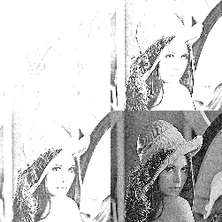

for row in range(1, height-1, 2):
pix.setSig_even_odd(0)
for row in range(2, height, 2):
pix.setSig_even_odd(1)

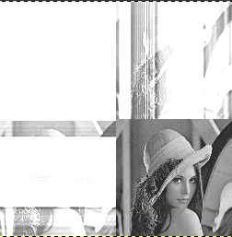

for row in range(2, height, 2):
pix.setSig_even_odd(0)
for row in range(1, height-2, 2):
pix.setSig_even_odd(1)

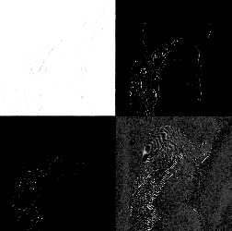

for row in range(2, height, 2):
pix.setSig_even_odd(1)
for row in range(1, height-2, 2):
pix.setSig_even_odd(0)

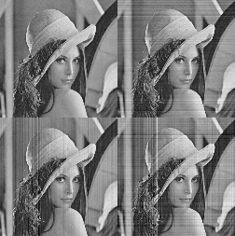

Performing 2 levels of Fwd DWT

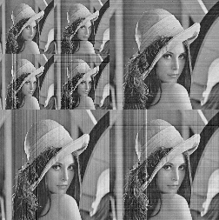

for row in range(2, height, 2):

pix.setSig_p(0)

pix.setSig_even_odd(1)

pix.setSig_fwd_inv(1)

pix.setSig_left(int(s[row-1][col]))

pix.setSig_right(int(s[row+1][col]))

pix.setSig_sam(int(s[row][col]))

even, odd = add_mul_ram(pix)

s[row][col] += float(odd)

#s[row][col] += a1 * (s[row-1][col] + s[row+1][col])

# Update 1. y0

for row in range(1, height-1, 2):

pix.setSig_p(0)

pix.setSig_even_odd(0)

pix.setSig_fwd_inv(1)

pix.setSig_left(int(s[row-1][col]))

pix.setSig_right(int(s[row+1][col]))

pix.setSig_sam(int(s[row][col]))

even, odd = add_mul_ram(pix)

s[row][col] += float(even)

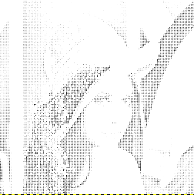

Original image lena_512.png

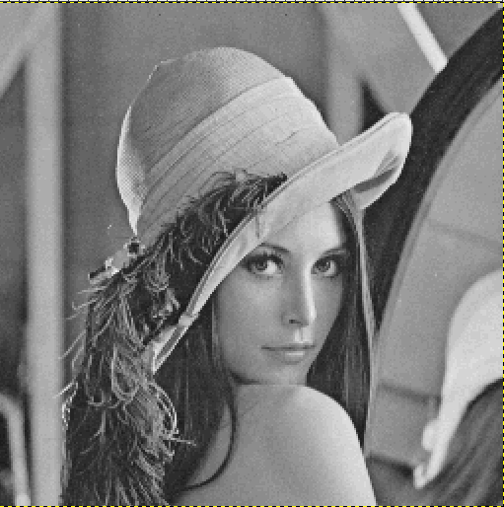

fwd 1 pass 512 x 256 image

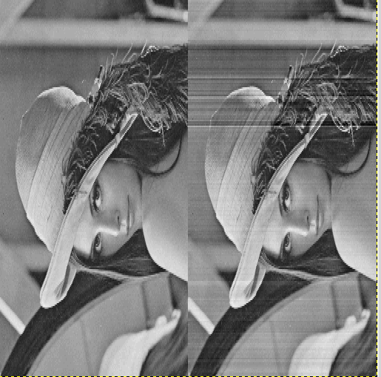
2nd pass 128 x 128 in the upper left corner.

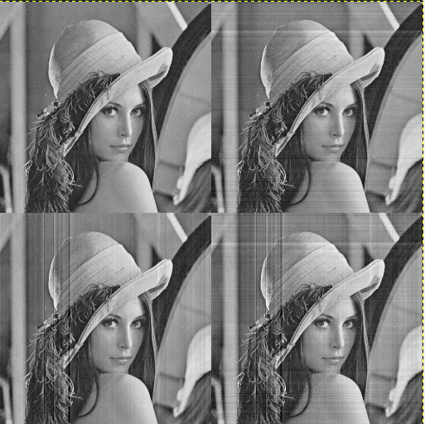

The 1 pass of inverse is lower than 1 pass of fwd.

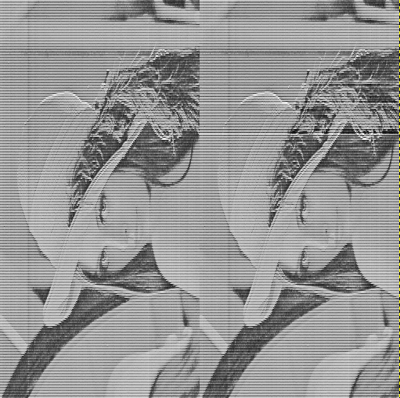

With the last changes the inverse got better
