Starting out with a 256 X 256 image.



Following each fwd operation the inverse was performed. This is only the pass.

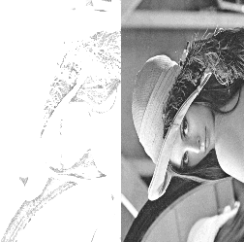

The code in red is the inverse process.
for col in range(width): # Do the 1D transform on all cols:
''' Core 1D lifting process in this loop. '''
''' Lifting is done on the cols. '''
# Predict 1. y1
pix = Add_mul_top()
for row in range(1, height-1, 2):
pix.setSig_p(0)
pix.setSig_even_odd(1)
pix.setSig_fwd_inv(1)
pix.setSig_left(int(s[row-1][col]))
pix.setSig_right(int(s[row+1][col]))
pix.setSig_sam(int(s[row][col]))
even, odd = add_mul_ram(pix)
s[row][col] += float(even)
pix.setSig_fwd_inv(0)
even, odd = add_mul_ram(pix)
s[row][col] += float(even)
#s[row][col] += a1 * (s[row-1][col] + s[row+1][col])
##s[height-1][col] += 2 * a1 * s[height-2][col] # Symmetric extension

# Update 1. y0

for row in range(2, height, 2):
pix.setSig_p(0)
pix.setSig_even_odd(0)
pix.setSig_fwd_inv(1)
pix.setSig_left(int(s[row-1][col]))
pix.setSig_right(int(s[row+1][col]))
pix.setSig_sam(int(s[row][col]))
even, odd = add_mul_ram(pix)
s[row][col] += float(odd)
even, odd = add_mul_ram(pix)
s[row][col] += float(odd)
pix.setSig_fwd_inv(0)
even, odd = add_mul_ram(pix)
s[row][col] += float(odd)
#s[row][col] += a2 * (s[row-1][col] + s[row+1][col])
##s[0][col] += 2 * a2 * s[1][col] # Symmetric extension

# Predict 2.
for row in range(1, height-1, 2):
pix.setSig_p(1)
pix.setSig_even_odd(1)
pix.setSig_fwd_inv(1)
pix.setSig_left(int(s[row-1][col]))
pix.setSig_right(int(s[row+1][col]))
pix.setSig_sam(int(s[row][col]))
even, odd = add_mul_ram(pix)
s[row][col] += float(even)
pix.setSig_fwd_inv(0)
even, odd = add_mul_ram(pix)
s[row][col] += float(even)
#s[row][col] += a3 * (s[row-1][col] + s[row+1][col])
##s[height-1][col] += 2 * a3 * s[height-2][col]

# Update 2.
for row in range(2, height, 2):
pix.setSig_p(1)
pix.setSig_even_odd(0)
pix.setSig_fwd_inv(1)
pix.setSig_left(int(s[row-1][col]))
pix.setSig_right(int(s[row+1][col]))
pix.setSig_sam(int(s[row][col]))
even, odd = add_mul_ram(pix)

s[row][col] += float(odd)
pix.setSig_fwd_inv(0)
even, odd = add_mul_ram(pix)
s[row][col] += float(odd)

#s[row][col] += a4 * (s[row-1][col] + s[row+1][col])
##s[0][col] += 2 * a4 * s[1][col]

With 2 passes.

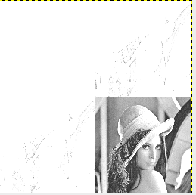

With 1 pass fwd.
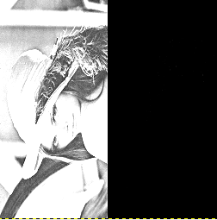

With 2 passes.

