The following batch files are transferred to the Desktop from the GitHub location "c:\Users\vidal\Documents\GitHub\jpeg-2000-test”. These 3 batch files are used to upload a hex file to the XulA2-LX9 SDRam, download from XulA2-LX9 SDRam to a file, and compare the values of the upload/download files.

wr.bat
cd "c:\Program Files (x86)\XSTOOLs"
xsload.exe -usb 0 -f hex -ram "c:\Users\vidal\My Documents\GitHub\jpeg-2000-test\ipython_fixbv\lena.hex"
rd.bat
m:
dir ttt.hex
del ttt.hex
"c:\Program Files (x86)\XSTOOLs\xsload.exe" -usb 0 -f hex -u 0x00000 0x7FFFF -ram ttt.hex
dir ttt.hex
copy ttt.hex "c:\Users\vidal\Documents\GitHub\jpeg-2000-test\ipython_fixbv"
dir "c:\Users\vidal\Documents\GitHub\jpeg-2000-test\ipython_fixbv\ttt.hex"
pause
cmp.bat
cd "c:\Users\vidal\Documents\GitHub\jpeg-2000-test\ipython_fixbv"
python rd_lx9.py | more
The image below is showing the first 11 values of 524288 that are stored in the SDRam on XulA2-LX9. The number stored at address 0 & 1 is 00 9C hex or 0 156 decimal.

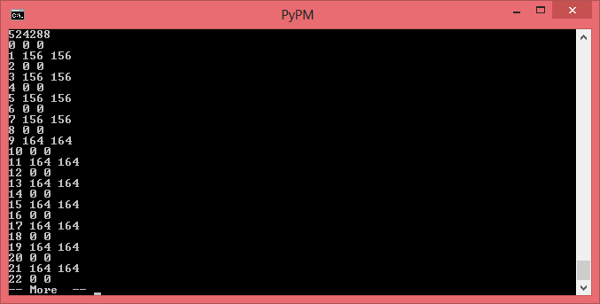
Information on how the file lena.hex was created.
Step 1 python lena2short.py
Step 2 python /bin/bin2hex.py tmp.bin lena.hex
So, the 4 bytes are: 90, AB, 12, CD where each byte requires 2 hex digits.
It turns out there are two ways to store this in memory.

Big Endian
In big endian, you store the most significant byte in the smallest address. Here's how it would look:
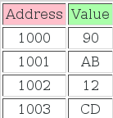

Little Endian
In little endian, you store the least significant byte in the smallest address. Here's how it would look:
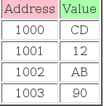

big endian view lena.hex
:020000040000FA

:10000000009C009C009C009C00A400A400A400A4F0
:1000100000A400A400A400A4009C009C00A400A4D0

.
:10FFF000005C005C005C005C00640064006C006CF1

:00000001FF

little endian lena.hex.orig
:020000040000FA

:100000009C009C009C009C00A400A400A400A400F0

:10001000A400A400A400A4009C009C00A400A400D0

.
:10FFF0005C005C005C005C00640064006C006C00F1

:00000001FF

