http://www.intopix.com/products/index/index/id/15/lang/en#.VUA5t5PPbtg
JPEG 2000 compression IP-Cores for FPGA
The most powerful and flexible JPEG 2000 implementation available today for capture, production, video over IP, storage and playback.

intoPIX JPEG 2000 encoding and decoding IP-cores respect and protect images with high intrinsic value. Handling simultaneously deep color precisions, high data rates and extensive JPEG 2000 encoding know-how, intoPIX IP-cores enable best-in-class picture quality.

Being compliant and optimized for the most up-to-date FPGA platforms, intoPIX IP-cores allow achieving unprecedented performances in terms of bit rates, frame rates and resolutions .

Benefiting from a modular architecture and completed with a wide range of interfaces, memory, security IP-cores, intoPIX solution provides an easy, timely and cost-effective way to implement JPEG 2000 technology.

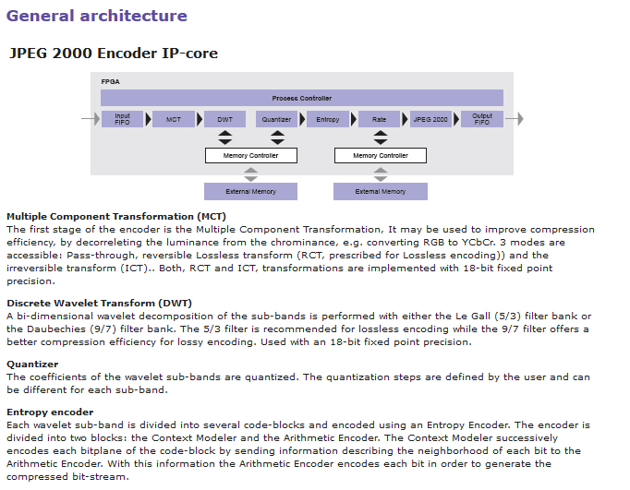
next pg
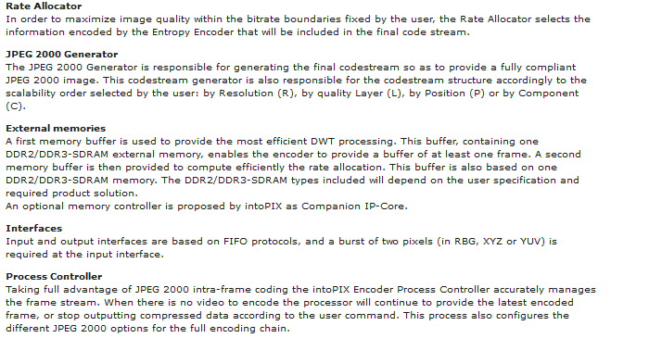
next pg
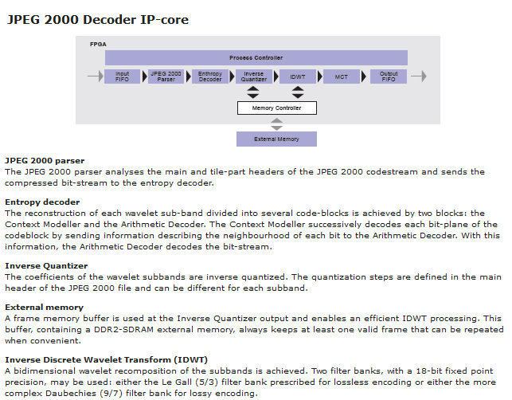
next pg
