Currently using clk_s for FSM and clk_fast for jpeg.
Would not work with clk_fast. ????

Ram values are written by
:1000000000A100A400A700AA00AD00B0540001792F
161 164 167 170 173 176
0 1 2 3 4 5
comparing fast_clk_jpeg/top_level_mod.vhd
top_level_mod.bit
python pc_top_level_mod_ram.py

##################################################################
# This program tests the interface between the host PC and the FPGA
# on the XuLA board that has been programmed to act as a jpeg_lifting .
##################################################################

356 86 312 1 0 555 555 170
sum_r is okay currently sending sam_r
jpeg result okay
using jpeg.v

jpeg_ram/
1000000000A100A400A700AA00AD00B000B3454DB8
161 164 167 170 173 176
0 1 2 3 4 5
python pc_jpeg_sig.py
The jpeg result is error.
sum_r is okay
left sam right are okay
##################################################################
# This program tests the interface between the host PC and the FPGA
# on the XuLA board that has been programmed to act as a jpeg_lifting .
##################################################################

1 1
128 1011 167 170 173 0b1 0b1
1 0
128 1011 167 170 173 0b1 0b1
0 1
128 1011 167 170 173 0b0 0b0
0 0
128 1011 167 170 173 0b0 0b0
161 + 164 + 167 + 170 + 173 + 176 = 1011
gxsload
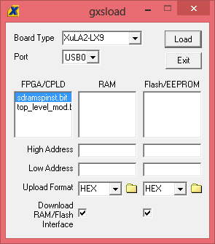

python pc_jpeg_sig.py

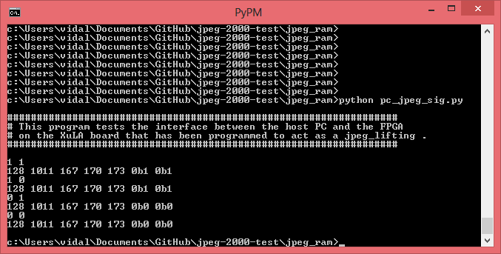

top_level_mod.bit

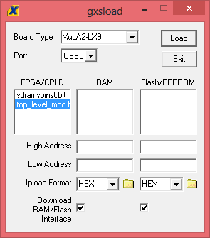

python pc_top_level_mod_ram.py

