PIC18F14K50-I/SO-ND
1 | 2.82000 | 2.82
10 | 2.35000 | 23.50
25 | 2.16000 | 54.00
100 | 1.95000 | 195.00

XC6SLX9-2FTG256C-ND

90 | 18.02156 | 1,621.94

W9825G6JH-6

1 | 3.66000 | 3.66
10 | 3.32000 | 33.20
25 | 3.24800 | 81.20
50 | 3.23000 | 161.50
100 | 2.89680 | 289.68
250 | 2.88596 | 721.49
500 | 2.77966 | 1,389.83
1,000 | 2.64276 | 2,642.76
2,500 | 2.61574 | 6,539.

. /opt/14.4/ISE_DS/settings64.sh
ise

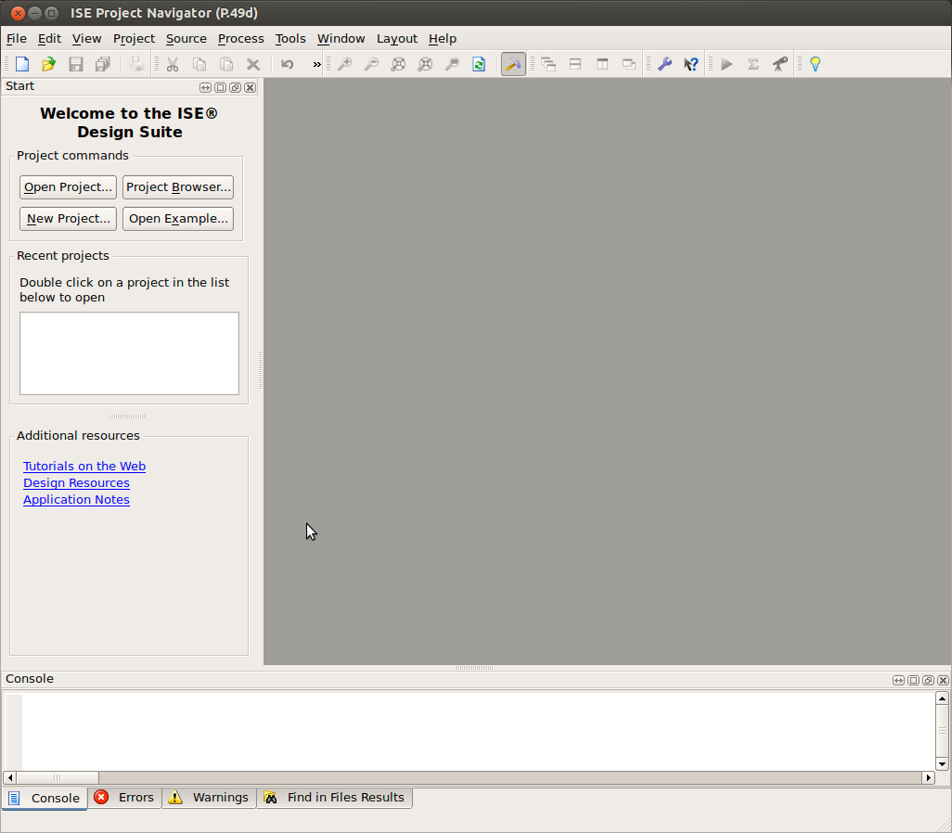
New project Spartan XC6SLX9 new source need to add a name
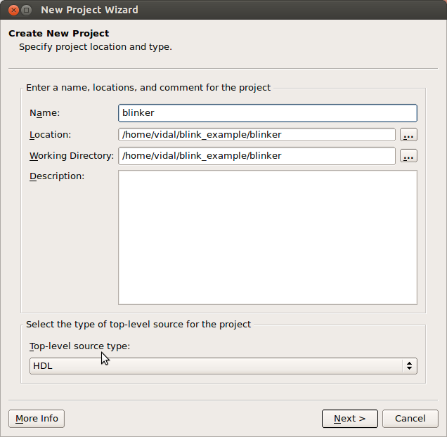
Press next
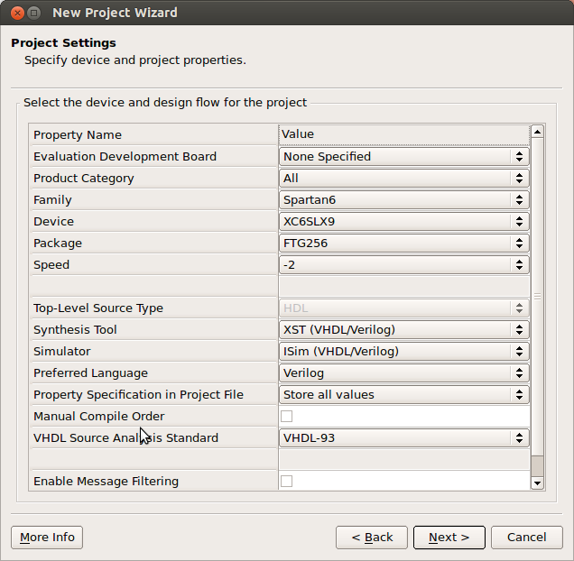
This is where the Family Spartan6 Device XC6SLX9 Package FTG256 Speed -2
Depess Next
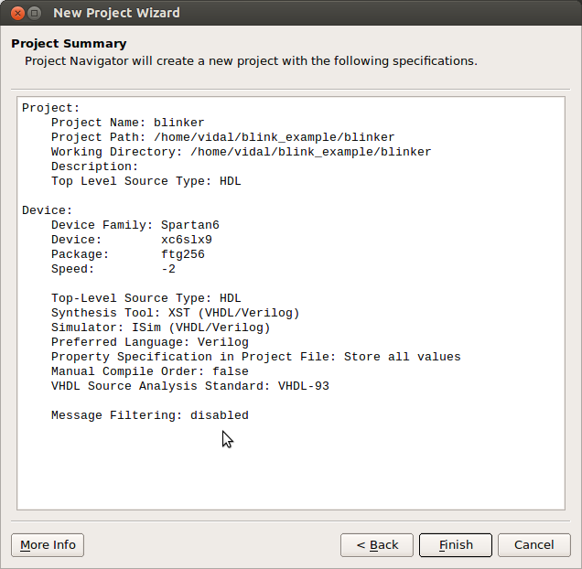
Now we have a summary of the project.
Noe we are adding a module. This module is going to be VHDL.

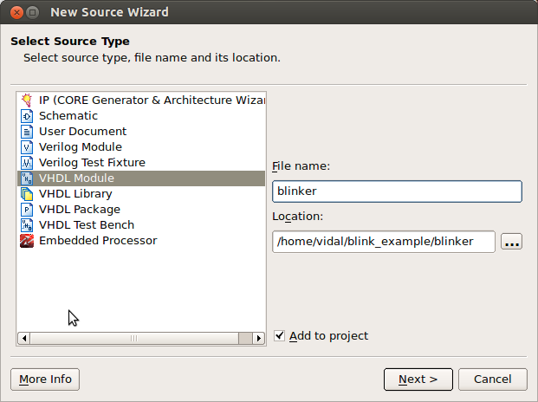
Now we need a clk_i input & blinker_o output

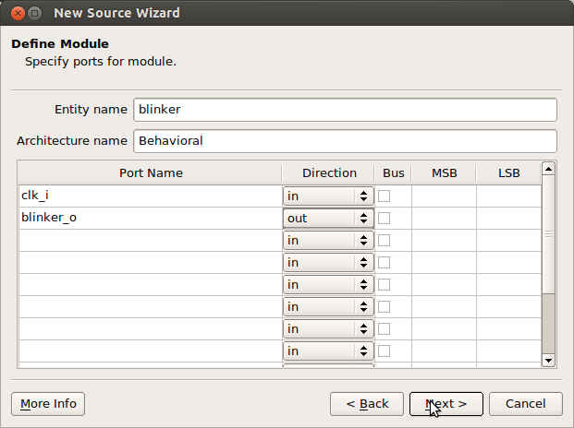
When depress Next We see the clk_i and blinker_o signals.
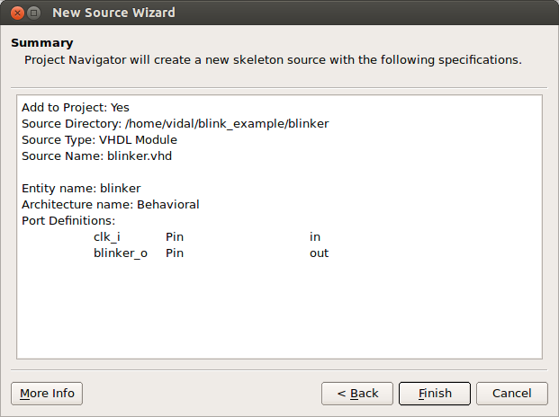
Depress Finish The file blinker.vhd is now in the right pane. The

architecture Behavioral of blinker is

begin
Needs logic
signal cnt_r : std_logic_vector(22 downto 0);
begin

process(clk_i) is
begin
if rising_edge(clk_i) then
cnt_r <= cnt_r + 1;
end if;
end process;

blinker_o <= cnt_r(22);

This process was getting an error.
Line 44: found '0' definitions of operator "+", cannot determine exact overloaded matching definition for "+"

use IEEE.STD_LOGIC_UNSIGNED.ALL;

Now we need a Testbench

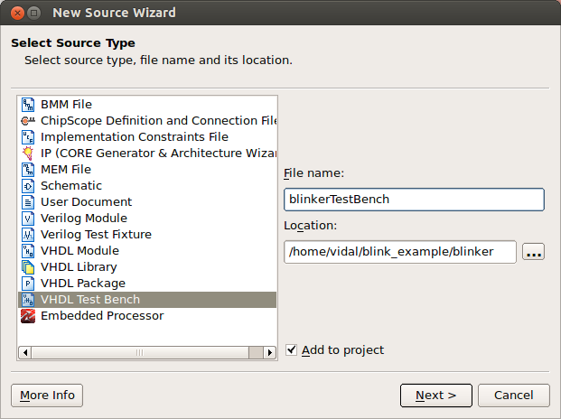
Depress Next
You will be prompted to associate with blinker

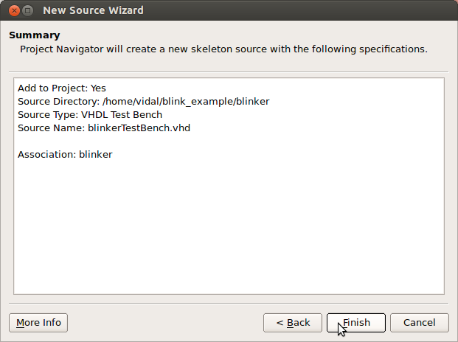

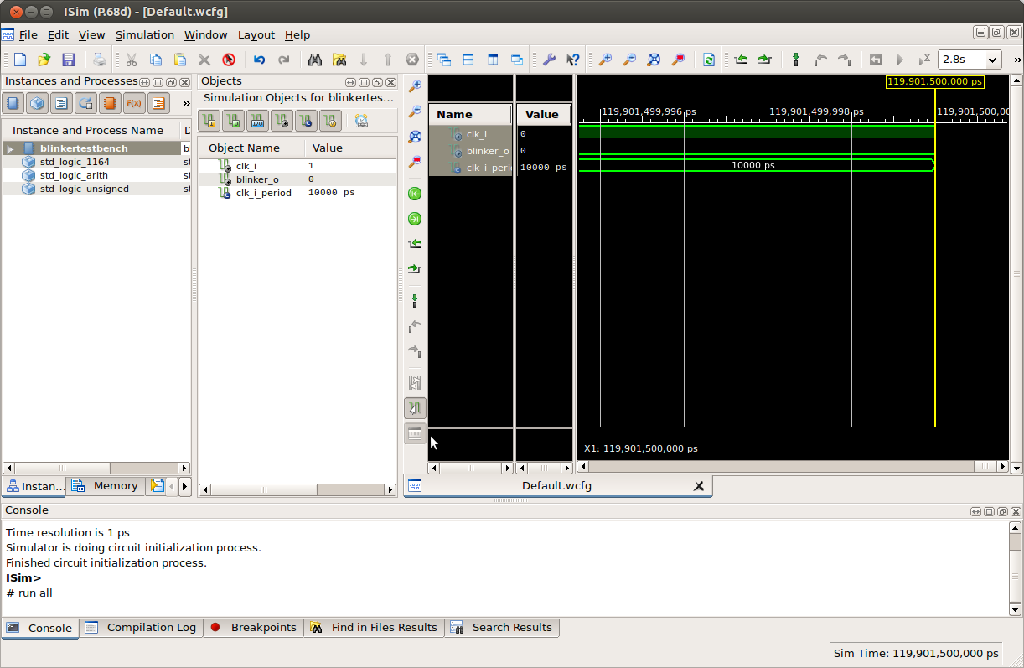
Design Summary

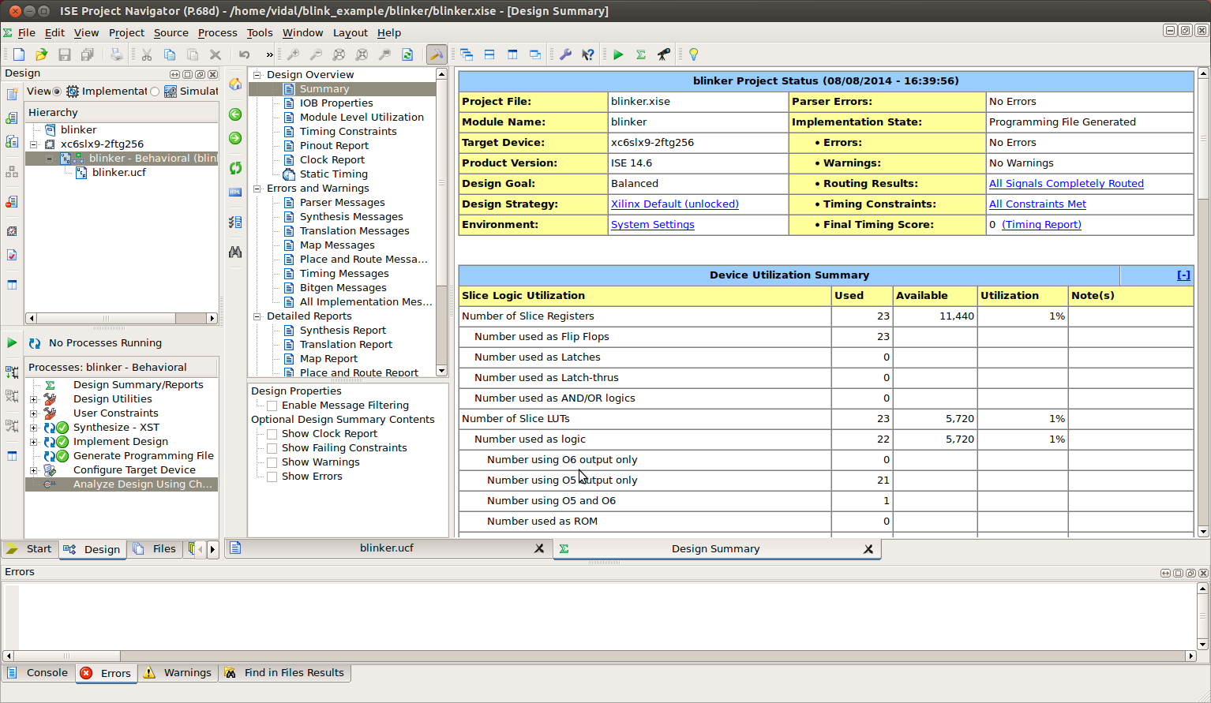
Next we need the bit file compatible with XulA2
The Unused IOB Pins and JTAG Pin TCK need to be modified.
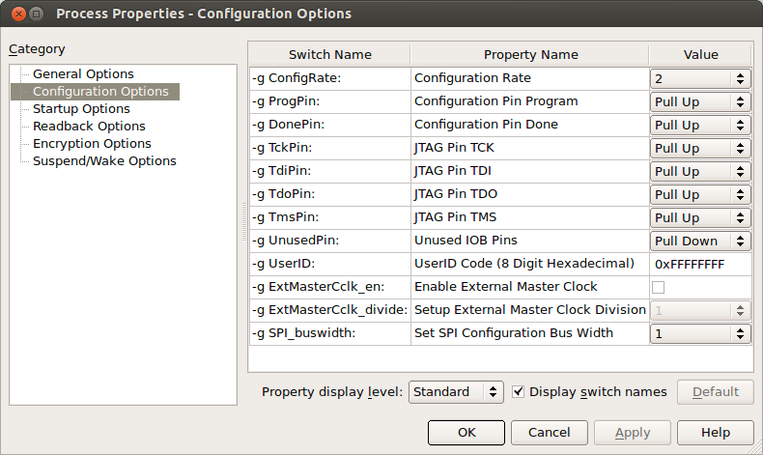
This is how it should appear.Then, click on the Unused IOB Pins drop-down menu and select Float from the list of

options. This will cause all FPGA I/O pins that are not specifically used in your design to

float in a high-impedance state. (VERY IMPORTANT: If you are using a XuLA2 board,

you must also set the JTAG Pin TCK value to Float
)

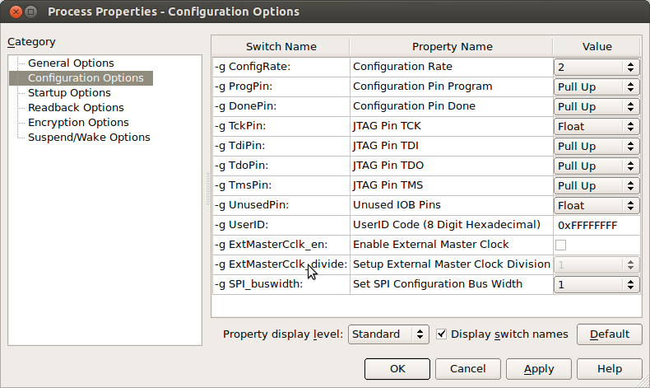
Startup Options

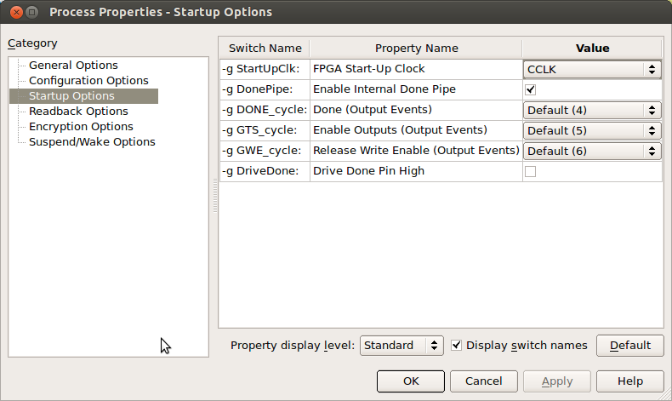

Finally, select the Startup Options category and set the FPGA Start-Up Clock to one of

the following values:

FPGA Start-Up Clock Settings

JTAG Clock Use this setting when your bitstream will be downloaded directly into the

XuLA2's FPGA through the USB cable.

CCLK Use this setting when your bitstream will be downloaded into the

XuLA2's serial configuration Flash for eventual transfer to the FPGA

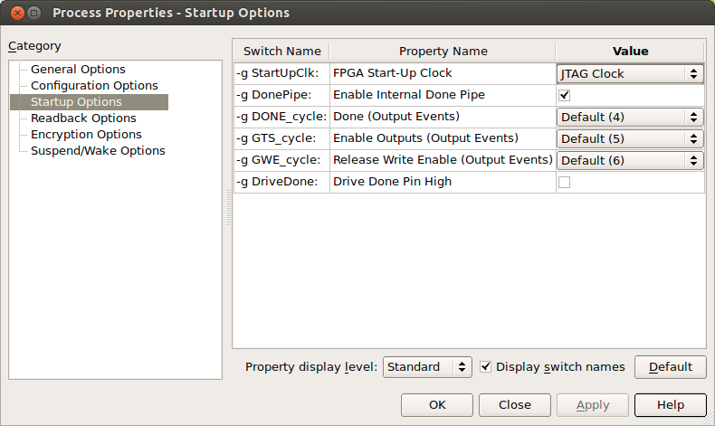
Need to change the ucf file.

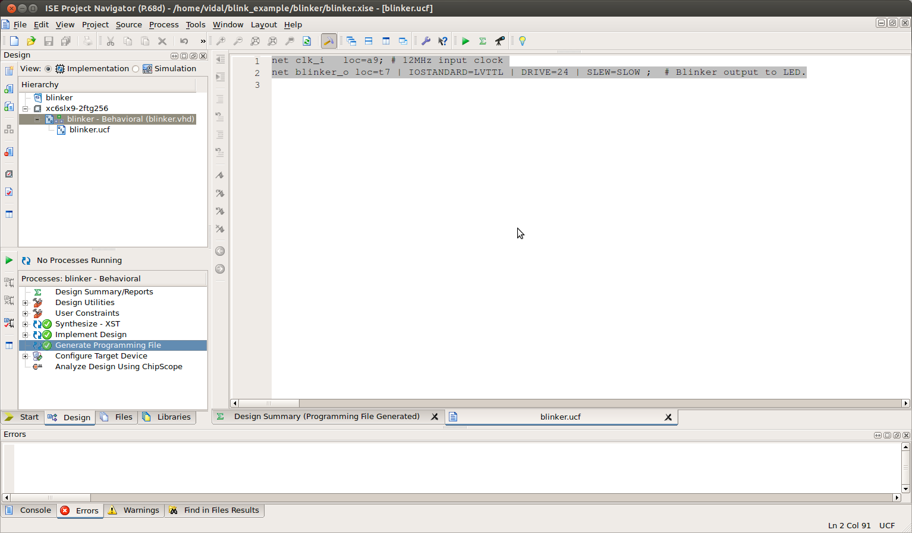
blinker.vhd
----------------------------------------------------------------------------------
-- Company:
-- Engineer:
--
-- Create Date: 15:20:09 08/08/2014
-- Design Name:
-- Module Name: blinker - Behavioral
-- Project Name:
-- Target Devices:
-- Tool versions:
-- Description:
--
-- Dependencies:
--
-- Revision:
-- Revision 0.01 - File Created
-- Additional Comments:
--
----------------------------------------------------------------------------------
library IEEE;
use IEEE.STD_LOGIC_1164.ALL;
use IEEE.STD_LOGIC_UNSIGNED.ALL;
-- Uncomment the following library declaration if using
-- arithmetic functions with Signed or Unsigned values
--use IEEE.NUMERIC_STD.ALL;

-- Uncomment the following library declaration if instantiating
-- any Xilinx primitives in this code.
--library UNISIM;
--use UNISIM.VComponents.all;

entity blinker is
Port ( clk_i : in STD_LOGIC;
blinker_o : out STD_LOGIC);
end blinker;

architecture Behavioral of blinker is
signal cnt_r : std_logic_vector(22 downto 0) := (others => '0');
begin

process(clk_i) is
begin
if rising_edge(clk_i) then
cnt_r <= cnt_r + 1;
end if;
end process;

blinker_o <= cnt_r(22);

end Behavioral;

blinker.ucf

net clk_i loc=a9; # 12MHz input clock
net blinker_o loc=t7 | IOSTANDARD=LVTTL | DRIVE=24 | SLEW=SLOW ; # Blinker output to LED.

Adding DCM manager.
With the DCM the counter_o signal changes faster. Using a divide of 1 and a mul of 10 the 12MHz becomes 120 Mhz The cnt_r goes 2^23 which 8388606
8.33333333333e-08 12MHz
2^23
8388608 to count it takes 0.699050666667

8.33333333333e-09 120MHz
8388608 to count it takes 0.0699050666667

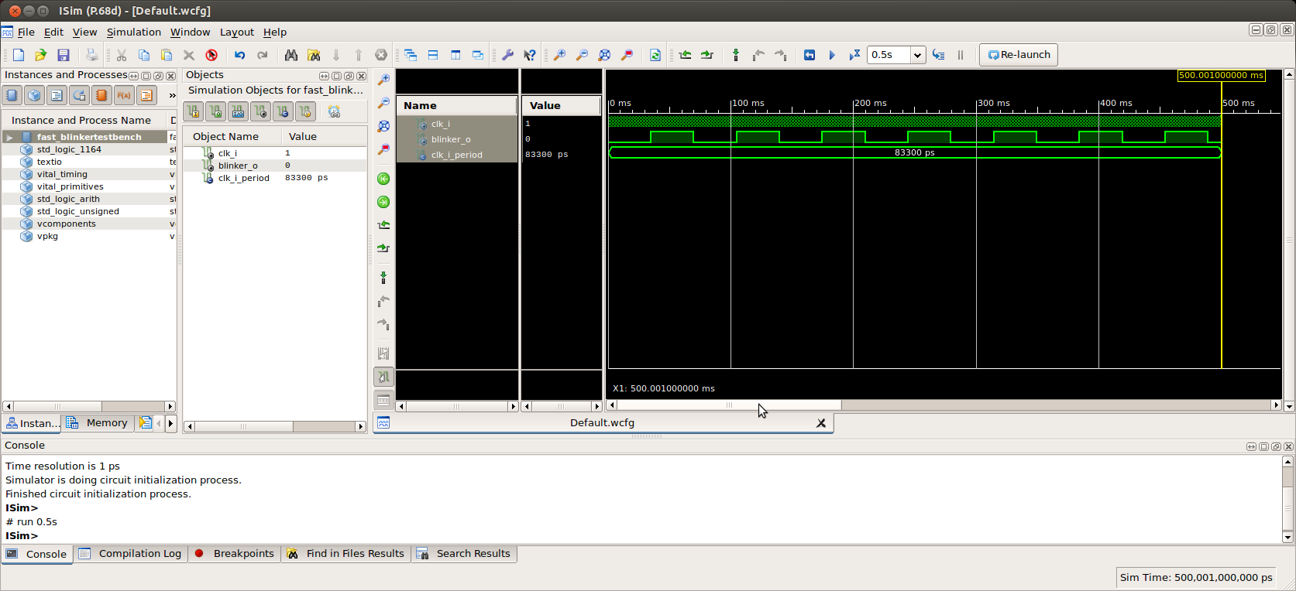
Now instead of enity blinker there is an entity fast_blinker.

entity fast_blinker is
Port ( clk_i : in std_logic;
blinker_o : out STD_LOGIC);
end fast_blinker;

architecture Behavioral of fast_blinker is
signal clk_fast : std_logic;
signal cnt_r : std_logic_vector(22 downto 0) := (others => '0');
begin
-- DCM_SP: Digital Clock Manager
-- Spartan-6
-- Xilinx HDL Language Template, version 14.6

DCM_SP_inst : DCM_SP
generic map (

CLKFX_DIVIDE => 1, -- Divide value on CLKFX outputs - D - (1-32)
CLKFX_MULTIPLY => 10 -- Multiply value on CLKFX outputs - M - (2-32)

)
port map (
CLKFX => clk_fast, -- 1-bit output: Digital Frequency Synthesizer output (DFS)
CLKIN => clk_i,
RST => '0' -- 1-bit input: Active high reset input

);

process(clk_fast) is
begin
if rising_edge(clk_fast) then
cnt_r <= cnt_r + 1;
end if;
end process;

blinker_o <= cnt_r(22);

end Behavioral;

In the fast_blinkerTestBench need to chg
--constant clk_i_period : time := 10 ns;
constant clk_i_period : time := 83.3 ns;
for 12MHz

