Testing the project
Need to Download the bit file that was created with ISE Xilinx Tools.

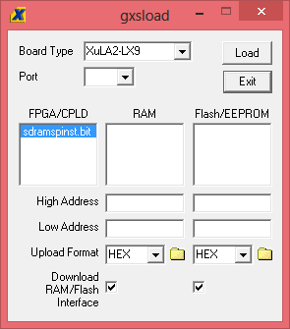

With a pyton program see below sends 3 16 bit numbers and 2 1 bit numbers. The FPGA sends back 2 16 bit numbers. You can test the code that you just downloaded

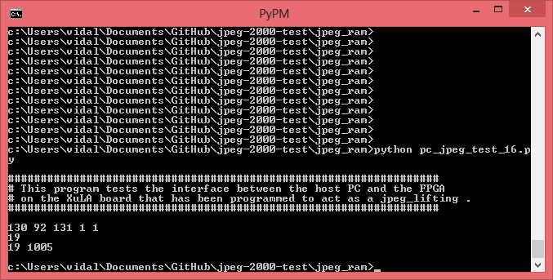

# /***********************************************************************************
# * This program is free software; you can redistribute it and/or
# * modify it under the terms of the GNU General Public License
# * as published by the Free Software Foundation; either version 2
# * of the License, or (at your option) any later version.
# *
# * This program is distributed in the hope that it will be useful,
# * but WITHOUT ANY WARRANTY; without even the implied warranty of
# * MERCHANTABILITY or FITNESS FOR A PARTICULAR PURPOSE. See the
# * GNU General Public License for more details.
# *
# * You should have received a copy of the GNU General Public License
# * along with this program; if not, write to the Free Software
# * Foundation, Inc., 59 Temple Place - Suite 330, Boston, MA
# * 02111-1307, USA.
# *
# * (c)2011 - X Engineering Software Systems Corp. (www.xess.com)
# ***********************************************************************************/

from xstools.xsdutio import * # Import funcs/classes for PC <=> FPGA link.
from random import * # Import some random number generator routines.

print '''
##################################################################
# This program tests the interface between the host PC and the FPGA
# on the XuLA board that has been programmed to act as a jpeg_lifting .
##################################################################
'''

USB_ID = 0 # USB port index for the XuLA board connected to the host PC.
JPEG_ID = 4 # This is the identifier for the jpeg in the FPGA.

# Create a jpeg intfc obj with three 17-bit inputs and one 17-bit output.
even_odd = 1
fwd_inv = 1
jpeg = XsDut(USB_ID, JPEG_ID, [16, 16, 16, 1, 1], [16, 16])
sam = randint(0, 511) # Get a random, positive byte...
left = randint(0, 511) # Get a random, positive byte...
right = randint(0, 511) # Get a random, positive byte...
loc_lift = sam - ((left>>1) + (right>>1))
print sam, left, right, even_odd, fwd_inv
print loc_lift
lift , sum = jpeg.Exec(right, left, sam, even_odd, fwd_inv ) # Use the jpeg in FPGA.
print lift.int, sum.int

