Using 8 X 8 cblk instead processing the entire image.
This first pass is shown below.

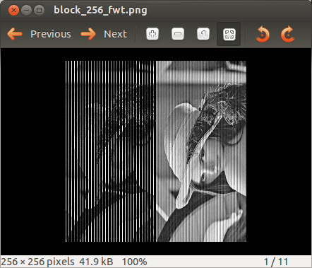

Processing the 2nd pass yields without lower_upper method.

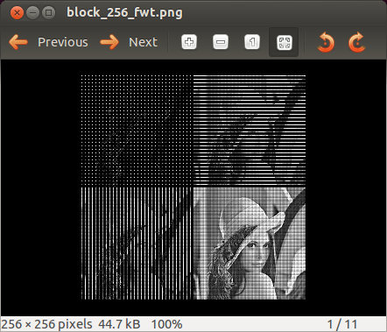

In the above images it clearly demonstrates the Vertical processing in the lower left and the Horizontal processing in upper right, and the Vertical/Horizontal processing in the upper left. The low pass in the lower right is the best quality.

Processing the 2nd pass yields and adding the lower_upper method.

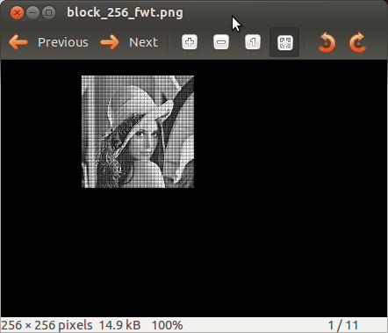

When the entire image is processed. Even without symetrical extension the first pass is as below.

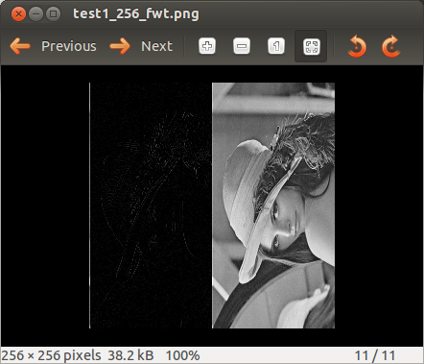

With the 2nd pass.
