Simulation of XESS SDRAM and Computing the lifting Scheme for JPEG 2000

The results in the simulation were improved considerably when the following lines were added to the file
XESS_SdramSPInstTB.vhd
diff --git a/jpeg2k/XESS_SdramSPInst/ex_lib_files/XESS_SdramSPInstTB.vhd b/jpeg2k/XESS_SdramSPInst/ex_lib_files/XESS_SdramSPInstTB.vhd
index 942ae71..9eb0209 100644
--- a/jpeg2k/XESS_SdramSPInst/ex_lib_files/XESS_SdramSPInstTB.vhd
+++ b/jpeg2k/XESS_SdramSPInst/ex_lib_files/XESS_SdramSPInstTB.vhd
@@ -371,6 +371,12 @@ xess_jpeg_top_u0 : xess_jpeg_top
sdDqmh_o => sdDqmh_o, -- SDRAM high-byte databus qualifier is connected on the XuLA2.
sdDqml_o => sdDqml_o -- SDRAM low-byte databus qualifier is connected on the XuLA2.
);
+ -- Connect the SDRAM controller signals to the FSM signals.
+ dataToSdram_s <= dataToRam_r;
+-- dataToSdram_s <= std_logic_vector(dataToRam_r);
+ dataFromRam_s <= RamWord_t(dataFromSdram_s);
+-- addrSdram_s <= std_logic_vector(TO_UNSIGNED(addr_r, addrSdram_s'length));
+ addrSdram_s <= addr_r;
-- Clock process definitions.
-- This generates the 12 MHz clock.
fpgaClk_process :process

The SDRAM was written by reading the data from a ROM into a FIFO

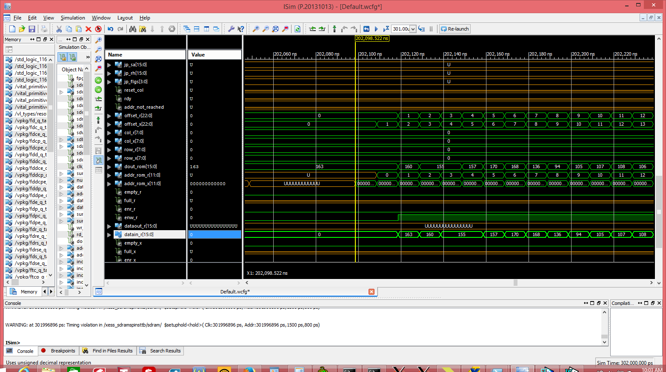

The FIFO was then written to SDRAM.

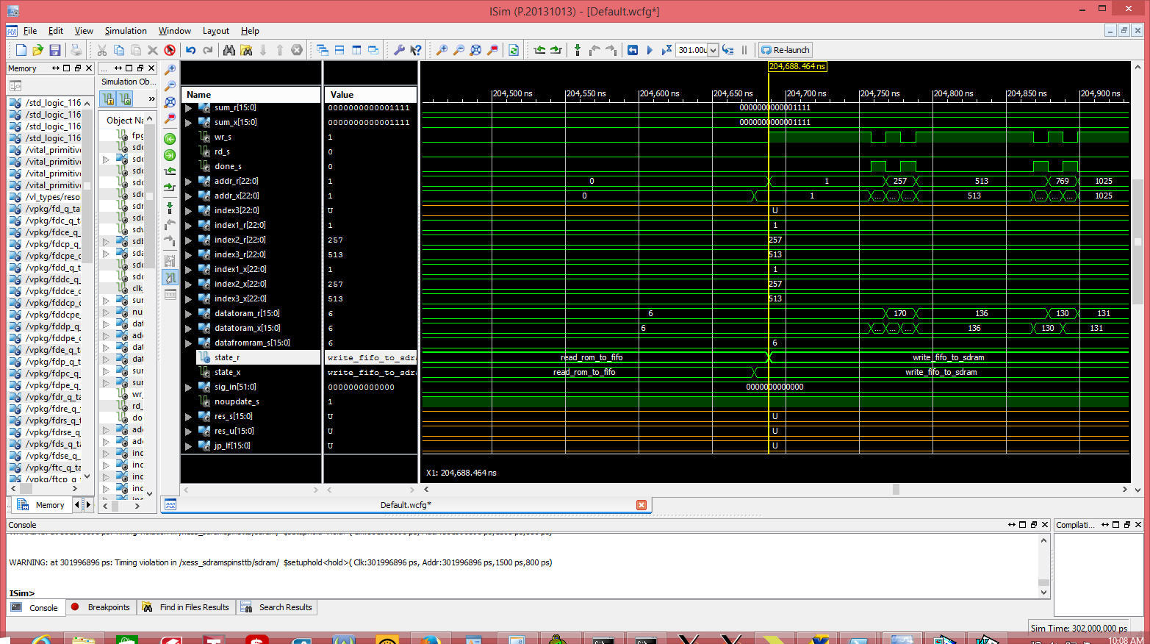

Reading the SDRAM at addr 1, 257, 513.
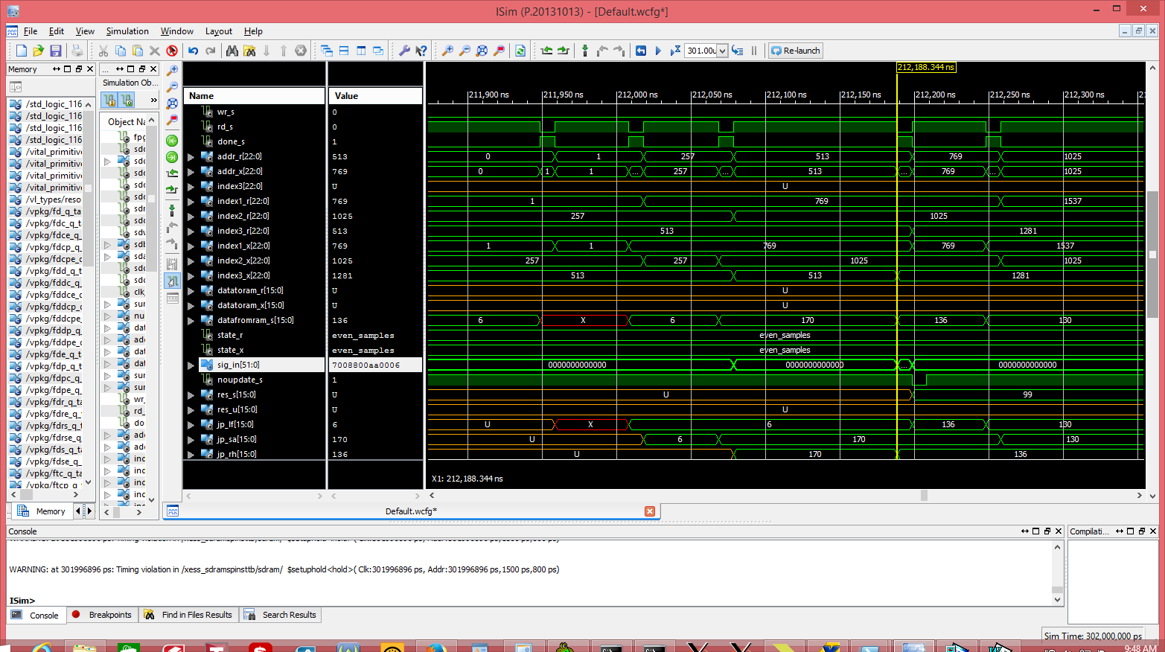
The data addr 1, 257, 513 is combined in sig_in with jp_flgs
sig_in 0x7008800aa0006
jp_lf 0x0006 jp_sa 0x00aa jp_rh 0x0088
6 170 136
jpeg_process computes
res_s <= signed(sig_in(32-1 downto 16) - (shift_right(sig_in(16-1 downto 0), 1) + shift_right(sig_in(48-1 downto 32), 1)));

res_s = 99 = 170 -((136 + 6)/2)

